DATA FILE MAINTENANCE
TABLE OF CONTENTS

SUMMARY: 4
FIRM MAINTENANCE 5
Firm Maintenance Screen 5
Firm Billing Options 9
ATTORNEY FILE MAINTENANCE 14
Attorney Maintenance Screen 14
Attorney Billing Options 15
Attorney Rates 16
CLIENT FILE MAINTENANCE 18
Client File Maintenance Screen 18
Client Bill Information 20
Client Notes 22
Rate Assignments 23
Attorney Rates 23
Class Rates 24
Utilizing Attorney & Class Rates Simultaneously 25
Client Branch Address 26
Originating Attorney Credit 27
Conflict Of Interest 28
Unit Costs by Client 29
Scratch Pad Processing 30
MATTER FILE MAINTENANCE 31
Matter File Maintenance Screen 32
Insurance Information / Matter Notes 35
Miscellaneous Billing Name & Address 36
Billing Schedule 37
Branch Address Definition 38
Originating Attorney Credit by Matter 39
BILL CODE FILE MAINTENANCE 41
Bill Code Maintenance Screen 41
Summary of Task Code Processing 41
ATTORNEY CLASS MAINTENANCE 45
Attorney Class Maintenance Screen 45
Class Rate Definition 46
COURT/LOCATION FILE MAINTENANCE 47
Court / Location Maintenance Screen 47
MATTER TYPE FILE MAINTENANCE 48
Matter Type Maintenance Screen 48
SCRATCH PAD PROCESSING 49
Scratch Pad Processing Screen 49

DATA FILE MAINTENANCE

SUMMARY:
L.A.W.S. requires basic information regarding the firm, its attorneys, clients and matters to operate. This information is entered through the Data File Maintenance and Listings (DFM) menu. The menu is divided into two columns. The left column is titled “Maintenance”, while the right column is titled “File Listings”. The Maintenance Column allows maintenance (additions, changes, or deletions), to the L.A.W.S. Master File information. The File Listings column allows the requested Master File information to be printed or displayed.

After selecting the Data File Maintenance option from the Master Menu, the following menu is displayed:

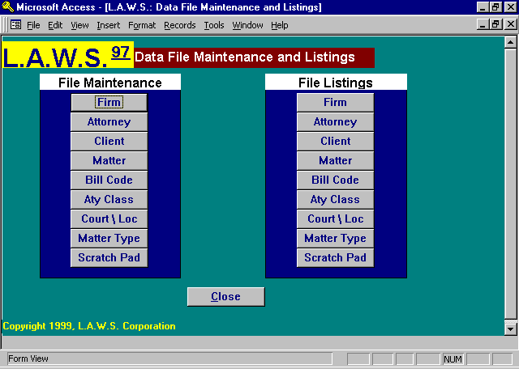

All functions contained in the Maintenance column, will, upon selection, display the first entry in the selected table. To select an entry simply scroll down the dropdown box until the desired record is displayed. Once displayed, click on the record to display the associated data. As an alternative, simply start typing the code associated with the desired record. L.A.W.S. will automatically display the codes matching the entered text. Press enter once the appropriate code is displayed.

New records are added by entering a code not previously used. L.A.W.S. automatically displays a blank screen with the notation "*** New Record ***" alerting you to the fact that you are processing a new record. Simply enter the information pertaining to the new record. If desired, click the “ADD” button in the footer of the screen to display a blank form.
Please Note: If you enter information incorrectly on en existing record, press the escape (Esc) key to undo your changes. It may be necessary to press the Esc key twice, once to undo the current field, and the second time to undo the entire record. The record is undone when the pencil disappears from the record selector.

________________________________________

FIRM MAINTENANCE

Firm Maintenance allows entry of information unique to your firm. Firm numbers identify firms. The primary law firm is always identified as firm Number 1. Secondary firms may be defined using numbers 2 and above. After selecting Firm Maintenance from Data File Maintenance, the following FIRM FILE MAINTENANCE screen will be displayed:

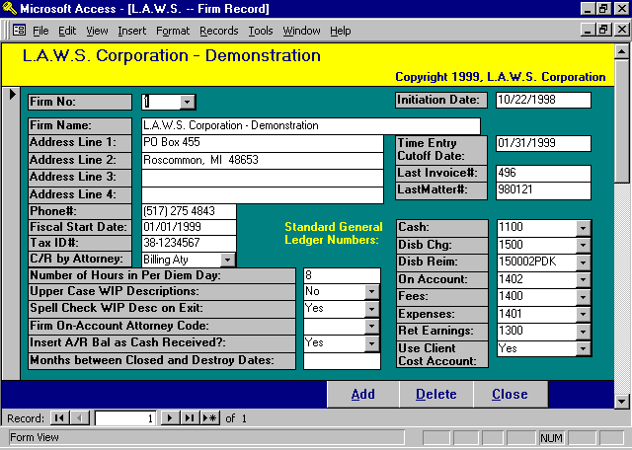

Firm Maintenance Screen

FIRM NO
Enter the number, which is going to be assigned to your firm. The primary law firm MUST be firm # 1 (one). The firm name printed for all reports comes from firm # 1. Many verification items, such as billing options, etc. also come from firm #1. Secondary firm numbers may be entered and used within the billing and general ledger applications only.
INITIATION DATE
Specifies the date the law firm started using L.A.W.S. The current system date is automatically recorded when the firm is defined. Only transactions dated after this Date of Initiation are used in the computation of the date and amount of last payment received from clients. L.A.W.S. Corporation has found that data imported from other systems into L.A.W.S. often contains inaccurate dates and amounts of last payments.
For example: Converted receivable data imported into L.A.W.S. may contain total billings and total payments by client. Each transaction may be dated the date of the conversion, which would be prior the L.A.W.S. Date of Initiation. Assuming, within this example, no other transactions have been received from this client, it would be misleading if L.A.W.S. printed the total receipts and conversion date as the Date and amount of last payment on client statements and reminder notices.

FIRM NAME
Enter the Firm’s name. The Firm’s name is automatically centered over L.A.W.S. report headings.

ADDRESS LINES 1-4
Enter the Firm’s address.

PHONE #
Enter the Firm’s telephone number, area code first, then the remainder of the number.

FISCAL START DATE
Enter the date of the first day of the firms’ current fiscal year. The date must be entered using the Standard Date Format. The fiscal start date is used to verify dates throughout the system. General ledger activity must fall within the current fiscal year. Year to Date reports utilize the fiscal start date as the default value for selection of data.

TAX I.D.#
Enter the Firm’s Federal Tax ID number. The Tax ID Number prints in the heading on client invoices.

C/R BY ATTORNEY
Cash Receipts by Attorney. Specifies the manner in which fees received should be posted to the General Ledger. The available options are:
None: Fees received from clients are totaled then posted to the standard “Fees” G/L number without regard to attorney.
Billing Aty: Fees received from clients are totaled within Billing Attorney. L.A.W.S. creates a new fee account by adding the Billing Attorneys initials to the standard “Fees" G/L number noted in the firm file. If the created general ledger number exists, the accumulated fees by billing attorney are posted to this account. Otherwise, the accumulated fees are posted to the standard “Fees" G/L number without regard to the Billing Attorney.
Cont Aty: Fees received from clients are totaled within Contributing Attorney. L.A.W.S. creates a new fee account by adding the Contributing Attorneys initials to the standard “Fees" G/L number noted in the firm file. If the created general ledger number exists, the accumulated fees by Contributing Attorney are posted to this account. Otherwise, the accumulated fees are posted to the standard “Fees" G/L number without regard to the Contributing Attorney.

NUMBER OF HOURS IN PER DIEM DAY
L.A.W.S. has the ability of recording time and assigning rates on a per diem day basis. (See Bill Code Maintenance for reference to Per Diem Status). Many management reports display hours worked. L.A.W.S. must convert days to hours worked. L.A.W.S. multiplies the entered number of hours in a Per Diem Day by the number of per diem days worked. The default value is 8 hours.

UPPER CASE WIP DESCRIPTIONS
Specifies the case in which Work In Process is entered into the system. WIP may be entered in both Upper and Lower Case or Uppercase only. The available options are:
No: WIP Entry / Modifications are Case Sensitive - Upper and Lower.
Yes: WIP Entry/Modifications Upper Case Only.

SPELL CHECK WIP DESCRIPTION ON EXIT
L.A.W.S. offers the option of automatically spell checking the WIP Description upon exiting the field. L.A.W.S. uses the Microsoft WORD spelling dictionary. The options available with this field include:
Yes The spelling in the WIP Description is automatically check when the field is exited.
No The spelling in the WIP description is not checked when the field is exited.
If the No option is chosen, the WIP description may be manually spell checked by double clicking the description field.

FIRM ON ACCOUNT ATTORNEY CODE
Specifies how credit for On Account receipts are allocated to billing attorneys. If this option is left blank, On Account receipts are posted as fees received to the billing attorney. When the On Account receipt is utilized, the On Account credit is deducted from the billing attorney; then re-allocated to the billing and contributing attorneys as a normal accounts receivable receipt. If a firm On Account attorney code is entered, all On Account credit is posted to the entered attorney code. When the On Account credit is utilized, On Account credit is deducted from the entered attorney and reposted to the appropriate billing and contributing attorneys as a normal A/R receipt.

INSERT A/R BAL AS CASH RECEIVED:
As cash receipts are processed, L.A.W.S. offers the option of automatically inserting the balance due per invoice as the amount of cash received. The available options include:
Yes The AR balance will be inserted as the amount received when processing receipts. The user will
need to change receipt amounts which do not relieve the amount due in full.
No The amount received will be blank when processing cash receipts. The user must enter the
amount of cash received.

MONTHS BETWEEN CLOSED AND DESTROY DATES:
L.A.W.S. offers the ability of automatically computing a destroy date when a matter is closed. To utilize this feature, enter the desired number of months between the close date and the desired destroy date. For example, if you desire that a closed date be automatically computed 6 years after the closed date, then enter "72" in this field. In this example, each time a matter is closed a destroy date will automatically be computed 72 months after the closed date. See the "Purged Matters" function within the Miscellaneous Menu for a detailed description of how matters may be removed from the system using the destroy date.

TIME ENTRY CUTOFF DATE
Specifies the period from which time may be entered from timesheets. L.A.W.S. will not allow attorneys time to be entered into the system if the date of service is on or before the Time Entry Cutoff Date. This verification allows the firm the option of “Closing” a month, as far as time entry is concerned, so that values contained on productivity reports will not inadvertently be changed by the entry of late time. This date is also used as the default “through date” for many productivity reports. This date must be entered using the Standard Date Format. This date has no bearing on WIP Adjustments. Accordingly WIP containing any service date whatsoever may be modified through WIP Adjustments.

LAST INVOICE#
This is a system-monitored number representing the last invoice number assigned during the generation of client bills. This field does not need to be modified except at the initiation of the system.

LAST MATTER#
This is a system-monitored number representing the last Matter number assigned during the entry of new matters from Matter File Maintenance.

STANDARD GENERAL LEDGER NUMBERS
L.A.W.S. automatically posts normal day-to-day financial activity to the general ledger. The Standard General Ledger Numbers are used to create the General Ledger Postings. All entries are verified for accuracy against the existing Chart of Accounts. Use the drop down boxes to display the existing chart of accounts. If these numbers are left blank, L.A.W.S. will be unable to create valid journal entries.
Cash: Enter the general ledger cash account number used for the normal day-to-day posting of cash deposits and disbursements.
Disb Chg: Enter the general ledger number to which client disbursements are posted when the disbursement check is generated.
Disb Reim: Enter the general ledger number to which reimbursement of client costs are posted when the client reimburses disbursements.
On Account: Enter the general ledger number to which client On Account payments are posted. On Account payments are retainers posted to the firms General Cash Account.
Fees: Enter the general ledger number to which fees received for services should be posted.
Expenses: Enter the general ledger number to which reimbursed client expenses (reimbursement of overhead charges) should be credited. All client expenses must be identified by a bill code. L.A.W.S. offers the option of assigning a reimbursement general ledger number for each expense bill code. If entered, expense reimbursements will be posted to the G/L number is associated with the bill code, otherwise, this referenced Expense account will be used for expense reimbursement.
Ret Earnings: Enter the Retained Earnings general ledger number. L.A.W.S. creates a year-end closing entry zeroing the Income and Expense accounts to this Retained Earnings account.
USE CLIENT COST ACCOUNT
Specifies if Client Costs must be posted to a Client Cost general ledger number. General ledger numbers are classified as Client Cost accounts through General Ledger Maintenance. The available options include:
Yes Client Cost Line Items must be posted to client cost general ledger numbers.
No Client Cost Line Items may be posted to any general ledger number.

Additional Firm related options are available by scrolling down the screen. The user has the option of pressing the “Page Down” key, or by “Dragging” the right “Navigation Button” towards the bottom of the form. Listed below is the Page Down continuation of the Firm Maintenance Form:

Firm Billing Options

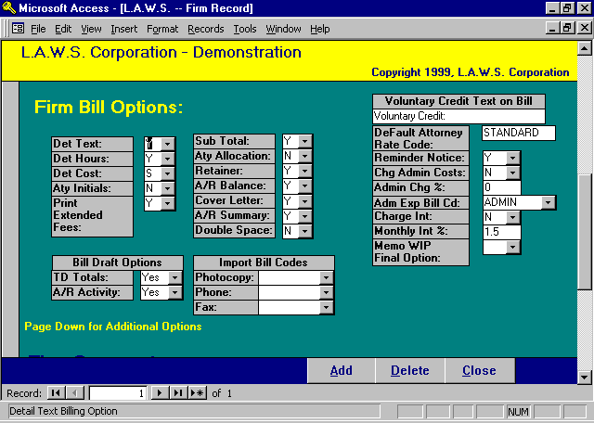

VOLUNTARY CREDIT TEXT ON BILL
L.A.W.S. allows voluntary credit, a discount from actual fees, to be given to a client at the time of billing. If this discount is to be noted on the invoice, the response to this field is the heading that will print on the invoice associated with the voluntary credit. Some Firms like to use headings such as “Professional Courtesy”, while others like terms such as “Voluntary Credit”.

Billing options are Yes / No type questions which determine the manner in which Client Invoices are created. You may specify billing options at the Firm level creating a standardized bill format for the entire firm. If desired, bill options may be modified for specific clients through Client File Maintenance or for a specific billing attorney through Attorney File Maintenance.

Client invoices can consist of up to four distinct sections. These sections include:
Cover Letter: A brief statement at the beginning of the invoice summarizing total Fees and Costs contained on the invoice.
Detail Text: A detailed accounting of all fees and costs contained on the current invoice. Each individual WIP transaction is noted on the Detail statement.
A/R Summary: A statement which lists and ages all outstanding Accounts Receivable invoices associated with the current invoices’ client and/or matter.
Task Code Summary: A statement which summarizes all Work In Process within Bill Code.

Listed below is a detailed explanation of the available billing options.

DET TEXT
This option specifies whether the Detail Text portion of the client invoice should be printed. Available options:
Y : Yes: The Detailed Text portion of the invoice WILL be printed,
N : No: The Detailed Text portion of the invoice WILL NOT be printed,

DET HRS
This option specifies if detailed hours should be itemized on each individualized line item on the detailed client invoice. Available options:
Y: Yes: The Hours will be noted on each WIP transaction line item.
N: No: The hours will not on each WIP transaction line item.
T: Total Only: The total hours billed will be displayed, hours will not be displayed beside each line
item.

DET COSTS
Specifies how costs should be presented on the detailed client invoice bill. Available options:
Y: Yes: Each individual cost item will be noted on the detail client invoice.
S: Summary: Costs will be summarized based on the utilized bill code. This option works in
conjunction with the bill code's Summary Option. Please review Bill Code Maintenance
for additional information on the Bill Code Summary option.

ATTY INITIALS
Specifies whether the attorney's initials should be itemized on each individualized line item: on the detailed client invoice. Available options:
Y: Yes: The attorney initials will print on each line item.
N: No: The attorney initials will not print on each line item.

PRINT EXTENDED FEES
This option allows you to specify if the extended fee value should be itemized on each individualized line item on the detailed client invoice. The extended fee value is computed by multiplying the hours worked by the assigned hourly rate. Available options:
Y: Yes: The extended fees will print on each line item.
N: No: The extended fees will not print on each line item.

SUB TOT
Specifies whether each statement should include a single matter only or multiple matters for the same client sub-totaled on a single statement. Available options:
Y: Yes: Multiple matters for a single client will be sub-totaled on a single statement.
N: No: Each Matter will be printed on its own statement.

ATY ALLOCATION
Specifies whether a schedule of “Attorney Fee Allocations” should print on the detailed client invoice. This schedule summarizes by attorney the total hours worked along with the assigned Billing Rate. Available options:
Y: Yes: An Allocation of Fees by Attorney will print ,after the fee section on each statement, for
each matter.
N: No: The Attorney Allocation of Fees will not be printed.
RETAINER
Specifies if retainer balances should be applied against the current statement total. Retainers may be stored in the General Cash Account as an “On Account Payment”, or may be stored in the Trust Account as a “Trust Retainer”. Available options:
Y: Yes: Trust retainers and On Account payments will be applied against the current invoice total. Trust Retainers will be applied first and On Account balances will be applied last.
N: No: Neither the Trust Retainer nor the On Account balance will be applied against the current
invoice balance.

NOTE: On Account payments and Trust Retainers decrease the total amount due on the client invoice. The accounts receivable posting is created for the full amount of the client statement without regard for the retainer. For trust checks, the system automatically creates a trust disbursement entry to the firm in the trust processing system. For on account payments, L.A.W.S. automatically creates a positive cash receipt entry, and a negative retainer entry to correctly apply the retainer. It is the users responsibility to generate and apply the trust disbursement check, or to complete the cash receipts posting of the on account payment. L.A.W.S. alerts the user to the fact that a trust disbursement check or cash receipts entry has been generated.

A/R BALANCE
Specifies if the outstanding accounts receivable balance should or should not appear on the invoice. The A/R balance will refer to the matter if the subtotal option is “No” or to the client if the subtotal option is “Yes”.
Available options:
Y: Yes: The outstanding A/R balance will be added to the amount due this invoice. The “Total Due This Invoice ” will include the current invoice along with the outstanding A/R balance.
N: No: The outstanding A/R balance will not be reflected on the client invoice.

COVER LETTER
Specifies whether the Cover Letter section of the client invoice should be printed. Available options:
Y: Yes: A Cover Letter will be printed.
N: No: A Cover Letter will Not be printed.

A/R SUMMARY
Specifies whether the Accounts Receivable Summary section of the client invoice should be printed. Available options:
Y: Yes: The A/R Summary will be printed.
N: No: A Cover Letter will Not be printed.

DOUBLE SPACE
Specifies whether or not a double space should be placed between fee transactions on the client bill. Available options:
Y: Yes: A space will be included between fee entries on the detail client invoice.
N: No: A line WILL NOT appear between fee entries on the detail client invoice.

DEFAULT ATY RATE CODE
Multiple rates may be assigned to each attorney based on user defined Rate Codes. (See Attorney File Maintenance). This option allows the firm to specify the standard rate code to be used for the assignment of rates by attorney. The noted attorney rate code will be used in the assignment of billing rates unless a different rate code has been assigned at the client or matter.

REMINDER NOTICE
Specifies the firm default value for the printing of Reminder Notices. This option works in conjunction with the Client Reminder Notice option. Available options:
Y: Yes: Reminder Notices will be printed for all clients unless otherwise specified at the client.
N: No: Reminder Notices will Not be printed for clients unless otherwise specified at the client.
CHARGE ADMIN COSTS
Specifies the firm default value for charging administrative expenses. The administrative expense is a charge added to the clients statements based on a percent of fees. This charge represents firm overhead costs charged to clients and is used in place of detailed cost item charges. For example, the firm may elect to charge clients 3.5% of the fees to cover photocopy and telephone charges. Rather than entering into Work In Process each telephone or photocopy charge and then listing the exact charges on the statement, the firm could elect to have a single line description appear on the statement with a corresponding percent of fees as the charge.
Available options:
Y: Yes: Administrative Expenses will be computed and charged to the client.
N: No: The Administrative Expense will not be computed.

ADMIN CHG %
The percent used in the computation of administrative expenses. The value of 3.5% would be entered as “3.5” not as “.035”.

ADMIN EXP BILLCD
The Bill Code assigned to the Administrative Expense charge. If administrative expenses are charged, the description associated with this bill code is used as the description of the Administrative Charge.

CHARGE INT
Specifies whether Interest should be charged to the client on outstanding accounts receivable balances.
Available options:
Y: Yes: Interest will be computed and charged to the client.
N: No: Interest will Not be computed

MONTHLY INT %
Specifies the Monthly interest rate to be charged. If you wish to charge 1.5% per month, the rate would be entered as “1.5” not as ”015”.

MEMO WIP FINAL OPTION
Specifies how “Memo” entries should be treated at the time of final billing. Memo Entries are transactions posted to WIP which are coded not to appear on the client invoice. Memo entries may be billable WIP entries marked not to appear on the current invoice but which should appear on future invoices, or they may be notes from the attorney which should be in the WIP but should not print on this or future client invoices. Available options:
Y: Assumes that Memo Entries should be billed. After the current bill is finalized, all existing memo entries are changed to active, non-Memo, entries which will appear on the next client invoice.
N: The status of Memo entries is not changed during the finalization process. These entries will not be billed unless the status is changed manually.

BILL DRAFT OPTIONS:
TD Totals: Specifies whether to-date totals should be printed on the billing draft. The available options include:
Yes To Date Totals will print on the work in process billing draft. To date totals include to date hours worked and to date fees, costs and expenses billed.
No To Date Totals will not print on the work in process billing draft.

A/R Activity Specifies whether A/R Summary totals should be printed on the billing draft. The available options include:
Yes A/R Summary information will print on the bill. A/R Summary information includes total fees, costs, and expenses billed, total fees, costs, and expenses received, and total fees, costs, and expenses adjusted.
No A/R Summary information will not print on the work in process billing draft.
IMPORT BILL CODES
The import bill codes allow L.A.W.S. users to define bill codes used when importing data from remote sources. The available options include:
Photocopy: Identify the photocopy bill code to be used when importing photocopy cost information through Remote Time Processing.

Phone: Identify the phone bill code to be used when importing telephone cost information through Remote Time Processing.

Fax: Identify the fax bill code to be used when importing fax cost information through Remote Time Processing.

Additional Firm related options are available by scrolling down the screen. The user has the option of pressing the “Page Down” key, or by “Dragging” the right “Navigation Button” towards the bottom of the form.

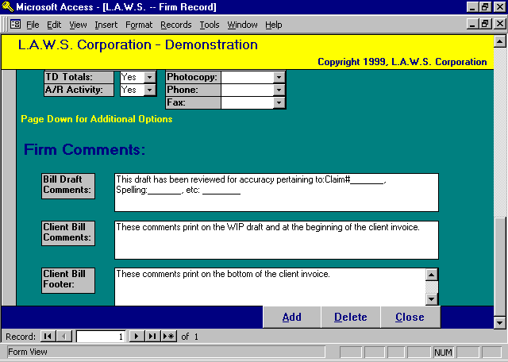
BILL DRAFT COMMENTS
Firm wide notes to the BILLING ATTORNEY, which print on WIP Billing Drafts.

CLIENT BILL COMMENTS
Firm wide notes to the CLIENTS, which print on the top portion of the client invoice. The Client Bill Comments also print on the WIP Billing draft allowing review by the billing attorney prior to billing.

CLIENT BILL FOOTER
Comments that print at the end of the client invoice. Client Bill comments may be modified or deleted on a client by client basis when the bills are generated.

ATTORNEY FILE MAINTENANCE

Attorney File Maintenance allows for the entry of basic information pertaining to each attorney (timekeeper) and to set basic hourly billing rates. Attorneys must be entered into the system before becoming accessible to other functions within L.A.W.S. After selecting Attorney from the File Maintenance column, the following screen will appear:

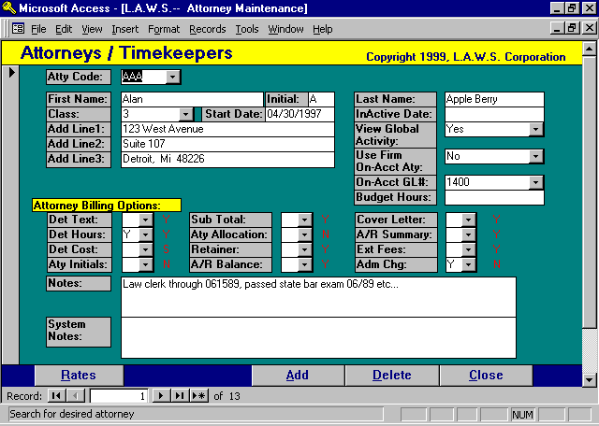

Attorney Maintenance Screen

ATTORNEY CODE
Enter a unique code, which is used to identify this attorney throughout the system. Although any code may be used, the attorneys’ initials seem to be one of the most popular codes used by law firms to identify attorneys. Although there is no practical limit to the attorney code, 50 Characters, it is best to use a small code, 2 to 3 characters since this code must be entered each time the attorney is referenced. Depending on the billing options selected, it is possible for the attorney code to print on the client statement. Therefore is best to use a code easily identifying the attorney.

FIRST NAME-INITIAL-LAST NAME
Enter the attorney’s FIRST NAME, MIDDLE INITIAL and LAST NAME in the appropriate fields. When the attorney is referenced on correspondence to the client, such as client bills, the full attorneys’ name prints. The last name is used for alphabetical sorting and internal reporting and inquiry. Do not enter a period after the attorneys initial.

CLASS
Enter the classification code used to designate the attorney’s level within the firm. For example, 1 - Partner; 2 - Associate; 3 - Paralegal. The Classification Code must be a valid code entered via the Aty Class file maintenance option located on the Data File Maintenance Form.

START DATE
Enter the date the attorney became associated with the firm. Utilize the Standard Date Format.

INACTIVE DATE
The date the attorney left the firm. WIP may not be accumulated on inactive attorneys, so this date must be blank in order for time to be entered for the specified attorney. Utilize the Standard Date Format.

ADDRESS LINE 1 - LINE 3
Enter the attorney’s address. L.A.W.S. has the ability of creating address labels from the entered address information.

VIEW GLOBAL ACTIVITY
Specifies whether this attorney should have the ability to view other attorney’s WIP, calendar and/or docket entries. Available options:
Yes: The attorney may view other attorney’s activity.
No: The attorney MAY NOT view other attorney’s activity.

USE FIRM ON-ACCT ATTORNEY
Specifies whether On-Account credit received for this billing attorney should be posted to this billing attorney or be posted the firms On-Account billing attorney. Please review the Firm On Account Attorney Code section of Firm File Maintenance for a review of the On-Account Attorney. Available options:
Yes: On-Account credit for this billing attorney will be posted to the Firm defined “On-Account Attorney”.
No: On-Account credits will always be given to the billing attorney.

ON-ACCT GL#:
Specifies the General Ledger number to which On Account receipts should be posted. If this account number is left blank, then On Account receipts will be posted to the On Account G/L # identified in the Firm file.

BUDGET HOURS
L.A.W.S. provides extensive attorney productivity budget capabilities. If desired, the budgeted hours worked may defined for an individual attorney, or for a class of attorneys. To assign budget hours to a specific attorney, enter the desired budget hours in this field. Please review the Attorney Class maintenance section of this chapter for a review of budget assignment by class.

Attorney Billing Options
Billing options may be assigned at the firm, attorney, or client level. The order of assignment is client options first, then billing attorney options, and lastly the firm options. Enter attorney billing options only if the desired billing options of the billing attorney differ from the standard firm billing options described in the Firm File. The standard firm billing options are noted in red beside each entry.

Please review the billing options discussed in the Firm File Maintenance section of this manual for a detailed explanation of the available billing options.

NOTES:
Miscellaneous notes associated with the specified attorney. An unlimited volume of notes may be entered and viewed by simply scrolling through the Notes window.

SYSTEM NOTES:
The System Notes are a historical log of system actions performed on this attorney. System Notes are for review only and are non-modifiable. Example: If the attorney code is changed through the Miscellaneous functions from one code to the another, notation is made in the system notes documenting this occurrence.

Attorney Rates
Billing Rates may be assigned by Attorney, Client or Matter. If the rate structure for clients and matters are blank, then the standard attorney rate structure is used. All override rates specified by attorney may be modified or viewed by pressing the RATES button which displays the following form:

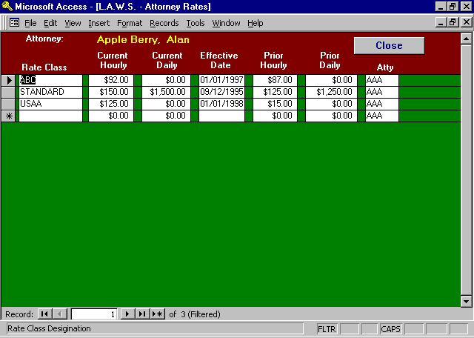

The Attorney Rate form will display all override rates associated with this attorney. Override rates may be assigned to clients and/or matters. If an override rate is assigned to a client, it is usually easiest to utilize the assigned client code as the Rate Class. If the override rate is assigned to a specific matter, it is easiest to utilize the Client and Matter as the Rate Class. Even though all override rates for a specific attorney are displayed on this form, IT IS MUCH EASIER to modify override rates for specific clients or matters on the Client or Matter Maintenance screens rather than on this screen. This form is used primarily to assign or modify the attorneys Standard Rate or to review all previously override rates.

The attorneys Standard Rate is the rate assigned to this attorney’s time in lieu of rate assignments at the client or matter levels. It is easiest to use the word “STANDARD” to define the standard rate class. The Standard Rate class code must be consistent amongst all attorneys. The Standard Rate Class Code must be noted in Firm File Maintenance as the Default Attorney Rate Code.

All budget reporting utilize the Budget attorney rate class.

RATE CLASS
Specifies the rate class code used to identify different attorney rates. The rate class should be coordinated amongst the attorneys within the firm. If the Default Attorney Rate Code in Firm File Maintenance is “STANDARD”, then all attorneys should be assigned a “STANDARD” rate class.
CURRENT HOURLY
Enter the current hourly billing rate for the attorney identified.

CURRENT DAILY
Enter the current daily rate utilized by the attorney.

The system utilizes the hourly or daily rate based on the associated bill codes “Per Diem” status. A Per Diem status of “Yes” will charge a daily rate, otherwise an hourly rate will be charged. Please review the Bill Code Maintenance section of this chapter for a further explanation of Per Diem rates.

EFFECTIVE DATE
Enter the date the current rates became effective. As WIP is entered into the system, L.A.W.S. compares the service date against the effective date and assigns the appropriate rate. . If a prior rate is not entered, leave the effective date as 1/1/1900, and the system will always assign the current rate to WIP.

PRIOR HOURLY RATE
Enter the prior hourly billing rate, if any, for the attorney identified. The system verifies the production date of WIP against the effective date of performance and assigns the appropriate, current or prior, rates.

PRIOR DAILY RATE
The prior daily rate utilized by the attorney

As previously noted, billing rates can be assigned at the attorney, client or matter level. When assigning a billing rate for services performed, L.A.W.S. first utilizes the billing rate assigned to the matter. If a rate is not found, L.A.W.S. then looks for a billing rate at the client level. Again, if a rate is not found, L.A.W.S. assigns the standard attorney billing rate.

________________________________________

CLIENT FILE MAINTENANCE

Client File Maintenance allows entry or modification of client information. The term CLIENT refers to a specific client of the firm, such as ABC Corp., while MATTER refers to specific files associated with a given CLIENT. For example, client ABC might have two matters; ABC v. Walker and ABC v. Smith). The client file contains all information pertaining to the client as a whole, such as client name, address billing options etc.

After selecting Client from the Data File Maintenance menu, the following screen is displayed.

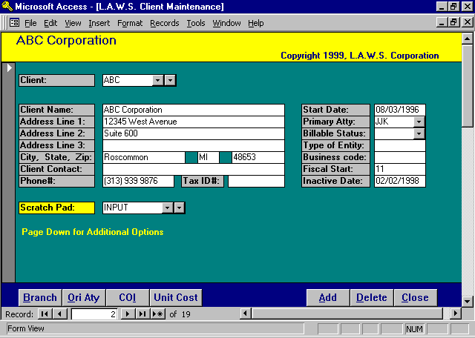

Client File Maintenance Screen

CLIENT
Enter a unique code that identifies this client. The code may be either numeric or alphabetic. If an existing client is entered, the existing data will be displayed. If a new client code is entered, a blank screen will be displayed with the notation “*** New Client ***” as the client name. For ease in finding clients, the field supports two dropdown boxes. The left box lists all clients in order by code while the right box lists all clients in order by name.

CLIENT NAME
Enter the full name of the client. The information placed on this line is used to alphabetize client listings. Accordingly, if the client is an individual enter the name using the format of LAST NAME, FIRST NAME, MIDDLE INITIAL. Corporations should be entered in a manner that will allow for reasonable alphabetical sorting.
NOTE: There is a field within the client bill information which allows the client’s name to be entered as it is to appear on client statements. For example: there may be a client called “Joe Smith”. Joe’s Client Name would be entered “Smith, Joe”, while his billing name would be entered as “Mr. Joe Smith”.

ADDRESS LINES 1-3
L.A.W.S. provides three lines on which a client’s address may be entered. Do not enter the client’s city, state or zip within the address lines since these fields are prompted below. Leave extra address lines blank if not needed.

CITY, STATE, ZIP
Enter the clients city, state and zip. The specific identification of the city, state and zip allow extraction of clients based on these fields for reporting and mailings.

CLIENT CONTACT
Enter the name of the client contact person. A client contact may also be specified at the matter level. The Client Contact will print on the client invoice. Enter the contact's name only. Do not add the prefix "Attention" as this prefix is automatically added when the invoice is printed.

PHONE #
Enter the client’s phone number.

TAX ID#
Enter the client’s Tax Identification number. Social Security numbers are often used for individuals while the corporate Tax ID number is used for corporations.

SCRATCH PAD
Enter the desired scratch pad code identifying additional, user defined, information pertaining to this client. Once entered, click the yellow heading “Scratch Pad” to enter scratch pad information specific to this client. A detailed description of the client scratch pad function follows at the end of this section. Multiple scratch pad codes may be associated with a client although only the last referenced scratch pad code is displayed.

START DATE
Specify the start date for the client using Standard Date Format. If left BLANK, it will default to system entry date.

PRIMARY ATTY
Specify the attorney who is primarily responsible for firm-client relations. L.A.W.S. uses this field when printing the client list by attorney. This field is also used as a default for the billing and responsible attorney during within Matter File Maintenance.

BILLABLE STATUS
Specifies whether the client is billable or non-billable. Non-billable clients will not have a rate assigned to WIP entries and entered time will be considered non-billable in management reporting. Available Options:
Blank: Client is considered billable – WIP will be assigned a billing rate.
NB: Client is considered non-billable – WIP will not be assigned a billing rate.

TYPE OF ENTITY
User defined field. No verification is applied to this field. This field is utilized for selection of clients for client labels and/or listings. Examples of Entity Type could be “Ind” for individual, “Corp” for Corporation, etc.

BUSINESS CODE
User defined field. No verification is applied to this field. This field is utilized for selection of clients for client labels and/or listings. Examples of the Business Code could be the Standard Industrial Codes used by the federal government.
FISCAL START
Enter the client’s fiscal start month. Enter the appropriate numeric code with January as 01 and December as 12. This field is informational only and may be useful if the firm performs year-end services.

INACTIVE DATE
The date the client became inactive. Enter the date using the Standard Date Format. If the Inactive Date is blank, the client is considered ACTIVE, otherwise, the client is considered INACTIVE. WIP cannot be entered for an inactive client. Client listings may be generated including active, inactive or all clients.
When an Inactive Date is entered, L.A.W.S. will prompt "Close all Matters associated with this client". If Yes is entered, all open matters associated with this will have the client's inactive date inserted as the matters closed date. If No is entered, the matters will remain open.

Additional client related options are available by scrolling down the screen. The user has the option of pressing the “Page Down” key, or by “Dragging” the right “Navigation Button” towards the bottom of the form.

Listed below is the Page Down continuation of the Client Maintenance Form:

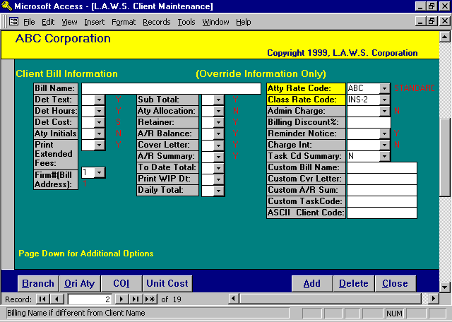

Client Bill Information

BILL NAME
Enter the billing name to print on the client’s statement if the CLIENT NAME field is not in the format desired for use on client statements. When a client bill is produced, L.A.W.S. checks to see if a billing name is present. If a billing name is present, L.A.W.S. substitutes the billing name for the client name. A billing name is used, for instance, when the client is an individual and the client’s name was entered last name first on the “Name” line. For example: “Name” = Smith, John and Mary; “Billing Name” = Mr. and Mrs. John Smith.

BILLING OPTIONS
Client statements may be customized as desired by using different combinations of billing options. The RED codes noted beside each option are the Firm defaults. Enter a client option only if it differs from the Firm default. A BLANK option at the client level automatically defaults to the option specified at the Billing Attorney and/or Firm Level.

Please review the billing option portion of FIRM Maintenance for an explanation of the following options.
DetText, Det Hours, Det Cost, Aty Init, Print Extended Fees, Sub Total, Aty Allocation, Retainer, A/R Balance, Cover Letter, A/R Summary, Charge Interest, Admin Charge, Reminder Notice.

FIRM #(BILL ADDRESS)
It may be necessary to have a different firm address print on client invoices for different clients. The firm name and address associated with Firm #1 will always print at the top of each client invoice unless an alternative firm number is entered in this field.

TO DATE TOTAL
Specifies if To-Date Fees and Costs billed to the matter should be referenced at the bottom of the client invoice. Available Options:
Y: Yes – To Date Fees and Costs WILL be noted on the bottom of the client invoice,
N: No – To Date Fees and Costs WILL NOT be noted on the client invoice.

PRINT WIP DT
Specifies if WIP Service Date should print on each transaction line item within the Detail Text portion of the client invoice. Available Options:
Y: Yes – The WIP Service Date will be printed with each transaction line item.
N: No – The WIP Service Date will not be printed with each transaction line item.

DAILY TOTAL
Specifies if a Total number of hours should be computed and printed per day on the Detail Text portion of the client invoice. Available Options:
Y: Yes – Daily Totals will print on the client invoice.
N: No – Daily totals will not print on the client invoice.

ATTY RATE CODE/CLASS RATE CODE
Enter the appropriate Rate Codes to be used in the assignment of a billing rate. Please review the Rate Assignment section of this chapter for a detailed explanation of rate assignments.

ADMIN CHARGE
Specifies if an administrative charge should be computed and included on client invoices. An Administrative Charge is a percentage of fees charged to the client in lieu of the actual expense amounts for items such as telephone or postage. The Administrative charge percent is stored in the FIRM file. Available Options:
Blank: Default to the setting noted in the FIRM File.
Y: Charge an Administrative Fee to the client.
N: Do Not Charge an Administrative Fee to the client.

BILLING DISCOUNT %
Represents the percent discount to be deducted from this client’s fees. Billing rates are assigned at the gross amount. When the client statement is produced, L.A.W.S. computes the fee discount by multiplying the entered discount times the total fee value. The Discount is then subtracted from the client’s balance due. The discount value should be entered in whole numbers. Accordingly, a four percent discount would be entered as “4”, while a three and one half percent discount would be entered as “3.5”.

TASK CD SUMMARY
L.A.W.S. offers the ability of generating a Task Code Summary report along with the client invoice. A Task Code Summary Report lists the transactions contained on the client by Bill Code. Available Options:
Blank: Default to the setting noted in the FIRM File.
Y: Print the Task Code Summary portion of the invoice.
N: Do NOT print the TASK Code Summary portion of the invoice.

CUSTOM BILL NAME
CUSTOM CVR LETTER
CUSTOM A/R SUM
CUSTOM TASK CODE
L.A.W.S. allows the option of having custom invoices developed and printed in place of the existing standard invoices. If custom invoices have been developed for a client, enter the name of the custom invoice beside the appropriate heading.

ASCII CLIENT CODE
L.A.W.S. has the ability of creating ASCII files containing client invoice information. Several of these ASCII Files refer to a required “Client Code” which identifies your law firm. The client receiving the invoice usually assigns this Client Code to the firm. This field allows the assigned client code to be recorded.

Additional Client related options are available by scrolling down the screen. The user has the option of pressing the “Page Down” key, or by “Dragging” the right “Navigation Button” towards the bottom of the form.

Client Notes

Listed below is the Page Down continuation of the Client Maintenance Form

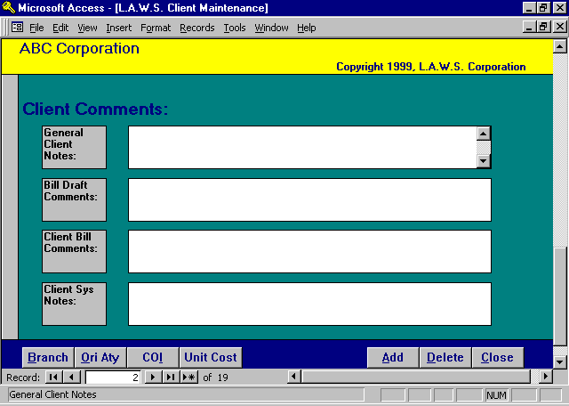

GENERAL CLIENT NOTES
General, informational notes pertaining to the client. These notes print on the detail client list.

BILL DRAFT COMMENTS
Comments pertaining to the client which will be printed on all WIP billing drafts associated with this client code. Bill draft comments should contain information helpful to the billing attorney during the review of the WIP billing draft. Bill draft comments could specify a unique rate agreement, listing of approved charges, etc.
CLIENT BILL COMMENTS
Comments pertaining to the client which SHOULD print on each invoice generated for this client. Client bill comments also print on the WIP draft for attorney review.

CLIENT SYS NOTES
System generated comments, which record historical, system generated activity. System notes record information pertaining to the changing of client codes etc.

____________________________________________

Rate Assignments

Either Attorney Rates or Class Rates may assign rates to WIP. Rates may be assigned to Work In Process entries at either the matter, client or attorney level. The standard attorney rate code, entered in the firm file, will be used if nothing else is specified. If the client should be charged a rate different from this standard rate, then a different default rate structure may be assigned to the client or matter.

Attorney Rates
Example: The firm may have two attorneys “PDK” and “AAA”. Each attorney may have two standard rates as noted below:
Attorney Atty Rate Code Hourly Rate
PDK Corporate 150.00
PDK Standard 100.00
AAA Corporate 140.00
AAA Standard 130.00

If the Firm Default Attorney Rate Code is “Standard”, and no change is specified at the client level, then Attorney “PDK” will charge 100/hr and “AAA” will charge 130/hr. If desired, an Attorney Rate Code of “Corporate” could be entered at the client level. Then attorney “PDK” would charge 150/hr and “AAA” would charge 140/hr.

If desired, an Attorney Rate structure may be customized to a specific client or matter. Rates assigned to specific clients or matters are usually identified as the Client or Client/Matter codes. For example, assume we have one client, ABC, for which attorney PDK is to charge $87/hr and attorney AAA is to charge $92/hr. The easiest way to accomplish this rate structure would be to set up a customized rate class of “ABC”, at the client level, as follows:
Attorney Atty Rate Class Hourly Rate
PDK ABC 87
AAA ABC 92
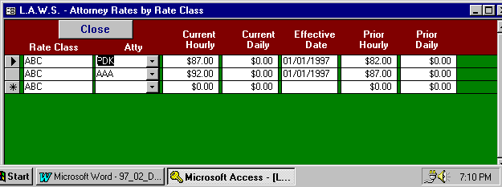
To enter this customized attorney rate structure into the computer, enter the Attorney Rate Code as “ABC” then click on the corresponding yellow heading to display the following Attorney Rate Screen as noted below:

ATTY
Enter the attorney code for which the rate override applies.

CURRENT HOURLY
Enter the current hourly fee that should be charged for this attorney and rate code combination. Current rates apply to all WIP entries dated on or after the specified effective date.

CURRENT DAILY
Enter the current daily fee that should be charged for this attorney and rate code combination. Current rates apply to all WIP entries dated on or after the specified effective date. Daily rates are utilized with bill codes identified as “per diem”.

EFFECTIVE DATE
Enter the date on which the current rates become effective.

PRIOR HOURLY
Enter the prior hourly fee that should be charged for this attorney and rate code combination. Prior rates apply to all WIP entries dated before the specified effective date.

PRIOR DAILY
Enter the prior daily fee that should be charged for this attorney and rate code combination. Prior rates apply to all WIP entries dated before the specified effective date. Daily rates are utilized with bill codes identified as “per diem”.

Class Rates
L.A.W.S. allows an alternative method of rate assignment by the class of attorney. The method of defining the class of attorneys is described under Attorney Class Maintenance later in this chapter. Classes of attorneys are assigned to attorneys through the Attorney File Maintenance function.

Typical classes of attorneys could be partners, associates, law clerks, etc. The classes may be as broad or as specific as desired. Instances may arise where clients desire that billing rates be assigned by the classification of attorney. For example, client ABC may desire that all partners charge $125/hr, associates charge $95/hour and law clerks charge $25/hr. The class rate structure may be entered by either client or matter. To enter the class rate structure by client, simply enter the desired Class Rate code then click on the yellow “Class Rate Code” heading. The previously described example would be entered as follows:

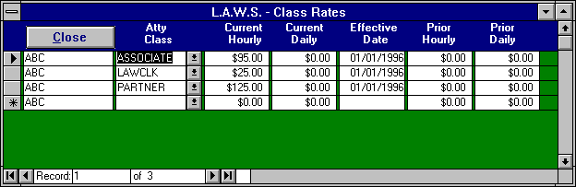

ATTY CLASS
Enter the attorney class for which the rate override applies.
CURRENT HOURLY
Enter the current hourly fee that should be charged for this Class Rate. Current rates apply to all WIP entries dated on or after the specified effective date.

CURRENT DAILY
Enter the current daily fee that should be charged for this Class Rate. Current rates apply to all WIP entries dated on or after the specified effective date. Daily rates are utilized with bill codes identified as “per diem”.

EFFECTIVE DATE
Enter the date on which the current rates become effective.

PRIOR HOURLY
Enter the prior hourly fee that should be charged for this Class Rate. Prior rates apply to all WIP entries dated before the specified effective date.

PRIOR DAILY
Enter the prior daily fee that should be charged for this Class Rate. Prior rates apply to all WIP entries dated before the specified effective date. Daily rates are utilized with bill codes identified as “per diem”.

Utilizing Attorney & Class Rates Simultaneously
It is possible to mix Class Rate and Attorney Rate structures at either the client or matter levels. L.A.W.S. utilizes the following order in rate assignment:

1st: Attorney rate structure at the matter level;
2nd: Class rate structure at the matter level;
3rd: Attorney rate structure at the client level;
4th: Class rate structure at the client level;
5th: Standard rate identified at the firm level.

An example of mixing rates follows:
A client, ABC Corporation, utilizes the following Class Rates: Partners @ $125, Associates @ $95, and Law Clerks @ $25. For this client only, one law clerk, LC, out of 5 should charge the associate’s rate of $95. This client would utilize the class rate structure as noted above along with a unique attorney rate structure entry for the single law clerk of $95 for this client. When the rate is assigned, the system will first assign the law clerk exception entry first, then assign the remaining attorneys based on the class rate structure. Both the Class Rate and the Attorney Rate Structures may be use the same code, “ABC”,

Class Rate Structure: Class Rate Atty Rate Structure: Attorney Rate
Partner $125 LC $ 95
Associates $ 95
Law Clerks $ 25

Client Branch Address
Often time’s clients conduct business from multiple locations. L.A.W.S. offers the capability of assigning multiple addresses to clients. The client’s primary address is always entered via the client name and address on the Client File Maintenance form. The matter always utilizes the primary client name and address unless a branch address is assigned to the matter. To enter branch addresses, click the Branch button to display the following form.

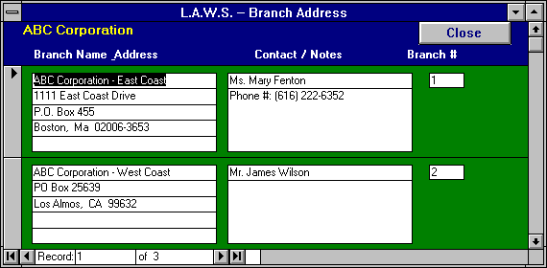

BRANCH NAME AND ADDRESS
Enter the client’ s branch address information. The information entered will replace the primary client address when a bill is generated for matters utilizing the branch address option. There is no “BILLING NAME” associated with the branch. Accordingly, enter the branch name, as it should appear in correspondence to the client.

CONTACT
Enter the client contact for the specified branch.

NOTES
Enter any miscellaneous notes about the branch such as phone number, type of cases handled at that branch, attorneys who have dealings with that branch, etc.

BRANCH#
L.A.W.S. will automatically assign a branch number to all branch addresses.

Originating Attorney Credit
L.A.W.S. offers the ability of assigning Originating Attorney Credit to the Accounts Receivable Billing and Cash Receipt’s activity. The Originating Attorney Credit tracks billing and receipt performance based on the attorneys who originated the activity. Multiple attorneys may receive originating attorney credit for the same client based on percent. If the total originating percent does not equal 100%, then the difference is posted to the Primary Attorney assigned to the client.

Clicking the Ori Aty button will display the following form:

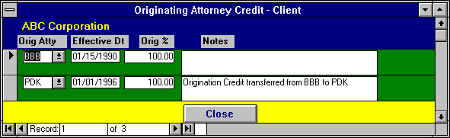

ORIG ATTY
The Attorney to receive Originating Credit.

EFFECTIVE DT
The Effective Date of the originating credit for the specified attorney. It is possible that originally a single attorney could receive 100% originating credit. Over time, other attorneys in the firm may develop a relationship with the client and earn originating credit with the client. If multiple attorneys are to receive originating credit for client performance, then for each attorney, the effective date and percent must be entered. L.A.W.S. totals all percentages together based on effective date. If the total percentage for a given effective date does not equal 100%, the difference will be allocated to the primary client attorney.

ORIG %
The amount of credit to be allocated to the referenced attorney. The percent should be entered as whole numbers. Fifty percent would be entered as “50”. Forty Nine and one half percent would be entered as “49.5”

NOTES
Miscellaneous notes pertaining to the entered information.

Conflict Of Interest

L.A.W.S. allows the capability of recording Conflict Of Interest information for a given client or matter.

After clicking the COI button, the following form is displayed:

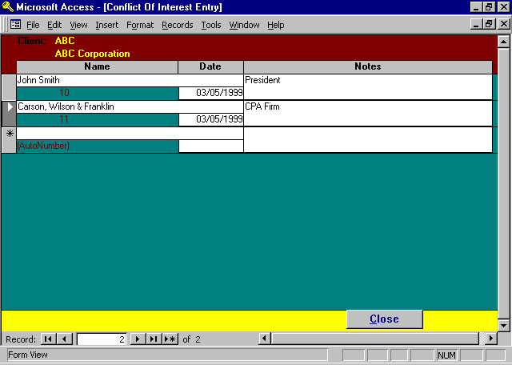

NAME
Enter the name of the conflict. L.A.W.S. has the ability of performing full text searches. Accordingly the name may be entered either first name firms or last name first, which ever is easiest for the firm.

DATE
The date the COI was recorded.

NOTES
Notes explaining why the conflict may exist.

Unit Costs by Client

L.A.W.S. allows the capability of recording Unit Cost charges per client. Each expense bill code has a unit cost charge amount that may be assigned through Bill Code Maintenance. If desired, this unit cost charge may be tailored to specific clients utilizing this Unit Cost option. For example, assume the firm default charge for photocopies is $.25 per copy. A large client, ABC Corporation, will reimbursement the firm only $.10 per photocopy. The $.10 unit cost would be entered through the Unit Cost Function.

Enter unit cost amounts by client only if the client charges are different from those associated with the bill code.

After clicking the Unit Cost button, the following form is displayed:

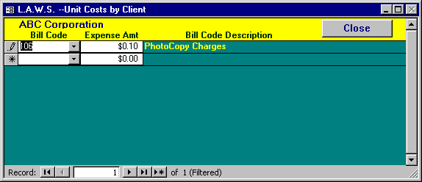

BILL CODE
Enter the Bill Code for which a specific unit cost should be assigned for this client.

EXPENSE AMT
Enter the amount the specified client should be charged, per unit, for referenced bill code.

BILL CODE DESCRIPTION
The bill code description is displayed for user verification.

Scratch Pad Processing

Scratch Pad Processing allows user defined, miscellaneous data, to be accumulated by client or matter. Miscellaneous information is grouped together in a logical fashion within a “Scratch Pad”. The Scratch Pad must be defined via the Scratch Pad option listed on the Data File Maintenance menu prior to being accessed. (See Scratch Pad Processing later in this chapter). An example of a Scratch Pad could be client related phone numbers. There is no place within the standard Client File Maintenance for the storage of multiple phone numbers. If multiple phone numbers are important, than a Scratch Pad could be developed for phone numbers which could be referenced as needed.

To access a Scratch Pad, move the cursor to Scratch Pad field and select the desired scratch pad. As many scratch pads as desired may be associated with a client, but only the last referenced scratch pad code is displayed. Once the desired Scratch Pad entry has been selected, click the cursor on the yellow “Scratch Pad” heading to display the requested scratch pad data as noted on the following screen.

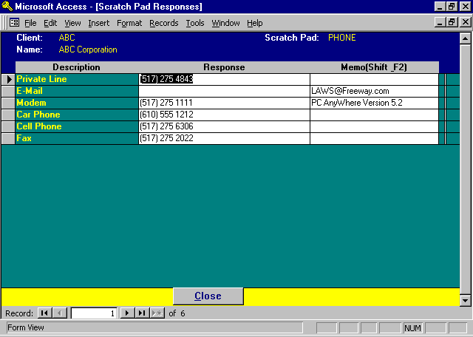
DESCRIPTION
The Description column represents the fields of information to be accumulated by the scratch pad.

RESPONSE
The responses column is used to record specific client data. Responses are not required. If a response is not applicable, leave it blank.

MEMO
Provides area for additional description pertaining to the line item. In the above example, the modem phone number was provided as the response. The memo entry further defined the response by identifying the communications software utilized.

MATTER FILE MAINTENANCE

This option allows the entry or maintenance of MATTERS. The term CLIENT refers to a specific entity, such as ABC Corporation, while the term MATTER refers to a specific file for a given Client. For example, Client ABC may have two Matters, ABC vs Walker and ABC vs Smith.

After selection the MATTER File Maintenance option, the following form is displayed.

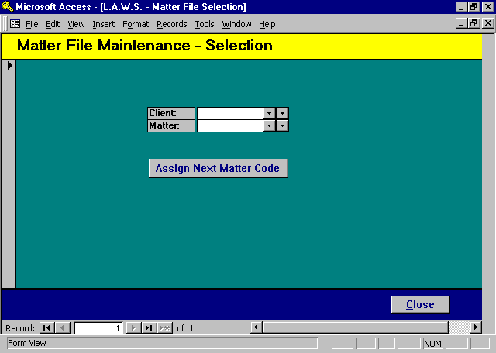
CLIENT
Enter the Client to which this Matter applies. The Client must be defined through the Client Maintenance option.

MATTER
Enter a unique Matter code used to identify this particular matter. The Matter Code may be numeric or alphabetic, which ever works best for the law firm. The Matter code must be unique within Client. Accordingly, many Clients could have a "TAX" matter. If a given Client for the firm has a large number of Matters, it is probably best to simply assign a consecutive numbering system to the Matters. If an existing client/matter combination is entered, the existing matter information is displayed, otherwise a blank matter record will be displayed.

If desired, L.A.W.S. will automatically assign a matter code to new matters by incrementing the Last Assigned Matter Number by 1. The Last Assigned Matter Number is stored in Firm Maintenance. Please review the Firm File Maintenance section of this chapter for additional information.

To have L.A.W.S. automatically assign a matter code, perform the following steps:
1: Enter the desired client code,
2: Leave the matter code blank,
3: Click the Assign Next Matter Code Button.

The following Matter Maintenance screen is displayed after entering a Matter code, or by clicking the Assign Next Matter Code button.

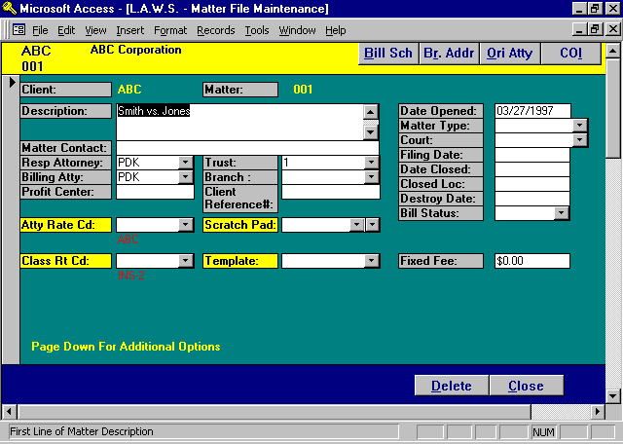

Matter File Maintenance Screen

CLIENT/MATTER
Brought forward from the previous form.

DESCRIPTION
Enter the Description of the Matter. The Description may be up to 255 characters.

MATTER CONTACT
The Client’s Contact Person associated with this matter. Note: If a single contact person is associated with all matters pertaining to a client, then enter the contact once at the client level. If the Matter Contact is blank, the Client Contact is used.

RESP ATTY
The attorney to which this matter has been assigned. The responsible attorney usually has day to day responsibility for the matter. The Primary Attorney assigned to the Client is used as a default if the Responsible Attorney is left blank.

BILLING ATTY
The billing attorney associated with this matter. The billing attorney normally has the overall responsibility for the matter even though the day to day responsibility has been delegated to the responsibility attorney. The specified billing attorney receives billing attorney credit for the performance of this matter. The Primary Attorney assigned to the Client is used as default if the Billing Attorney is left blank.

PROFIT CENTER
The Profit Center allows matters to be assigned to logical divisions within the law firm. Logical divisions may apply to physical locations of branch offices within the law firm; such as profit center 1= satellite office of firm in Detroit, profit center 2= satellite office of law firm in Lansing. Profit centers may also represent logical divisions of the firms caseload, such as profit center 1=corporate, 2=litigation, 3=domestic matters etc.

The profit center integrates into the general ledger system through the general ledger sub account. When fees are received for services, L.A.W.S. automatically attaches the profit center assigned to the matter to the standard fee account identified in the firm file. If a valid G/L # is created, fees are posted to the created G/L #. If the profit center is blank, or the created # does not represent a valid G/L #, then the fees post to the standard fee account.

ATTY RATE CD
The Standard Attorney Rate Code used to assign hourly billing rates to WIP associated to this matter. (See Client File Maintenance -- Atty Rate Code.)

CLASS RATE CD
The Standard Class Rate Code used to assign hourly billing rates to WIP associated to this matter. (See Client File Maintenance -- Class Rate Code.) Enter the desired Class Rate Code if Class Rates are to be utilized, and the desired Class Rate code is different from the Class Rate default assigned to the Client.

TRUST
The Trust Account to be utilized by this matter. It is possible for the firm to have several physical trust accounts. All trust activity pertaining to this matter will automatically default to the specified trust account.

BRANCH
The branch address assigned to this matter. If correspondence pertaining to this matter should be directed to an address OTHER than the primary client address, you may enter the client branch address number in this field. If the desired address is not listed, utilize the Matter File "BR Addr" button to add a new branch address. Branch addresses should be used only if there are multiple matters associated with this address. For a single matter associated with a single address, use the miscellaneous address feature described later in this chapter. For more information on Branch Address’s please review Client File Maintenance – Client Branch Addresses or the Branch Address section later in this chapter.

CLIENT REFERENCE #
Enter the client’s internal number that corresponds to this matter. Examples of client’s reference # could be insurance claim numbers for insurance matters, loan numbers for real estate closings, or tax ID numbers for corporations or individuals.

SCRATCH PAD
Displays the last utilized Scratch Pad associated with this matter. Multiple Scratch Pads may be utilized, but the last Scratch Pad accessed is always displayed. For more information see the Scratch Pad Option associated with Client File Maintenance.

TEMPLATE
The Template relates to a predefined set of user activities created and utilized within the DOCKET & CALENDAR system. Please review Docket and Calendar processing for a detailed review of Template Processing. Templates are assigned to matters. This template field allows Template activity to be assigned to matters at the time matters are opened or modified. All entered template activity automatically flows into the Docket and Calendar system.

DATE OPENED
Enter the date this matter is opened in Standard Date Format. If the Date Opened is blank, the current system date is utilized.

MATTER TYPE
Enter the Matter Type code that corresponds to the appropriate type of matter. Matter Types must be entered through Matter Type File Maintenance. For additional information, please review Matter Type File Maintenance later in this chapter.

COURT
Enter the Court Code that corresponds to the appropriate court for this matter. If a court is not applicable, leave this field blank. Courts must be entered through the Court / Location File Maintenance. For additional information, please review the Court / Location File Maintenance later in this chapter.

FILING DATE
Enter the filing date, if applicable.

DATE CLOSED
Enter the date the matter is closed. If a date is entered in the Date Closed field, then the matter is considered closed, if the Date Closed field is blank, the matter is considered open. WIP cannot be entered against closed matters. L.A.W.S. will automatically close matters at the time of billing if the Interim/Final bill type is classified as “Final” by inserting the invoice date into the date closed. To re-open a matter, simply blank out the date closed.

CLOSED LOC
Files close in a different order than they open. Accordingly, many firms assign a closed file number to closed files when files are moved out of the office. If the matter is closed, and the file is moved to a new location, enter the Closed File number in this field

DATE DESTROY
The date this matter should be destroyed. L.A.W.S. will not automatically destroy the matters. The Destroy Date value is used to print a list of matters that should be destroyed within a certain date range.

BILL STATUS
Specifies how L.A.W.S. should classify and value the WIP associated with this matter. Available options:
C: Contingent Matter. A rate is not assigned to WIP entries. Hours worked are considered Contingent Hours worked and Fees received are considered Contingent Fees Received.
NB: Non-Billable Matter. A rate is not assigned to WIP entries. Hours worked are considered Non-Billable Hours Worked.
B: Billable Matter. Rates are assigned to WIP entries. Hours worked are considered Billable Hours Worked.
Blank: Defaults to the Billable Status assigned to the Client. If the Client Billable Status is also Blank, the matter is considered Billable.

FIXED FEE
L.A.W.S. can assign a fixed fee to a matter. For example: A Will may be quoted at a fixed fee of $250. When the matter is created enter $250 in the fixed fee field. When a billing draft for this matter is generated, all existing fees and costs will be displayed and totaled showing the actual accumulated WIP total. The fixed fee value will be displayed immediately following the actual WIP value. At the time of billing, the fixed fee value is automatically inserted as a fee override value. If the fixed fee is not to be utilized, it may be deleted from the fee override at the time of billing. The fixed fee value is not automatically cleared. Accordingly, the annual estimated fees on a matter might be billed at regular intervals throughout the year. For example, legal fees for a matter may be estimated at $12,000. A fee override value of $1,000 may be entered along with a monthly billing cycle. Each month a bill will be produced for $1,000. At the end of the cycle the fixed fee may be adjusted or eliminated.

Additional matter related options are available by scrolling down the form.
Listed below is the Page Down continuation of the Matter File Maintenance form.

Insurance Information / Matter Notes

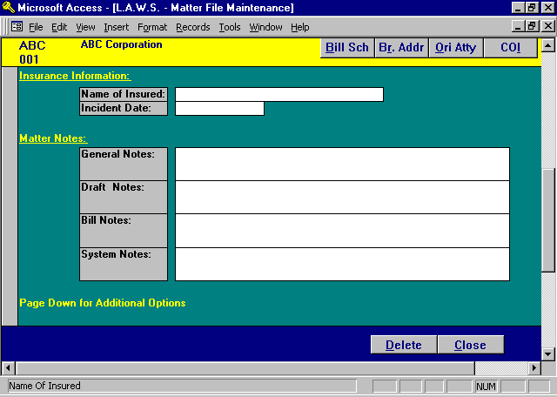

NAME OF INSURED
If the matter refers to an insurance company matter, enter the name of the insured party.

INCIDENT DATE
If the matter refers to an insurance matter, enter the incident date using Standard Date Format.

GENERAL NOTES
General matter notes pertaining to this matter. These notes are displayed through Matter Inquiry, or are printed on the detailed matter list.

DRAFT NOTES
Comments pertaining to this matter which will print on the WIP billing draft. The matter draft notes print in conjunction with the firm and client draft notes.

BILL NOTES
Comments which print on the Client Invoice. The Bill Notes also print on the WIP bill draft for review by the billing attorney.

SYSTEM NOTES
Non-modifiable system notes document system changes to the matter. System changes consist of actions such as the changing of client or matter codes, etc.

Additional matter related options are available by scrolling down the form. Listed below is the Page Down continuation of the Matter File Maintenance form.

Miscellaneous Billing Name & Address

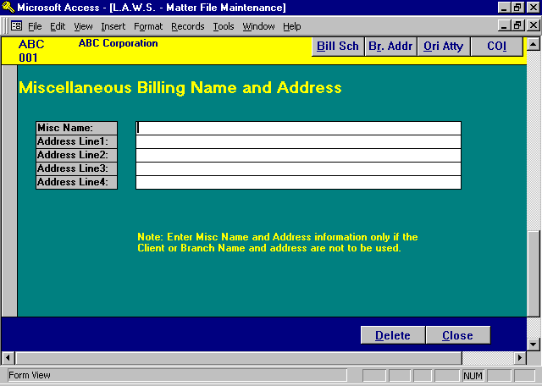

MISCELLANEOUS BILLING NAME AND ADDRESS
If applicable, enter a miscellaneous name and address to be used for billing this matter. Many firms perform single repetitive tasks for many different clients. An example may be the preparation of a will. Rather than setting up a client entry for each will created, many firms set up a client called WILLS without specifying a client name and address. When an individual comes to the firm for a will only, then a matter can be opened under the Client WILLS, and the billing name and address may be entered under the miscellaneous name and address fields. This allows the firm to service the individual without cluttering up the Client file and Branch Address file with one time entries.

MISC NAME:
MISC ADDRESS LINE 1 – LINE 4
Enter the desired miscellaneous name and address associated with this matter. If utilized, enter the full miscellaneous name and address. L.A.W.S. will not combine portions of the client address with missing portions of the Miscellaneous address.

Billing Schedule

L.A.W.S. allows the option of specifying predefined billing schedules for matters. After Clicking the Bill Sch option, the following form is displayed.

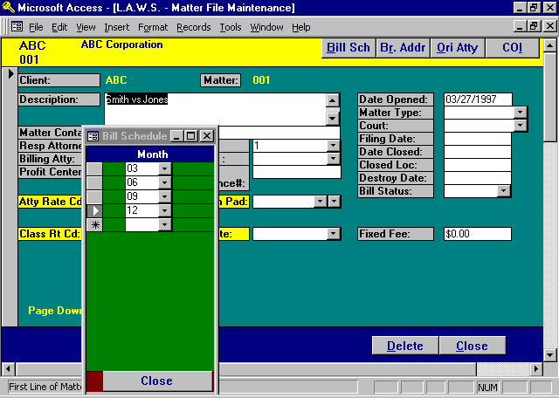

MONTH
Enter the month that this matter should be automatically selected for generation of a billing draft.
Example: The firm opens a matter on 2/15/98. This matter should be billed quarterly based on the date opened. A billing schedule would be established for 02 (February), 05 (May), 08 (August), and 11 (November). Billing drafts can be generated based upon this billing schedule. Accordingly, all matters to be billed in May can be selected by specifying the interim bill selection month of MAY during the selection of billing drafts. If matters should be billed monthly, specify a single interim bill cycle of “M” to denote monthly.

The interim bill cycle can be modified from the Interim Bill Schedule option within the Miscellaneous Menu. Please review the related topics of Print Client Drafts - Interim Bill Month option on the Client Bill menu and the Interim Bill Schedule on the Miscellaneous Menu.

Branch Address Definition

L.A.W.S. allows the option of assigning branch addresses to matters. The branch address number for a matter is entered in the branch field on the matter file maintenance form. If the desired branch address does not exist, then branch addresses may be entered through the BR Addr (Branch Address) button.

Listed below is a copy of the Matter File Maintenance Branch Address screen:

All existing Branch Addresses previously assigned to the client will be displayed. Pressing the page down key, or using the record selector at the bottom of the form may access additional Branch Addresses not displayed.

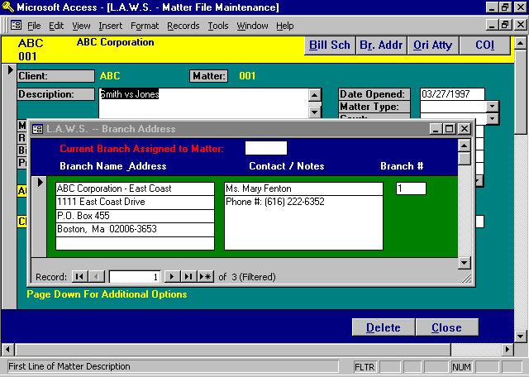

CURRENT BRANCH ASSIGNED TO MATTER
Displays the branch address number previously assigned to this matter. If blank, no branch address has been assigned to the matter. If this field is blank, and a new branch is entered, the system will automatically assign the new branch as the branch for this matter.

Please refer to Client File Maintenance - Client Options - Address for a detailed description of branch address definition.

Originating Attorney Credit by Matter

L.A.W.S. offers the ability of assigning originating credit by client or matter. If originating credit is to be assigned by matter, click on the ORI ATTY button from Matter File Maintenance.

Listed below is a copy of the Matter File Maintenance - Originating Attorney Credit form:

For a detailed explanation of information to enter, please review Client Options - Originating Attorney.

Either matter or client must assign credit. Accordingly, 50% credit may not be identified at the client level and the remainder assigned at the matter level. L.A.W.S. checks to see if any originating credit information is posted to the matter. If so, originating attorney credit is assigned at the matter level only. If originating attorney credit is not defined at the matter level, then credit will be assigned at the client level. If both the matter and client are blank, then originating credit is assigned 100% to the billing attorney assigned to the matter.

When assigning originating credit to the matter, it may be helpful to review the originating credit currently posted to the client. To do so, click on the Show Client Originating %.

Conflict of Interest
L.A.W.S. allows conflict of interest information to be assigned at either the client or matter level. If conflicts are to be assigned to matters, press the COI button to display the following screen.

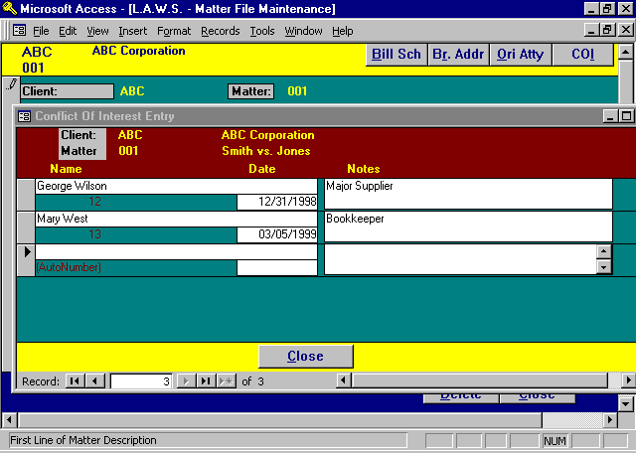

If Conflict data is specific to matters, enter the COI data at the matter level. If Conflict data is associated with all matters pertaining to a client, enter the conflict data at the Client level.

Please review Client File Maintenance-Conflict of Interest for a detailed review of the conflict of interest processing.

BILL CODE FILE MAINTENANCE

This program allows you to establish basic billing codes for functions performed regularly (such as research, preparing answers, telephone calls with clients, etc.). Creating and utilizing billing codes streamlines recording billable hours. When the Bill Code option is selected from the Data File Maintenance menu, the following screen is displayed:

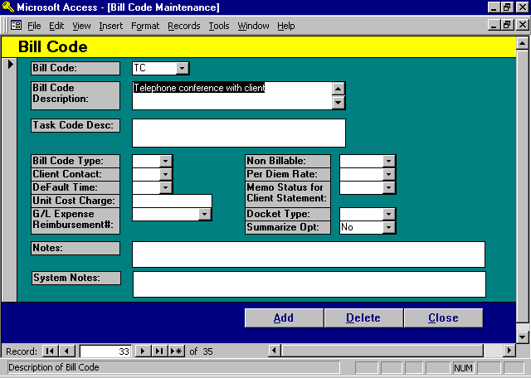

Bill Code Maintenance Screen

BILL CODE
Enter the desired bill code. These codes can be numeric or alphabetic. It is best to make the bill code short and concise so the attorneys can easily memorize the codes facilitating data entry.

BILL CODE DESCRIPTION
Enter the desired description that coincides with the bill code. This description will appear as text when time is entered.

Summary of Task Code Processing
Task Codes are synonymous with Bill Codes. Task Codes represent a uniform coding structure developed by the American Bar Association. Task Codes are normally four characters consisting of a letter identifying the group along with three digits. The groupings consist of:
- Litigation Codes -- represent major categories of service such as:
- Court Mandated Conferences;
- Written Discovery;
- Discovery Motions, etc.
- Activity Codes -- represent commonly performed activities such as:
- Phone Calls,
- Correspondence, etc.

E- Expense Codes -represent out of pocket charges or client cost disbursements such as:
- Photocopy charges,
- Filing Fees, etc.

Task Codes associated with Fees usually consist of both a Litigation Code and an Activity Code. Expense Task Codes are normally entered individually. For example, the Activity function "Telephone Calls" can be made in conjunction with the Litigation function of "Court Mandated Conferences".

For this example assume that “Court Mandated Conferences” are defined as bill code “L230” and “Telephone Conference” is defined as “A100”. Assume that a 36-minute phone call was made in conjunction with a Court Mandated Conference. When the time entry recording this service was entered into the L.A.W.S. time entry program, the bill codes associated with this entry would consist of “L230” and “A100”. Additional description could be added to this description through the use of nested bill codes and/or the typing of additional description such as is noted below. As soon as the description field is exited, the description extends out as follows:

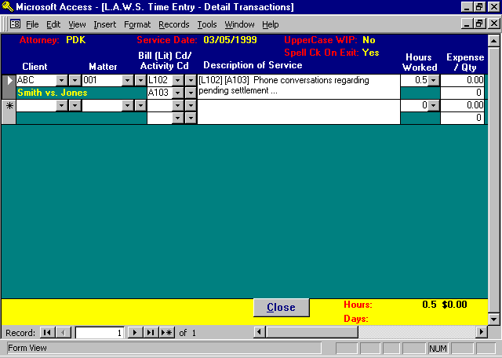
If desired, a task code summary report may be produced at the time of invoicing that summarizes all activity by the entered task codes.

For additional information pertaining to Task Code Billing, please review the Task Code Summary in the Client Billing section of this documentation manual.

TASK CODE DESCRIPTION
The description of the Task Code which prints on the client billing Task Code Summary Report.

BILL CODE TYPE
This field identifies the type of bill code referenced. Three distinct types are available including:
“D” indicates a cash disbursement for which a check has been generated (such as filing fees).
“E” indicates a non-cash expense such as photocopying.
“Blank” indicates fee entry - hours worked times hourly rate.

CLIENT CONTACT
L.A.W.S. provides the ability of tracking the number of days since the last contact with the client. Contact is determined through the use of a bill code marked as “Contact Yes”. Usually the firm has a single bill code specifying direct contact with the client. When this bill is used, L.A.W.S. automatically records the date of use as the date of last contact with the client. The Date of last contact is noted on the Matter List.

DEFAULT TIME
Enter the amount of time that will be assigned to a fee entry if the billable hours are left blank.

UNIT COST CHARGE
The dollar value associated with a per unit expense item. For example: The firms policy may be to charge $.25 per photocopy. A per unit expense amount of $0.25 would be entered in this field. If desired, the photocopy charge could be recorded in WIP by entering the number of photocopies, say 10, in the QTY field. The system would then multiply the number of photocopies entered, 10, times the “Unit Cost Charge”, $.25, generating a total expense of $2.50.

G/L EXPENSE REIMBURSEMENT #
This field allows you to define the general ledger number to be used for posting expense reimbursements associated with client receipts. If this number is blank, the expense reimbursement will post to the “Expense” general ledger numbers identified within the firm file.

NON BILLABLE
This field allows specification of non-billable status. Available options:
Blank: Entries utilizing this code are considered billable so that a rate will be assigned, and the hours
worked will be classified as Billable Hours Worked.
“Y” Yes: Entries utilizing this code are considered Non-Billable so that a billing rate will not be
assigned and the hours worked will be classified as Non-Billable Hours Worked.

PER DIEM RATE
Specifies whether the WIP entry should utilize an hourly rate or per-diem rate. Available options:
“Y” Yes: A Per-Diem rate is desired. The “hours worked” associated with the time entry represent
“Days Worked”. Days Worked are automatically converted to hours for inquires and
management reporting utilizing the Hours Per Day value in the Firm File.
Blank: An Hourly Rate is assigned.

MEMO STATUS FOR CLIENT STATEMENT
Entries coded with a “Y” will post to the Work In Process and will print on the pre-bill worksheets, but they will not appear on the clients statements.

An example of use could be for “UnBilled-Telephone Calls”. Whenever a long distance call is made, the attorney would record the entry utilizing the “UnBilled Telephone Calls” code along with the telephone number of the call. The entry would be stored in WIP and would print on the pre-bill worksheet, but would not print on the client statements. When the firm received the telephone bill, and the actual charges were known, then the entries could be recalled, and the actual charge could be entered. The bill code would then be changed from “UnBilled Telephone Calls” to something like “Long Distance Telephone Charges”, which would print on the client statement.
DOCKET TYPE
Bill codes may be used in conjunction with the calendar and docket program. One option available within the docket system is a classification as to the type of docket entry. (ie trial, deposition, etc.) If a bill code is used to describe a docket entry that also identifies a specific docket type, then the docket type associated with the bill code will automatically be assigned to the new docket entry.

SUMMARIZE OPT
Summarize option for costs on the client invoice. If desired, costs may be summarized on the client invoice by bill code. It is possible that some bill codes should be summarized while others may not. For example, the firm may desire that photocopy entries may be summarized, but jury fees not be summarized. If cost entries are to be summarized by bill code, then this field must be “Yes”. Otherwise, the cost entries will not be summarized.

NOTES
Any internal notes the firm wishes to associate with the bill code.

SYSTEM NOTES
Non-modifiable system generated comments pertaining to the bill code. Examples would include system generated notes created by the Miscellaneous Menu - Change Codes function.

ATTORNEY CLASS MAINTENANCE

Attorney Class Maintenance allows the definition of timekeeper classes within the firm to be used in conjunction with class rate assignment. It also allows the entry of budget production values by class of timekeeper. Budget values are entered as hours produced by month

After Aty Class is selected from Data File Maintenance, the following Attorney Class Maintenance form is displayed:

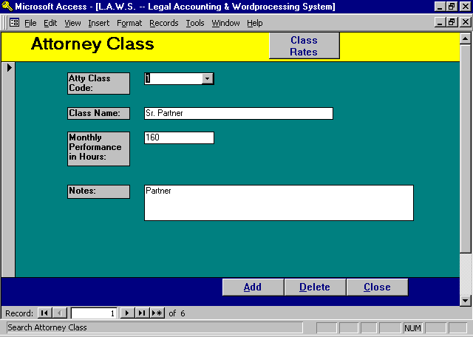

Attorney Class Maintenance Screen

ATTY CLASS CODE
Enter the identification for the attorney class (i.e., 1 - Partner; 2 - Associate; 3 - Paralegal, etc.). The class codes are totally user defined and may correspond to any class designation the firm desires.

CLASS NAME
Enter the description of the class.

MONTHLY PERFORMANCE IN HOURS
Enter the average number of monthly hours each attorney in this class should produce. This value is used in management reporting comparing actual hours produced against this expected value.

NOTES
Enter miscellaneous notes pertaining to this attorney class.

Class Rate Definition

L.A.W.S. offers the option of assigning billing rates by class of attorney through either client or matter file maintenance. If class of Attorney has assigned billing rates, Click the CLASS RATES button to display the existing rates associated with the displayed class.

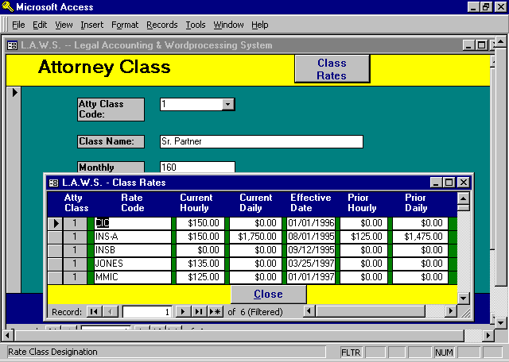

Class Rates function as follows:

Suppose an insurance company expects all Partners, Class 1, to charge $150/hr and all associates, Class 2, to charge $99.50/hr., regardless of the various hourly billing rates of the partners or associates. The firm would access the CLASS RATE option for each attorney class utilized by the firm and establish a common class code. Within each class code, the desired rate structure would be entered. The assigned Class Rate Code would then be inserted in the CLASS RATE field in CLIENT or MATTER FILE MAINTENANCE. This informs L.A.W.S. that Class Rates should be used instead of Attorney Rates.

Please note that it is much easier to work with Class Rates from Client or Matter file maintenance. For a detailed description of Class Rate, please refer to Client File Maintenance - Class Rates.

COURT/LOCATION FILE MAINTENANCE

This program allows you to enter Court names and/or other locations (such as conference rooms etc.), allowing L.A.W.S. to track activity associated with the defined courts or locations through the Docket Program. When the Court/Location option is selected from the Data File Maintenance menu, the following screen is displayed.

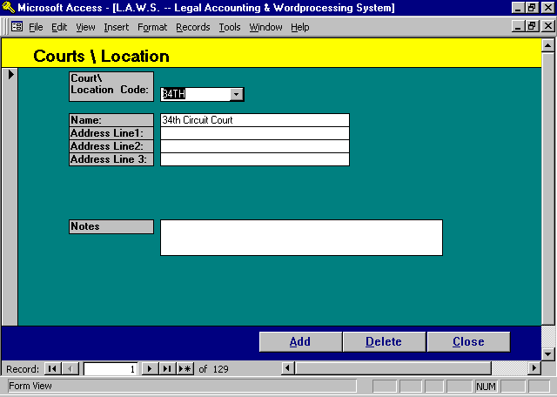

Court / Location Maintenance Screen

COURT/LOCATION CODE
Enter the desired Court/Location code.

COURT/LOCATION NAME
Enter the name corresponding with the code.

ADDRESS
Enter the address of the court or location.

NOTES
Enter any notes associated with the entered court or location. Example of notes could be directions, hours, phone numbers, contact people etc.

MATTER TYPE FILE MAINTENANCE

The purpose of this program is to allow definition of the types Matters (i.e., auto negligence, malpractice, bankruptcy, etc.) practiced by the firm. L.A.W.S. has the ability to report firm performance by matter type as well as to analyze the attorneys caseload by the matter type. When Matter Type Maintenance is selected from the Data File Maintenance menu, the following screen is displayed.

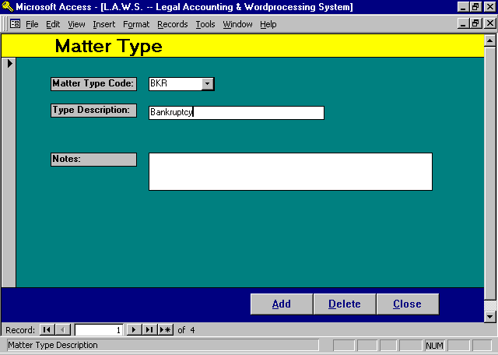

Matter Type Maintenance Screen

MATTER TYPE CODE
Enter the desired matter type code to identify the Matter Type.

MATTER TYPE DESCRIPTION
Enter the desired matter type description for the matter type entered.

NOTES
Enter any internal miscellaneous notes associated with the Matter Type.
.

SCRATCH PAD PROCESSING

The Scratch Pad function allows the firm to identify additional fields of information that may then be associated with Clients and/or Matters.

After selecting Scratch Pad from Data File Maintenance, the following form is displayed:

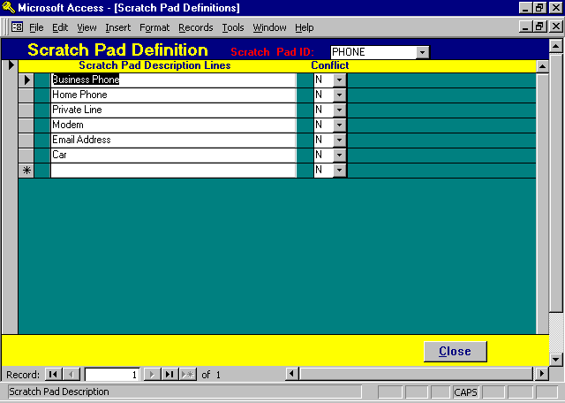

Scratch Pad Processing Screen

SCRATCH PAD ID
Enter the Scratch Pad Code containing the data you wish to enter, modify or delete. If an existing Scratch Pad Code is entered, the existing data will be displayed. If a new code is entered, the Scratch Pad Description lines will be Blank. This Example utilized a demonstration Scratch Pad Code of PHONE.

SCRATCH PAD DESCRIPTION LINES
Enter the description headings corresponding to the data to be collected. As many lines as desired may be added to a scratch pad.

NOTE: The responses entered into the Scratch Pad from the Client or Matter forms are associated with specific line numbers. In the example noted above, “Home Phone” is noted as the second line description. If the title is changed from “Home Phone” to “Pager”, the corresponding data previously entered from the client or matter on line two, “Home Phone” , will still correspond to the second line of the Scratch Pad now identified as “Pager”. In all likelihood, the data would be incorrect. Accordingly, use care when switching scratch Pad description lines. It will probably be best to simply add a new line rather than modify an existing line.
CONFLICT
Specifies if this Scratch Pad line item should be considered when Conflict of Interest searches are initiated against the Scratch Pad (See Case Management - Conflict Search). Many fields within the scratch pad contain responses such as dates, yes/no or the like. When a conflict search is performed, all fields marked with a “Y”, yes, will be searched and displayed. The Conflict option of “N” eliminates non-applicable fields from being searched and displayed during conflict searches on the Scratch Pad.

