TIME PROCESSING
TABLE OF CONTENTS
TIME PROCESSING 84
TIME ENTRY 85
Time Entry Selection Screen 85
Time Entry - Detail Transactions 87
Clearing a Partially Entered Line 88
System Notes 90
Deleting a Time Entry 90
Spell Checking Capabilities 90
HOURS WORKED CALENDAR 92
Hours Worked Calendar - Selection Screen 92
View Hours Worked Button 94
Print or View The Hours Worked Report 96
Sample Report:- Daily Hours Worked by Attorney 96
WIP ADJUSTMENTS 98
WIP Adjustment Selection Screen 98
WIP Adjustment - Detail Screen 99
Client Costs Posted from WIP 100
Writing off a Transaction 102
WIP INQUIRY 103
WIP Inquiry Selection 103
WIP Inquiry - Summary by Matter 104
WIP Inquiry - Detail Transactions 105
CONTRIBUTING ATTORNEY HOURS WORKED 107
Contributing Attorney Hours Worked - Selection 107
SUMMARY OPTIONS 108
Sample: Hours Worked by Contributing Attorney - Summarized by Client 108
Sample: Hours Worked by Contributing Attorney - Detail Transactions 108
Sample: Hours Worked by Contributing Attorney - Time Sheet Order 108
WIP REPORT 112
WIP Report Selection 112
Sample: Unbilled WIP, sorted by Billing Attorney, summarized by Attorney 113
Sample: Recomputed WIP, sorted by Client, Detail Transactions 113
YEAR TO DATE ACTIVITY REPORT 116
YTD Activity Report Selection 116
Sample: YTD Activity - Summary Report 117
Sample: YTD Activity - Detail Report 117
Sample: YTD Activity - Comparative 117
WIP ADJUSTMENT REPORT 121
WIP Adjustment Report - Selection 121
TRAN TYPE 121
Sample: WIP Adjustment Report - Detail Transactions 122
Sample: WIP Adjustment Report - Summary by Client 122
REMOTE TIME 125
Remote Time Processing 125
Importing Remote Time 126
REMOTE TIME 126
ERS PHOTOCOPIES 127
ADD2PC (Delimitated) 128
ADD2PC (DOS) 129
COPYGUARD 129
Edit/Error Listing 130
Sample: Remote Time Error Listing 130
Sample: Complete Remote Time Edit Listing 130
Remote Time Maintenance 133
Post To Wip 135

TIME PROCESSING

The Time Processing menu provides the means of entering, modifying and reporting the Work In Process accumulated by timekeepers.

After Selecting Time Processing from the Master Menu, the following menu is displayed:

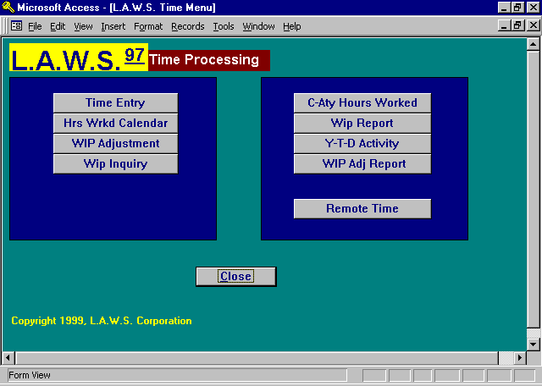

A detailed review of all functions available through Time Processing is discussed throughout the remainder of this chapter.

TIME ENTRY

The Time Entry option is used to enter time worked. After identifying the attorney and date of service, a complete time sheet for the specified date and attorney is displayed. After selecting the Time Entry option, the following screen appears:

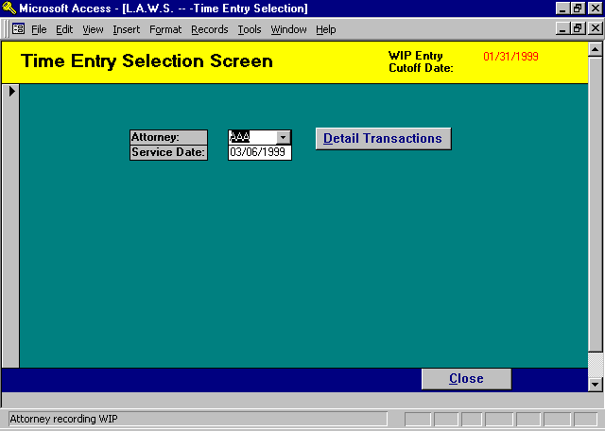

Time Entry Selection Screen

ATTORNEY
Enter the code of the attorney for which time is being entered. This option may be modified to select the authorized attorneys associated with the user signing onto the system. The authorized attorneys are identified within the Define User function of Case Management as well as by the View Global Activity option in Attorney Maintenance. Please review Define User in Calendar / Case Management chapter and the “View Global Activity” field in Attorney File Maintenance for additional information.

SERVICE DATE
Enter the date the work was performed using Standard Date Format. L.A.W.S. assumes the current system date.

WIP ENTRY CUTOFF DATE:
The firm's administrator, through Firm Maintenance, enters the WIP Entry Cutoff Date displayed in the upper right corner of the form. After all time has been entered for a given month, the WIP Entry Cutoff Date should be set to equal the last day of the completed month. Time may be entered or modified through, Time Entry, AFTER this date only but not before. Use of the WIP Entry Cutoff Date provides the firm with confidence that WIP may be billed and management reports be run without unanticipated changes from additional time being entered prior to the WIP ENTRY CUTOFF DATE.

If the entered Service Date is less than the displayed WIP Entry Cutoff Date, a message is displayed “Service Date is less than WIP Entry Cutoff Date. Data may be Viewed only.” along with the options to continue or cancel. Continue will allow review, but not modification, of the WIP entered on the specified date. Cancel will return the user to the selection screen to modify the entered criteria.

If a time dated prior to the WIP Entry Cutoff Date must be entered, simply change the WIP Entry Cutoff Date in FIRM Maintenance allowing the time to be entered.

DETAILED TRANSACTIONS Button
If the default information displayed is correct, the DETAILED TRANSACTIONS button may be pressed which will display the Time Entry screen.

After the required information is entered, the following TIME ENTRY - DETAIL TRANSACTIONS screen is displayed:

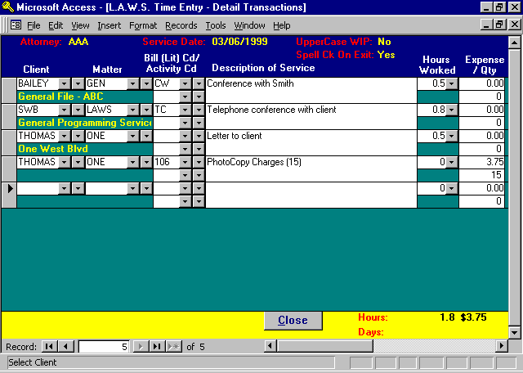

Time Entry - Detail Transactions

The Attorney/Service Date information is carried over from the previous screen. This information should be verified prior to entering the time sheet. It is easier to correct an incorrect service date or attorney prior to completing the timesheet then after.

CLIENT
This column identifies the Client for which the work was performed.

MATTER CODE
Enter the matter code for the time entry. If the client and matter are blank, the client and matter codes entered on the prior line are automatically duplicated.

If all matter codes are unique, it is possible to enter a matter code without a client code. L.A.W.S. will then automatically display the associated client. If duplicate matters codes exist with different client codes, the first Client Code will automatically be selected.

The client matter combination for each entry is verified against data entered in the client and matter master files. If the data is found to be invalid, a message is displayed and the transaction cannot be posted. WIP may be posted to active matters only. Matters are considered ACTIVE if the inactive date, associated with the matter, is blank.

BILL (LIT) CD/
ACTIVITY CD
The L.A.W.S. Time Entry program allows reference to two bill code fields. The first Bill Code is classified as the Litigation Code while the second Bill Code is classified as the Activity code. Bill Codes are optional for fee transactions, hours worked times rate. At least one Bill Code is required for expense transactions. The text associated with the Bill Code(s) is displayed in the DESCRIPTION OF SERVICE column. If both fields are entered, the description associated with both codes is inserted as the description of service. The bill code is used as the primary identification of the type of WIP. Some management reports allow selection of WIP based on the Bill Code. All Bill Codes are classified as fees, disbursements or expenses. L.A.W.S. checks the status of the Bill Code to ensure that fee codes are used with fee entries and expense codes are used with expense entries. Bill Codes identified as a disbursement cannot be entered in Time Entry. Disbursements are automatically added to WIP through Cash Disbursements processing. Please see the Cash Disbursements Chapter for more information on processing Cash Disbursements.

Many firms are required to submit ASCII billing files, along with the physical copies of the client invoices, to clients. A requirement of many ASCII billing files is the utilization of the American Bar Association (ABA) TASK CODE structure. The ABA task coding structure consists of three major classifications of codes identified as follows:
Lxxx Litigation Codes
Axxx Activity Codes
Exxx Expense Codes.

Each ABA code consists of letter identifying the type of code followed by three digits. Fee transactions usually require a litigation code along with an activity code. Expense transactions usually require an expense code only. If your firm is required to use the ABA Task Codes, please contact the either the ABA, or the client imposing the task code requirement for a complete listing of the Task Codes.

DESCRIPTION OF SERVICE
Enter the description of service performed. If bill code(s) were used, the description associated with the code(s) will be displayed if the Description of Service field is blank. If desired, additional bill codes can be used within the Description of Service (to save time typing only) by placing a "\" (back slash) before a bill code within the Description Of Service.
Example: A bill code “CW” may be used which inserts into the Description of Service “Conference with”. If a bill code has been established as “PA” for “Plaintiff Attorney”, then the characters “\pa “ may be entered after “Conference with" -- (“Conference with \pa “). Upon exiting the field, the Description of Service will automatically be extended to “Conference with Plaintiff Attorney”.

To enlarge the Description of Service field, ensure that the cursor is located within the desired field then press the SHIFT and the F2 key simultaneously to activate the ZOOM Box. Exit the ZOOM Box by pressing ENTER or clicking on OK.

There is no practical limit to the amount of data that can be inserted into the Description of Service.

HOURS WORKED
Enter the hours or fraction thereof, for the time entry. Commonly used increments may be selected using the selection arrow. Hours are entered in tenths of hours, so 30 minutes would be entered as .5 while 1 hour would be entered at 1.

EXPENSE
Expenses incurred such as parking, meals, photocopies, etc. can be recorded directly through Time Entry. Expenses are costs which are being charged to the client, BUT FOR WHICH THE FIRM IS NOT GENERATING A DISBURSEMENT CHECK. Be sure not to duplicate Cash Disbursement entries that are automatically entered through the Check Writing program.

QTY
If applicable, enter the quantity of expense units. For example: Faxes are charged at $1.00 per page. A $1.00 charge per page may be associated with the fax bill code as the “unit cost” in Bill Code Maintenance. If a 5-page fax was sent, a quantity of 5 could be entered instead of a $5.00 expense amount. L.A.W.S. will then multiply the quantity-entered times the unit cost, generating an expense amount. The quantity entered is automatically appended to the existing bill code description. If desired, the computed expense value may be overridden.

NOTE: Both Hours Worked and Expenses may be entered thorough the Time Entry Option. However, hours and costs must be entered on separate lines.

Values entered as “Hours worked” are considered hours unless a Per Diem Bill Code is used. A Per Diem Bill Code (Per Diem = Yes in Bill Code File Maintenance) automatically converts the Hours Worked value into Days Worked. Accordingly, in the displayed Detail Transaction screen at the beginning of this section, the second entry, Trial Day, is marked as Per Diem. The system prints the word “Day” under the hours worked so that the user knows that a per diem bill code has been used.

Clearing a Partially Entered Line
All verifiable data is checked for accuracy prior to posting the line item. If, for whatever reason, a partially entered line item must canceled, press the ESC key. It is possible that the ESC key must be pressed twice. The first ESC will clear data from the current field while the second ESC will clear the entire record. Since L.A.W.S. performs extensive verification procedures, a partially entered record cannot be exited without pressing the ESC key.

The footer of the form displays the total hours worked along with the total days worked for visual verification by the user.

If desired, the horizontal arrow, at the bottom of the form, may be used to display additional information pertaining to the entered time.

After pressing the right horizontal arrow, the following additional time entry information is displayed for review:

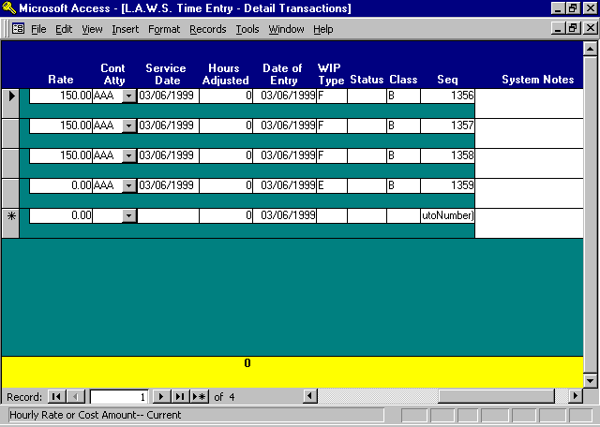

RATE
If desired, enter the desired rate for the WIP transaction. Otherwise, the rate is assigned as follows:
L.A.W.S. checks to see if there is rate information associated with the matter. If so, the rate is assigned. Otherwise, L.A.W.S. checks the client level for rate information. If rate information is not assigned at either the matter or client level, then the Standard Attorney Rate identified within the firm is utilized. Rates are assigned for all transaction on the Detail Transaction screen when the screen is closed.

If the entry is posted to a non-billable or contingent client or matter, or if the utilized bill code is non-billable, then a zero rate is assigned.

Cont Atty
The Contributing Attorney (the attorney who physically performed the service) assigned to this entry. The contributing attorney may be changed if the entry was inadvertently posted to the wrong attorney.

Service Date
The date service was performed. The service date may be changed if the entry was inadvertently posted to the wrong date.

Hours Adjusted
The total amount of hours this time entry has been adjusted via WIP Adjustment. Adjusted WIP Transactions cannot be modified through Time Entry.

Date of Entry
The date the time entry was entered into the system, regardless of the service date. This field may not be modified.
WIP Type
The transaction type. The transaction type is extracted from the utilized bill code. If the Bill code is blank, the transaction is classified as a Fee. This field may not be modified. The available options are:
F: Fee,
E: Expense,
D: Disbursement.

Status
The transaction status. Only entries with a blank status may be modified through the time entry option. This field may not be modified. The Status is posted from other portions of the system. The Billing status is posted during the finalization of the client invoices. The Adjusted status is posted through the WIP Adjustment program. The available options are:
Blank: Unbilled and not Adjusted,
B: Billed,
A: Adjusted

Class
Class of entry. The class of entry is extracted from the Matter to which the WIP is posted. This field may not be modified. The available options are:
B: Billable
NB: Non-Billable
C: Contingent

Sequence
System assigned unique identification number.

System Notes
Non-modifiable system generated notes detailing the history of the transaction. System notes reference bill reversal, cash disbursement, or transfer information.

Deleting a Time Entry
To delete a time entry, simply select the record to be deleted by clicking the entry’s record selector, then press the delete key.

Spell Checking Capabilities
L.A.W.S. is developed using Microsoft Access 97. This product is part of the Microsoft Office 97 Office Family. L.A.W.S. utilizes the Spell Checker incorporated into Microsoft Word 97.

Spell Checking can be performed in two different fashions as described below.
SPELL CHECK WIP DESC ON EXIT
Within Firm Maintenance is a field called Spell Check WIP Desc On Exit. It "Yes" is entered in this field, the WIP Description will automatically be Spell Checked upon exiting the WIP Description field. If "No" is entered, the WIP Description will not be Spell Checked.

DOUBLE CLICK THE WIP DESCRIPTION FIELD
Double Clicking the WIP Description is an alternative Spell Check option if automatic Spell Checking On Exit is not desired. Simply double clicking the field will perform the spell check option.
Please Note: the default setting for the Access/Word 97 Spell Checker is to ignore upper case words. To change the Spell Checking options, perform the following procedures.

1: Intentionally enter a lower case spelling error in the WIP description. If necessary change the
option in FIRM Maintenance, "Upper Case WIP Description" to "NO" to allow lower case entry.

2: Either exit or Double Click the WIP Description field to display the Spelling screen as noted below.

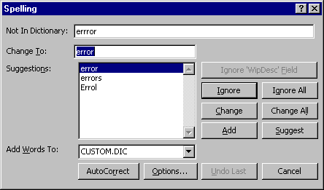
3: Click the Options button to display the available Spell Options as displayed below:

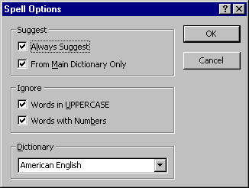
4: Remove the desired check mark(s) from the Ignore Section.

5: Click OK when finished.

6: Exit the Spelling screen by any available method - Cancel, Ignore, Change, etc,

HOURS WORKED CALENDAR

The Hours Worked Calendar summarizes WIP accumulated each day by timekeeper within a specified month. It serves two distinct functions.

First, timekeepers may review their total accumulated hours worked per day within any given month. If necessary, the displayed hours may be modified. This function allows timekeepers to easily review all time posted during the specified month. The timekeeper can easily spot days for which time has not been posted. The timekeeper has the option of viewing and/or correcting the detail transactions associated with each day.

The Hours Worked Calendar may also generate a report listing the total hours worked by day for all attorneys within a specified month. This report provides an excellent audit tool to ensure that all time is entered for all attorneys prior to the initiation of the current billing cycle.

After selecting the Hours Worked Calendar from the Time Processing menu, the following form is displayed.

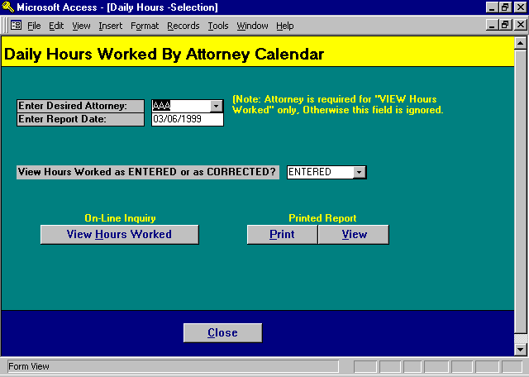

Hours Worked Calendar - Selection Screen

ENTER DESIRED ATTORNEY
Enter the Attorney whose calendar should be displayed. This entry is required for the on-line inquiry function of Viewing Hours Worked. The entry is ignored for the report that includes all attorneys with hours worked in the specified month.
This option may be modified to select the authorized attorneys associated with the user signing onto the system. The authorized attorneys are identified within the Define User function of Case Management as well as by the View Global Activity option in Attorney Maintenance. Please review Define User in Calendar / Case Management chapter and the “View Global Activity” field in Attorney File Maintenance for additional information.

ENTER REPORT DATE
Enter the date of the report using the standard date format. An entire month’s activity will be selected. L.A.W.S. looks at the month and year combination to determine the relevant information for inclusion.

VIEW HOURS WORKED AS ENTERED OR AS CORRECTED
The user has the option of looking at hours worked as entered (as they were originally entered regardless of adjustments to date), or as corrected (the original hours worked net of adjustments to time made through WIP Adjustment). The available options include:
ENTERED: WIP will be accumulated and displayed based on the original value of WIP entered.
CORRECTED: WIP will be accumulated and displayed based on the adjusted value of WIP.

Example: A time transaction is entered into the system for two (2) hours. Upon review of this time, prior to billing, the billing attorney writes down the transaction to one (1) hour. Assuming this is the only transaction posted, the "Entered" option would display a total of 2 hours worked, while the "Corrected" option would display 1 hour. When the Detail Transactions are displayed, the Hours Worked always displays the current (Corrected) value of the transaction. Moving the screen right will show the accumulated adjustments applied to the transaction.

View Hours Worked Button

The View Hours Worked button displays the Hours Worked Calendar for the specified attorney and month. The calendar displays each day of the month along with the total hours worked for each day. Per Diem entries are always converted to hours worked using the “Hours Per Day” value entered in the Firm file. The hours worked value will either be as entered or as corrected based on the selection criteria.

After selecting the View Hours Worked Option, the following form is displayed:

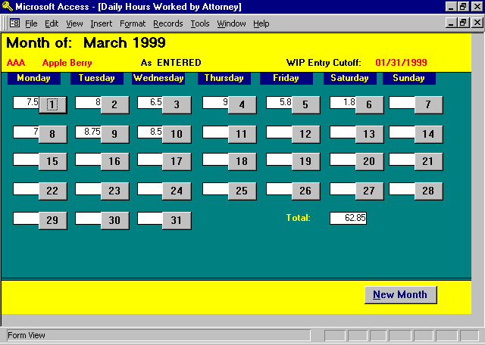

The Daily Calendar always displays 31 days within the month, yet only the actual numbers of days within the month contain activity.

The WIP Entry Cutoff Date is displayed at the top of the form. Only WIP dated after the WIP Entry Cutoff Date may be modified. WIP dated prior to this cutoff date may be viewed, but not modified. WIP, which has been purged from the Active WIP file, (an option in the Miscellaneous Functions menu), will not be displayed on this screen.
Display the detail transactions by simply clicking the desired day. After clicking March 10th, the following Time Entry screen is displayed.

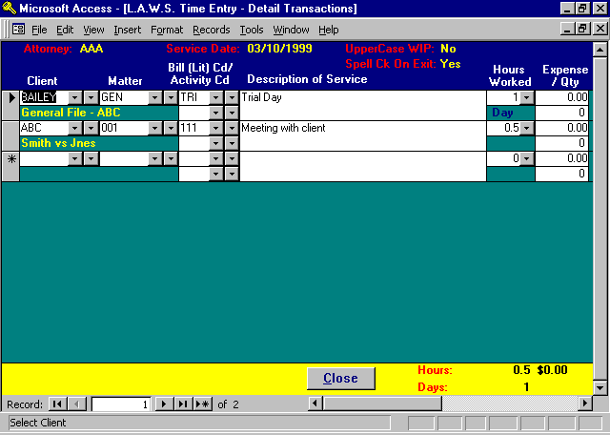

Please note that the Total Hours Worked for March 10th on the daily Calendar is 8.5 hours. When displayed on the Time Entry Form, the activity is depicted as 0.5 hours and 1 day. L.A.W.S. automatically converts Days to Hours on the Daily Calendar.

Please review the TIME ENTRY portion of this manual for specifics on the entry of time.

Print or View The Hours Worked Report

L.A.W.S. allows the option of printing or viewing the hours worked for all attorneys within the firm using the Print or View report buttons. Since all attorneys with hours-worked activity are automatically included on this report, the entered attorney is ignored. The generated report summarizes all activity, from the first to last day, of the entered month.

Note: If the user signing onto the system does not have access to “Global Activity”, then the Hours Worked Report is not available.

A copy of the Daily Hours Worked Report generated by the Print or View Button can be found on the next page.

Sample Report:- Daily Hours Worked by Attorney

L.A.W.S. CORPORATION - DEMONSTRATION
Daily Hours Worked By Attorney - As: ENTERED
Month Month of: March 1998
Attorney Total 1 2 3 4 5 6 7 8 9 10 11 12 13 14 15 16 17 18 19 20 21 22 23 24 25 26 27 28 29 30 31
______________________________________________________________________________________________________________________________________________________
SSJ Jones 9.50 6 4
PDK Karlsberg 52.60 1 8 11 8 8 9 9
JJK Kingston 14.00 6 8
______________________________________________________________________________________________________________________________________________________
FirmTotal: 76.10 7 11 8 9
6 8 12 8 9

_____________________________________________________________________________________________________________________________________________________________________________
Copyright 1998 L.A.W.S. Corporation 3/10/98 5:49:54 PM 1
As Entered: Hours Worked represents hours entered from timesheets. WIP Adjustments to time entered are not reflected.
As Corrected: Hours Worked represents actual WIP value -- Hours Entered from Timesheets +/- WIP adjustments.
Daily hours are rounded to the nearest whole hour. Totals are computed as actual, then rounded to the nearest whole hour.
WIP_3: Time Menu - Inquiry By Day

WIP ADJUSTMENTS

The WIP Adjustment function is used to adjust or correct unbilled WIP transactions. The WIP Adjustment screen is very similar to the Time Entry screen except that transactions grouped by matter rather than by attorney and date. Unlike Time Entry, the WIP adjustments may occur regardless of the date of the transaction since the WIP Entry Cutoff Date is not utilized.

L.A.W.S. tracks all adjustments made to WIP. On management reports, reference will be made to various classifications of Hours Worked and WIP Adjustments. Hours Worked are always generated by Time Entry, while WIP adjustments are always generated by this WIP adjustment function.

After selecting WIP Adjustments, the following form is displayed:

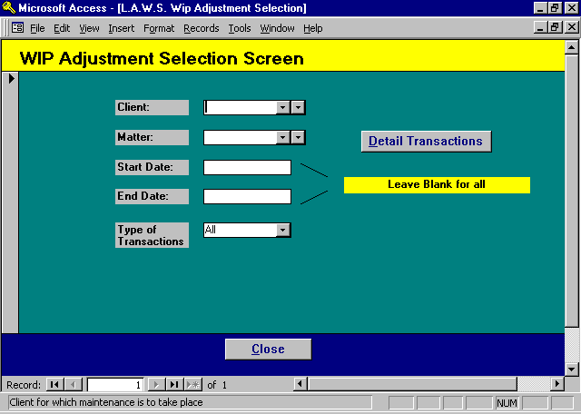
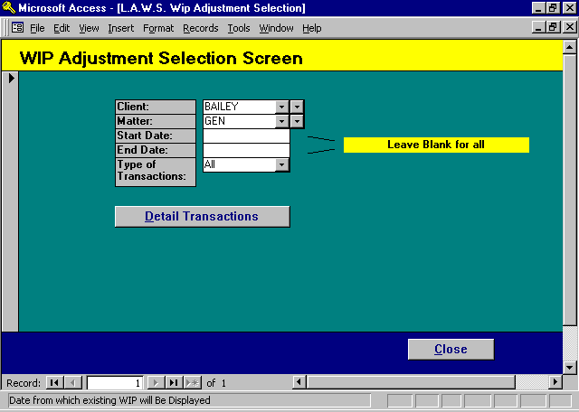

WIP Adjustment Selection Screen

CLIENT/MATTER
Enter the desired Client Matter combination. If all matter codes are unique, it is possible to enter a matter code only. L.A.W.S. will then automatically display the associated client. If duplicate matters exist with the same matter code but different client codes, the lowest client code will automatically be selected.

START/END DATE
Enter the date range from which the WIP associated with the matter is to be displayed. If the dates are blank, all WIP associated with the matter will be displayed. After the dates are entered, L.A.W.S. will automatically display the detail WIP adjustment screen matching the entered criteria. A blank start date will select from the first WIP entry forward. While a blank end date will display WIP through the last entry.

TYPE OF TRANSACTIONS
WIP may be selected based on the type of transaction. If the Type of Transaction is blank, all WIP will be displayed. The available options include:
ALL Both Fees and Costs are selected and displayed.
FEES ONLY Only Fee transactions are selected and displayed - Transaction Type "F"
COSTS ONLY Only Cost transactions are selected and displayed - Transaction types "D" and "E"

The WIP Adjustment - Detailed Transactions screen is displayed by either tabbing through all fields on the selection screen or by clicking the “Detailed Transactions” button.

After entering the required criteria, the following Screen is displayed:

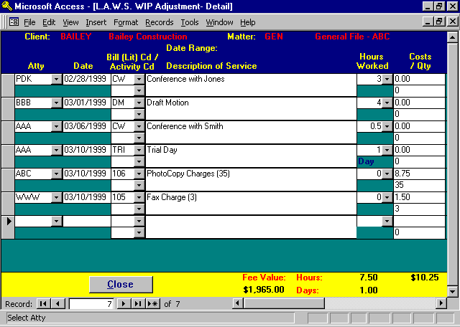

WIP Adjustment - Detail Screen

Please Note: New transactions may be entered through WIP Adjustments, but the hour value of new transactions will be considered HOURS ADJUSTED rather than HOURS WORKED on the management reports. Hours Worked are generated through Time Entry while Hours Adjusted are generated through WIP Adjustments.

A historical transaction log is maintained for all WIP adjustments. This log may be printed or viewed through the WIP Adjustment Report discussed later in this chapter.
ATTY
Enter/modify the attorney who performed the service.

DATE
Enter/modify the date the service was performed.

Bill(LIT)CD/
ACTIVITY CD
Enter/modify the bill code(s) associated with this transaction. Please review the detailed description of these fields in the TIME PROCESSING section of this manual.

NOTE: The Per Diem status of an entry cannot be changed. An entry originally entered as Days may be changed to a new Bill Code with a “Day” Per Diem Status. Likewise a non Per Diem Bill Code may be changed to another non Per Diem Code.

If the need arises to change the Per Diem Status, write off (as described below) the original entry then re-key a new entry.

DESCRIPTION OF SERVICE
Enter/modify the Description of Service. This field is virtually unlimited in size. Use the scroll bars to navigate through the field. Simultaneously pressing the SHIFT and F2 keys will display the "Zoom Box" which enlarges the description field for viewing.

The Description of Service may be spell checked by double clicking on the field, or to configure the system to spell check on exit. Please review the Description of Service section of the Time Entry section of this chapter for an in-depth description of the spell check function.

HOURS WORKED
Enter/modify the hours worked associated with this transaction.

COSTS
Enter/modify the expense or disbursement value associated with this WIP entry.

Please Note: As in time entry, hours and costs transactions must be entered on separate lines.

QTY
If desired, enter/modify the quantity of a cost generating the expense. Please review the quantity field description noted in the Time Entry portion of this manual.

Client Costs Posted from WIP
The Cash Disbursement module automatically posts client costs transactions to WIP. Client Cost Transactions are posted to WIP as the Cash Disbursement distribution line item is entered. If the Cash Disbursement distribution line item is changed or deleted, multiple transactions will be posted to WIP reflecting the original entry, change, and/or deletion of the client cost item. If Client Invoices summarize costs, the multiple transactions will be summarized into a single line item. If detail cost transactions print on the Client Invoice, the firm may elect to manually combine the multiple transactions prior to generating the Client Invoice. WIP Adjustments have no affect on Cash Disbursement Transactions.

Additional data is available through WIP Adjustments by using the horizontal navigation buttons to move the screen right.

A copy of additional fields within the WIP Adjustment form is listed below:

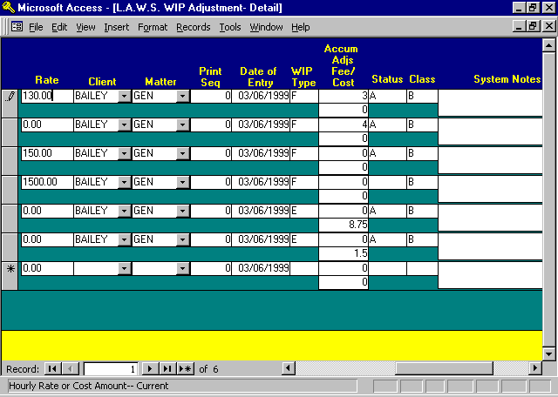
RATE
Enter/modify the rate assigned to the transaction.

CLIENT/MATTER
Enter/modify the client /matter combination with which the transaction is associated. All data displayed on this screen is grouped by a specific Client/Matter. Modification of the Client and Matter fields allows the transaction to be transferred from one matter to another. To re-assign a matter, display all transactions posted to the originally used matter. Change the Client/Matter combination from the incorrect matter to the desired matter. The transactions will remain on the screen until the screen is closed.

PRINT SEQUENCE
The print sequence governs the placement of the WIP entry on the client's invoice. If the print sequence is zero, the WIP entries will print on the invoice in the order of entry, i.e.: the system assigned sequence number. If a different print sequence is desired, the user may assign a print sequence number to all transactions with a common date. The system will then order the transactions according to the print sequence number. Transactions without a print sequence number always print first within a date range.

INQUIRY ONLY FIELDS
Several inquiry only fields are displayed but cannot be modified. These fields are described below:

DATE OF ENTRY
The date the transaction was physically entered onto the system.

WIP TYPE
Type of transaction:. Available options include:
F Fee
D Disbursement
E Expense

ACCUMULATED ADJUSTMENTS
FEES/COSTS
Total accumulated to date adjustments pertaining to this transaction. The top field accumulates fee adjustments while the bottom line accumulates cost adjustments. For example: Assume the original transaction was entered as 1 hour. After review by the billing attorney, the transaction was written down to .75 hours. The Hours Worked value would be .75 while the accumulated adjustments would be -.25. L.A.W.S. determines the original hours worked by subtracting the accumulated adjustments from the current hours worked.

STATUS
Identifies the status of the entry. The available options include:
Blank: The entry has not been billed, adjusted or written off.
A The transaction has been adjusted through WIP Modifications.

Note: An entry can only be adjusted through WIP Adjustments. Changes to WIP through TIME ENTRY are not considered adjustments.

CLASS
Identifies the type of entry. L.A.W.S. uses the class of the transaction to classify hours worked on management productivity reports. The Class of transaction is derived from the Client or Matter Billable status. The available options include:
B Billable Transaction
NB Non Billable
C Contingent

SYSTEM NOTES
Displays system generated notes pertaining to the WIP Entry. System notes identify Cash Disbursement activity, billing reversals, WIP Transfers, etc.

SEQUENCE(Not Shown)
System assigned consecutive unique identification number.

Writing off a Transaction

Writing off a transaction deletes the transaction from WIP. The written off transaction will not appear on the client invoice. A full transaction log is maintained for written off activity. If management production reports are generated "As Entered", then the written off amount will be included in performance activity. If the reports are generated "As Corrected", the written off amount will not be referenced.

Transactions must be written off individually. To write off a transaction perform the following:
1: Select the transaction to be written off by clicking the transactions record selector.
(the record selector is the gray box located to the left of the transaction.)
2: Once the record selector is highlighted, press the "Delete" key.

An easier alternative method involves simply double clicking the record selector.

When the record is written off, the hours or costs are set to zero, the accumulated adjustments are set to reflect the total of the original transaction, and the notation "Write Off" is associated with the transaction. If a transaction is written off in error, simply re-enter the appropriate hour or cost value to reverse the write off.

The written off transaction will be displayed until the screen is closed. When the Detail WIP transactions are re-displayed, the written off transactions will not appear.

WIP INQUIRY

WIP Inquiry enables review of all WIP by client or matter. WIP Inquiry allows either un-billed or billed WIP to be selected and displayed. Modifications to WIP cannot be performed through this option. When WIP Inquiry is selected, the following form appears:

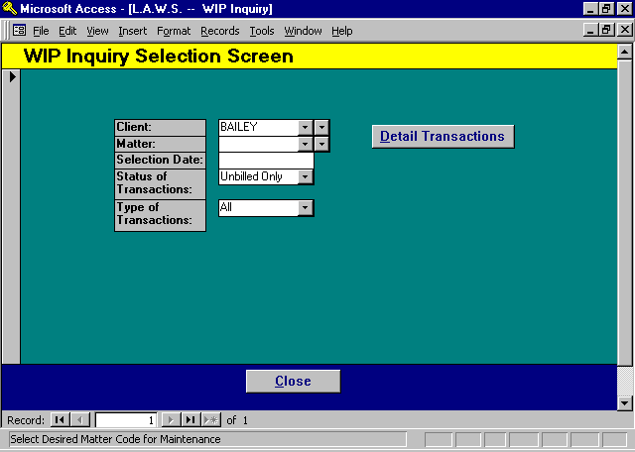

WIP Inquiry Selection

CLIENT
Enter the client code for which WIP should be displayed. The client code must be entered prior to performing the inquiry. If the client code is not known it may be left blank. Once a matter is selected, the client associated with the matter will automatically be entered.

MATTER
Enter the matter code for which WIP should be displayed. If the matter code is blank, all WIP associated with the client will be totaled and displayed by matter. If the matter is not blank, the detail transactions associated with the matter will be displayed.

SELECTION DATE
Specify the date from where the review will begin. For example, a matter may have many months of WIP accumulated. If you desire to review only the current month's activity, enter a start date for the first day of the month. WIP will only be displayed from the start date forward. By leaving the start date blank, you may review all WIP accumulated for any given matter from the beginning to the current date.
STATUS OF TRANSACTIONS
Selects transactions based on the status of the entry. The available options include:
UNBILLED Un-billed WIP only will be displayed.
BILLED Billed WIP only will be displayed.

TYPE OF TRANSACTIONS
Enter the type of transactions to be displayed. Available options include:
ALL For all transaction types including Fees and Costs
FEES ONLY Fee transactions will be displayed.
COSTS ONLY Costs transactions will be displayed -- Disbursements and Expenses.

WIP Inquiry - Summary by Matter

If a client code is entered and the matter code is blank, the following WIP Inquiry - Summary by Matter screen is displayed.

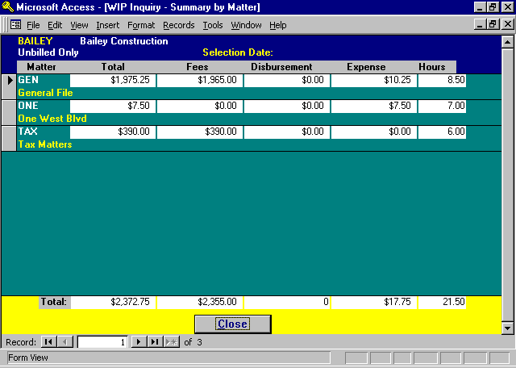
This screen accumulates total WIP, total fees, total disbursements, total expenses, and total hours for all matters matching the entered selection criteria.

To display the detail transactions associated with a specific matter, double click on the desired matters record selector.

WIP Inquiry - Detail Transactions

The Detail Transaction WIP Inquiry screen is displayed directly from the WIP Inquiry Selection Screen if both the Client and Matter are entered. It is displayed from the WIP Inquiry Summary by Matter screen by double clicking on the desired matter's record selector.

Listed below is an example of the WIP Inquiry - Detail Transaction Screen.

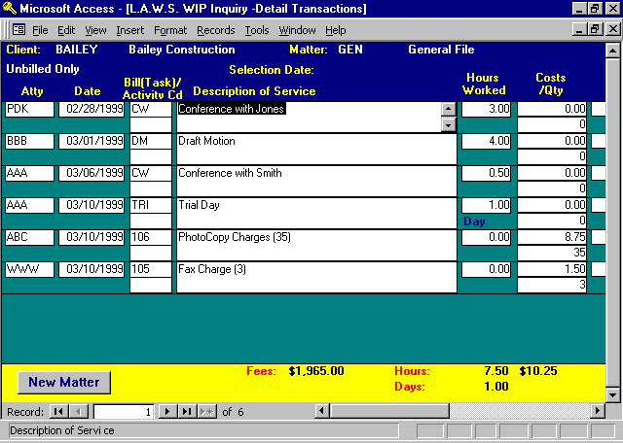

The displayed inquiry information is virtually the same as it is displayed through the WIP Adjustment program. The fields of data displayed on the first WIP Inquiry program are:
Atty;
Date;
Bill Code(s);
Description of Service;
Hours Worked;
Costs;
Qty.

For a detailed description of these fields, please review the WIP Adjustment section of this chapter.

The bottom of the screen displays Total Fees, Total Hours, Total Days and Total Costs. The Totals are computed based on the selection criteria, and do not necessarily represent the total UNBILLED WIP. To view total Unbilled WIP on a matter, leave the selection dates blank and select a transaction type of “UNBILLED”.

Additional information may be displayed by moving the form using the right horizontal navigation button. Please review the WIP Adjustment section of this chapter for a detailed review of this data. The additional data includes:
RATE
INVOICE #
INVOICE DATE
DATE ENTERED
WIP TYPE
ACCUMULATED ADJ
STATUS
CLASS
SEQUENCE #
SYSTEM NOTES
CASH DISBURSEMENT REFERENCE NUMBER
The Cash Disbursement Reference Number identifies the cash disbursement entry from which a client cost was created.

CONTRIBUTING ATTORNEY HOURS WORKED

The Contributing Attorney Hours Worked report will summarize and display the hours worked by each contributing attorney within a user specified time period. The hours reported may be billed or unbilled. The report categorizes attorney’s production by Billable, Non Billable and Contingent hours worked. The information may be printed in detail form, or summarized in a variety of methods.

After selecting C-Aty Hours Worked, the following form is displayed:

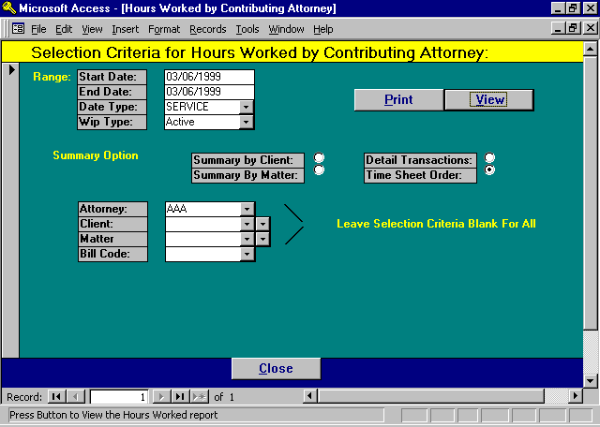

Contributing Attorney Hours Worked - Selection

START DATE/END DATE
Specifies the date range for inclusion of data on the report. The default date range is always the first day of the WIP Entry Cutoff Date month through the WIP Entry Cutoff Date. This date is modified through Firm File Maintenance.

DATE TYPE
Specifies whether the transactions should be extracted based on the date of service or the date of entry. The available options include:
ENTRY Selection is based on the date transactions are entered into the system regardless of
date of service.
SERVICE Selection based on the date the service was performed regardless of the date of entry.
WIP TYPE
Specifies the source of the WIP for the report. The available options include:
ACTIVE WIP form the Active WIP file is selected. Billed WIP is not included on
the report. This is the quickest method of generating the report. It should be
used to print off a copy of the current day’s time sheet work in process.
COMPLETE WIP from both the Active and Billed WIP files are utilized for creation of the report. This method must be used when billed hours worked must accurately be reported. If the firm has accumulated a significant amount of Billed WIP, the length of time required to generate the report could be significant.

SUMMARY OPTIONS
Identifies the manner in which the report should be printed. The available options include:
CLIENT Attorney performance is summarized on a single line per client.
MATTER Attorney performance is summarized on a single line for each matter with totals
for each client.
DETAIL
TRANSACTIONS: Attorney performance is displayed in detail form, summarized by matter.
Each WIP transactions detail the date, description, hours, adjustments, rate and
dollar value.
TIME SHEET
ORDER: Attorney performance is displayed in detail form summarized by date of service
with total hours worked by day.

ATTORNEY
Allows selection of a single contributing attorney, or the entire firm. Only attorneys with activity within the specified date range will be included in the report. This option may be modified to select the authorized attorneys associated with the user signing onto the system. The authorized attorneys are identified within the Define User function of Case Management as well as by the View Global Activity option in Attorney Maintenance. Please review Define User in Calendar / Case Management chapter and the “View Global Activity” field in Attorney File Maintenance for additional information.

CLIENT
Allows selection of a single client, or of all clients.

MATTER
Allows the selection of a single matter, or of all matters. Matters must be selected in conjunction with clients.

BILL CODE
Allows selection of hours worked based on a single bill code or all bill codes. This selection is useful if the firm wants to review a limited scope of performance, such as time spent on trials, etc. The bill code selection is limited to the primary bill code only.

All the above selection options work in conjunction with each other allowing the report to be as detailed or as broad as desired.

The initial options always default to the current day with a data type service for the currently signed on attorney in time sheet order. These options allow the attorney to print a hard copy of the current days time entered through time entry.

Samples of the Hours Worked by Contributing Attorney reports are displayed on the following pages.

Sample: Hours Worked by Contributing Attorney - Summarized by Client

Sample: Hours Worked by Contributing Attorney - Detail Transactions

Sample: Hours Worked by Contributing Attorney - Time Sheet Order
L.A.W.S. CORPORATION - DEMONSTRATION From: Jan 01 , 1998
Hours Worked by Contributing Attorney - Client Summary: Through: Mar 31 , 1998
Selection Criteria: Attys: PDK Matter: * All * Activity Selected based on Date of SERVICE
Clients: * All * Bill Cd: * All *
Original Adj'd
Client/ Hours Hours Hours
Matter Description Worked Adj'd Wrkd Value
_________________________________________________________________________________________________________________________________
PDK Paul D Karlsberg
Billable Hours Worked:
(BAILEY) Bailey Construction 8.00 0.00 8.00 $10,000.00
(CARSON) Carson Manufacturing 10.00 -10.00 0.00 $0.00
(DEAN) Dean Plating 0.50 0.00 0.50 $50.00
(JOHNSON) Johnson And Johnson 8.00 0.00 8.00 $800.00
(JONES) Jones And Wilson 18.50 0.00 18.50 $11,050.00
(140) MMIC 5.00 0.00 5.00 $500.00
(SWB) Smith, Wilson And Brown 7.50 0.00 7.50 $750.00
(1) Water Corporation 9.00 0.00 9.00 $900.00
Total Billable Hours Worked: 66.50 -10.00 56.50 $24,050.00
Contingent Hours Worked:
(1) Water Corporation 1.10 0.00 1.10 $0.00
Total Contingent Hours Worked: 1.10 0.00 1.10 $0.00
Attorney Total PDK : 67.60 -10.00 57.60 $24,050.00

_________________________________________________________________________________________________________________________________
L.A.W.S. Corporation Original Hours Worked = Hours entered from time sheet 3/11/98 12:42:31 PM 1
WIP-1 Client Hours Adj'd = Write up's or downs to original hours worked prior to billing
Time Menu-Hrs Adj'd Hours Wrkd = Current Amount of time -- (Original Hours +/- Hours Adjusted)
Wrked by Aty Value = Value of Adjusted Hours Worked - (Adj'd Hours Worked * Hourly Rate)
L.A.W.S. CORPORATION - DEMONSTRATION From: Through: Mar 01 , 1998 Mar 06 , 1998
Hours Worked by Contributing Attorney - Detail Transactions: Through: Mar 06 , 1998
Activity Selected based on Date of SERVICE
Selection Criteria: Attorneys: PDK Clients: * All *
Bill Code * All * Matter: * All * Original Adj'd
Service Bill PerDiem Hours Hours Hours Entry
Date Name Description Code Stat Entry Worked Adj'd Wrkd Rate Value Date
_________________________________________________________________________________________________________________________________________________________________________
Paul D Karlsberg (PDK)
Billable Hours Worked:
(JOHNSON) Johnson And Johnson
(JOHNSON GENERAL) NEW MATTER
03/03/1998 Meeting with client (JOHNSON 8.00 0.00 8.00 $100.00 $800.00 03/10/1998
GENERAL)
Matter Total- GENERAL : 8.00 0.00 8.00 $800.00
Client Total- JOHNSON : 8.00 0.00 8.00 $800.00
(JONES) Jones And Wilson
(JONES 11199) New matter for mr jones
03/04/1998 Conference with client (JONES 11199) 10.50 0.00 10.50 $100.00 $1,050.00 03/10/1998
03/05/1998 Trial Day (JONES 11199) TRI Days (1) 8.00 0.00 8.00 $1,250.00 $1,250.00 03/10/1998
Matter Total- 11199 : 18.50 0.00 18.50 $2,300.00
Client Total- JONES : 18.50 0.00 18.50 $2,300.00
(SWB) Smith, Wilson And Brown
(SWB LAWS) General Programming Services
03/06/1998 Meeting (SWB LAWS) 7.50 0.00 7.50 $100.00 $750.00 03/10/1998
Matter Total- LAWS : 7.50 0.00 7.50 $750.00
Client Total- SWB : 7.50 0.00 7.50 $750.00
Total Billable Hours Worked: 34.00 0.00 34.00 $3,850.00
Contingent Hours Worked:
(1) Water Corporation
(1 98770) DEMO
03/02/1998 conference with client (1 98770) 1.00 0.00 1.00 $0.00 $0.00 03/02/1998
03/02/1998 receipt and review (1 98770) 0.10 0.00 0.10 $0.00 $0.00 03/02/1998
Matter Total- 98770 : 1.10 0.00 1.10 $0.00
Client Total- 1 : 1.10 0.00 1.10 $0.00
Total Contingent Hours Worked: 1.10 0.00 1.10 $0.00
Attorney Total PDK : 35.10 0.00 35.10 $3,850.00

_________________________________________________________________________________________________________________________________________________________________________
L.A.W.S. Corporation Status: "B"=Billed "A"=Adjusted Blank = Active 3/11/98 1:06:12 PM 1
Original Hours Worked = Hours entered from time sheet PER Diem Entries: Days entered are converted to hours,
WIP-1 Detail Hours Adj'd = Write up's or downs to original hours worked prior to billing Value = Adj Days * Rate, Number in () is Adj Days
Time Menu-Hrs Adj'd Hours Wrkd = Current Amount of time -- (Original Hours +/- Hours Adjusted)
Wrked by Aty Value = Value of Adjusted Hours Worked - (Adj'd Hours Worked * Hourly Rate)
L.A.W.S. CORPORATION - DEMONSTRATION From: Mar 01 , 1998
Hours Worked by Contributing Attorney - Time Sheet Order: Through: Mar 31 , 1998
Selection Criteria: Attorneys: PDK Clients: * All * Activity Selected based on Date of SERVICE
Bill Code * All * Matter: * All * Original Adj'd
Client/ Service Bill PerDiem Hours Hours Hours Entry
Matter Date Description Code Stat Entry Worked Adj'd Wrkd Rate Value Date
_________________________________________________________________________________________________________________________________________________________________________
PDK Paul D Karlsberg
03/02/1998
1 98770 receipt and review 0.10 0.00 0.10 $0.00 $0.00 03/02/1998
1 98770 conference with client 1.00 0.00 1.00 $0.00 $0.00 03/02/1998
Time Sheet Total: 03/02/1998 : 1.10 0.00 1.10 $0.00
03/03/1998
JOHNSON GENERAL Meeting with client 8.00 0.00 8.00 $100.00 $800.00 03/10/1998
Time Sheet Total: 03/03/1998 : 8.00 0.00 8.00 $800.00
03/04/1998
JONES 11199 Conference with client 10.50 0.00 10.50 $100.00 $1,050.00 03/10/1998
Time Sheet Total: 03/04/1998 : 10.50 0.00 10.50 $1,050.00
03/05/1998
JONES 11199 Trial Day TRI PD (1) 8.00 0.00 8.00 $1,250.00 $1,250.00 03/10/1998
Time Sheet Total: 03/05/1998 : 8.00 0.00 8.00 $1,250.00
03/06/1998
SWB LAWS Meeting 7.50 0.00 7.50 $100.00 $750.00 03/10/1998
Time Sheet Total: 03/06/1998 : 7.50 0.00 7.50 $750.00
03/09/1998
1 98769 Telephone Call 9.00 0.00 9.00 $100.00 $900.00 03/10/1998
Time Sheet Total: 03/09/1998 : 9.00 0.00 9.00 $900.00
03/10/1998
DEAN GEN Conference with Plaintiff Attorney CW 0.50 0.00 0.50 $100.00 $50.00 03/10/1998
BAILEY LOAN Trial Day TRI PD (1) 8.00 0.00 8.00 $1,250.00 $1,250.00 03/10/1998
JOHNSON GENERAL Conference with Wilson CW 0.00 0.00 0.00 $100.00 $0.00 03/10/1998
Time Sheet Total: 03/10/1998 : 8.50 0.00 8.50 $1,300.00
Attorney Total PDK : 52.60 0.00 52.60 $6,050.00

_________________________________________________________________________________________________________________________________________________________________________
L.A.W.S. Corporation Status: "B"=Billed "A"=Adjusted Blank = Active 3/11/98 1:12:31 PM 1
Original Hours Worked = Hours entered from time sheet PER Diem Entries: Days entered are converted to hours,
WIP-1TmeSht Hours Adj'd = Write up's or downs to original hours worked prior to billing Value = Adj Days * Rate, Number in () is Adj Days
Time Menu-Hrs Adj'd Hours Wrkd = Current Amount of time -- (Original Hours +/- Hours Adjusted)
Wrked by Aty Value = Value of Adjusted Hours Worked - (Adj'd Hours Worked * Hourly Rate)

WIP REPORT

L.A.W.S. offers the ability of printing WIP reports in a variety of formats. The WIP report may include Unbilled WIPor Billed WIP. The WIP report can re-compute the outstanding WIP balance at a specific period in time. WIP may be sorted and summarized in a wide variety of methods.

After selecting the WIP Report option from the TIME Menu, the following form appears:

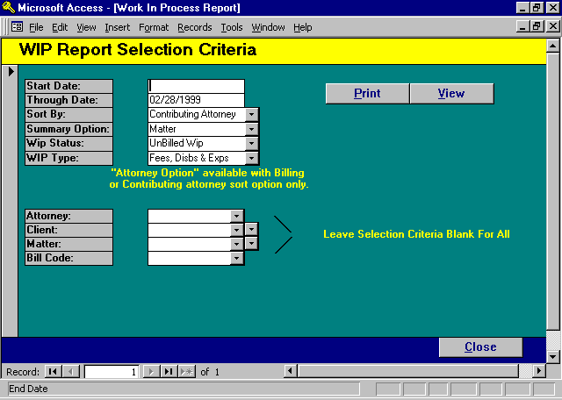

WIP Report Selection

START DATE
THROUGH DATE
All WIP entries dated on or before the “Through Date” will be included on the report. Enter the date utilizing the Standard Date Format. The default “Through Date” is the “WIP Entry Cutoff Date” stored in the Firm File.

SORT BY
Enter the desired grouping selection. The Available options include:
CONTRIBUTING ATTORNEY: WIP will be accumulated and sorted by contributing attorney.
BILLING ATTORNEY: WIP will be accumulated and sorted by billing attorney.
CLIENT: WIP will be accumulated and sorted by client.
SUMMARY OPTION
Enter the desired level of detail to be included on the report. The available options include:
DETAIL
TRANSACTIONS: Each WIP transaction will be included on the report detailing.
MATTER: Detail transactions will be omitted. A summary line will be printed by
matter, client and attorney.
CLIENT: Detail transactions will be omitted. WIP activity is summarized by
Client within Attorney.
ATTORNEY: Detail transactions are omitted. A single summary line prints for each
attorney. This option is not available with the “Client” sort option.

WIP STATUS
Specifies the billing status of WIP entries to be included on the report. The available options include:
UNBILLED WIP: Only unbilled work in progress will be noted on the report.
BILLED WIP: Work in Process entries which have previously been billed will be included on
the report. Unbilled WIP transactions are omitted.
RECOMPUTED: An accurate WIP balance is computed as of the date of the report. All transactions dated after the report date are ignored. The report includes all unbilled transactions dated before the reports cutoff date. The report also includes all billed transactions dated before the cutoff date but billed after the cutoff date.
BILLED/UNBILLED Includes both Billed and Unbilled WIP on the report.

PLEASE NOTE: The work in process reports accumulate the current value of each WIP transaction. It does not consider the timing of adjustments to transactions.

For example: Assume that a time transaction is posted to WIP on 12/31/98 for 2 hours. When a WIP report is run, the value in WIP will be reported as 2 Hours. Assume that this transaction is adjusted, through he WIP Adjustment option, to 1.5 hours on 1/31/99. When WIP reports are generated, regardless of date, the value of this WIP transaction will be 1.5 Hours.

An Unbilled WIP report generated on 12/31/98 will not agree with a recomputed report run on 2/15/99 utilizing a cutoff date of 12/31/98 because of this adjustment.

WIP TYPES
Specifies the type of transaction to be included on the report. The available options include:
FEES, DISBS & EXPS: All transaction types including fees, disbursements and expenses will be
included on the report.
FEES ONLY: Only Fees will be included on the report.
DISBURSEMENTS
ONLY: Only Disbursements will be included on the report.
EXPENSES ONLY: Only Expenses will be included on the report.

SELECTION CRITERIA
All selection criteria options work in conjunction with each other. Leave the criteria blank for all. The available options include:
ATTORNEY: Enter a specific attorney, or leave blank for all. Works in conjunction with the SORT
option. Billing attorney is referenced with the billing attorney SORT option. Otherwise,
contributing attorney is referenced.
CLIENT: Enter a specific client, or leave blank for all.
MATTER: Enter a specific matter, or leave blank for all.
BILL CODE: Enter a specific bill code, or leave blank for all.

Samples of the WIP Reports can be found on the following pages.

Sample: Unbilled WIP, sorted by Billing Attorney, summarized by Attorney

Sample: Recomputed WIP, sorted by Client, Detail Transactions

L.A.W.S. CORPORATION - DEMONSTRATION UnBilled Wip Selection Criteria: Attorneys: * All *
Work In Process Report - Summary by: Billing Attorney Fees, Disbs & Exps Clients: * All *
Matter * All *
From: Through: Mar 31 , 1998 WIP Extended Bill Cd: * All *
Attorney Hours Fees Cost Total
_________________________________________________________________________________________________________________________________________________________________________
BBB Barker B Bob 29.70 3370.00 110.00 3480.00
CCC Carol C Cliffton 16.55 1362.50 186.35 1548.85
FKG Fred K Geissler 15.20 1520.00 39.00 1559.00
PDK Paul D Karlsberg 382.60 38555.00 -1068.50 37486.50
Firm Total: 444.05 44807.50 -733.15 44074.35

_______________________________________________________________________________________________________________________________________________________________________
Copyright 1998 L.A.W.S. Corporation 3/12/98 7:55:48 AM
Sorted Alphabetically by Billing Attorney Name
WIP-6 Summary by Attorney
CORPORATION - DEMONSTRATION ReComputed Attorneys: * All *
Work In Process by Report - Detail Transactions within Client Fees, Disbs & Exps Clients: BAILEY
Matter: * All *
From: Through: Dec 31 , 1997 Bill Cd: * All *
Client/ Service Bill Cont Per WIP Extended
Matter Date Description of Service Invoice# Diem Rate Hours Fees Cost Total
_________________________________________________________________________________________________________________________________________________________________________
Bailey Construction (BAILEY)
ABC Corporation Vs James Smith & Geroge Wilson (132)
02/01/1997 test D CCC 407 3/98 0.00 0.00 0.00 100.00 BAILEY 132
02/27/1997 D BBB 407 3/98 0.00 0.00 0.00 61.35 BAILEY 132
03/11/1997 Filing fee D CCC 407 3/98 0.00 0.00 0.00 15.00 BAILEY 132
03/11/1997 Filing fee D PDK 407 3/98 0.00 0.00 0.00 -15.00 BAILEY 132
03/14/1997 Conference with Smith CW PDK 407 3/98 150.00 2.00 300.00 0.00 BAILEY 132
03/25/1997 Conference with jiffy man. CW FIRM 407 3/98 0.00 0.90 0.00 0.00 BAILEY 132
03/25/1997 PhotoCopy Charges 106 PDK 407 3/98 0.00 0.00 0.00 25.00 BAILEY 132
03/28/1997 Conference with Smith PDK 407 3/98 150.00 0.75 112.50 0.00 BAILEY 132
Matter Total- 132 : 3.65 412.50 186.35 598.85
Construction Loan (LOAN)
12/18/1997 Meeting with client Conference with 111 PDK 100.00 0.50 50.00 0.00 BAILEY LOAN
Matter Total- LOAN : 0.50 50.00 0.00 50.00
General File - ABC (GEN)
03/10/1997 Conference with Smith CW PDK 0.00 1.00 0.00 0.00 BAILEY GEN
03/10/1997 Meeting with client 111 PDK 150.00 0.20 30.00 0.00 BAILEY GEN
03/10/1997 Meeting with client 111 PDK 150.00 1.00 150.00 0.00 BAILEY GEN
03/19/1997 D BBB 0.00 0.00 0.00 30.00 BAILEY GEN
04/09/1997 Conference with CW PDK 150.00 0.80 120.00 0.00 BAILEY GEN
04/09/1997 Prepare letter PL PDK 150.00 0.50 75.00 0.00 BAILEY GEN
04/09/1997 Meeting with client 111 PDK 150.00 1.00 150.00 0.00 BAILEY GEN
Matter Total- GEN : 4.50 525.00 30.00 555.00
Tax Matters (TAX)
03/05/1997 Deed Prep DP PDK 100.00 3.00 300.00 0.00 BAILEY TAX
03/07/1997 Conference with Smith conference with regarding sale CW PDK 100.00 2.00 200.00 0.00 BAILEY TAX
03/11/1997 Conference with Jones CW PDK 100.00 3.00 300.00 0.00 BAILEY TAX
03/19/1997 meeting with Mr. Bailey without Bill code PDK 100.00 5.00 500.00 0.00 BAILEY TAX
03/19/1997 Fax Charge Expense Code (50) 105 PDK 0.00 0.00 0.00 25.00 BAILEY TAX
03/25/1997 Conference with Mr. Bailey CW PDK 100.00 2.50 250.00 0.00 BAILEY TAX
03/25/1997 filing fee D PDK 0.00 0.00 0.00 40.00 BAILEY TAX
Matter Total- TAX : 15.50 1550.00 65.00 1615.00
Client Total- BAILEY : 24.15 2537.50 281.35 2818.85

_________________________________________________________________________________________________________________________________________________________________________
Copyright 1998 L.A.W.S. Corporation 3/12/98 9:26:09 AM 1
Sorted alphabetically by client name within Attorney - PER Diem Entries: Days entered are converted to hours
WIP-6 Detail byAttorney

YEAR TO DATE ACTIVITY REPORT

The Year to Date Activity Reports are concise reports which summarize year to date performance. The report may be generated in a wide variety of formats summarizing current year activity only, comparing the current year activity to prior years values or comparing the current years performance to standards set by the firm.

After selecting the “ Y-T-D Performance” option, the following form appears:

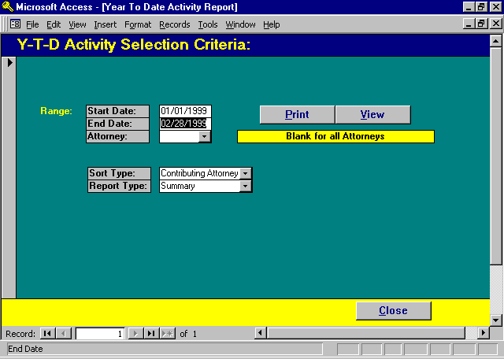

YTD Activity Report Selection

START DATE
The Starting Date for inclusion of data on the report. The start date automatically defaults to the firm’s fiscal start date stored in the Firm File.

END DATE
The Ending Date for inclusion of data on the report. The End Date automatically defaults to the WIP Entry Cutoff Date stored in the Firm File.

Please Note: The start and end date range cannot be greater than one year.
ATTORNEY
Select a specific attorney for reporting, or leave blank for all attorneys.

SORT TYPE
Specify the method in which the report should be generated. The available options include:

CONTRIBUTING
ATTORNEY: Data will be accumulated and sorted by contributing attorney.
BILLING
ATTORNEY: Data will be accumulated and sorted by billing attorney.
MATTER
TYPE: Data will be accumulated and sorted by matter type.
CLIENT: Data will be accumulated and sorted by client.

REPORT TYPE
Specifies the manner in which the report will be generated. The available options are identified below:
Detail - Activity reports will include one line for each line of performance criteria analyzed. Each line contains a year to date total along with a breakdown of performance by month. The matter type option will list month to date and year to date performance by matter within matter type.
Summary - Will summarize within a single line the month to date and year to date performance of
the attorney or matter type.
Comparative- Compares current year's activity against the prior years activity. Variances are
computed for each category reported. A single page report is printed for each attorney
with the firm total's reported last.
Comp -
Total Only - Prints the single page firm total of the Comparative YTD report.
Budget -
Budget - Compares current year's activity against the budgeted performance standards set by the
firm. Variances are computed for each category reported. A single page report is
printed for each attorney with the firm total's reported last.
Budget
Total Only - Prints the single page firm total of the Budget YTD report.

Budget-
Summary Prints a summary report, one line per attorney, comparing actual hours worked, fees
worked, fees billed and fees received to budget performance.

Note: To utilize budget processing, monthly budget hours must be entered in the Attorney Class file or the Attorney file through Data File Maintenance. Budgeted fees billed and budgeted fees received are computed by multiplying the attorneys budget hours by the attorneys current Hourly Rate within the "BUDGET" rate structure.

A sample of the Attorney Year to Date Activity Report are found on the following pages.

Sample: YTD Activity - Summary Report

Sample: YTD Activity - Detail Report

Sample: YTD Activity - Comparative

L.A.W.S. CORPORATION - DEMONSTRATION Attorney: * All * From: January 01 1998
Attorney Year to Date Activity Summary Report Contributing Attorney Through: March 31 1998
Month To Date - 3/1/98 thru 3/31/98 Year To Date - 1/1/98 thru 3/31/98
Matters A/R WIP Productive Productive
Attorney Balance Balance Fees Billed Hours Wrkd Fees Recvd Fees Billed Hours Wrkd Fees Recvd
_________________________________________________________________________________________________________________________________________________________________________
Alan A Apple Berry (AAA) 6 $1,266.77 $0.00 $0.00 0.00 $0.00 $0.00 0.00 $264.38
Barker B Bob (BBB) 2 $1,296.61 $1,440.00 $0.00 0.00 $0.00 $0.00 0.00 $425.62
Carol C Cliffton (CCC) 0 $290.00 $380.00 $0.00 0.00 $0.00 $0.00 0.00 $0.00
Alice B Cotton (ABC) 1 $123.78 $0.00 $0.00 0.00 $0.00 $0.00 0.00 $0.00
Firm Firm (FIRM) 2 $0.00 $0.00 $0.00 0.00 $0.00 $0.00 0.00 $0.00
Fred K Geissler (FKG) 4 ($100.00) $0.00 $0.00 0.00 $0.00 $0.00 0.00 $0.00
Susan S Jones (SSJ) 3 ($22.06) $1,190.50 $0.00 9.50 $0.00 $0.00 9.50 $0.00
Paul D Karlsberg (PDK) 9 $42,294.09 $39,341.00 $412.50 52.60 $0.00 $412.50 57.60 $0.00
John J Kingston (JJK) 2 $1,713.29 $1,094.00 $0.00 14.00 $0.00 $0.00 14.00 $0.00
Mary P LARSON (MPL) 0 ($29.39) $0.00 $0.00 0.00 $0.00 $0.00 0.00 $150.00
MARY M MORGAN (MMM) 0 $136.64 $30.00 $0.00 0.00 $0.00 $0.00 0.00 $200.00
Report Totals: 29 $46,969.73 $43,475.50 $412.50 76.10 $0.00 $412.50 81.10 $1,040.00

_________________________________________________________________________________________________________________________________________________________________________
Copyright 1998 L.A.W.S. Corporation * Productive Hours Worked includes Billable and Contingent 3/12/98 10:23:45 AM 1
hours only (Not NonBillable Hours) Net of Adjustments
Matters Open represents the number of open matters per attorney regardless of activity during the reporting period.
Wip_2_Sum - Menu Tim - Atty YTD Activity
L.A.W.S. CORPORATION - DEMONSTRATION From: January 01 1998 Attorney: * All *
Attorney Year to Date Activity Report Contributing Attorney Through: March 31 1998
Y-T-D
Attorney Totsl Jan Feb Mar Apr May Jun Jul Aug Sep Oct Nov Dec
_________________________________________________________________________________________________________________________________________________________________________
Alan A Apple Berry
Fees Rcvd: 264.38 264.38
_________________________________________________________________________________________________________________________________________________________________________
Barker B Bob
Fees Rcvd: 425.62 425.62
_________________________________________________________________________________________________________________________________________________________________________
Firm Firm
Hrs Billed 0.90 0.90
_________________________________________________________________________________________________________________________________________________________________________
Susan S Jones
Fees Worked 1187.50 1187.50
Hrs Wrkd-Billable 9.50 9.50
_________________________________________________________________________________________________________________________________________________________________________
Paul D Karlsberg
Fees Billed: 412.50 412.50
Fees Worked 7550.00 1500.00 6050.00
Hrs Adjusted -7.00 -5.00 -2.00
Hrs Billed 2.75 2.75
Hrs Wrkd-Billable 66.50 15.00 51.50
Hrs Wrkd-Cont 1.10 1.10
_________________________________________________________________________________________________________________________________________________________________________
John J Kingston
Fees Worked 910.00 910.00
Hrs Wrkd-Billable 14.00 14.00
_________________________________________________________________________________________________________________________________________________________________________
Mary P LARSON
Fees Rcvd: 150.00 150.00
_________________________________________________________________________________________________________________________________________________________________________
MARY M MORGAN
Fees Rcvd: 200.00 200.00
_________________________________________________________________________________________________________________________________________________________________________
Report Totals:
Fees Billed: 412.50 412.50
Fees Rcvd: 1040.00 1040.00
Fees Worked 9647.50 1500.00 8147.50
Hrs Adjusted -7.00 -5.00 -2.00
Hrs Billed 3.65 3.65
Hrs Wrkd-Billable 90.00 15.00 75.00
Hrs Wrkd-Cont 1.10 1.10
_________________________________________________________________________________________________________________________________________________________________________

Copyright 1998 L.A.W.S. Corporation
Wip_2 Fees Worked are computed using the total hours worked during the period * the assigned Hourly Rate 3/12/98 10:33:30 AM 1

L.A.W.S. CORPORATION - DEMONSTRATION Current Year:01/01/1998- 03/31/1998
Prior Year: 01/01/1997 - 03/31/1997
Attorney Year to Date Comparative Report Contributing Attorney
Attorney Y-T-D Jan Feb Mar Apr May Jun Jul Aug Sep Oct Nov Dec
Paul D Karlsberg
A/R Adj:
Current Year: 0 0 0 0 0 0 0 0 0 0 0 0 0
Prior Year: 4599 1358 0 3240 0 0 0 0 0 0 0 0 0
Variance -4599 -1358 0 -3240 0 0 0 0 0 0 0 0 0
A/R Adj:Cont
Current Year: 0 0 0 0 0 0 0 0 0 0 0 0 0
Prior Year: 329 0 0 329 0 0 0 0 0 0 0 0 0
Variance -329 0 0 -329 0 0 0 0 0 0 0 0 0
Fees Billed:
Current Year: 413 0 0 413 0 0 0 0 0 0 0 0 0
Prior Year: 5989 1489 2800 1700 0 0 0 0 0 0 0 0 0
Variance -5576 -1489 -2800 -1288 0 0 0 0 0 0 0 0 0
Fees Billed:Cont
Current Year: 0 0 0 0 0 0 0 0 0 0 0 0 0
Prior Year: 393 393 0 0 0 0 0 0 0 0 0 0 0
Variance -393 -393 0 0 0 0 0 0 0 0 0 0 0
Fees Received:
Current Year: 0 0 0 0 0 0 0 0 0 0 0 0 0
Prior Year: 8904 4929 -451 4426 0 0 0 0 0 0 0 0 0
Variance -8904 -4929 451 -4426 0 0 0 0 0 0 0 0 0
Fees Received:Cont
Current Year: 0 0 0 0 0 0 0 0 0 0 0 0 0
Prior Year: 500 0 500 0 0 0 0 0 0 0 0 0 0
Variance -500 0 -500 0 0 0 0 0 0 0 0 0 0
Fees Worked:
Current Year: 7550 0 1500 6050 0 0 0 0 0 0 0 0 0
Prior Year: 12388 5610 1000 5778 0 0 0 0 0 0 0 0 0
Variance -4838 -5610 500 273 0 0 0 0 0 0 0 0 0
Hrs Adjusted:
Current Year: -7 0 -5 -2 0 0 0 0 0 0 0 0 0
Prior Year: 24 0 2 22 0 0 0 0 0 0 0 0 0
Variance -31 0 -7 -24 0 0 0 0 0 0 0 0 0
Hrs Billed:
Current Year: 3 0 0 3 0 0 0 0 0 0 0 0 0
Prior Year: 79 23 45 11 0 0 0 0 0 0 0 0 0
Variance -76 -23 -45 -8 0 0 0 0 0 0 0 0 0
Hrs Wrkd-Billable
Current Year: 67 0 15 52 0 0 0 0 0 0 0 0 0
Prior Year: 91 28 9 54 0 0 0 0 0 0 0 0 0
Variance -24 -28 6 -3 0 0 0 0 0 0 0 0 0
Hrs Wrkd-Cont
Current Year: 1 0 0 1 0 0 0 0 0 0 0 0 0
Prior Year: 1 0 0 1 0 0 0 0 0 0 0 0 0
Variance 0 0 0 0 0 0 0 0 0 0 0 0 0
Hrs Wrkd-NonBil
Current Year: 0 0 0 0 0 0 0 0 0 0 0 0 0
Prior Year: 3 0 0 3 0 0 0 0 0 0 0 0 0
Variance -3 0 0 -3 0 0 0 0 0 0 0 0 0
RATE (Average Billing):
Current Year: 150 0 0 150 0 0 0 0 0 0 0 0 0
Prior Year: 81 81 63 162 0 0 0 0 0 0 0 0 0
Variance 69 -81 -63 -12 0 0 0 0 0 0 0 0 0
RATE (Average WIP):
Current Year: 112 0 100 115 0 0 0 0 0 0 0 0 0
Prior Year: 135 204 111 104 0 0 0 0 0 0 0 0 0
Variance -23 -204 -11 11 0 0 0 0 0 0 0 0 0

___________________________________________________________________________________________________________________________________________
Copyright 1998 L.A.W.S. Corporation 3/12/98 10:53:37 AM 1
Wip2_Comparative Fees Worked are computed using the total hours worked during the period * the assigned Hourly Rate

WIP ADJUSTMENT REPORT

The WIP Adjustment Report displays adjustments made to Work in Process through the WIP Adjustment option. Entry or modification of WIP through the Time Entry option is not reflected on this report.

After selecting the WIP Adj Report option, the following form is displayed:

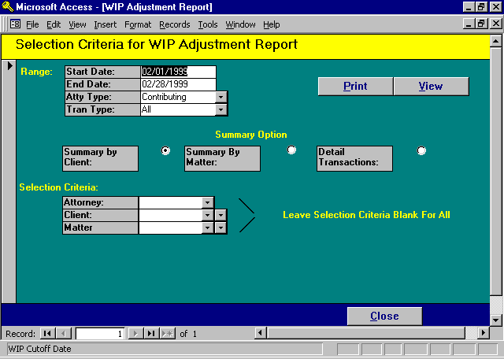

WIP Adjustment Report - Selection

START/END DATE
Enter the date range for inclusion of data on the report. The Start Date defaults to the first day of the WIP Entry Cutoff Date month, while the End Date is the WIP Entry Cutoff Date. Data for the report is always selected based on the date of the adjustment rather than the date of service.

ATTORNEY TYPE
Enter the type of attorney, billing or contributing, for which the report should be produced.

TRAN TYPE
ALL The report includes all adjustments including fees, disbursements and expenses.
FEES The report includes fee adjustment only.
DISB The report includes disbursement adjustments only.
EXP The report includes expense adjustments only.
SUMMARY OPTIONS
Enter the desired Report Summary Option. The available options include:
CLIENT: One summary line per client within each attorney along with attorney totals.
MATTER: One summary line per matter with client and attorney totals.
DETAIL
TRANSACTIONS: The actual detail associated with each entry.

SELECTION CRITERIA

All selection criteria options work in conjunction with each other. Leave the entry blank to include all, or enter a specific value to include that value only. The available inclusion options are:

ATTORNEY: Enter a specific attorney, or leave blank for all.
CLIENT: Enter a specific client, or leave blank for all.
MATTER: Enter a specific matter, or leave blank for all.

If the Time Modification involves changing the client, matter, attorney, or date, then two entries are produced. The first reverses the original entry in full, while the second reinstates the entry with the new value. A description line is created identifying the nature of the transaction.

Sample Work In Process Adjustment Reports are displayed on the following pages.

Sample: WIP Adjustment Report - Detail Transactions

Sample: WIP Adjustment Report - Summary by Client

CORPORATION - DEMONSTRATION Start: Jan 01/1998
Through: Mar 31/1998
Work In Process Adjustments - Detail Transactions Contributing Attorney
Selection Criteria: Attorneys: PDK Clients: * All * Matter: * All *
Date of Date Of Bill Per Hours Cost Original
Atty Change Service Code Diem Rate Change Change Description Seq #
_________________________________________________________________________________________________________________________________________________________________________
Paul D Karlsberg
Bailey Construction (BAILEY)
Construction Loan (LOAN)
PDK 02/10/1998 08/15/1998 $0.00 5.00 0.00 New Entry 1048
PDK 03/11/1998 12/18/1997 CW $100.00 -2.00 0.00 Write Off: Conference with Smith 1038
Matter Total: 3.00 0.00
Client Total: 3.00 0.00

Carson Manufacturing (CARSON)
Cccc (LAWS)
PDK 02/17/1998 02/06/1998 $100.00 -10.00 0.00 Write Off 1049
Matter Total: -10.00 0.00
Client Total: -10.00 0.00
Attorney Total: -7.00 0.00

_________________________________________________________________________________________________________________________________________________________________________
Copyright 1998 L.A.W.S. Corporation 3/12/98 11:23:10 AM 1
WIP_4 Adjustment Entries are selected based on the Date of Change rather than the Date of Service
L.A.W.S. CORPORATION - DEMONSTRATION Start: Jan 01/1998
WIP Adjustments - Summary By Client Contributing Attorney Through: Mar 31/1998
Matter: * All *
Selection Criteria: Attorneys: PDK Clients: * All *
Hours Cost
Attorney Client Change Change
_________________________________________________________________________________________________________________________________
Paul D Karlsberg
Bailey Construction (BAILEY) PDK 3.00 $0.00
Carson Manufacturing (CARSON) PDK -10.00 $0.00
Attorney Total: -7.00 $0.00

_________________________________________________________________________________________________________________________________
Copyright 1998 L.A.W.S. Corporation 3/12/98 11:37:59 AM
Adjustment Entries are selected based on the Date of Change rather than the Date of Service 1
WIP_4 - Client

REMOTE TIME

Remote Time Processing provides a method whereby non-verified WIP, entered from a remote PC, may be integrated into L.A.W.S. (Please review the TIME ENTRY section of this chapter for a complete review of time entry.)

Once time is remotely entered, a transfer file must be created. The transfer is simply an ASCII file, created at the remote source, containing the remotely entered WIP. This file must be transferred from the remote PC to a full access L.A.W.S. system. The method of transfer does not matter and may be done by using diskettes or by electronic file transfer.

If an existing transfer file exists on the system it will be overwritten. Make sure that the prior remote time has been imported into the L.A.W.S. system prior to replacing this file with the new file.

Once the remote time has successfully been transferred into work in process on the main system, backup then purge existing remote WIP at the remote site before entering new information into the remote file. This will help ensure that the remote WIP is not duplicated..

After selecting the REMOTE TIME option from the Time Menu, the following form is displayed.

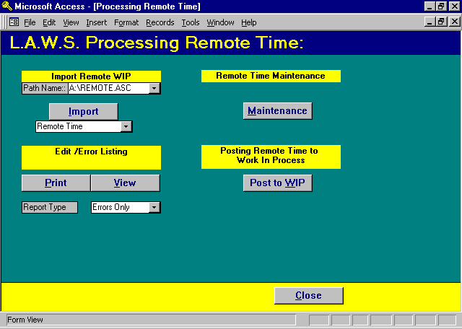

Remote Time Processing

Remote Time Processing consists of importing data, verifying the accuracy of the imported data, correcting errors contained in the imported data, then posting the valid data to the firms Work in Process.

Importing Remote Time
Importing Remote Time physically copies time transactions from an ASCII file into the current database. The Remote Time must be imported before it can be further processed.

PATH NAME
Enter the complete path name identifying the ASCII file to be importing. The displayed paths, displayed via the drop down box, are suggestions only which have been used at current user sites.

Remote time may be created from either the L.A.W.S. Remote Time Program loaded on non-networked computers, or it can be imported from cost recovery programs. The available options for importing time are:

REMOTE TIME
ASCII file created from the L.A.W.S. Remote Time Entry Program. The time is stored in a file called "\REMOTE.ASC". Listed below is the Remote Time ASCII file layout and a sample ASCII File.

File Format: Delimitated
Field Delimiter: , (comma)
Text Qualifier: " (quotes)
Headings : Required

Field Name | Data Type | Indexed | Skip
WipSeq | Long Integer | No | skip
Client | Text | No | 0
Matter | Text | No | 0
WipDate | Date/Time | No | 0
WipContAtty | Text | No | 0
WipHoursWorked | Double | No | 0
WipBilCd | Text | No | 0
WipDesc | Memo | No | 0
WipCostAmt | Currency | No | 0
WipDateEntered | Date/Time | No | 0
WipCostQty | Double | No | 0
WipACode | Text | No | 0

Sample File:

"WipSeq","Client","Matter","WipDate","WipContAtty","WipHoursWorked","WipBilCd","WipDesc","WipCostAmt","WipDateEntered","WipCostQty","WipAcode"
16,"103","108",2/17/99,"PDK",0.00,"PC","10 @ .25",$2.50,2/17/99,10,
17,"108","117",2/17/99,"PDK",0.00,"PC","117 @ .10",$11.70,2/17/99,117,
18,"109","120",2/20/99,"PDK",0.00,"TC","(508) 555 1212",$7.80,2/17/99,0,

Notes:
1) The first line of the table should contain field names.
2) Commas should separate Fields.
3) The text fields should be surrounded by quotes.
4) The WIP hours should be zero.
5) I used bill codes of "PC" and "TC" which could stand for "Photocopy charges" or
"Telephone charges". The bill code(s) actually inserted into the file should be the firms
actual bill codes relating to the relevant charges.
6) The description field should contain information which will be appended to the normal bill
code description. For example. The first line contains the bill code "PC" and the description
"10 @ .25". Assumming the bill code description for the code PC is "Photocopy charges", the WIP transaction would read "Photocopy charges 10 @ .25" when posted to L.A.W.S. Do not duplicate the bill code description.
7) The extended charge should be posted in the WIPCostAmt field.
- The WIPDateEntered field corresponds to the date the transaction is imported into L.A.W.S.
9) The WIPCostQty field represents the amount of copies.

ERS PHOTOCOPIES
L.A.W.S. is capable of importing time from the VERITRAK photocopy and FAX
cost control program. The VERITRAK program must create an ASCII containing the transactions to be imported into a file often called "ERSCUST.DAT". Listed below is the ERS Photocopies ASCII file layout and a sample ASCII File.

File Format: Fixed
Field Delimiter: None
Text Qualifier: None
Headings : No Headings

Photo copy import specifications

Field Name | Data Type | Start | Width | Indexed | Skip
code | Text | 1 | 1 | No | 0
matter | Text | 2 | 16 | No | 0
year | Text | 18 | 4 | No | 0
mo | Text | 22 | 2 | No | 0
day | Text | 24 | 2 | No | 0
space1 | Text | 26 | 124 | No | skip
sapce2 | Text | 150 | 9 | No | skip
copies | Text | 159 | 8 | No | 0
space3 | Text | 167 | 8 | No | skip
cost | Text | 175 | 8 | No | 0

Fax import specifications

Field Name | Data Type | Start | Width | Indexed | Skip
code | Text | 1 | 3 | No | 0
matter | Text | 4 | 14 | No | 0
year | Text | 18 | 4 | No | 0
mo | Text | 22 | 2 | No | 0
day | Text | 24 | 2 | No | 0
space1 | Text | 26 | 124 | No | skip
phone | Text | 150 | 16 | No | 0
space3 | Text | 166 | 18 | No | skip
qty | Text | 184 | 8 | No | 0
space2 | Text | 192 | 16 | No | skip
cost | Text | 208 | 8 | No | 0

Sample File
C11198 19990228 00000007 00000070
C11199 19990215 00000015 00000150
C98770 19990213 00000400 00004000
F 98771 19990215 517 275 4843 00000005 00000750
F 11200 19990213 248 555 1212 00000022 00002200
Notes:
- The code field represents the type of transaction. Options include ‘C’ for photocopies or ‘F’ for fax. Transactions can be intermingled in a single file.
- The matter number must be unique. The client code is not stored in this file and is assigned during the importation process. If the matter numbers are not unique, all cost transactions will be assigned to the lowest client code.
- If the unit cost is not entered, It will be computed when imported based on unit cost figures within the bill code file and/or the client unit cost values.
- The bill codes assigned to the WIP are stored within the Firm File.
- The attorney assigned to the transaction is the attorney associated with the logged in user.
- Only VALID Matters are imported into remote WIP

ADD2PC (Delimitated)
L.A.W.S. is capable of importing time from the ADD2PC photocopy cost control program. The Add2PC program must create an ASCII containing the transactions to be imported into a file often called "ADD2PC.ASC". Listed below is the ADD2PC delimited ASCII file layout and a sample ASCII File.

File Format: Delimited
Field Delimiter: , (comma)
Text Qualifier: “ (quote)
Headings : No Headings

ADD2PD Delimited import specifications

Field Name | Data Type | Indexed | Skip
client | Text | No | 0
matter | Text | No | 0
atty | Text | No | 0
qty | Long Integer | No | 0
value | Long Integer | No | 0
date | Date/Time | No | 0
space1 | Text | No | skip
space2 | Text | No | skip
space3 | Long Integer | No | skip

Sample File

"","11199","BBB",185,0,"09-25-1998","14:34:40","00166E",0
"WARD","ONE","AAA",185,0,"09-25-1998","14:34:40","00166E",0
"","11198","PDK",200,0,"09-25-1998","14:34:40","00166E",0
"","11200","JJK",57,0,"09-25-1998","14:34:40","00166E",0

Notes:
- If the client code is blank, the first client code matching the matter will be assigned.
- The charge amounts are computed by utilizing the unit cost assigned to the bill code or Client/Bill code multiplied by the quantity.
- The Photocopy Bill Code stored in the firm file is assigned as the bill code.

ADD2PC (DOS)
L.A.W.S. is capable of importing time from the ADD2PC photocopy cost control program. The Add2PC program must create an ASCII containing the transactions to be imported into a file often called "ADD2PC.ASC". Listed below is the ADD2PC (DOS fixed record length) ASCII file layout and a sample ASCII File.

File Format: Fixed
Field Delimiter: None
Text Qualifier: None
Headings : No Headings

ADD2PD (DOS fixed) import specifications

Field Name | Data Type | Start | Width | Indexed | Skip
mo | Text | 1 | 2 | No | 0
day | Text | 3 | 2 | No | 0
yr | Text | 5 | 2 | No | 0
client | Text | 7 | 6 | No | 0
matter | Text | 13 | 6 | No | 0
amt | Currency | 19 | 9 | No | 0
copies | Long Integer | 28 | 7 | No | 0
source | Text | 35 | 2 | No | 0

Sample File

092599WARD ONE 0000000000000010
092599 11199 0000018500000185
092599 11198 0000000000000020
092599 11200 0000000000000185

Notes:
1) If the client code is blank, the first client code matching the matter will be assigned.
2) The charge amounts are computed by utilizing the unit cost assigned to the bill code or Client/Bill code multiplied by the quantity.
3) The Photocopy Bill Code stored in the firm file is assigned as the bill code.

COPYGUARD
L.A.W.S. is capable of importing time from the COPYGUARD photocopy cost control program. The COPYGUARD program must create an ASCII containing the transactions to be imported into a file often called "COPYGUARD.ASC". This file is created by printing the Account Summary report to disk. Listed below is the COPYGUARD Photocopies ASCII file layout and a sample ASCII File.

File Format: Fixed
Field Delimiter: None
Text Qualifier: None
Headings : No Headings

Field Name | Data Type | Start | Width | Indexed | Skip
Field1 | Text | 1 | 6 | No | -1
matter | Text | 7 | 6 | No | 0
Field3 | Text | 13 | 27 | No | -1
qty | Text | 40 | 5 | No | 0
Field5 | Text | 45 | 36 | No | -1

COPYGUARD import specifications

_ACCOUNT SUMMARY REPORT 02-15-1999
Page 1

Account Number Group Limit Total Units Total Cost Cumulative Total
-------------------------------------------------------------------------------

0000011198 1 65520 6 1.20 1.20
0000011198 1 65520 151 30.20 31.40
0000011199 1 65520 1233 246.60 278.00
0000011199 1 65520 5202 1040.40 1318.40
0000011200 1 65520 132 26.40 1344.80
0000011200 1 65520 130 26.00 1370.80
0000098767 1 65520 442 88.40 1459.20
0000098767 1 65520 86 17.20 1476.40
0000098768 1 65520 3 0.60 1477.00
0000098768 1 65520 31 6.20 1483.20
0000098768 1 65520 46 9.20 1492.40
0000098769 1 65520 300 60.00 1552.40
0000098769 7 65520 654 130.80 1683.20
0000098770 1 65520 66 13.20 1696.40
0000098770 1 65520 169 33.80 1730.20

Notes:
1) If the client code is blank, the first client code matching the matter will be assigned.
2) The assigned Attorney is the billing attorney in the matter file.
3) The Photocopy Bill Code stored in the firm file is assigned as the bill code.
- The date of the transaction is the date the file is processed.
- Only transactions containing valid matters are imported.

To import remote time, click the IMPORT button. After clicking import, a continue verification message is displayed. Select Yes to continue, otherwise, click No to cancel. Time is not removed from the \LAWS97\ERSCUST.DAT file.

Edit/Error Listing
Remote time is not verified for accuracy on the remote PC's at the time of entry, and may contain errors. L.A.W.S. allows Remote Transactions to be summarized and totaled in report form.

The Report Type parameter specifies the method in which the report should be printed. The available options include:
COMPLETE EDIT: The report will list all imported remote transactions including valid and invalid
transactions.
ERRORS ONLY: Only transactions containing errors will be noted on the report.

Please review the Remote Time sample reports on the following pages.

Sample: Remote Time Error Listing

Sample: Complete Remote Time Edit Listing

L.A.W.S. CORPORATION - DEMONSTRATION
Remote Hours Worked Error List by Contributing Attorney :
Client/ Service Bill/Act Hours Entry
Matter Date Description Code(s) Worked Cost Qty Date Error Description
_________________________________________________________________________________________________________________________________________________________________________
Paul D Karlsberg
06/08/1998
BAILEY TAX PDK PhotoCopy Charges 106 QQQ 0.00 6.25 25 06/08/1998 Invalid Act Code
Time Sheet Total: 06/08/1998 : 0.00 6.25
Attorney Total PDK : 0.00 6.25

_________________________________________________________________________________________________________________________________________________________________________
Copyright 1998 L.A.W.S. Corporation 6/9/98 10:19:03 AM 1
WIP-1Rmt Error List
Remote Time Menu-Edit List -Error List
L.A.W.S. CORPORATION - DEMONSTRATION
Remote Hours Worked by Contributing Attorney :
Client/ Service Bill / Act Hours Entry
Matter Date Description Code(s) Worked Cost Qty Date Error's
_________________________________________________________________________________________________________________________________________________________________________
Paul D Karlsberg
06/08/1998
BAILEY LOAN PDK Telephone conference with client Smith regarding sale of TC 2.00 $0.00 0 06/08/1998
properties.
BAILEY TAX PDK PhotoCopy Charges Fax Charge 106 105 0.00 $6.25 25 06/08/1998
_________________________________________________________________________________________________________________________________________________________________________
Time Sheet Total: 06/08/1998 : 2.00 $6.25
Attorney Total PDK : 2.00 $6.25

_________________________________________________________________________________________________________________________________________________________________________
Copyright 1998 L.A.W.S. Corporation 6/9/98 10:11:38 AM 1
WIP-1Rmt
Remote Time Menu-Edit List - Complete

Remote Time Maintenance
The Remote Time Maintenance feature allows errors contained within the remote time to be corrected. After Clicking the Maintenance button, the following form is displayed:

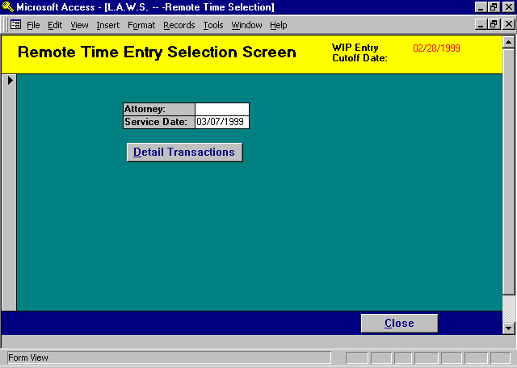
Information to Enter

The Remote Time Maintenance screen is very similar to the standard time entry screen. The parameters to be entered are described in detail below.

ATTORNEY
Enter the attorney code as it was originally entered from the remote PC. If the attorney code was originally entered incorrectly, the incorrect code must be entered at this prompt.

SERVICE DATE
Enter the date of service as it was entered on the remote PC.

Both the Attorney and Service Date are noted on the Remote Time Edit List.

After entering the service date, the detail transactions associated with the entered criteria is displayed.

After entering the desired selection criteria, the standard L.A.W.S. Time Entry Screen is displayed. Any or all errors may be corrected through this time entry screen. If the attorney code must be modified, move the screen right to display and/or modify the attorney code.

Displayed below is a example of the Detail Time Entry screen.

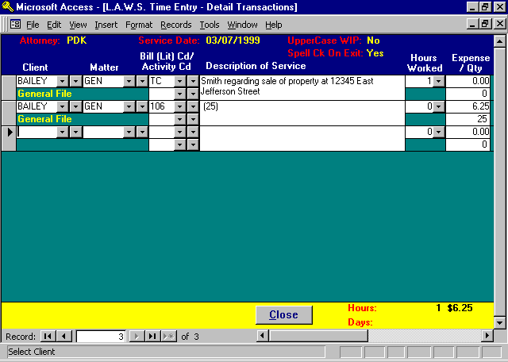

Please refer to the Time Entry portion of this manual for a detailed explanation of time entry.

PLEASE NOTE: The extended bill code description is not automatically inserted, and SHOULD NOT BE INSERTED, into the Description of Service column of remote time transactions. Only the additional description, which is appended to the standard bill code description, should be entered as the description of service. L.A.W.S. will automatically insert the bill code descriptions to the remote time when it is posted to WIP.

After making all the required corrections, it may be useful to re-run the Error Only Listing to ensure that all the corrections have been made.

Post To Wip

After the remote time has been imported, edited, and, if necessary, corrected, it must be posted to WIP.

Only valid entries will be posted to WIP. Entries containing errors will not be posted but will remain in the remote time system until corrected.

To complete the processing of remote time, click the Post to WIP button that displays the following message:

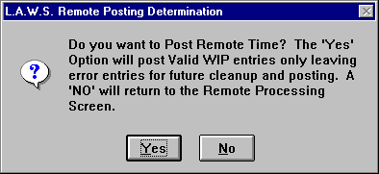

To continue with the posting of Remote Time, click Yes, otherwise click NO to cancel the posting and return to the Remote Time Process menu.

After selecting Yes, L.A.W.S. verifies the accuracy of all entries. If the entry is valid, L.A.W.S. inserts the appropriate bill code description, assigns the proper billing rate then adds the remote time to WIP. After processing, posted entries are removed from the remote time table leaving only entries containing errors.

Upon completion of the Posting to WIP, the Remote Time Processing menu is closed and the Time Menu is displayed.

