CLIENT BILLING
TABLE OF CONTENTS

CLIENT BILLING 138
PRINT BILLING DRAFTS 139
Wip Draft Selection Screen 139
Sample: WIP Billing Draft - Order by Date 141
Sample: WIP Billing Draft - Summary Report 141
PRINT CLIENT BILLS 144
Generation of Client Invoices Screen 144
Print Bills Button 151
Sample: Client Invoice -Cover Letter 151
Sample: Client Invoice - Detail Text 151
Sample: Client Invoice - Task Code Summary 151
Sample: Client Invoice - Accounts Receivable Summary 151
ASCII File: 156
YES option - Generic ASCII File 157
ELF option - ELF ASCII File 157
EXAMEN option - EXAMEN ASCII File 158
LAS option - Law Audit Services ASCII File 158
LG option - LegalGuard ASCII File 159
MLM option - Michigan Lawyers Mutual ASCII File 160
SMMJ option- Stuart, Maue, Mitchell & James ASCII File 161
TRAVELERS option- Travelers Insurance ASCII File 162
Finalization 163
PRINT SPLIT BILLS 164
Generation of Split Bills Screen 164
Change Options 165
Split Bill Maintenance 165
Custom Bill 167
ASCII File 168
ASCII File = Yes 168
ASCII File = ELF 168
View Option 169
Remove 0% Records 169
Finalize Button 169
Global Percentages 170
Conventions pertaining to split billings 171
Sample: Split Bill - Cover Sheet 171
Sample: Split Bill - Detail Support 171
Sample: Split Bill – Recomputed Option (rptBill_Split1) 171
BILLING JOURNAL 175
Billing Journal Selection Screen 175
Sample: Billing Journal - Summary by Attorney within Contributing Attorney 176
Sample: Billing Journal - Summary by Invoice 176
Sample Billing Journal – Split Bill Worksheet 176
REVERSE BILLS 180
Reverse Finalized Bills Selection Screen 180
PRINT DUPLICATE BILL 182
Print Duplicate Bill Screen 182
Sample: Duplicate Bill 183

CLIENT BILLING

The L.A.W.S. Billing program is designed to process client billings as efficiently as possible. The Client Bill menu processes common billing functions in sequential order, which makes your job easier. Work In Process billing drafts may be generated in a variety of ways, including the automatic generation of billing drafts based on a predefined billing schedule. Bills can be run in a variety of formats to suit client specifications.

After selecting Client Billing from the Master Menu, the following Client Billing screen is displayed:

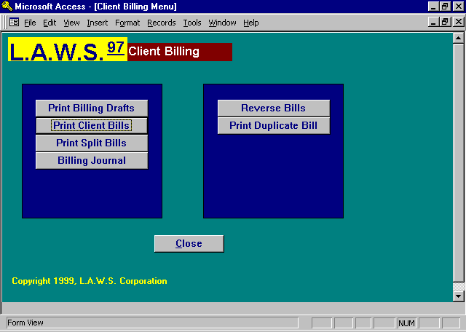

Each option contained on the Client Billing Menu is discussed in detail throughout this chapter.

PRINT BILLING DRAFTS

A Bill Draft is a report listing the detailed Work In Process associated with a matter. The Draft is used by the billing attorney to review and/or modify WIP prior to billing. Billing drafts may be generated for a specified matter on demand, by client or attorney, or based on an interim billing schedule.

After selecting the Print Billing Draft option, the following form is displayed:

Wip Draft Selection Screen

START DATE
The starting date used in the selection of WIP. If the Start date is blank, all WIP for the matter will be selected. Otherwise only WIP greater then or equal to the start date will be included on the draft. To insure that all WIP is selected, leave the start date blank.

CUTOFF DATE
The ending date used in the selection of WIP. The default date is always the Time Entry Cutoff date entered in the Firm file.

Selection Criteria
The selection criteria is used to select matters en mass. If selection criteria is entered, L.A.W.S. searches the system and selects all matters matching the entered selection criteria. Do not use the selection Criteria to select single matters. Drafts may be generated by a single matter by entering the desired client/matter combination within the Selected Drafts section of this form.

INTERIM BILL MO
Enter the desired interim bill month. Each Matter may be assigned a pre-defined interim billing cycle. (see Matter File Maintenance). This interim billing cycle may be used for selection of matters that are to receive billing drafts. If an Interim Billing month is specified, than all matters containing the specified month in their billing cycle will be selected for drafts.

BILL ATTORNEY
Select a single billing attorney, or leave blank for all.

CLIENT
Select a single client, or leave blank for all.

ORDER BY
This option specifies the order in which the WIP Transaction will print on the billing draft. Regardless of the Order By option, WIP transactions are always grouped within the type of transaction (Fees, Disbursements, or Expenses). The Order by option specifies the order of printing within the type of transactions. The available options include:
DATE WIP transactions are listed chronologically within transaction date.
BILL CODE WIP transactions are grouped and listed by Bill Code. Total activity within a bill code is
computed and displayed on the billing draft.

TO DATE TOTALS
Determines whether to-date hours worked, fees billed and fees received will be printed on the WIP Drafts. This option accumulates information from large historical files which may degrade the billing draft selection speed. The available options include:
Yes To date totals will print on the WIP draft
No To date totals will not print on the WIP draft

PRINT A/R ACTIVITY
Determines whether Accounts Receivable activity should print on the WIP Draft. This value is stored in the Firm File. The available options include:
Yes Accounts Receivable Activity will print in the Draft
No Accounts Receivable Activity will NOT print on the draft

ZERO BALANCE MATTERS
Determines whether matters with a zero value WIP balance should be selected for processing. The available options:
No Only matters with a non-zero WIP Balance will be selected for drafts.
Yes All matters meeting the selection criteria will be selected for drafts regardless of WIP value.

MINIMUM WIP VALUE
If a minimum value is entered, all selected matters must have a WIP balance equal to or greater than the entered value. If the minimum WIP value is zero, all matters with a non-zero balance, meeting the other criteria will be selected for drafts.

SELECT (BUTTON)
After the desired selection criteria are entered, the SELECT button will analyze the criteria and select the appropriate matters for drafts.

During the selection process, the words “Selecting Drafts” are displayed above the SELECT button. Once the selection is complete, the words disappear and the selected drafts are listed in the SELECTED DRAFT section of the screen.

SELECTED DRAFTS
The SELECTED DRAFTS section displays all matters selected for the generation of drafts based on the entered criteria. Selected drafts may be deleted by clicking the desired draft's record selector then pressing the DELETE key on the keyboard. All Billing Drafts selected via the selection criteria are automatically displayed. If desired, drafts for individual matters may be requested by simply entering the desired client/matter combination.

CLIENT/MATTER
Displays the client and matter codes identifying the requested drafts. Individual Drafts may be requested by simply entering the desired client/matter combination on the first blank line.

CUTOFF DATE
Displays the cutoff date used for the selection of WIP Transactions on the Drafts. This date automatically defaults to the Cutoff Date entered at the top of this form. If desired, individual drafts may have different cutoff dates.

ATTY
Informational only: Displays the Billing Attorney associated with the selected matter. Drafts are sorted within the Billing Attorney

MO
Informational Only: Displays the interim bill month associated with the selected drafts. If the Interim Bill Month was not utilized as selection criteria, this month column will be blank.

WIP VALUE
Informational Value: Displays the Value of WIP associated with the selected matter.

FIXED FEE
Informational Value: Displays the Fixed Fee Value associated with the selected matter. Matters without a WIP balance, but with a Fixed Fee amount, will be mass selected for drafts only in conjunction with an interim billing month.

NOTE: Matters have a zero balance if both the WIP Value and Fixed Fee amounts are zero. If either the WIP Value or Fixed Fee amounts exist, the matter will be considered for selection.

WIP DRAFT (Print/View)
The Print/View Draft button will print the detail WIP drafts to the default printer or display screen, depending on the button selected. The Billing Drafts are sorted within Billing Attorney. If Print is specified, all selected drafts will be cleared from the system after printing and L.A.W.S. will exit the Draft program.

WIP SUMMARY (Print/View)
The Print/View Summary button will print a concise one line summary for each selected matter within Billing Attorney.

CLOSE (BUTTON)
The Close button will exit the program. If entries have been selected, but not printed, the following message is displayed:

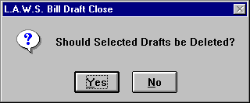

The “YES” option will delete the selected drafts so that the next time the bill draft option is selected, the drafts will be gone. (The drafts will only be gone from the selection area, not from the system.) If “NO” is entered, the selected drafts will remain in the selection area. The next time the bill draft option is selected, the selected drafts will be re-displayed, and if desired, can be printed.

Samples of WIP Draft Reports are displayed on the following pages.

Sample: WIP Billing Draft - Order by Date

Sample: WIP Billing Draft - Summary Report

L.A.W.S. Corporation - Demonstration
WipStart: Work In Process Billing Draft through: Jan 31,1999 BBB
ABC Corporation Barker B Bob
12345 West Avenue Det Text: Y Sub Total: Y Cvr Letter: Y
Suite 600 Det Hours: Y Atty Aloc: N Discount:
Det Cost: S Retainer: Y Adm Chg: N
Roscommon MI 48653 Aty Initials: N A/R Bal: Y Adm Pct: 0
ABC Mary Wilson Ext Value: Y A/R Sum: Y
NEW New Matter Description
Client Ref#: 028-36-9643
___________________________________________________________________________________________________________________
Date of Bill(Task)/ Hours
Service Atty Activity Description of Service Worked Rate Value
___________________________________________________________________________________________________________________
Fees:
03/21/1997 PDK 111 Meeting with client 0.70 $125.00 $87.50
04/01/1997 CCC CW Conference with 0.80 $125.00 $100.00
04/08/1997 CCC R Reviewed job cards of Johnson and Baker for 30 worksites 2.00 $125.00 $250.00
in PA and WV
11/26/1997 PDK 102 Jury Fee 0.50 $100.00 $50.00
12/10/1997 PDK DM Draft Motion 0.00 $100.00 $0.00
Total Fees: 4.00 Hours $487.50
Expenses:
03/21/1997 PDK 106 original signature and court number $3.00
11/28/1997 WWW PH Telephone Conversation Charge Telephone conference $0.00
with client

Total Expenses: $3.00
Billed Received Adjusted Matter Totals: $490.50
TD Fees: $453.00 $454.00 ($1.00)
TD Costs: $120.40 $32.76 ($11.36)
$573.40 $486.76 ($12.36) Amount Due This Matter: 4.00 Hours $490.50
TD Hours Worked: 4.00
Allocation of Fees by Attorney Time Rate Value
Carol C Cliffton (CCC) 2.80 $125.00 $350.00
Paul D Karlsberg (PDK) 0.50 $100.00 $50.00
Paul D Karlsberg (PDK) 0.70 $125.00 $87.50
Total: 4.00 $487.50
Accounts Receivable Summary On Account
Invoice # Invoice Date A/R Balance Balance
147 06/16/1995 $99.00 $0.00
$99.00 $0.00
Total (0-30) (31-60) (61-90) (Over 90)
$99.00 $0.00 $0.00 $0.00 $99.00
Last Pay Amt/Dt: ($7.48) 02/10/1999 Mtr Trust Bal: $0.00 Cli Trust Bal: $0.00
Last Bill Amt/Dt: $10.40 10/25/1996 Thru: Mtr Trust Ret: $0.00 Cli Trust Ret: $0.00
Draft Notes: This draft has been reviewed for accuracy pertaining to:Claim#_______, Spelling:_______, etc: ________
Bill Notes:

___________________________________________________________________________________________________________________
Copyright 1999 L.A.W.S. Corporation 3/8/99 8:50:44 AM 1
rptBillDraft - Menu Bill
L.A.W.S. CORPORATION - DEMONSTRATION
WIP Billing Draft Summary Report - by Billing Attorney:
WIP Interim
Bill Attorney Client Matter Cutoff Date Bill Month Wip Value Fixed Fee
______________________________________________________________________________________________________________________________________________________________________________________
Paul D Karlsberg (PDK)
PDK (AIRWAY) Airway Computers (98766) Tax 03/31/1998 ($97.50) $0.00
PDK (BAILEY) Bailey Construction (LOAN) Construction Loan 03/31/1998 $1,045.50 $350.00
PDK (BAILEY) Bailey Construction (ONE) One West Blvd 03/31/1998 $390.00 $0.00
PDK (CARSON) Carson Manufacturing (5) Carson - Matter #5 03/31/1998 $712.50 $0.00
PDK (CHEATHAM) Cheatham Graphics, Inc (123) Art Work - Simpson 03/31/1998 ($40.00) $0.00
PDK (DEAN) Dean Plating (GEN) General Programming Services 03/31/1998 $70.00 $0.00
PDK (JONES) Jones And Wilson (11199) New matter for Mr. Jones 03/31/1998 $2,365.00 $0.00
PDK (140) MMIC (001) Smith vs Jones 03/31/1998 $387.50 $0.00
PDK (PI) Pers. Inj (1) Jones 03/31/1998 $30,000.00 $0.00
PDK (SWB) Smith, Wilson And Brown (LAWS) General Programming Services 03/31/1998 $752.50 $0.00
PDK (SWB) Smith, Wilson And Brown (11198) NEW MATTER 03/31/1998 $5.00 $0.00
PDK (1) Water Corporation (98769) EPA VIOLATION DUPLICATE ENTRY 03/31/1998 $1,210.00 $0.00
Billing Attorney Total: $36,800.50 $350.00

______________________________________________________________________________________________________________________________________________________________________________________
Copyright 1996 L.A.W.S. Corporation 3/18/98 2:27:50 PM 1
Menu Bill -Brint Billing Drafts - Summary
rptDraft_Sum

PRINT CLIENT BILLS

The Client Bill program allows for the selecting, printing and finalizing of client invoices. The L.A.W.S. bill program allows the firm to develop a standard billing format at the firm level, which will be used as the default for all client invoices. If desired, billing options may be customized per Billing Attorney or Client by modifying billing options associated with the attorney or client through Attorney or Client File Maintenance. All billing pre-defined billing options may be modified when the matter is selected for billing.

After selecting Print Client Bills, the following form is displayed:

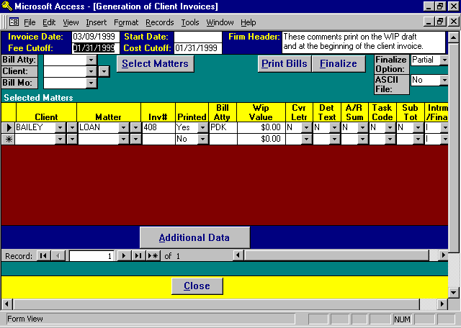

Generation of Client Invoices Screen

The Header information, the blue section at the top of the form, contains data that is inserted into each newly selected matter. This header information then becomes a permanent part of that matters invoicing data. Individual matters displayed on the screen can contain different header information. Changing the Header information has no bearing whatsoever on data that has been previously assigned to selected matters. Pressing the Additional Data button will display the header information previously associated with the each selected matter. Header information associated with previously assigned matters must be changed on the Additional Data screen.

INVOICE DATE
Enter the date the invoices should be dated. L.A.W.S. defaults to the current system date.

FEE CUTOFF
Enter the Cutoff date to be used in the selection of fees. Fees, time entries, dated on or before the fee cutoff date will be included on the invoice. To print a bill containing costs only, enter the fee cutoff date or "1/1/1901". This special fee cutoff date will exclude all fee entries from the bill and omit the header line "For Services Rendered ..." at the top of the invoice.
START DATE
Enter the starting date for inclusion of WIP on the invoice. If the start date is blank, all WIP through the cutoff dates will be included on the invoice. Otherwise, only WIP dated between the Start Date and the Cutoff Date(s) will be included on the invoice. If the start date is blank, the terminology ” For professional services rendered through ......” will be printed on the invoice. If the start date is entered, the terminology: “For professional services rendered from .... through .....” will be printed.

COST CUTOFF
All costs, disbursements and expenses, dated on or before the cost cutoff date will be included on the invoice.

FIRM NOTES
The firm bill comments to be printed on the client invoices, stored in Firm Maintenance, are displayed for review. As invoices are selected for processing, the displayed firm notes will be printed on the invoice. If desired, the firm notes may be blanked out or modified for the current batch of bills.

MASS SELECTION CRITERIA
L.A.W.S. offers the option of selecting matters for billing based on the billing attorney, client, and/or interim bill month. All selection criteria work in conjunction with each other so that one or all fields may be entered. At least one of the selection criteria fields must be entered. Matters with a zero WIP balance will NOT be selected for billing.

BILL ATTY
Enter the billing attorney for the mass selection of matters for billing.

CLIENT
Enter the client code for the mass selection of matters for billing.

BILL MO
Enter the interim billing month for the mass selection of matters for billing.

SELECT MATTER BUTTON
Once the desired mass selection criteria is entered, press the SELECT MATTER button. L.A.W.S. redisplays the selection criteria for operator review with an option to re-key the criteria, or to accept it as entered. Once the selection criteria is accepted, then matters matching the entered criteria will be selected for billing and listed under the Selected Matters portion of this form.

The Mass Selection of Matters feature may be used repeatedly, with different criteria, within a billing batch. For example, assume the firm has multiple billing attorneys, but desires to generate bills for two attorneys only. Selection criteria for the first billing attorney may be entered which results in the listing of the selected matters in the Selected Matter section. Criteria may then be entered for the second billing attorney that will result in the addition of the selected matters for the second billing attorney to the existing matters for the first billing attorney.

SELECTED MATTERS
The SELECTED MATTERS lists the matters that have been selected for billing. Individual matters may be entered on blank lines in this section bypassing the Mass Selection procedures. The fields within the Selected Matters portion of the screen are discussed below.

CLIENT/MATTER
Displays the desired CLIENT/MATTER combination identifying the matter to be billed.

Once the matter has been selected, L.A.W.S. automatically retrieves the pre-defined billing options associated with the matter. The preset billing defaults options are extracted from client, attorney or firm files.

INV#
Displays the invoice number assigned to the printed invoices. If the invoice number is blank prior to the printing of the statements, L.A.W.S. automatically assigns the next available invoice number from the Firm file. If desired, an invoice number may be manually entered instead of having the system automatically assign the invoice number.
PRINTED
Specifies the status of the generated invoice. Available options include:
Yes The invoice has been printed.
No The invoice has not been printed, or, the invoice has been printed and the option has been manually
changed to “No”. Matters marked as Printed-NO will print an invoice when the Print Bills button is
pressed
Final Specifies an alternative method for finalizing invoices. To Finalize individual invoices, change the
Printed “Yes” option to “Final”. If the Finalize Option, noted in the upper right corner of the screen, is
set to "Partial", then only entries classified as ”Final” in the Printed column will be finalized.

NOTE: The printed option should not be changed to “Yes” or “Final” without having the system physically process the invoice. During the processing of invoices, L.A.W.S. physically inserts the invoice number and the date of the invoice into each WIP transaction appearing on the invoice. If the printed status is changed to “Yes” or “Final” without the actual processing of the invoice, the WIP associated with the matter will not have been marked with invoice information. If the matter is finalized, WIP will not be relieved and an erroneous A/R entry may be created.

BILL ATTY
Informational purposes only. Displays the billing attorney assigned to the matter. Invoices print in order by billing attorney for efficient distribution.

WIP VALUE
Displays the WIP Value to be billed based on the specified cutoff dates. After the invoice is printed the actual charges associated with the invoice, including billing discounts and administrative charges, will be inserted in this field.

NOTE: Each client invoice may consist of one to four different types or reports. Each type of report associated with the client billing is noted below.

CVR LETR
Specifies whether a cover letter should be included with the clients' invoice. A cover letter summarizes all totals noted on the client invoice. Available options include:
Y A Cover Letter will be generated.
N A Cover Letter will not be generated.

DET TEXT
Specifies whether the detail text should be included with the clients' invoice. The detail text consists of the individual WIP transactions associated with the matter being billed. The available options include:
Y The Detail Text will be included as part of the invoice.
N The Detail Text will not print as part of the client invoice.

A/R SUM
Specifies whether the accounts receivable summary, a schedule of detailing the clients outstanding accounts receivable balance, should be printed as part of the client invoice. Available options include:
Y The Accounts Receivable Summary will be printed.
N The Accounts Receivable summary will not be printed.

TASK CODE
Specifies whether a task code summary should print as part of the client invoice. The task code summary summarizes all transactions contained on the invoice by service type (task code). Available options include:
Y The Task Code Summary will be included as part of the client invoice.
N The Task Code Summary report will not be generated.

SUB TOTAL
Specifies whether an invoice should contain a single matter, or multiple matters. The available options are:
Y All matters selected for a given client will be printed on a single invoice.
The detail text portion of the invoice will list each matter with the matter subtotal. The total
of all billed matters will be noted at the end of the invoice. The cover letter and
A/R summary will summarize client activity.
N One matter will appear on each statement. If multiple matters are being billed for the same client, multiple invoices will be generated. All balances associated with the invoice pertain to the matter only, not the client.

Note: If multiple matters are being billed for a given client, the sub total option is taken from the first matter associated with the client. Accordingly, if three matters for a given client are selected for billing, and two matters are marked as sub total = “Y”, while the other is “N”. L.A.W.S. will review the first matter (the lowest matter code) and utilize that sub total option for all of the following matters.

INTRM/FINAL
Specifies whether an invoice should be considered interim or final. Classification as a final bill automatically closes the matter by inserting the invoice date as the matter’s closed date. Final bills print the verbiage “FINAL BILL" on the cover letter and/or itemized statement. An interim bill will not automatically close the matter.

NOTE: (WIP ADJUSTMENT OPTION) The WIP adjustment option may be directly accessed from the Selected Matters section of the form by double clicking the record selector preceding the desired matter. Only WIP transactions dated prior to the cutoff date will be displayed.

Additional Data Button
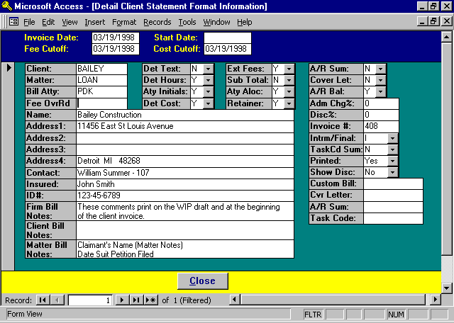

The Additional Data Button displays all billing data associated with a selected matter. A matter is considered “selected” if the record selector associated with the matter is shaded. After pressing the Additional Data
Button, the following form is displayed detailing the additional billing options for the selected matter.

INVOICE DATE; START DATE; FEE CUTOFF; COST CUTOFF:
Header information carried over from the prior bill selection screen. This information may be modified on a matter by matter basis.
CLIENT; MATTER; BILL ATTY
This information is carried over from the prior screen and cannot be modified. If desired, the entire line item may be deleted from the prior screen then re-keyed.

Billing Options
Standard billing options are stored at the Firm, Attorney, Client and Matter. L.A.W.S. retrieves all billing information stored at the Matter level first. L.A.W.S. then reviews the client information and, if defined, assigns the billing options. All non-assigned billing options are then retrieved from the Billing Attorney's billing options. All billing options that have not been assigned through the Matter, Client or Billing Attorney, are assigned from Firm billing options.

The billing options allow the firm to customize the design of the client invoice. Billing options generally function independently from each other and may be mixed and matched in virtually any combination.

A brief explanation of the billing options follow. For a detailed explanation of the billing options please review the Firm File Maintenance portion of this documentation manual.

FEE OVRRD
Specifies the Fee Override Amount. The normal fee amount is the computed WIP fee value (hours worked times rate). If the desired fees to be charged are different than the computed WIP fee value, enter the desired fees as a Fee Override amount. The Fee Override value will replace the computed WIP value. If a Fee Override amount is entered, and the Show Discount value is "No", the EXT FEES value is automatically set to "No".

If a Fixed Fee amount is assigned to a matter through Matter File Maintenance, it is automatically treated as a Fee Override when the matter is selected for billing. If desired the Fixed Fee value may be modified or deleted from the Fee Override field during the creation of the invoice.

DET TEXT
The detail text option, carried over from the prior screen, specifies if the detailed support section of the bill should be printed.

DET HOURS
The detail hours option. Specifies whether the time value associated with each transaction should be printed alongside each fee transaction. The available options are:
Y The time will print with each fee entry.
N The amount of time will not print with each fee entry.

ATY INITIALS
The attorney initials option. Specifies whether the attorney performing the service should be printed alongside each fee transaction. The available options are:
Y The attorney initials will print with each fee entry.
N The attorney initials will not print with each fee entry.

DET COST
The detail cost option. Specifies whether the costs contained on the invoice should be printed in detail or summarized by bill code. The available options are:
Y Each detail cost transaction will be noted on the invoice. For example, it there are 20 photocopy
entries being billed, 20 line items will print on the bill noting the date and amount of each charge.

S Cost transactions will be summarized by bill code. This option works in conjunction with the summary
option associated with the bill code within Bill Code Maintenance. If the summary option for the bill code is "Yes", then all cost transactions utilizing this bill code will be summarized into a single line item. If the summarize option associated with the bill code is no, then the detail activity will be printed for each cost transaction.

EXT FEES
The Extended Fee Option. Specifies whether the extended fees (hours worked times rate) should be printed alongside each fee transaction. The available options are:
Y The Extended Fee will print with each fee entry.
N The Extended Fee will not print with each fee entry
SUB TOTAL
The Sub Total option carried over from the previous screen. Specifies whether each matter for a given client should be printed on a separate invoice, or if all matters for a given client should be sub totaled on a single invoice.

ATTY ALOC
The Attorney Allocation option. Specifies if the Allocation Of Attorney Fees schedule should print after the fee section on the client invoice. The allocation of fees summarizes by attorney the total hours worked times billing rate. The available options are:
Y The Allocation of Fees by Attorney will print after the total fees on the invoice.
N The Allocation of Fees by Attorney will not print after the total fees on the invoice.

RETAINER
Specifies whether a previously received retainer should be applied against the current invoice’s balance. The retainer option applies to both On Account Payments stored in the general fund, as well as to Trust Retainers stored in the trust processing system. On account balances are applied first, with trust retainers applied thereafter. The available options are:
Y The Trust Retainers and/or On Account payments will be applied against the current invoice.
N The Trust Retainers and/or On Account payments will not be noted on, or applied against, the current
invoice.

NOTE: If retainers are applied against the current invoice, L.A.W.S. notes the allocations of funds on the invoice but does not actually decrease the current balance due from the client. The invoice is posted to the accounts receivable system in total. For on account allocations, L.A.W.S. automatically creates cash receipt transactions within the accounts receivable system, which applies previously received on account payments to the current invoice. When these system generated cash receipt entries are posted, the receivable will be reduced to the amount noted on the client invoice.

If a Trust Retainer is to be applied against a current invoice, L.A.W.S. automatically creates a trust disbursement transaction, payable to the firm, within the trust processing system. The firm must process the system generated trust disbursement check. This trust check is then deposited into the general fund against the current invoice as a normal cash receipt.

L.A.W.S. displays prominent messages during the finalization process if retainer transactions are added to either the cash receipts or trust disbursement systems.

A/R SUM
The Accounts Receivable Summary option carried over from the prior screen. Specifies whether the Accounts Receivable Summary Report should be printed.

COVER LET
The Cover Letter option carried over from the prior screen. Specifies whether a cover letter should be generated with this invoice.

A/R BAL
The Accounts Receivable Balance option. Specifies whether the outstanding accounts receivable balance should be noted on the current invoice. This option works in conjunction with the sub total option. If the sub total is “N”, one matter per invoice, then only the matter’s A/R balance will be referenced on the invoice. If the sub total option is “Y”, multiple matters per invoice, then the entire client’s A/R balance will be noted on the invoice. The available options are:
Y The outstanding A/R balance will be noted on the current invoice.
N The outstanding A/R balance will not be noted on the current invoice.

ADM CHG %
Specifies the amount of an administrative charge to be computed on this invoice. An administrative charge is a percent of fees added to the bill to cover overhead charges not itemized on the invoice. For example, some firms include an administrative charge of 4% of fees to cover telephone and photocopy charges, rather than itemizing each telephone call or photocopy on the invoice. The ADM CHG% value is entered as a whole number. Accordingly, a 4.5% charge would be entered as “4.5”. If a percentage is entered, the charge will be computed.

The Administrative Charge Percent is entered through Firm File Maintenance. The "Yes" or "No" option to compute the charge is stored in the client, attorney, or firm files.
DISC%
Specifies the discount percent to be applied against this invoice. The discount percent is always a percent of fees. Accordingly, if the firm desired, a client could by given a 4.5% discount on fees by entering 4.5 in the DISC% field.

The discount percent is stored in client file maintenance.

INVOICE #
The system assigned invoice number. If the invoice number is blank, the system will assign the next consecutive invoice number from the Firm File. If the invoice number is present, then the entered invoice number will be utilized. This field is carried over from the prior billing screen.

INTRM/FINAL
The Interim or Final Bill classification carried over from the prior screen. Matters which are final billed are automatically closed upon finalization by having the statement date inserted into the matters closed date.

TASKCD SUM
Specifies the Task Code Summary Option carried over from the prior-billing screen. The available options are:
Y A Task Code Summary report will be printed as part of the client invoice.
N A Task Code Summary Report will not be printed as part of this client invoice.

PRINTED
The Invoice Printed status carried over from the prior billing screen. The Available options are:
Yes The invoice has been printed. This invoice will be finalized with a Finalize option of “All”.
No This invoice has not been printed, or, the invoice has been printed and the Printed status was
manually changed from “Yes” to “No” to re-run the invoice or to avoid finalization.
Final The invoice has been printed and the status has been changed from “Yes” to “Final” to specify that this
invoice should be finalized when a Partial Finalization option is specified.

SHOW DISC
The Show Discount billing option. This option may be entered only at the time of billing through this Additional Data billing screen. The value is not stored at the firm, attorney or client. The show discount option works in conjunction with the fee override. The show discount bill option specifies whether the decrease in fees resulting from the fee override should be noted on the bill. The Show Discount option is automatically set to "No" if the computed discount is negative. The available options are:
Yes The WIP fee value is noted on the invoice as Gross Fees due this invoice. The difference between
the WIP fees and the fee override is shown on the bill as a discount value. The fee override is shown as Total Fees due this invoice. The heading for the computed discount must be defined in Firm File Maintenance - Voluntary Text Credit on Bills.
No The computed discount will not be noted on the client invoice.

CUSTOM BILL
Enter a Custom Bill Name if one has been predefined and is to be used.

CVR LETTER
Enter a Custom Cover Letter Name if one has been predefined and is to be used.

A/R SUM
Enter a Custom A/R Summary Name if one has been predefined and is to be used.

TASK CODE
Enter a Custom Task Code Name if one has been predefined and is to be used.

NAME/ADDRESS/CONTACT
Displays the name and address that will be printed on the invoice. If the invoice is to be sent to a third party, such as another attorney, then the third parties name and address may be inserted in these fields.

The Name and Address are determined as follows:
1st: The matter is checked for the presence of a miscellaneous name and address. If found, this
information is used.
2nd: The matter is checked for the presence of a branch address. If found, this information is used.
3rd: The client’s address is used. L.A.W.S. checks for the presence of a client “Billing Name”. If found, the
billing name is substituted for the client name.

INSURED
Specifies the name of the insured party associated with the matter being billed. If present, the name of the insured will print on the invoice.

ID#
Specifies the identification number associated with the matter being billed. The ID# resides in the matter file and may be the insurers claim number, a corporations Tax ID number or an individuals Social Security number.

FIRM/CLIENT/MATTER BILL NOTES
Messages to be printed on client invoices may be stored in the firm, client, and/or matter files respectively. If a cover letter is printed, then the firm and client notes are printed on the cover letter. The matter notes are printed on the detail support section prior to the detail transactions. If a cover letter is not printed, then all notes are printed on the detail support section.

After review or modification, press the CLOSE button to return to the bill selection screen.

Print Bills Button
Once all matters are selected for invoicing, the actual printing of the bills is initiated by pressing the PRINT BILLS button. L.A.W.S. reviews the selected matters and prints an invoice of all matters with a "Printed:" code of "No". If the “Printed” field is “YES”, the matter is considered printed and will not be re-printed. If the matter has been printed, but needs to be re-printed, simply change the printed status from “Yes” to “No” and a second invoice will be generated.

If the invoice number is blank, L.A.W.S. will print a client invoice regardless of the "Printed" status.

L.A.W.S. reviews each matter then prints the appropriate schedules-cover letter, detail text, A/R summary, and / or task code summary -based on the supplied billing options.

Once all the invoices have been printed, the following screen is displayed.

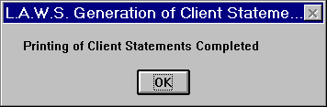

Press OK to acknowledge the completion of the printing of the invoices.

Samples of bills can be found on the following pages.

Sample: Client Invoice -Cover Letter

Sample: Client Invoice - Detail Text

Sample: Client Invoice - Task Code Summary

Sample: Client Invoice - Accounts Receivable Summary
L.A.W.S. CORPORATION - DEMONSTRATION
PO Box 455
Roscommon, MI 48653
(517) 275 4843
38-1234567
Bailey Construction March 19,1998
11456 East St Louis Avenue
Detroit MI 48268
Attention: William Summer - 107
Invoice Number: 408
For professional services rendered through March 19,1998 PDK
BAILEY
_____________________________________________________________________________________________________________________________________________

(LOAN) Construction Loan
Reference#: 123-45-6789
Insured: John Smith

Total Fees due this invoice: $907.50
Total Costs due this invoice: $3.75
Total Due This Matter: $911.25
Plus: Prior Outstanding Accounts Receivable Balance: $2,559.21
Total Amount Due: $3,470.46

_____________________________________________________________________________________________________________________________________________
Invoice
L.A.W.S. CORPORATION - DEMONSTRATION
PO Box 455
Roscommon, MI 48653
(517) 275 4843
38-1234567
Bailey Construction March 19,1998
11456 East St Louis Avenue
Detroit MI 48268
Attention: William Summer - 107 Invoice Number: 408
PDK
For professional services rendered through March 19,1998 BAILEY
_____________________________________________________________________________________________________________________________________________
Date of
Service Attorney Description of Service Time Value
_____________________________________________________________________________________________________________________________________________

(LOAN) Construction Loan
Reference#: 123-45-6789
Insured: John Smith
Incident Date: 12/16/1995

Fees:
12/18/1997 PDK Meeting with regarding the sale of property at 12345 West Huntington 5.00 $375.00
Street. - Discussed long term financing options via land contract.

01/01/1998 JJK Research Michigan Tax Laws 0.50 $32.50

01/15/1998 PDK Phone Conference with client regarding mortgage application and 5.00 $500.00
supporting documents.
__________ ______________
Total Fees: 10.50 Hours $907.50
Costs:
01/15/1998 E108 - Photocopies (15) $3.75
Total Costs: $3.75
Current Charges this Matter: $911.25
Plus: Outstanding Accounts Receivable Balance $2,559.21
Amount Due: $3,470.46

_____________________________________________________________________________________________________________________________________________

Invoice 1
L.A.W.S. CORPORATION - DEMONSTRATION
PO Box 455
Roscommon, MI 48653
(517) 275 4843
38-1234567
Bailey Construction March 19,1998
11456 East St Louis Avenue
Detroit MI 48268
Attention William Summer - 107
Invoice Number: 408
PDK
Task Code Summary:
Description Attorney Rate Time Value
_____________________________________________________________________________________________________________________________________________
RE BAILEY LOAN Construction Loan
Reference#: 123-45-6789
Insured: John Smith
Fees:
Blank ()
Paul D Karlsberg $100.00 5.00 $500.00
John J Kingston $65.00 0.50 $32.50
Task Total: 5.50 $532.50
Discovery (L102)
Paul D Karlsberg $75.00 5.00 $375.00
Task L102 Total: 5.00 $375.00
Total Fees: 10.50 $907.50
Disbursements:
Photocopies (E108)
Paul D Karlsberg $3.75
Task E108 Total: $3.75
Total Disbursements: $3.75
________ _________
Matter Total: 10.50 $911.25

_____________________________________________________________________________________________________________________________________________
Invoice
L.A.W.S. CORPORATION - DEMONSTRATION
PO Box 455
Roscommon, MI 48653
(517) 275 4843
38-1234567
Bailey Construction March 19,1998
11456 East St Louis Avenue
Detroit MI 48268
Attention William Summer - 107
Reference#: 123-45-6789 Invoice Number: 408
Insured: John Smith PDK
Accounts Receivable Summary
A/R Unallocated
Invoice# Matter Invoice Date Balance BAILEY
_____________________________________________________________________________________________________________________________________________
325 LOAN 01/13/1997 $844.17
337 LOAN 01/21/1997 $422.08
56389 LOAN 02/15/1997 $1,292.94
RETAINER LOAN 01/02/1997 ($488.41)
408 Current Invoice 03/19/1998 $911.25 $0.00

Date of Last Payment: 03/28/1997 Total: $2,912.94 ($488.41)
Last Payment Amount: $334.16
Accounts Receivable Aging
Total 0-30 Days 31-60 Days 61-90 Days Over 90 Days
$3,470.46 $911.25 $0.00 $0.00 $2,559.19

_____________________________________________________________________________________________________________________________________________
Invoice

ASCII File:
L.A.W.S. offers the ability of creating ASCII files, in a variety of formats, containing invoiced WIP transactions. The ASCII file option has no effect whatsoever on the finalization process. All invoices selected for printing will post WIP to the ASCII file. The ASCII file is overwritten each time invoices are printed. Ensure that the needed ASCII files are copied from the system prior to overwriting the file with new data. The available ASCII File options include;

No An ASCII File will NOT be created

YES Will create a generic ASCII file containing WIP entries for all invoices included in the last batch of bills
printed. The file will be named C:\LAWS\BILL.ASC. If an existing file exists, the file will be written
over. Once the file is created, it may be copied to disk or transmitted as desired.

ELF Will create an ASCII file containing all WIP entries for all invoices included in the last batch of bills
printed in the required ELF format. The file will be named C:\LAWS97\[matter code].ASC. If an existing file exists, the file will be written over. Once the file is created, it may be copied to disk or transmitted as desired.

EXAMEN Will create an ASCII file containing all WIP entries for all invoices included in the last batch of bills
printed in the required EXAMEN format. The file will be named C:\LAWS97\[matter code].ASC. If an
existing file exists, the file will be written over. Once the file is created, it may be copied to disk or
transmitted as desired.

LAS Will create an ASCII file containing WIP entries for all invoices included in the last batch of bills printed
in Law Audit Service format. The header portion of the file contains headings explaining the contents of the field. An individual ASCII file is created for each matter. The file will be named C:\LAWS97\[matter code].ASC. If an existing file exists, the file will be written over. Once the file is created, it may be copied to disk or transmitted as desired.

LG Will create an ASCII file for each WIP entry for all invoices included in the last batch of bills printed in
LegalGuard format. An individual ASCII file is created for each matter. The file will be named
C:\LAWS97\[matter code].ASC If an existing file exists, the file will be written over. Once the files are
created, it may be copied to disk or
transmitted as desired.

MLM Michigan Lawyers Mutual Format. Creates one large file called "C:\LAWS97\BILL.ASC". This file
requires an MLM assigned client code. This code is stored in the Client file in a field called "ASCII
Client Code". The client "Entity Type" must be MLM identifying the code as the MLM assigned client
code. Review the MLM sample for details regarding this option.

SMMJ Stuart, Maue, Mitchell & James. This option creates one ASCII file per matter in the required SMMJ
format. Review the SMMJ sample for details regarding this option.

TRAVELERS ASCII File created for Travelers Insurance Company.

View View Bills - Ability to transfer to Microsoft Word - Displays the Detail Text section of the bill on the
screen. This document may then be exported to Microsoft Word for modification and/or printing.

Summarizing Cost Transactions
The summarization of Costs on invoices combines multiple cost entries into a single line item. See the "Det Cost" bill option for additional information. The summarized line item does not contain a date. If costs are summarized, the summarized ASCII file cost transactions will not contain dates. To eliminate this problem, do not summarize costs on matters for which ASCII Files will be produced.

After the ASCII file is created, the following message is displayed to the operator.

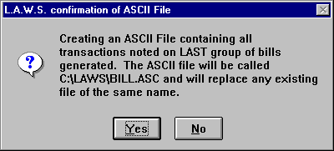

The following pages contain samples of the available ASCII Files

YES option - Generic ASCII File

The first line of the generic file contains headings. The fields within the file are delimited by pipes (|). One large ASCII file is created containing data from all processed invoices called "C:\LAWS97\BILL.ASC".

Client|Matter|WipType|WipDate|WipContAtty|WipBilCd|WipACode|WipDesc|WipHoursWorked|WipRate|WipCostAmt|WipInvNo|WipInvDate|MIDNumber
BAILEY|LOAN|F|12/18/97 0:00:00|PDK|L102|A104|Meeting with regarding the sale of property at 12345 West Huntington Street. - Discussed long term financing options via land contract. |5.00|0.00|$0.00|408|3/17/98 0:00:00|
BAILEY|LOAN|F|1/15/98 0:00:00|PDK|||Phone Conference with client regarding mortgage application and supporting documents. |5.00|100.00|$0.00|||
BAILEY|LOAN|F|1/1/98 0:00:00|JJK|||Research Michigan Tax Laws |0.50|65.00|$0.00|||

ELF option - ELF ASCII File

The first line of the ELF file contains headings. The fields within the file are delimited by pipes (|). One large ASCII file is created containing data from all processed invoices called "C:\LAWS97\BILL.ASC".

INVOICE|INVOICE_DATE|INVOICE_TYPE|INVOICE_TOTAL|INVOICE_AMOUNT|START_DATE|END_DATE|CLIENT|BILLING_ENTITY|TAX_ID_NUMBER|CONTACT|MATTER|MATTER_NUMBER|MATTER_NAME|CASE|SUMMARY_WORK_PERFORMED|DATE|TIMEKEEPER|TIMEKEEPER_ID|TIMEKEEPER_CATEGORY|TASK_CODE|ACTIVITY_CODE|RATE|HOURS|EXPENSE_CODE|NUMBER_OF_EXPENSE_UNITS|UNIT_COST|LINE_ITEM_COST|NARRATIVE|LINE_ITEM_COUNT
408|19990308|I|911.25|911.25|19971218|19990131|BAILEY|L.A.W.S. Corporation - Demonstration|38-3085621|Paul D Karlsberg|LOAN|123-45-6789|Construction Loan|||19971218||PDK||111||75.00|5.00||||375.00|Meeting with client regarding sale of property at 12345 West Huntington Street. Discussed long term financing options via land contract |
408|19990308|I|911.25|911.25|19971218|19990131|BAILEY|L.A.W.S. Corporation - Demonstration|38-3085621|Paul D Karlsberg|LOAN|123-45-6789|Construction Loan|||19980101||JJK||||65.00|0.50||||32.50|Researched Michigan Tax Laws |
408|19990308|I|911.25|911.25|19971218|19990131|BAILEY|L.A.W.S. Corporation - Demonstration|38-3085621|Paul D Karlsberg|LOAN|123-45-6789|Construction Loan|||19980115||PDK||||100.00|5.00||||500.00|Phone conference with client regarding mortgage application and supporting documents |
408|19990308|I|911.25|911.25|19971218|19990131|BAILEY|L.A.W.S. Corporation - Demonstration|38-3085621|Paul D Karlsberg|LOAN|123-45-6789|Construction Loan|||19980115||PDK||||||E108|15|0.25|3.75|E108 - Photocopies (15)|

EXAMEN option - EXAMEN ASCII File

There are several sections within each EXAMEN ASCII file consisting of Header, Fees, Disbursements, Footer and Biller summary. Pipes delimit multiple fields within each section (|). One ASCII file is created containing data from each matter and is called "C:\LAWS97\(Matter Code).ASC".

[HEADER]
Law Firm Matter Code: (BAILEY / LOAN)
L.A.W.S. Corporation - Demonstration
PO Box 455
Roscommon, MI 48653
(517) 275 4843
Tax ID#: 38-1234567
Bailey Construction
11456 East St Louis Avenue
Detroit MI 48268
William Summer - 107
Paul D Karlsberg
Construction Loan
123-45-6789
3/19/98
408
[FEES]
[Date|[Attorney]|[Rate]|[Hours]|[Description]|[Calculated_Charge]
12/18/97|PDK|75.00|5.00|"[111] Meeting with client regarding sale of property at 12345 West Huntington Street. Discussed long term financing options via land contract "|$375.00
01/01/98|JJK|65.00|0.50|"Researched Michigan Tax Laws "|$32.50
01/15/98|PDK|100.00|5.00|"Phone conference with client regarding mortgage application and supporting documents "|$500.00
[DISBURSEMENTS]
[Date]|[Description]|[Amount]
01/15/98|"[E108] E108 - Photocopies (15)"|3.75
[FOOTER]
Total Fees: 907.50
Total Disbursements: 3.75
Fee Discount: 0.00
Total for this invoice: 911.25
Previous balance: 6556.37
Balance: 7467.62
Social Security #: 123-45-6789
Loan Number: 200-63-9563
Home Address: 42637 East Jefferson Ave
Detroit, MI 48224
[Biller Name]|[Title]|[Rate]
John J Kingston|PARA LEGAL|$65.00
Paul D Karlsberg|Sr. Partner|$100.00
Paul D Karlsberg|Sr. Partner|$75.00

LAS option - Law Audit Services ASCII File

The Law Audit Service (LAS) Ascii file is divided into two sections. A file is created for each matter identified as "C:\LAWS97\[matter code].ASC". The initial section contains header information concerning the matter while the following section lists the detail transactions associated with the bill. The initial field within the header portion defines the heading information. The fields within the file are delineated by the pipe symbol (|). The client city, state and zip are taken from the city, state and zip fields in the client file. The law firm city, state and zip are taken from the last line of address in the firm file. The LAS option is very similar to the LG option except the LAS option provides heading identification to the ASCII data fields.

Each transaction line contains the following: Date of Transaction, Attorney, Rate -or- Expense Amount, hours Worked, Bill Code, Description of Service

Header 1 Client Name: (BAILEY LOAN)| Bailey Construction
Header 2 Claim Off/State:(BAILEY LOAN)| Detroit MI 48268
Header 3 Law Firm Name: (BAILEY LOAN)| L.A.W.S. Corporation - Demonstration
Header 4 Law Firm Cty/St:(BAILEY LOAN)|
Header 5 Matter Name: (BAILEY LOAN)| Construction Loan
Header 6 Claim Number: (BAILEY LOAN)| 123-45-6789
Header 7 Invoice Date: (BAILEY LOAN)| 3/19/98
Header 8 Invoice Number: (BAILEY LOAN)| 408
Header 9 Adjuster Name: (BAILEY LOAN)| William Summer - 107
Header10 Invoice Fees: (BAILEY LOAN)| 907.50
Header11 Invoice Expenses(BAILEY LOAN)| 3.75
Header12 Total Invoice: (BAILEY LOAN)| 911.25
Header13 Date of Loss: (BAILEY LOAN)| 12/16/95
Header14 Insured Name: (BAILEY LOAN)| John Smith
Header13 Matter Notes: (BAILEY LOAN)| Social Security #: 123-45-6789
Loan Number: 200-63-9563
Home Address: 42637 East Jefferson Ave
Detroit, MI 48224
[Date|[Attorney]|[Rate or Expense]|[Hours]|[Description]
[FEES]
12/18/97|PDK|75.00|5.00|"[111] Meeting with client regarding sale of property at 12345 West Huntington Street. Discussed long term financing options via land contract "
01/01/98|JJK|65.00|0.50|"Researched Michigan Tax Laws "
01/15/98|PDK|100.00|5.00|"Phone conference with client regarding mortgage application and supporting documents "
[Expenses]
01/15/98|XXX|3.75|1.00|"[E108] E108 - Photocopies (15)"

LG option - LegalGuard ASCII File
The LegalGuard ASCII file is divided into two sections. A file is created for each matter identified as "C:\LAWS97\[matter code].ASC". The initial section contains header information concerning the matter while the following section lists the detail transactions associated with the bill.

Field Layout, Legalguard

The following is a list of header lines required by legalgard and the corresponding fields in LAWS.

Legalguard L.A.W.S. 97

HEADER LINE 1: Client Name Client Name Field
HEADER LINE 2: Client Office Location Client Address Line 4
HEADER LINE 3: Law Firm Name Firm Name Field
HEADER LINE 4: Law Firm City, State Firm Address Line4
HEADER LINE 5: Matter Name Matter Description
HEADER LINE 6: Claim Number Reference # Field In Matter File
HEADER LINE 7: Invoice Date Date Of Invoice generated from Client Billing
HEADER LINE 8: Law Firm Invoice # Invoice Number generated from Client Billing
HEADER LINE 9: Adjuster Name Matter Contact
HEADER LINE 10: Invoice Fees Total Fees generated from Client Billing
HEADER LINE 11: Invoice Expense Total Expenses generated from Client Billing
HEADER LINE 12: Total Invoice Amount Total Invoice generated from Client Billing
HEADER LINE 13: Date Of Loss Incident Date Field In Matter File
HEADER LINE 14: Insured's Name Insured Field In Matter File
HEADER LINE 15: Claimant's Name First line in Matter Bill Notes [Ctrl] [Enter]
HEADER LINE 16: Date Suit Petition Filed Second line Matter Bill Notes [Ctrl] [Enter]
HEADER LINE 17: Jurisdiction Code Third Line Matter Bill Notes [Ctrl] [Enter]
HEADER LINE 18: Loss Type Code Fourth Line Matter Bill Notes [Ctrl] [Enter]
HEADER LINE 19: Opposing Counsel Fifth Line Matter Bill Notes [Ctrl] [Enter]
HEADER LINE 20: Opposing Law Firm Sixth Line Matter Bill Notes

Header Lines 15 through 20 do not have a corresponding field in L.A.W.S. Enter information in sequential order as defined above. Do not skip any header lines. If the firm does not have the information for any header lines 15 through 20, insert an * in the place of the information.

Each transaction line contains the following:
Date of Transaction, Attorney, Rate -or- Expense Amount, hours Worked, Bill Code, Description of Service

Listed below is a sample LegalGuard ASCII File

[HEADER]
Bailey Construction
Detroit MI 48268
L.A.W.S. Corporation - Demonstration
Roscommon, MI 48653
Construction Loan
123-45-6789
3/19/98
408
William Summer - 107
907.50
3.75
911.25
12/16/95
John Smith
Claimant's Name (Matter Notes)
Date Suit Petition Filed
Jurisdiction Code
Loss Type Code
Opposing Counsel
Opposing Law Firm

[FEES]
12/18/97|PDK|75.00|5.00|"[111] Meeting with client regarding sale of property at 12345 West Huntington Street. Discussed long term financing options via land contract "
01/01/98|JJK|65.00|0.50|"Researched Michigan Tax Laws "
01/15/98|PDK|100.00|5.00|"Phone conference with client regarding mortgage application and supporting documents "
[Expenses]
01/15/98|XXX|3.75|1.00|"[E108] E108 - Photocopies (15)"

MLM option - Michigan Lawyers Mutual ASCII File
The MLM ASCII File option creates a single ASCII file called C:\LAWS97\BILL.ASC. The fields within the file are delimited by pipes (|).

The MLM ASCII file requires that an MLM assigned client code, identifying the law firm, be associated with each ASCII file. The method of recording and utilizing this MLM client code is discussed below:
- Through Client File Maintenance, access the client record requiring the MLM ASCII File.
- Enter the initials “MLM” as the ‘Type of Entity’.
- Page down the client record to the field label “ASCII Client Code”.
- Enter the Client Code assigned by MLM to the law firm in the ‘ASCII Client Code’ field.

CLIENT|DATE|EXPENSE_CODE|LINE_ITEM_COST|HOURS|INVOICE_DATE|PERIOD_FROM|PERIOD_TO|INVOICE_NUMBER|MATTER|NUMBER_OF_EXPENSE_UNITS|RATE|TIMEKEEPER_ID|TASK_CODE|ACTIVITY_CODE|UNIT_COST|NARRATIVE
LAWS|12181997||+375.00|+5.00|03191998|12181997|03191998|408|123-45-6789||+75.00|PDK|111|||Meeting with client regarding sale of property at 12345 West Huntington Street. Discussed long term financing options via land contract
LAWS|01011998||+32.50|+0.50|03191998|12181997|03191998|408|123-45-6789||+65.00|JJK||||Researched Michigan Tax Laws
LAWS|01151998||+500.00|+5.00|03191998|12181997|03191998|408|123-45-6789||+100.00|PDK||||Phone conference with client regarding mortgage application and supporting documents
LAWS|01151998|E108|+3.75||03191998|12181997|03191998|408|123-45-6789|+15.00||PDK|||+0.25|E108 - Photocopies (15)

SMMJ option- Stuart, Maue, Mitchell & James ASCII File
SMMJ will not allow missing data in the general file information. The SMMJ ASCII File Format requires the identification of the law firm’s city and state. L.A.W.S. does not identify the city and state in the FIRM file.

Identify the law firm’s city and state as follows:
- Create, or modify, a client utilizing the client code ‘FIRM’.
- Enter the firms name as the client name,
the firm’s city in the client’s city field,
the firms state in the clients state field.

Other required information is retrieved from the following sources:
The file consists of four sections:
Section 1 summarizes case and invoice information,
Section 2 summarizes distribution of fees by Attorney. Atty | Hours | Rate | Value
Section 3 details fee entries. Date | Atty | Hours | Description | Bill Code | Activity Code | Value
Section 4 details cost entries. Date| Atty | Value | Description | Expense cCode

Required Data Source of data within LAWS
Claim Number Matter File - Client Reference Number
Examiner Number Matter File - first three characters of the
Matter Contact. SMMJ does not want the contact name, only the Examiner Number. Accordingly, the matter contact should contain the Examiner number along with the name if desired.

Example: Examiner number is 123, the name is John Smith. Enter the contact name in the matter file as ’123 - John Smith’. LAWS will extract the 123 as the Examiner number. the contact name printing on the bill will print as 123-John Smith.
Name of Policy Holder Matter File - Insured
Date of Loss Matter File - Incident Date
Firm File Number Client Code & Matter Code
Invoice Number, Date
Fees Billed, Expenses Billed: System Assigned

A sample of the SMMJ ASCII File is listed below.

123-45-6789
Wil
John Smith
12/16/95
408
3/19/98
BAILEY-LOAN
907.5
3.75

JJK|0.5|65|32.5
PDK|5|75|375
PDK|5|100|500

12/18/97|PDK|5|Meeting with client regarding sale of property at 12345 West Huntington Street. Discussed long term financing options via land contract |111||375
1/1/98|JJK|0.5|Researched Michigan Tax Laws |||32.5
1/15/98|PDK|5|Phone conference with client regarding mortgage application and supporting documents |||500

1/15/98|PDK|3.75|E108 - Photocopies (15)|E108

TRAVELERS option- Travelers Insurance ASCII File

Creates one large file, C:\LAWS97\BILL.ASC, containing all WIP transactions contained within the last batch of generated bills.

The first line of the file contains header information consisting of :
Firm Name, Invoice date, Invoice number, Matter description, Client_Matter code, Claim Number, Total Fees, Total Costs, Invoice total.

Each Fee detail line transaction line consists of :
Client_Matter Code, Invoice date, Invoice Number, Date of service, Attorney Initials, Task Description, Time,
Rate, Total charge
Each Cost detail line transaction line consists of :
Client_Matter Code, Invoice date, Invoice Number, Date incurred, Amount, Expense code, Expense Description

L.A.W.S. Corporation - Demonstration|3/19/98|408|Construction Loan|BAILEY_LOAN|123-45-6789|907.50|3.75|911.25
BAILEY_LOAN|03/19/1998|408|12/18/1997|PDK|[111] Meeting with client regarding sale of property at 12345 West Huntington Street. Discussed long term financing options via land contract |5|$75.00|$375.00
BAILEY_LOAN|03/19/1998|408|01/01/1998|JJK|Researched Michigan Tax Laws |0.5|$65.00|$32.50
BAILEY_LOAN|03/19/1998|408|01/15/1998|PDK|Phone conference with client regarding mortgage application and supporting documents |5|$100.00|$500.00
BAILEY_LOAN|03/19/1998|408|01/15/1998|$3.75|[E108] E108 - Photocopies (15)

Finalization
The Print Bills button simply prints a client invoice. Work in process is not relieved and the account receivable is not created. In order to relieve WIP and post accounts receivable the finalization process must be performed.

FINALIZE OPTION
The finalize option provides two different ways of finalizing bills. The available options are:
ALL Will finalize all matters that are marked “YES’ and “FINAL” in the PRINTED field.
PARTIAL Will only finalize the matters marked “FINAL” in the PRINTED field.

If an on-account retainer is to be applied to an invoice being finalized, L.A.W.S. automatically creates two cash receipt entries within the cash receipts entry program. The first entry reverses the retainer applied reducing the retainer balance, while the second entry applies the retainer against the current statement. The firm’s cash balance is not affected since we have a negative retainer entry and a positive A/R entry off setting each other. The only action is a re-distribution of existing funds from retainer to disbursements, expenses and fees. L.A.W.S. does not post this entry, but alerts the operator to creation of these transactions. The transactions should be reviewed by the operator and posted through the cash receipts processing program as any other cash receipt would be.

If a trust retainer is to be applied to an invoice being finalized, L.A.W.S. automatically creates a trust disbursement transaction to the firm within the trust processing system. L.A.W.S. does not automatically post this disbursement check but alerts the operator to the creation of the transaction. After the trust disbursement is processed, the resulting check must be applied against the appropriate invoice through normal cash receipts processing.

All finalized invoices are removed from the bill selection program leaving only the non-finalized bills.

FINALIZE BUTTON
The Finalize Button performs the finalization of printed invoices. Bills are not printed when the Finalize button is pressed, but the appropriate bills are finalized. After pressing the Finalize Button the following message is displayed:

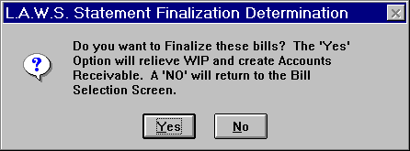

Available Options are:
YES The Finalization process will be performed on the appropriate invoices.
NO The Finalization process is canceled.

PRINT SPLIT BILLS

L.A.W.S. offers split billing capabilities. Split billing allows the WIP accumulated on specific matter to be billed to two or more other matters. The matter on which the WIP is accumulated is called the General Matter, while the matters to which the WIP should be billed are called the Split Matters. A percentage allocation of the charges associated with the General Matter must be assigned to each Split Matter.

Each split bill contains all WIP associated with the general file. The total section of the split bill allocates the total charges accumulated on the General Matter to the Split Matter based on the predefined percentage.

After selecting the PRINT SPLIT BILLS option, the following screen appears:
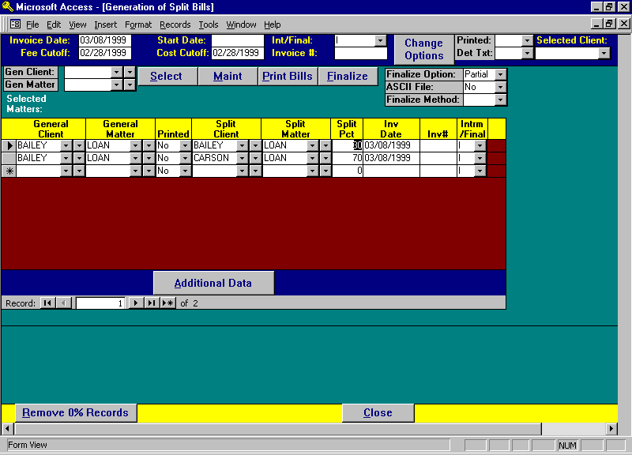

Generation of Split Bills Screen

Much of the information pertaining to split bill processing is similar to the standard client billing and accordingly will not be explained in detail. For a detailed explanation of the billing options, please review the Print Client Bills section of this manual.

INVOICE DATE; FEE CUTOFF; START DATE; COST CUTOFF, FIRM NOTES
Please review the client bill section of this manual for a detailed review. The Cutoff dates are used to extract WIP associated with the General Matter only.

INT/FINAL
A default Interim or Final designation assigned en masse when selecting split bills. The available options include:
I Interim bill. All selected split bills will be classified as Interim Bills. The matter will remain open after
billing.
F Final bill. All selected split bills will be marked as Final Bills. The matters will be closed after billing.

INVOICE #
Allows the option of assigning a common invoice number to all selected split bills. Enter the desired invoice number to assign a common invoice number to the selected split bills. Otherwise the system will assign the next available number if the invoice number is left blank.

Change Options
Often it is necessary to re-run a all or some of the selected split bills. The Change Option button allows the option of changing the "Printed" and Det Txt" options associated with selected split bills. To utilize the Change Options button, perform the following functions:
1) Enter the desired settings for the "Printed" and "Det Txt" options.
2) Identify the desired "Split Client" in the "Selected Client" field. Please Note, All matters associated with the
entered split client will have their "Printed" and "Det Txt" options set as entered in step 1.
3) Press the Change Options button to initiate the change.

GENERAL CLIENT / GENERAL MATTER
Identifies the general client and matter for which split bills are being generated. This information is required to enter, access or modify the split percentages associated with the general file.

MAINT Button
Displays split bill information pertaining to the general file. Displayed data may be reviewed or modified.
After pressing the MAINT button, the following form is displayed.

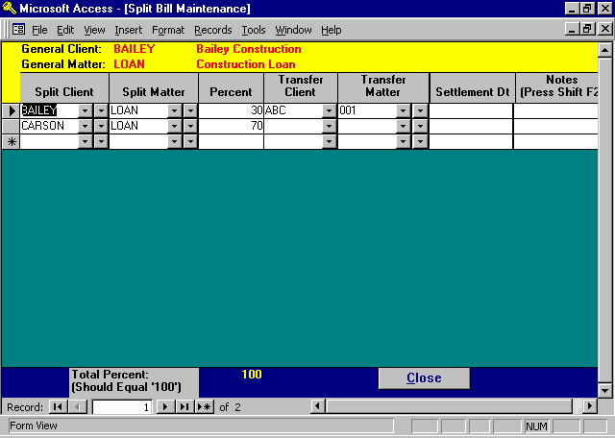

Split Bill Maintenance

GENERAL CLIENT / MATTER
Carried over from the prior screen identifying the general matter to which the split matters will be associated.

SPLIT CLIENT / MATTER
List all the split matters that should be associated with the general matter. The general matter should be entered only if a percentage of the general matter should be billed to itself.

PERCENT
Enter the percent of the general matter that should be billed to each split matter. Although not required, the total percent allocated to all split matters should equal 100%.

TRANSFER CLIENT / MATTER
If desired, Work In Process may be transferred from the general file to split files instead of creating a split Accounts Receivable transaction for the split file. For example, assume a general file has two transactions that is split evenly between two files. Assume also that one file is billed while the other file utilizes the transfer WIP function.
The fictitious transactions are listed below.

Date Description Rate Fee Transfer Client \ Matter
2/15/99 Review letter from client 2.0 Hr $300.00
1/25/99 Telephone conference with Smith. 1.0 Hr $150.00 ABC \ 001

Split Client/Matter
Carson \ Loan 70%
Bailey \ Loan 30%

Each split file will receive a percentage of the billing. The first matter, Carson \ Loan is not associated with a transfer client or matter. Accordingly, Carson \ Loan will have an accounts receivable transaction created for $315.00.

The second matter, Bailey \ Loan is associated with a transfer client \ Matter. Accordingly, when the split bills are finalized, two percentage adjusted WIP transactions will be posted to the specified transfer client \ matter code as noted below:

Assigned Client/Matter Date Description Rate Fee
ABC \ 001 1/25/99 Telephone conference with Smith. .3 Hr $150.00
ABC \ 001 2/15/99 Review letter from client .6 Hr $300.00

The next client statement generated for Bailey \ Loan will include the transferred WIP. A/R transactions are not created for matters associated with transferred WIP transactions.

Please note: The transfer client \ matter may, or may not, be the same as the split client \ matter.

SETTLEMENT DATE
If one split client settles their claim, prior to the settlement of the case by the other split clients, not the settlement date by split client. The system provides an option of correctly billing all split clients for WIP dated prior to the settlement dates, then re-computing the appropriate split billing percentages for the remaining split clients after the settlement date. One or more settlement dates can fall within the current billing period.

Please Note: In order to have the system re-compute percentages for the remaining split clients after a settlement date, use the custom bill format called "rptBill_Split1". Review the documentation in this chapter regarding custom Bill formats later in this chapter.

NOTES
If desired, the firm may make notations pertaining to the split matter entries.

Once all the split matter information has been entered into the system, close the form to return to the Generation of Split Bills form.

_________________________________________________

SELECT Button
The Select button automatically selects all split matters that have previously been associated with the general matter through the previously described MAINT Button.

All selected split matters will be listed in the "Selected Matters" section of the form. After pressing Select, the following message is displayed.

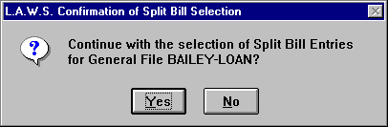

If the information contained in the message is correct, click “Yes” to continue the selection process. Otherwise, Click “No” to cancel the automatic selection of split matters.

When the selection process is complete, the entered general client / matter data is erased so that additional split bills may be added to the list if desired.

The Selected Matters portion of the screen lists all split matters associated with the general file. A common general client / matter code is assigned to all split matters which will receive a portion of the general matters billing.

In this example, all WIP associated with the general matter BAILY LOAN, will be billed to the two split matters; 30% to BAILY LOAN, and 70% to CARSON LOAN.

Please note that in this example the general matter, BAILY LOAN, is to receive a portion of its own billing. Accordingly, the client/matter combination of BAILY LOAN is entered in one transaction as both the general matter and the split matter.

SPLIT PCT
The split percent specifies the percentage of the general matters WIP that should be billed to the identified split matter.

INV DATE; INV #; PRINTED ; FINAL \ INTERIM
Please review the regular Client Billing procedures noted earlier in this section for a detailed explanation of these fields.

ADDITIONAL DATA Button
The Additional Data button displays all additional information associated with the split bill. The billing options are assigned to the split matter. Accordingly, split bills for different split matters within a common general matter, may have different billing options.

Please review the regular Client Billing procedures noted earlier in this section for a detailed explanation of these fields.

Split Billing does NOT offer the following options:
DETAIL COST: Assigns the detail cost option of "Y". Each detail transaction will be noted.
SUB TOTAL: Assigns the sub total option of "N". An invoice is created for each split matter .
RETAINER: Retainers are not automatically applied to split bills.
A/R SUM: Split bills will not contain an A/R Summary invoice section.
A/R BAL: Outstanding A/R Balances are not noted on Split Bills.
TASK CD SUM; Split Bills do not print the Task Code Summary section of the invoice.

Custom Bill
Two split bill formats exist within L.A.W.S.

The standard split bill relies on pre-entered percentages associated with each split file. L.A.W.S. either creates Accounts Receivable data, or transfers WIP, based on these user defined percentages. The standard split bill is created if this "Custom Bill" field is blank.

The second split bill option, referred to as the "re-computed method", consists of having L.A.W.S. compute percentages evenly based on the number of non-settled split clients associated with the general file. The computed percentages can vary within a single bill if a split client settles within the billing cycle. The recomputed bill is generated when "rptBIll_Split1" is entered in this "Custom Bill" field.

The Custom Bill format may be stored with the General Client via Client File Maintenance. Enter the code "rptBill_Split1" in the general Clients "CUSTOM BILL FORMAT" field.

PRINT BILLS Button
The concept of printing split bills is very similar to printing regular bills. Please review the regular Client Billing procedures noted earlier in this section for a detailed explanation of this feature.

All WIP associated with the general matter will be printed on each invoice. The “Total” section of each invoice identifies the percent of the general matter that should be allocated to the split matter.

An allocation summary of charges to all split matters is printed at the end of each split bill.

Please review the sample Split Bill printed at the end of this section.

ASCII File

Split Bill Processing can produce an ASCII file containing the detail transactions contained on the split bills. The available options include:

No An ASCII file will not be created.
Yes An ASCII File is created. The file is called C:\LAWS97\SPBILL.ASC.
Elf ELF ASCII File Format
View Selected bills are displayed in a single large report on the display screen. The displayed document
may then be transferred to a Microsoft Word document utilizing the full version of Access.

Listed below are sample ASCII files.

ASCII File = Yes

Bclient|BMatter|BSplitClient|BSplitMatter|WipType|WipDate|WipContAtty|WipBilCd|WipACode|WipDesc|WipHoursWorked|WipRate|WipCostAmt|bSplitPct|WipInvNo|WipInvDate|bMIDNo
BAILEY|LOAN|BAILEY|LOAN|E|1/15/98 0:00:00|PDK|E108||E108 - Photocopies (15) |0.00|0.00|$3.75|30.00|409|3/24/98 0:00:00|
BAILEY|LOAN|BAILEY|LOAN|F|1/1/98 0:00:00|JJK|||Research Michigan Tax Laws |0.50|65.00|$0.00|30.00|409|3/24/98 0:00:00|
BAILEY|LOAN|BAILEY|LOAN|F|1/15/98 0:00:00|PDK|||Phone Conference with client regarding mortgage application and supporting documents. |5.00|100.00|$0.00|30.00|409|3/24/98 0:00:00|
BAILEY|LOAN|CARSON|5|E|1/15/98 0:00:00|PDK|E108||E108 - Photocopies (15) |0.00|0.00|$3.75|70.00|409|3/24/98 0:00:00|
BAILEY|LOAN|CARSON|5|F|1/1/98 0:00:00|JJK|||Research Michigan Tax Laws |0.50|65.00|$0.00|70.00|409|3/24/98 0:00:00|
BAILEY|LOAN|CARSON|5|F|1/15/98 0:00:00|PDK|||Phone Conference with client regarding mortgage application and supporting documents. |5.00|100.00|$0.00|70.00|409|3/24/98 0:00:00|

ASCII File = ELF

L.A.W.S. offers the ability of generating an ASCII file in the required ELF format. Only clients with the code "ELF" entered in the "ASCII CLIENT CODE" field, within client file maintenance, will have the ELF ASCII file created. Please review Client File Maintenance for information pertaining to the "ASCII CLIENT CODE". L.A.W.S. creates one large ASCII file containing data on all split bills meeting the "ELF" criteria within the current batch.

INVOICE|INVOICE_DATE|INVOICE_TYPE|INVOICE_TOTAL|INVOICE_AMOUNT|START_DATE|END_DATE|CLIENT|BILLING_ENTITY|TAX_ID_NUMBER|CONTACT|MATTER|MATTER_NUMBER|MATTER_NAME|CASE|SUMMARY_WORK_PERFORMED|DATE|TIMEKEEPER|TIMEKEEPER_ID|TIMEKEEPER_CATEGORY|TASK_CODE|ACTIVITY_CODE|RATE|HOURS|EXPENSE_CODE|NUMBER_OF_EXPENSE_UNITS|UNIT_COST|LINE_ITEM_COST|NARRATIVE|LINE_ITEM_COUNT
501|19990308|I|911.25|911.25|19971218|19990228|BAILEY|L.A.W.S. Corporation - Demonstration|38-1234567|Paul D Karlsberg|LOAN|123-45-6789|Construction Loan|||19971218||PDK||111||75.00|5.00||||375.00|Meeting with client regarding sale of property at 12345 West Huntington Street. Discussed long term financing options via land contract |
501|19990308|I|911.25|911.25|19971218|19990228|BAILEY|L.A.W.S. Corporation - Demonstration|38-1234567|Paul D Karlsberg|LOAN|123-45-6789|Construction Loan|||19980101||JJK||||65.00|0.50||||32.50|Researched Michigan Tax Laws |
501|19990308|I|911.25|911.25|19971218|19990228|BAILEY|L.A.W.S. Corporation - Demonstration|38-1234567|Paul D Karlsberg|LOAN|123-45-6789|Construction Loan|||19980115||PDK||||100.00|5.00||||500.00|Phone conference with client regarding mortgage application and supporting documents |
501|19990308|I|911.25|911.25|19971218|19990228|BAILEY|L.A.W.S. Corporation - Demonstration|38-1234567|Paul D Karlsberg|LOAN|123-45-6789|Construction Loan|||19980115||PDK||||||E108|15|0.25|3.75|E108 - Photocopies (15)|

Helpful Hint: Many firms print and review the entire batch of split bills prior to creating ASCII Files. Once the bills are in good form, use the Change Codes Function to change en Masse the "Printed" code to "No" and the "Det Txt" code to "No", then re-print the split bills with the desired ASCII file format selected. The bills will not be reprinted due to the "Det Txt" option, but the ASCII file will be created.

View Option
Will display all selected invoices in a single large document on the display screen. The entries to be viewed must be marked as “Printed” = ‘No’ and “Det Txt” = ‘Y’. The split bills are displayed in standard split bill format only, Once displayed the “Printed” option is set to “Yes”.

Remove 0% Records
L.A.W.S. may automatically select matters for billing which have had the split percent set to 0 (zero). If you do not wish to print zero percent split bills, utilize the 'Remove 0% Records" button to remove these transactions.

Do not remove zero percent records when utilizing the recomputed split bill option. With this option percentages are not required since L.A.W.S. computes the appropriate percent at the time the bills are generated.

Finalize Button
The concept of finalizing split bills is very similar to finalizing regular bills. Please review the regular Client Billing procedures noted earlier in this section for a detailed explanation of this feature.

Finalization of split bills relieves the WIP associated with the general matter then creates accounts receivable transactions for each split matter.

The Split Bill Finalization is completely separate from the regular bill finalization. Accordingly, split bills must be finalized from the split bill screen while regular bills must be finalized from the regular client bill screen.

Global Percentages
It is possible that each file established for a general client should be distributed to common clients based on common percents. If desired, “Global” percentages can be established for a general client. Global Percentages identify the general client and the split clients and associated percentages to be billed to each split client. When selecting split bills, L.A.W.S. first checks for specifically entered split percentages per general file. If a general file exists, without specifically entered spit percentages, then L.A.W.S. automatically created split distributions based on the global percentages.

Prior to using global percentages, a matter must be established for the general file with the matter code “GLOBAL”.

Example: Suppose that the WIP associated with client “Bailey” is always billed to clients “ABC” and “CARSON” evenly. Global percentages could be setup as follows.

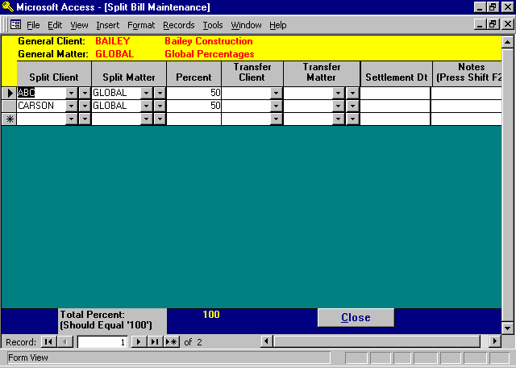
Note: A Matter has been set up for client “Bailey” and matter “Global”.
Split Bill distribution line items have been set up for clients “ABC” and “Carson” with the matters “Global”.

From this point forward, whenever a general file is billed for client “Bailey”, and predefined percentages have not been entered, then L.A.W.S. will automatically assign the Global Percentages.

Split Bill Distributions must be billed to matters. If Global percentages are used, and the split bill matters do not exist, then L.A.W.S. will create the distribution matter codes. The matters are created using the Global Split Bill Distribution client codes and the general file matter codes. Therefore, if a new matter was set up for “Bailey” coded “11111” and global percentages were used, then L.A.W.S. will create the matters “ABC / 11111” and “CARSON / 11111”.

Conventions pertaining to split billings

1) When working with split files, assign a common matter code to the general file and all associated split files. The split bill worksheet, as well as all split bill global percentages are designed to look for and retrieve general files and the associated split files by a common matter code.

2) Global percentages can only utilize the standard split bill format. Global percentages can not use the Recomputed split bill format (rptBill_Split1). Error messages will occur.

The next page displays a sample Split Bill.

Sample: Split Bill - Cover Sheet

Sample: Split Bill - Detail Support

Sample: Split Bill – Recomputed Option (rptBill_Split1)

L.A.W.S. CORPORATION - DEMONSTRATION
PO Box 455
Roscommon, MI 48653
(517) 275 4843
38-1234567
Bailey Construction March 24,1998
11456 East St Louis Avenue
Detroit MI 48268
Attention: William Summer - 107
Invoice Number: 409
For professional services rendered through February 28,1998
as itemized on the attached invoice: PDK BAILEY
General BAILEY Bailey Construction
LOAN Construction Loan
_____________________________________________________________________________________________________________________________________________
Construction Loan (BAILEY - LOAN)
Total Fees due this invoice: $907.50
Total Expenses due this invoice: $3.75
Total Charges This Matter: $911.25
Amount Due This Matter: 30% of Total: $273.38
Distribution of Charges % of Total Amount
Bailey Construction 30 % $273.38
Carson Manufacturing 70 % $637.88
100 % $911.25

_____________________________________________________________________________________________________________________________________________
Split Percentage Invoice
L.A.W.S. CORPORATION - DEMONSTRATION
PO Box 455
Roscommon, MI 48653
(517) 275 4843
38-1234567
Bailey Construction March 24,1998
11456 East St Louis Avenue
Detroit MI 48268
Attention: William Summer - 107 Invoice Number: 409
General BAILEY Bailey Construction PDK
LOAN Construction Loan
For professional services rendered through February 28,1998
_____________________________________________________________________________________________________________________________________________
Date of
Service Attorney Description of Service Time Value
_____________________________________________________________________________________________________________________________________________
Construction Loan (BAILEY - LOAN)

Fees:
12/18/1997 PDK Meeting with regarding the sale of property at 12345 West Huntington 5.00 $375.00
Street. - Discussed long term financing options via land contract.
01/01/1998 JJK Research Michigan Tax Laws 0.50 $32.50
01/15/1998 PDK Phone Conference with client regarding mortgage application and 5.00 $500.00
supporting documents.
Total Fees: 10.50 $907.50
Allocation of Fees by Attorney Time Rate Value
John J Kingston (JJK) 0.50 $65.00 $32.50
Paul D Karlsberg (PDK) 5.00 $100.00 $500.00
Paul D Karlsberg (PDK) 5.00 $75.00 $375.00
Total Allocation of Fees: 10.50 $907.50
Expenses:
01/15/1998 E108 - Photocopies (15) $3.75
Total Expenses: $3.75
Total Charges this Matter: $911.25
Amount Due This Matter: 30% of Total: $273.38

_____________________________________________________________________________________________________________________________________________
Split Percentage Invoice
L.A.W.S. Corporation - Demonstration
PO Box 455
Roscommon, MI 48653
5217 275-4843
38-1234567
Bailey Construction March 08,1998
11456 East St Louis Avenue
Detroit MI 48268
Attention: William Summer - 107 Invoice Number: 517
General BAILEY Bailey Construction PDK
LOAN Construction Loan

For professional services rendered through March 24,1998
_______________________________________________________________________________________________________
Date of
Service Description of Service Time Value
_______________________________________________________________________________________________________
Construction Loan (BAILEY - LOAN)
Reference#: 123-45-6789
Insured: John Smith
Incident Date: 12/16/1995
Social Security #: 123-45-6789
Loan Number: 200-63-9563
Home Address: 42637 East Jefferson Ave
Detroit, MI 48224
Fees:
12/18/1997 Meeting with client regarding sale of property at 12345 West 5.00 $625.00
Huntington Street - Discussed long term financing options via land
contract
01/01/1998 Research Michigan Tax Law 0.50 $37.50
01/15/1998 Phone conference with client regarding mortgage application and 5.00 $500.00
support documents.
Total Fees: 10.50 $1,162.50
Total Charges this Matter: $1,162.50
Date Range Total Charges Percent Allocation
12/18/1997 - 01/14/1998 $662.50 50.00% $331.25
01/15/1998 - 03/10/1998 $500.00 100.00% $500.00
$1,162.50 Amount Due This Matter: $831.25
Distribution by Carrier Allocation
Bailey Construction $831.25
Carson Manufacturing $331.25

_______________________________________________________________________________________________________
Split Percentage Invoice

BILLING JOURNAL

The purpose of the Billing Journal is to substantiate billing credit assigned to clients, contributing or billing attorneys. The Billing Journal lists each invoice credited to the selected attorney or client.

After selecting the Billing Journal option the following form is displayed.

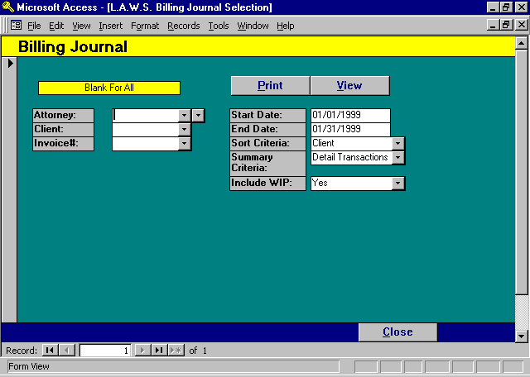

Billing Journal Selection Screen

ATTORNEY
Specifies the attorney to be included on the report. If the Attorney is left blank, all attorneys will be included on the report. If an attorney is specified, only transactions associated with the entered attorney will be included on the report.

CLIENT
Specifies the clients to be included on the report. If the Client is left blank, all clients will be included on the report. If a client is specified, only transactions associated with the entered client will be included on the report.

START & END DATE
Identifies the date range for inclusion of statement invoices on the Billing Journal. The default dates are the month range of the Time Entry Cutoff Date. The Start and End Dates should be entered using the Standard Date Format.

INVOICE #:
Allows selection of a single invoice. Used primarily when generating Split Bill Worksheets.
SORT CRITERIA
Specifies how billing information on the Billing Journal should be grouped. The available sort options include:
Client The Billing Journal is sorted by client code without page breaks by attorney.
Contributing
Attorney: The Billing Journal is sorted and totaled by client within contributing attorney. Page breaks
follow each contributing attorney unless the “Attorney Total” Summary Criteria is specified.
Billing Attorney: The Billing Journal is sorted and totaled by client within billing attorney. Page breaks follow
each billing attorney unless the “Attorney Total” Summary Criteria is specified.
Invoice: The Billing Journal is sorted and totaled by invoice number regardless of Client or Attorney.

SUMMARY CRITERIA
Specifies how information contained on the Billing Journal should be summarized. The available options Include:
Attorney
Totals: A single line will be printed by attorney summarizing billing performance within the specified
date range. This option works in conjunction with the Sort Criteria. If the Sort Criteria is
contributing attorney, then the information is summarized into one line per contributing
attorney. Otherwise, the report will summarize by billing attorney. Page breaks do not occur
after attorneys when “Attorney Totals” are chosen.
Client Totals: A single line will be printed summarizing client performance. Attorney totals are computed if
applicable.
Matter Totals: A single line will be printed summarizing matter performance. Attorney and/or client totals are
computed if applicable.
Detail
Transactions: Each individual invoice dated within the date range will be printed on the report. Client,
matter and attorney totals if applicable will be computed and printed on the report. A line
item within the report is generated for each attorney associated with the invoice.

Split Bill
Worksheet: Prints a split bill worksheet report that lists the general file and the associated billings to
each split client. The percentages per client are noted below each distribution total.

Global
Worksheet: Prints a split bill worksheet report that lists the general file and the associated billings to
each split client. The global percentages per client are noted in the header record and footer record, but not with each invoice.

SB Worksheet
No Pct: Prints a split bill worksheet report that lists the general file and the associated billings to
each split client. The percentages per split client are not noted below each distribution total. Computed percentages per client are noted in the report footer.

INCLUED WIP
Specifies if WIP Fees and Hours billed should be included on the billing journal. Available Options: “Yes” or “No”.

Samples of the Billing Journal can be found on the following pages.

Sample: Billing Journal - Summary by Attorney within Contributing Attorney

Sample: Billing Journal - Summary by Invoice

Sample Billing Journal – Split Bill Worksheet

L.A.W.S. CORPORATION - DEMONSTRATION Attorney: * All * Start Date Jan 01/1997
Billing Journal by: Contributing Attorney Client: * All * End Date: Dec 31/1997
A/R Fees
Attorney Total AR A/R Fees A/R Disb A/R Exp WIP Fees +/- WIP Hours
_________________________________________________________________________________________________________________________________________________________________________
Alan A Apple Berry (AAA) $3,217.66 $3,068.16 $57.00 $92.50 $2,985.00 $83.16 17.90
Barker B Bob (BBB) $633.00 $454.00 $150.00 $29.00 $470.00 ($16.00) 3.80
Carol C Cliffton (CCC) $975.00 $750.00 $225.00 $0.00 $750.00 $0.00 8.50
Alice B Cotton (ABC) $156.25 $156.25 $0.00 $0.00 $156.25 $0.00 2.75
Fred K Geissler (FKG) $0.00 $0.00 $0.00 $0.00
Susan S Jones (SSJ) $650.00 $625.00 $25.00 $0.00 $625.00 $0.00 5.00
Paul D Karlsberg (PDK) $78,452.84 $78,220.34 $86.75 $145.75 $42,560.00 $35,660.34 397.95
John J Kingston (JJK) $561.25 $561.25 $0.00 $0.00 $561.25 $0.00 5.75
Mary P LARSON (MPL) $975.00 $975.00 $0.00 $0.00 $975.00 $0.00 29.10
MARY M MORGAN (MMM) $887.50 $887.50 $0.00 $0.00 $887.50 $0.00 7.50
Walter W Wilson (WWW) $1,325.00 $1,325.00 $0.00 $0.00 $1,325.00 $0.00 13.25
Firm Total: $87,833.50 $87,022.50 $543.75 $267.25 $51,295.00 $35,727.50 491.50

_________________________________________________________________________________________________________________________________________________________________________
Copyright 1998 L.A.W.S. Corporation 3/25/98 10:32:14 AM
AR1_AtyAty Sorted Alphabetically by Accountant Last Name 1
Billing / AR Menus -- Billing Journal
L.A.W.S. CORPORATION -DEMONSTRATION Attorney: * All * Start Date Apr 01/1997
Billing Journal by Invoice Client: * All * End Date: Apr 30/1997
A/R Fees
Stmt# Date Client Case Bill Atty Total A/R A/R Fees A/R Disb A/R Exp Wip Fees +/- Wip Fees Hours
_______________________________________________________________________________________________________________________________________________________________________________________
350 04/09/1997 (DEAN) Dean Plating (GEN) General Programming PDK ($200.00) ($200.00) $0.00 $0.00 $0.00 ($200.00) 0.00
Services
368 04/02/1997 (BAILEY) Bailey Construction(LOAN) Construction Loan PDK $0.00 $0.00 $0.00 $0.00 $0.00 $0.00 0.00
369 04/03/1997 (DEAN) Dean Plating (GEN) General Programming PDK $135.00 $135.00 $0.00 $0.00 $135.00 $0.00 0.90
Services
372 04/03/1997 (BAILEY) Bailey Construction(TWO) Test MMM $350.00 $350.00 $0.00 $0.00 $350.00 $0.00 3.50
373 04/03/1997 (140) MMIC (001) Smith vs Jnes PDK $700.00 $625.00 $50.00 $25.00 $625.00 $0.00 6.50
374 04/03/1997 (BAILEY) Bailey Construction (2) PDK $25.00 $0.00 $0.00 $25.00 $0.00 $0.00 0.00
374 04/03/1997 (BAILEY) Bailey Construction(ONE) One West Blvd PDK $30.00 $30.00 $0.00 $0.00 $30.00 $0.00 0.20
375 04/03/1997 (BAILEY) Bailey Construction(LOAN) Construction Loan PDK $365.00 $350.00 $15.00 $0.00 $300.00 $50.00 3.00
376 04/03/1997 (CARSON) Carson (5) Carson - Matter #5 PDK $290.00 $290.00 $0.00 $0.00 $290.00 $0.00 4.40
377 04/03/1997 (CHEATHAM) Cheatham (123) Art Work - Simpson PDK $3.75 $0.00 $0.00 $3.75 $0.00 $0.00 2.30
378 04/03/1997 (SWB) Smith, Wilson And (LAWS) General PDK $31.25 $0.00 $0.00 $31.25 $0.00 $0.00 0.00
Programming Services
379 04/03/1997 (WARD) Ward Paint (GEN) General Programming PDK $100.00 $100.00 $0.00 $0.00 $100.00 $0.00 1.50
& Support Services
380 04/03/1997 (1) Water Corporation (98770) DEMO PDK $0.00 $0.00 $0.00 $0.00 $0.00 $0.00 0.00
380 04/03/1997 (1) Water Corporation (98769) EPA VIOLATION PDK $0.00 $0.00 $0.00 $0.00 $0.00 $0.00 0.00
DUPLICATE ENTRY
381 04/03/1997 (PI) Pers. Inj (1) Jones PDK $0.00 $0.00 $0.00 $0.00 $0.00 $0.00 0.00
382 04/03/1997 (SWB) Smith, Wilson And (11198) NEW MATTER PDK $30,000.00 $30,000.00 $0.00 $0.00 $30,000.00 $0.00 300.00
384 04/09/1997 (1) Water Corporation (98769) EPA VIOLATION PDK $0.00 $0.00 $0.00 $0.00 $0.00 $0.00 0.00
DUPLICATE ENTRY
385 04/09/1997 (1) Water Corporation PDK $835.00 $780.00 $50.00 $5.00 $780.00 $0.00 5.20
387 04/09/1997 (DEAN) Dean Plating (GEN) General Programming PDK $200.00 $200.00 $0.00 $0.00 $200.00 $0.00 2.00
Services
388 04/09/1997 (1) Water Corporation (98771) Testing report for FKG $0.00 $0.00 $0.00 $0.00 $0.00 $0.00 0.00
cardelli
389 04/09/1997 (1) Water Corporation FKG $0.00 $0.00 $0.00 $0.00 $0.00 $0.00 0.00
390 04/09/1997 (1) Water Corporation FKG $0.00 $0.00 $0.00 $0.00 $0.00 $0.00 0.00
392 04/11/1997 (1) Water Corporation (98767) EPA VIOLATION AAA $285.00 $240.00 $25.00 $20.00 $240.00 $0.00 1.60
#76589
393 04/11/1997 (AIRWAY) Airway (98766) Tax PDK $374.00 $205.00 $150.00 $19.00 $205.00 $0.00 10.30
394 04/11/1997 (1) Water Corporation (98770) DEMO PDK $40,050.00 $40,000.00 $50.00 $0.00 $0.00 $40,000.00 0.00
395 04/11/1997 (CARSON) Carson (LAWS) Cccc AAA $3,814.50 $3,710.00 $32.00 $72.50 $3,710.00 $0.00 28.85
Firm Total: $77,388.50 $76,815.00 $372.00 $201.50 $36,965.00 $39,850.00 370.25

_______________________________________________________________________________________________________________________________________________________________________________________
Copyright 1998 L.A.W.S. Corporation 3/24/98 4:07:15 PM
Sorted Alphabetically by Invoice # 1
L.A.W.S. Corporation - Demonstration Start Date: Jan 03/1999 End Date: Mar 31/1999 Invoice#: 502
Split Bill Worksheet - Distribution Summary by Carrier General Client: Bailey Construction (BAILEY)
Matter Total ABC CARSON
_________________________________________________________________________________________________________________________________________________________________________
ONE One West Blvd $600.00 $300.00 $300.00 $0.00 $0.00 $0.00 $0.00 $0.00 $0.00 $0.00
100.00% 50.00% 50.00% 0.00% 0.00% 0.00% 0.00% 0.00% 0.00% 0.00%
_________________________________________________________________________________________________________________________________________________________________________
Report Total- Fees: $600.00 $300.00 $300.00 $0.00 $0.00 $0.00 $0.00 $0.00 $0.00 $0.00
Report Total- Costs: $0.00 $0.00 $0.00 $0.00 $0.00 $0.00 $0.00 $0.00 $0.00 $0.00
Report Total: $600.00 $300.00 $300.00 $0.00 $0.00 $0.00 $0.00 $0.00 $0.00 $0.00
100.00% 50.00% 50.00% 0.00% 0.00% 0.00% 0.00% 0.00% 0.00% 0.00%

_________________________________________________________________________________________________________________________________________________________________________
Copyright 1999 L.A.W.S. Corporation 3/9/99 7:18:20 AM
AR1_SBW Split Bill Worksheet - Distribution by Carrier

REVERSE BILLS

The Reverse Bill option allows previously finalized bills to be reversed. Reversal occurs at the matter level. Accordingly, if multiple matters should be reversed for a given client, even if the different matters have the same invoice number, than each matter must be reversed individually. The reversal process involves the reactivation of the billed work in process and the relief of the associated accounts receivable. Invoices to which payments and/or adjustments have been applied cannot be reversed until the payment and/or adjustments have been reversed through the accounts receivable program.

After selecting the Reverse Bills option, the following form is displayed:

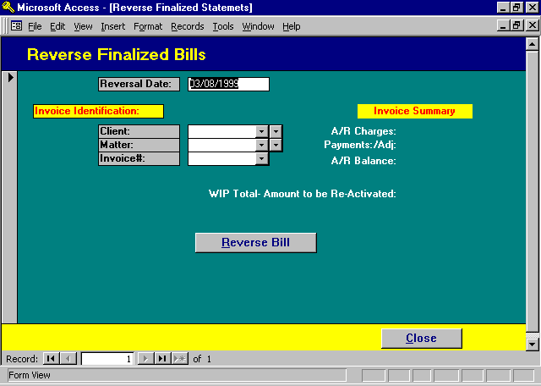

Reverse Finalized Bills Selection Screen

REVERSAL DATE
Enter the date the reversal should be posted. The attorneys received initial billing credit for the billed fees based on the original invoice date. The same attorneys will receive negative credit for the fees reversed based on the reversal date. For Example, a bill containing $100 fees was generated in March. The same bill is reversed in April. A total of $100 Credit will be awarded to attorneys in March and $100 negative credit will be awarded in April. If the reversal date is the same month as the invoice date month, then the positive and negative credit will negate themselves.

CLIENT/MATTER/INVOICE#
The client, matter, and invoice # must be entered to identify the invoice to be reversed. Each field has a drop down box allowing convenient scanning of desired data. If the bill to be reversed is a sub totaled bill, then all matters contained on the original statement must be reversed individually.

Once the invoice is identified, L.A.W.S. summarizes the invoices initial charges, accumulated payments and adjustments, and current balance. The invoice summary should be reviewed.

If payments or adjustments are present, then the bill may not be reversed. Payments or adjustments must be reversed exactly as they were originally entered. If the original receipt was distributed against several expense distribution line items as well as against several fee line items for different attorneys, then the receipt needs to be reversed exactly as originally entered. If doubt exists as to how the original receipt was entered, run a Detail Accounts Receivable report selecting out the original receipt. (See the Detail Accounts Receivable report in the Accounts Receivable Chapter of this manual.)

The form also displays the amount of the accounts receivable which will be reversed as well as the amount of WIP to be re-activated. These values may differ if fee overrides, discounts and/or administrative charges were included on the invoice.

Again, if payments or adjustments have been applied to the invoice, then they must be reversed through the accounts receivable program prior to continuing.

REVERSE BILL BUTTON
After the invoice to be reversed is identified and visually verified, initiate the reversal process by pressing the Reverse Bill button.

Notations are displayed on the screen as the WIP is being re-activated and as the accounts receivable entries are being relieved.

L.A.W.S. provides extensive reversal audit trails. Each reactivated WIP entry is noted with reversal date and original invoice number in the WIP System Notes. These notes are visible through the WIP Inquiry option within time processing. Reversal transactions are posted to the Accounts Receivable system allowing the review of the initial billing along with the reversal activity.

PRINT DUPLICATE BILL
Duplicate copies of previously finalized client invoices may be generated through the Print Duplicate Bill procedure. The user must identify an existing client/matter/invoice combination. L.A.W.S. then retrieves and reprints the work in process contained on the original bill. L.A.W.S. does not save the billing options associated with the original invoice. Accordingly, when a duplicate bill is generated, the user must supply the desired billing options. If a sub totaled bill is to be re-printed, all matters which were included on the original statement must be entered individually through the Print Duplicate Client Statement form.

After selecting Print Duplicate Bill, the following form is displayed.

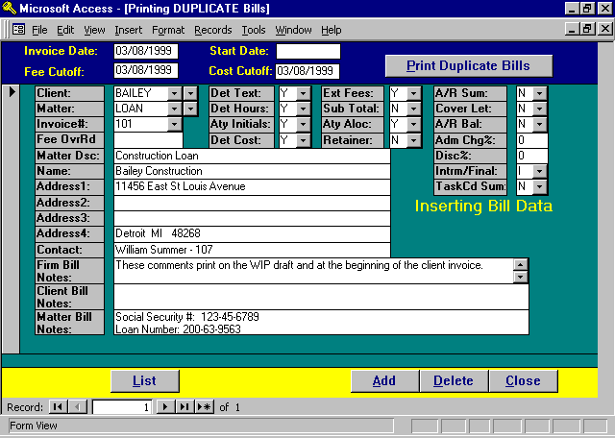

Print Duplicate Bill Screen

The selection screen for printing duplicate bills is very similar to the additional data screen associated with printing regular client invoices. The difference between the programs is that the regular statement program includes only un-billed WIP and offers the option of finalization whereas the duplicate bill program deals only with billed WIP and does not offer the option of finalizing.

The invoice number MUST be entered when running duplicate bills identifying the invoice that is to be re-printed. If a sub-total bill is to be re-printed, enter each matter that is to appear on the duplicate bill individually. Ensure that the sub-total option is set to “Y”.

The duplicate bill program does not allow the option of noting a retainer which was applied to a bill, showing the outstanding A/R balance at the time of the bill, or of printing the A/R summary sheet. The retainer and A/R balance information is not saved when the regular client statement is generated. There are many variables associated with the re-computation of these balances and it is very likely that the duplicated bill would have different A/R and /or retainer balances from the original bill.
INFORMATION TO ENTER
The allowable data to be entered when generating a duplicate bill is virtually the same as when a regular invoice is processed. Please refer to the “Print Client Bills-Additional Data Button” section of Client Billing for a detailed description of the allowable options.

LIST BUTTON
The List Button allows the user to display all matters selected for duplicate bill generation. After pressing the List Button, the following form appears.

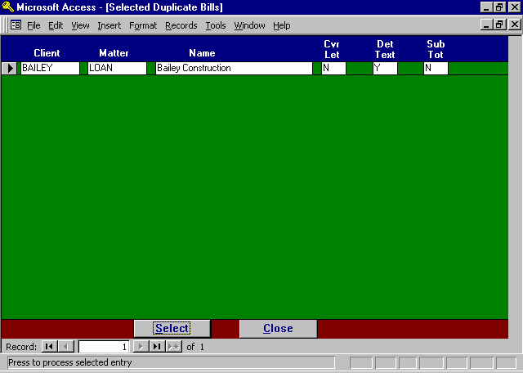

Information may not be entered through the Selected Duplicate Bills form, data may be reviewed only. To select a particular matter for modification, position the cursor on the desired record using the appropriate record selector, then press the SELECT Button. The duplicate billing selection screen will then be displayed.

The notation “Duplicate Invoice”. is printed at the bottom of each page of the duplicate bill.

A sample Duplicate Bill is displayed on the following page.

Sample: Duplicate Bill

L.A.W.S. CORPORATION - DEMONSTRATION
PO Box 455
Roscommon, MI 48653
(517) 275 4843
38-1234567
Bailey Construction March 12,1998
11456 East St Louis Avenue
Detroit MI 48268
Attention: Mr. James Connor Invoice Number: 407
CCC

For professional services rendered through March 12,1998 BAILEY
_____________________________________________________________________________________________________________________________________________
Date of
Service Description of Service Time Value
_____________________________________________________________________________________________________________________________________________
(132) ABC Corporation Vs James Smith & Geroge Wilson
Reference#: 028-36-9643
Insured: Mr. James Smith
Incident Date: 01/01/1993

Fees:
03/14/1997 Conference with Smith 2.00 $300.00

03/25/1997 Conference with client regarding ... 0.90 $0.00

03/28/1997 Conference with Smith 0.75 $112.50

Total Fees: 3.65 Hours $412.50
Costs:
PhotoCopy Charges $25.00
02/01/1997 Jury Fee $100.00
02/27/1997 Telephone Charges $61.35

Total Costs: $186.35
Current Charges this Matter: $598.85
Amount Due: $598.85

_____________________________________________________________________________________________________________________________________________

Duplicate Invoice

