GENERAL LEDGER
TABLE OF CONTENTS

GENERAL LEDGER 298
General Ledger Menu 298
Overview Of The General Ledger Account Number Structure 299
Profit Center Processing 300
G/L MAINTENANCE 302
General Ledger Maintenance Screen 302
Budget Values 304
Budget Values by Month Screen 304
JOURNAL ENTRY SOURCE MAINTENANCE 307
Journal Entry Source Maintenance Screen 307
JOURNAL ENTRY PROCESSING 309
Journal Entry Processing Screen 309
Print/View Button 310
Post Journal Entries 310
Out Of Balance Journal Entries 310
Sample: Journal Entry Edit List 311
YEAR END CLOSE 313
Year End Close Screen 314
Sample: Year End Close Journal Entry 315
JOURNAL ENTRY SUMMARY REPORT 317
Journal Entry Summary Report Selection 317
Sample: Journal Entry Summary Report 318
TRIAL BALANCE 320
Trial Balance Selection Screen 320
Sample: Trial Balance 320
DETAIL GENERAL LEDGER 322
Detail General Ledger Selection 322
Sample: Detail General Ledger Report 323
CHART OF ACCOUNTS 325
Chart of Accounts Selection 325
Sample: Chart of Accounts 325
FINANCIAL STATEMENTS 327
Financial Statement Processing Screen 327
Sample: Financial Statement Format List - Income Statement 333
Sample: Financial Statement Format List - Balance Sheet 333
Sample: Error List 333
Sample: Income Statement 333
Sample: Budget Statement 333
Sample: Balance Sheet 333
DAILY ACTIVITY 340
Daily Activity Selection 340
Inquiry Option 341
Daily Cash Inquiry Option 341
A/R Inquiry Option 342
WIP Inquiry Option 343
Daily Activity Report Options 344
Sample: Daily Cash, Accounts Receivable and WIP Activity 344
Sample: Monthly Summary of Cash, A/R and WIP 344

GENERAL LEDGER

The L.A.W.S. General Ledger module is fully integrated with all other systems within L.A.W.S. Revenue is automatically posted from cash receipts processing. Expenses are posted through cash disbursements. Trust activity may, or may not, be posted to the general ledger based on the firm’s accounting desires. Manual Journal Entries may be posted through the General Ledger system to account for all non-system generated entries.

L.A.W.S. utilizes the cash basis accounting method. Accordingly, WIP, A/R and open payable balances are not maintained within the general ledger. If accrual basis accounting is desired, journal entries may be generated at month end recording the desired accrual activity.

The General Ledger contains a variety of standard General Ledger reports that summarize or analyze firm performance. Income Statements, Balance Sheets and supporting schedules are all user defined allowing these statements to be customized to the firms specific needs.

After selecting GENERAL LEDGER from the MASTER MENU, the following form is displayed.

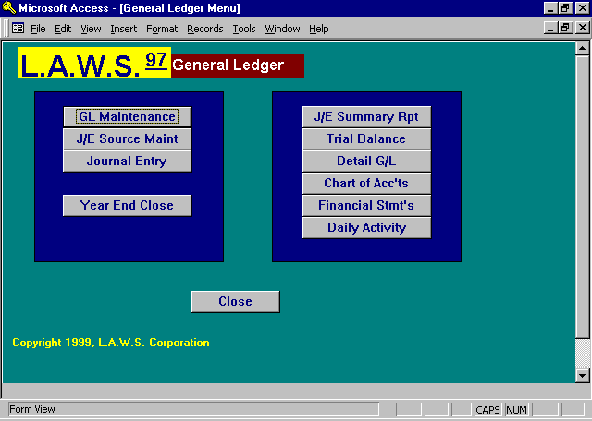

General Ledger Menu

A detailed description of each General Ledger function follows.

Overview Of The General Ledger Account Number Structure

The General Ledger Account Number consists of four components: Firm Number, Major Account, Sub Account, and Attorney. The combination of these components allow the firms Chart of Accounts to be as simple or as complex as desired. A simple general ledger structure would utilize the Firm Number and Major Account only. The Sub Account and Attorney would be blank. More complex structures would include the use of Sub Accounts and/or Attorneys codes. It is always best to keep the Chart of Accounts as simple as possible. Utilize the more complex features of the general ledger number only if they provide meaning to the firm. Initially, a simple chart of accounts should be developed, and modifications involving Sub Accounts and/or Attorneys may be phased in over time as needed.

Simple Chart of Accounts

An Example of a simple Chart would be as follows:

Firm # Major Account Description
1 500 Auto Expense
1 501 Insurance

More Detailed Chart of Accounts using Sub-Accounts

A more detailed general ledger structure may be established through the use of sub accounts as detailed below:

Firm # Major Account Sub Account Description
1 500 01 Auto Expense-Gas and Oil
1 500 02 Auto Expense-Leasing
1 500 03 Auto Expense-Parking

1 501 01 Insurance-Liability
1 501 02 insurance-Malpractice

Complex Chart of Accounts using Sub-Accounts and Attorney Codes

If desired, the chart may be further enhanced by using the attorney code as described below:

Firm # Major Account Sub Account Atty Description
1 500 01 JJK Auto Expense-JJK
1 500 01 PDK Auto Expense -PDK
1 500 01 VJC Auto Expense-VJC

The use of Sub Accounts and Attorneys provide very useful accumulation and reporting tools, but be sure not to make the chart more complex than it needs to be.

Profit Center Processing

L.A.W.S. supports the use of Profit Centers. A profit center is a division within the firm. This division may be physical such as multiple locations, or logical such as multiple areas of practice. If desired, the firm may elect to track performance within these divisions, or Profit Centers.

Example: Assume the firm has two locations, Detroit and Chicago. The firm wants to track profitability by location.

To implement Profit Center Accounting, perform the following steps:

1) Identify the desired Profit Centers and assign Profit Center Numbers.
In this example, the profit centers would correspond to physical location, Detroit and Chicago. The Profit Center codes should be numeric usually starting with one. In this example the profit centers are set defined as follows:
Detroit - 01
Chicago - 02

2) Create General Ledger Account Numbers utilizing Profit Centers for all relevant accounts.
Since the firm wants to capture productivity by location, the firm must identify general ledger accounts by profit center. In this instance, the Sub Account identifies the Profit Center. A sampling of the account structure follows:

Account Number
Firm - Major Account - Profit Center Description
1 400 Fees
1 400 01 Fees - Detroit
1 400 02 Fees - Chicago

1 500 Client Costs
1 500 01 Client Costs - Detroit
1 500 02 Client Costs - Chicago

1 501 01 Office Rent - Detroit
1 501 02 Office Rent - Chicago

1 502 01 Utilities - Detroit
1 502 02 Utilities - Chicago
Etc.

3) Identify Matters with the correct Profit Center.
Each Matter may be assigned a profit center through Matter File Maintenance. (See Matter File Maintenance within the Data File Maintenance chapter for additional information.) All matters which reside in Detroit should have the profit centers defined as profit center 01 while the Chicago files should be defined as profit center 02. It is not required that all matters be assigned a profit center. Financial activity associated with non-profit center matters will be posted to non-profit center accounts.

The profit center field within Matter File Maintenance is not a verified field. L.A.W.S. will accept any character whatsoever. Ensure that the Profit Centers are entered exactly as the Sub Account numbers were assigned within the chart of accounts.

4) Posting Revenue to Profit Centers
L.A.W.S. automatically posts revenue from the Cash Receipts Processing module within the Accounts Receivable system. The general ledger numbers utilized by L.A.W.S. for Cash received, Fees received, disbursements reimbursed and expenses reimbursed are stored in the Firm File. These numbers should be stored without sub accounts. In this example, the fee account stored in the Firm File would be 1 400 (without a Sub-Account). General ledger numbers for receipts are based on the matter that generated the receipt. L.A.W.S. retrieves the standard general ledger number from Firm Maintenance and automatically inserts the profit center assigned to the matter as the sub-account assigned to the standard general ledger account number. If the new general ledger number exists, including the profit center as the sub account, then L.A.W.S. will post the receipt information to the newly created account. Otherwise, L.A.W.S. will use the original General Ledger number without the profit center as the sub account.

In this example, all fee activity associated with matters within the Detroit profit center will post to the fee account 1 400 01. All fee activity for matters within the Chicago profit center will post to the fee account 1 400 02. Fees received for matters not assigned to profit centers will post to the standard fee account 1 400. The same logic is applied for all the other standard general ledger accounts retrieved from the Firm File including cash, disbursements and expenses.

Client Miscellaneous receipts utilize the same logic for retainers received and cost reimbursements. The actual General Ledger Account number must be specified for non-client miscellaneous receipts. Accordingly, the user simply selects the desired general ledger number with or without a profit center.

5) Posting Client Costs to Profit Centers
All Client Costs are posted to the General Ledger and Work In Process through the Cash Disbursement module. The standard Client Cost general ledger distribution number is the "Disb Chg" account number stored in the Firm file. Please review Firm File Maintenance within the Data File Maintenance chapter of this manual for review of the firm's standard general ledger numbers. The "Disb Chg" general ledger number should be entered into Firm Maintenance without a sub account.

As client costs are entered, L.A.W.S. automatically appends the matter's profit center as the sub account to the standard "Disb Chg" general ledger number. If a valid general ledger number is created, L.A.W.S. will utilize the newly created number, otherwise L.A.W.S. will use the standard account number without the appended profit center. The same logic applies to cash the cash account.

Specific general ledger numbers must be selected for non-client cost disbursements. For example, the Detroit utility check will be posted to the 1 502 01 general ledger account number, while the Chicago utility check will be distributed to the 1 502 02 general ledger account number.

G/L MAINTENANCE

General Ledger Maintenance allows the creation of, or modification to, account numbers constituting the firms Chart of Accounts. The account number consists of four sections including the Firm Number, Major Account, Sub Account and Attorney code. The Firm Number and Major Account are required, but the Sub Account and Attorney are not required.

After Selecting the G/L MAINTENANCE option, the following form is displayed:

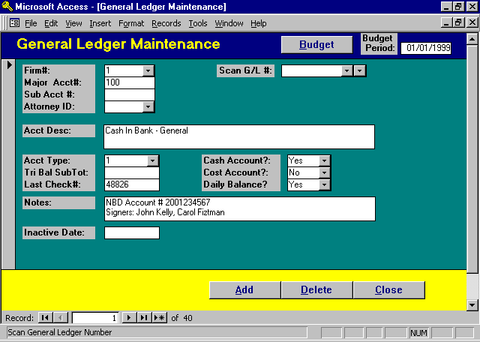

General Ledger Maintenance Screen

FIRM #
Enter the firm number associated with this entry. Firms must be defined through Firm Maintenance prior to being used.

MAJOR ACCT #
Enter the major account associated with this entry. The Major Account Numbers are typically 3 - 4 digits in length. The generally accepted grouping of major account numbers are as follows:

Account Number Range Account Type
100 - 199 or 1000 - 1999 Asset
200 - 299 or 2000 - 2999 Liability
300 - 399 or 3000 - 3999 Equity
400 - 499 or 4000 - 4999 Revenue
500 - 999 or 5000 - 9999 Expense

(See the above explanation of the General Ledger Account Number for detailed review.)
SUB ACCT#
Enter sub account associated with this entry. The sub account is optional. It is often used to identify distinctions such as profit centers or physical locations associated with the firm.

(See the above explanation of the General Ledger Account Number and Profit Center Processing for detailed review of the use of this field.)

ATTORNEY ID
Enter the attorney associated with this account. The attorney is optional. If used, the attorney is verified and must be defined through Attorney File Maintenance.

SCAN G/L #
Use this field to scan the existing chart of accounts. Once the account is selected, the relevant information is displayed for the selected account. This field may be viewed by either account number or account description. The left dropdown box references the account number while the right dropdown box references description.

ACCOUNT DESCRIPTION
Enter the description of the referenced account.

ACCOUNT TYPE
Enter the type of account. The available options are:
1 Asset
2 Liability
3 Equity
4 Revenue
5 Expenses

TRI BAL SUB TOT
This is a user-defined field, which determines subtotal classifications on the trial balance. All accounts with the same trial balance sub total code will be sub-totaled together, within the account type, on the trial balance.

LAST CHECK #
L.A.W.S. maintains the last check number used per cash account. If necessary, this number may be changed to reflect the starting point of a new batch of checks. This number is displayed when checks are printed. Modifications made to the check number when the check is printed are naturally carried back to this field.

CASH ACCOUNT
Use this field to classify cash accounts. Each Disbursement entry consists of a credit to cash and a debit to one or more distribution accounts. Only General Ledger Numbers classified as a Cash Account may be used as the credit account. The available options include:
Yes Disbursement checks can be drawn, credited, against this account.
No Disbursement checks cannot be drawn, credited, against this account.

COST ACCOUNT
Use this field to classify cost accounts. Client cost checks credit cash and debit a client cost account. Accounts debited on behalf of a client cost disbursement need to be marked as a “Yes” in this field. The available options include:
Yes Client cost amounts can be debited to this account.
No Client cost amounts cannot be debited to this account.

This option is ignored if the Use Client Cost Account option is set to No in Firm Maintenance.

DAILY BALANCE
A Daily Balance report, listed on the General Ledger Menu summarizes Cash, Accounts Receivable and WIP Balances. This Daily Balance field identifies the Cash general ledger accounts that should be summarized and reported as cash in the Daily Balance report. The available options include:
Yes The account will be summarized and reported as cash on the Daily Balance report.
No The account will not be summarized and reported as cash on the Daily Balance report.
NOTES
Enter notes associated with this account. Examples may be bank account numbers, contact people, serial numbers of assets, etc.

INACTIVE DATE
Specifies if the active status of the account. Accounts with blank Inactive Dates are active accounts and may be utilized throughout the system. Accounts containing an Inactive Date can not be utilized for day to day postings. As a general rule G/L account numbers should not be deleted since access to prior years history would be eliminated. A better solution is to classify unnecessary accounts as inactive eliminating current use of the account but allowing access to the prior years activity.

Budget Values

BUDGET Button
L.A.W.S. provides the ability of generating Budget Reports that compare actual financial performance against budgeted values. Budget values are normally entered for revenue and expense accounts only.

BUDGET PERIOD
Specifies starting date for display of the 12 months budget activity. The budget period always defaults to the fiscal start date noted in the firm file. L.A.W.S. can store budgets for multiple years simultaneously. For example, if the Budget Period is identified as 1/1/98, the 12 months within 1998 will be displayed. If the Budget Period of 1/1/99 is entered, the values for the 12 months within 1999 will be displayed.

Budget values are always entered for the general ledger number currently displayed. Ensure that the desired general ledger number is displayed prior to clicking the Budget Button. After clicking the Budget Button the following form is displayed.
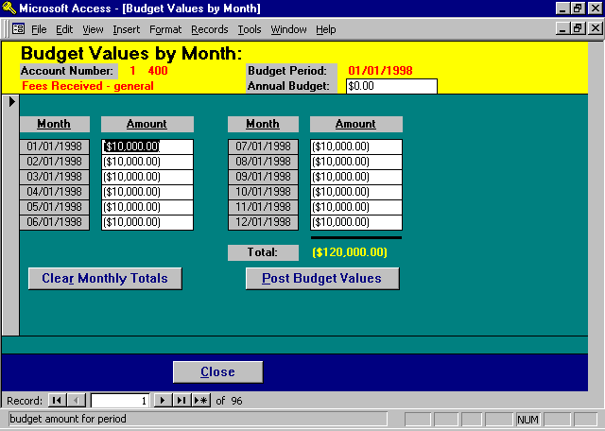

Budget Values by Month Screen

Note: Budget reports are run using the user defined financial statement formats. It is possible, likely, that multiple general ledger accounts are combined within each line which prints on the financial statement. It is not necessary that budget values be entered for each account number but simply for a single account number within the line item.

Example: The firm wishes to establish a budget for auto expense of $6,000. The auto expense line item on the Financial Statement Format may consist of three accounts including:

Account Description Actual Charges Budget Amount
Auto - Lease Charges $1200 $ 6000
Auto - Repair and Maintenance $1000 0
Auto - Gas and Oil $ 3600 0
Total Auto Expense $ 5800 $ 6000

When the Budget Report prints, a single line item will print showing auto expense of $5800 and a corresponding budget amount of $6000 with a computed variance of -$200.

If desired, budget values could have been entered for each individual account within the line item, but is not necessary.

ACCOUNT NUMBER
The account number for which budget values are being entered. This field is informational only.

BUDGET PERIOD
The budget period carried over from the prior screen. This field is informational only.

ANNUAL BUDGET
Allows the entry of an annual budget value. This annual budget value will be divided by 12 and inserted into each months budget value.

The annual budget distribution will be performed only if the existing monthly distribution values total zero. If monthly budget distribution values have previously been entered, an error message is displayed and the annual budget distribution is canceled. If unwanted values exist, use the Clear Monthly Totals button to clear the existing totals, then enter the annual budget amount.

Note: Budget values must be entered consistent with the natural storage of values in the general ledger. Budget values associated with revenue accounts must be posted as credits (negative values), and expenses must be entered as debits (positive values).

MONTH / AMOUNT (Monthly Distributions)
Specifies the budget dollar values assigned to each month within the budget period. L.A.W.S. will automatically distribute the Annual Budget value evenly between months. If desired, the monthly amounts may be entered differently to reflect seasonal fluctuations.

TOTAL
The total of the monthly budget amounts. This is informational and visual verification purposed only.
CLEAR MONTHLY TOTALS Button

The Clear Monthly Totals button provides a simple method of clearing monthly accumulations from the displayed 12 budget months. It performs the same function as manually tabbing through the form zeroing out each months budget value. After pressing the Clear Monthly Totals Button, the following message is displayed.

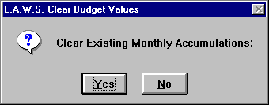

The available options include:
Yes Will clear the monthly totals.
No Will not clear the monthly totals.

POST BUDGET VALUES

Once the budget values have been assigned as desired to the budget months, press the Post Budget Values button to store the entered values. After posting, the budget form is closed and the general ledger maintenance form is displayed.

NOTE: If the Post Budget Values is not pressed, budget values will not be posted. Accordingly, if budget values are cleared and re-entered, then the budget form is closed without pressing the Post Budget Value button, the original budget values originally displayed on the screen will remain. The clearing and re-entering of the budget values will be ignored.

JOURNAL ENTRY SOURCE MAINTENANCE

The JOURNAL ENTRY SOURCE defines the “source” of journal entries within L.A.W.S. All Journal Entry Sources utilized by L.A.W.S. come pre-loaded with the software so there is not a need to enter new sources. If desired, the descriptions or last assigned reference number maybe modified to meet the firms needs.

After selecting the J/E SOURCE MAINT selection, the following form is displayed.

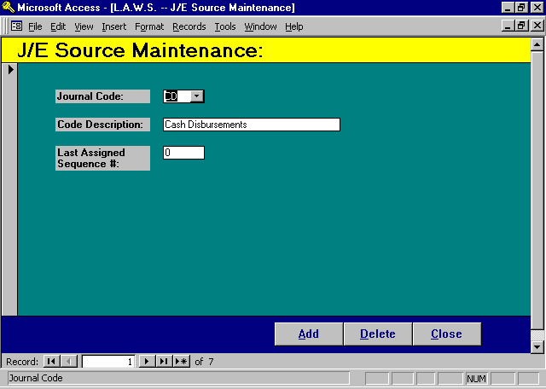

Journal Entry Source Maintenance Screen

JOURNAL CODE
The journal code identifies the type of journal entry. Standard journal codes used by L.A.W.S. include:
CD Cash Disbursements
CR Cash Receipts
TD Trust Disbursements
TR Trust Receipts
JE Manual Journal Entries
PR Payroll
YE Year End Close

The Source of the journal entry is automatically assigned by L.A.W.S. Additional User defined source codes will not be utilized.
Do not delete journal codes. An error may occur during posting to the general ledger if journal codes are deleted.

CODE DESCRIPTION
The description of the general ledger source code. Pre-defined descriptions are associated with the journal codes utilized by L.A.W.S. If desired, the descriptions may be changed.

LAST ASSIGNED SEQUENCE #
Every journal entry is automatically assigned one of the pre-defined source codes based on the source of the entry. Each journal entry is also assigned a consecutive sequence number within the source code. L.A.W.S. maintains the last assigned sequence number by journal entry source. If desired, this source may be reset at the start of each year.

JOURNAL ENTRY PROCESSING

All financial activity is posted to the general ledger through Journal Entries. Most Journal Entries are system created and posted through normal L.A.W.S. functions such as cash receipts and disbursements. Non-cash transactions or adjusting journal entries can be process through this Journal Entry Processing program.

L.A.W.S. utilizes the double entry bookkeeping method. Each Journal Entry must have offsetting debits and credits. Manual journal entries are automatically assigned a journal entry source code of “JE”.

After selecting Journal Entry, the following form is displayed:

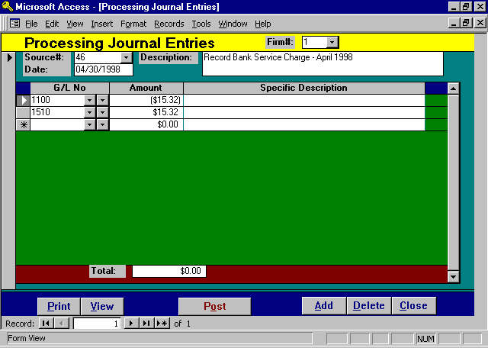

Journal Entry Processing Screen

FIRM #
Enter the firm number to which the journal entry applies. All account numbers within the journal entry must have the same firm #. The default firm number is one (1).

SOURCE #
The Journal Entry Source Number assigned to this manual journal entry. If a new journal entry is being processed, leave the source # blank and the next available Sequence Number associated with the “JE” Journal Entry Source code, will be assigned.

To reference an existing non-posted journal entry, use the drop down box to select the desired journal entry via the system assigned source number. All line items previously entered with this journal entry will be displayed.

DATE
Enter the date of the journal entry. The date must fall within the current fiscal year.

DESCRIPTION
Enter the global description pertaining to this journal entry. When this entry is posted, this description will be automatically posted with each line item. This is a required field.

The following columns are used to define the line items within the journal entry.

G/L NO
Enter the general ledger account number for which a value should be posted. All general ledger numbers must have the same firm number as identified within the header of the form. General Ledger Numbers may be selected by code using the left drop down box, or by the account description using the right drop down box.

AMOUNT
Enter the amount to be posted to the referenced G/L number. Debits are entered as positive numbers while credits are entered as negative.

SPECIFIC DESCRIPTION
If desired, a specific description may be associated with the referenced line item. Do not duplicate the global description. The entered specific description will automatically be added to the global description when posted.

TOTAL
Summarizes the total of all debits and credits contained in this journal entry. The entry is balanced if the total is zero.

Print/View Button

The Print/View button produces an edit listing of the current journal entry for visual verification.

A sample Journal Entry can be found at the end of this section.

Post Journal Entries

The POST button physically applies the journal entry transactions against the general ledger balances. If the journal entry is out of balance, a warning is displayed, but the posting is not automatically canceled.

After selecting POST, but before the actual posting commences, the following message is displayed.

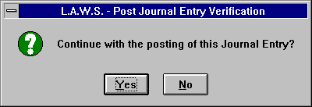

No- Will cancel the posting and return to the journal entry processing form.
Yes- Will post the journal entry to the general ledger, then delete this journal entry from the system.

Out Of Balance Journal Entries

If the journal entry is out-of-balance, (the total does not equal zero), the following warning message is displayed when you try to post.

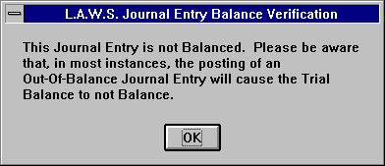

Out-of-balance entries MAY be posted, but be aware that out-of-balance entries might cause the trial balance not to balance.

Out-of-balance entries may be useful to correct a system posting error. For example, suppose a deposit is being processed, and for some reason, the fee account is not defined in the firm file. The system generated journal entry may be out of balance by the fee amount. An offsetting out of balance manual journal entry may be produced to correct this system entry.

When posting adjusting entries, it is a good idea to always refer to the original Journal Entry Source and Source number creating a viable audit trail.

A Sample Journal Entry is displayed on the following page.

Sample: Journal Entry Edit List
L.A.W.S. CORPORATION - DEMONSTRATION Manual Journal Entry
Journal Entry Edit: (Firm#: 1)
Source Date G/L Number Acct Description Debit Credit Description
_________________________________________________________________________________________________________________________________________________________________________
46 04/30/1998 Record Bank Service Charge - April 1998
1 100 Cash In Bank - General ($15.32)
_______________________________________________________________________________________________________________________________________________________
1 510 Office Expense $15.32
_______________________________________________________________________________________________________________________________________________________
Journal Entry Total: $15.32 ($15.32)

_________________________________________________________________________________________________________________________________________________________________________
Copyright 1998 L.A.W.S. Corporation 4/23/98 1:05:13 PM 1
rptGLJE Journal Edit Listing

YEAR END CLOSE

The Year End Close Procedure creates, then posts the year end closing journal entry. This entry will zero out the revenue and expense account balances then posts the difference to the firms Retained Earnings Account. It may be run multiple times per year. Each time the Year End Close is run, it closes transactions posted to the general ledger system since the last time the close was initiated. The close should be run initially after all normal day to day activity is completed for the year being closed. The close should be run a second time after all year end adjusting entries have been posted. If the prior years transactions are not cleared from the system, the prior years activity will be included in the current years beginning revenue and expense balances.

After selecting YEAR END CLOSE the following message is displayed

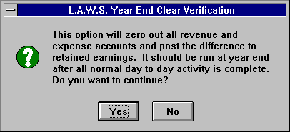

This is simply an informational message stating that the Year End Close option was selected. If it was selected in error, simple answer “No” to return to the G/L Menu, otherwise, select “Yes” to display the Year End Close Processing Screen displayed below.

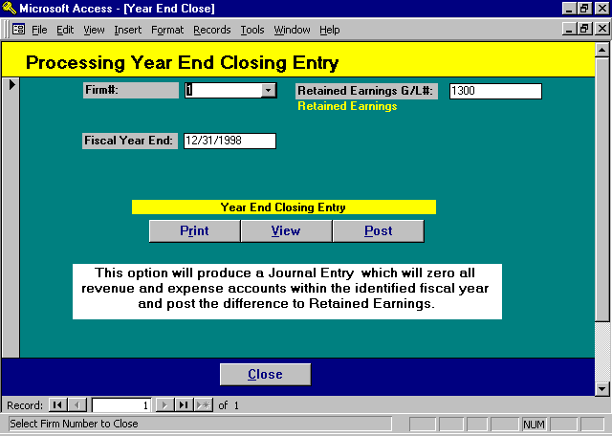

Year End Close Screen

FIRM #
Enter the firm number for which a closing entry should be produced. Firm number “1” is assumed. Once the firm is selected, the end date and retained earnings G/L # are automatically displayed based on the information in the Firm file.

FISCAL YEAR END
Enter the fiscal year end date corresponding to the year being closed. The system automatically adds one year to the fiscal start date in the Firm file as a default end date. This date may be modified as needed. The resulting journal entry will clear all revenue and expense activity through the specified Fiscal Year End Date.

RETAINED EARNINGS G/L #
The difference between total revenue and total expense will be posted to the retained earnings account noted in the Firm file. If the displayed account number is incorrect, the correction must be made through Firm Maintenance.

PRINT/VIEW BUTTON
The Print or View button will display the system generated closing entry.

A sample of this report can be found following this section.
POST BUTTON

The Post Button physically posts the system generated closing entry to the general ledger.

After pressing the Post Button, the following message is displayed:



Answering “Yes” will post the generated year end closing entry. “No” will return to the prior form.

A sample Year End Close Journal Entry is displayed on the following page.

Sample: Year End Close Journal Entry

L.A.W.S. CORPORATION - DEMONSTRATION
Year End Close Entry: (Firm#: 1)
_________________________________________________________________________________________________________________________________________________________________________
Source Date G/L Number Acct Description Debit Credit
YE 12/31/1998 400 Fees Received - general $8,620.50
400 AAA Fees Received - AAA $3,710.00
400 CCC Fees Received - CCC $3.00
400 FIRM Fees Received - Firm $149.32
400 PDK Fees received = PDK $49,119.54
400 01 AAA Fees Received - AAA - Profit Center 01 $475.00
401 Client Expense Reimbursement Account $1,420.99
402 Retainer's Received $3,340.00
500 Client Costs $362.36
500 01 AAA Client costs for alan Appleberry ($5.00)
500 02 PDK Client Costs for PDK $2,162.50
502 Rent Expense $175.00
506 Payroll Tax Expense ($359.81)
507 Payroll- Officers ($5,453.35)
508 Telephone Expense ($125.00)
508 01 Telephone Expense Reimbursement $2,500.00
508 02 Fax Reimbursement $161.50
509 Photocopy Expense ($5.00)
509 01 Photocopy Client Reimbursement $327.50
510 Office Expense ($140.32)
598 Postage $50.00
1300 Retained Earnings ($66,488.73)
_________________________________
Journal Entry Total: $72,577.21 ($72,577.21)

_

________________________________________________________________________________________________________________________________________________________________________
Copyright 1998 L.A.W.S. Corporation 12/31/1998 0:00:00 4/23/98 2:56:19 PM 1
rptGLYE - Year End Close Journal Entry

JOURNAL ENTRY SUMMARY REPORT

The purpose of the Journal Entry Summary Report is to reprint journal entries which have been previously posted to the general ledger. The JOURNAL ENTRY SUMMARY REPORT is a useful tool in analysis of an out of balance general ledger. All selection criteria works in conjunction with each other allowing for as broad or as narrow reporting as desired.

After selecting the J/E SUMMARY option, the following form is displayed.

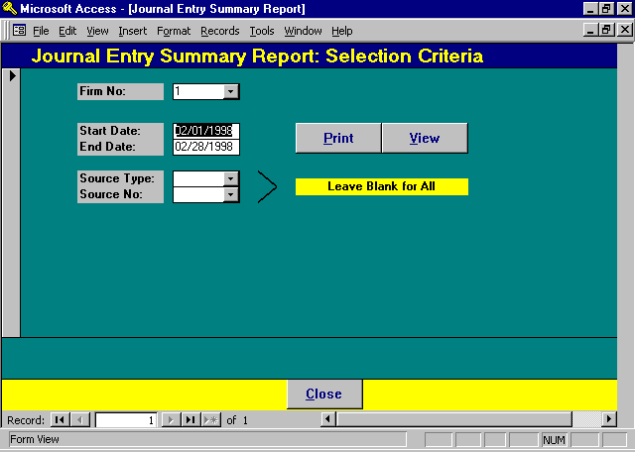

Journal Entry Summary Report Selection

FIRM NO
Enter the firm number with which the journal entries are associated. The default Firm # is “1”.

START AND END DATES
Enter the date range for inclusion of data on the report. All transactions falling within this date range, and meeting the other criteria, will be included on the report. The default dates for the report are the first and last day of the month referenced within the WIP Entry Cutoff Date in the Firm file.

SOURCE TYPE
Enter the desired “Source Type” of the journal entries to be selected. Leave the “Source Type” blank for all types. The available Journal Entry Source Types are listed below:

CD Cash Disbursements CR Cash Receipts
TD Trust Disbursements TR Trust Receipts
JE Manual Journal Entries PR Payroll
YE Year End Close
SOURCE NO
To select a single, specific journal entry, enter the system assigned G/L source number identifying the journal entry. Otherwise, leave this option blank to choose all entries meeting the other criteria.

After entering the desired criteria, select PRINT or VIEW to generate the report.

A sample of the Journal Entry Summary Report may be found on the following page.

Sample: Journal Entry Summary Report

L.A.W.S. CORPORATION - DEMONSTRATION J/E Source: CR Start Date: Feb 01/1998
Journal Entry Summary Report: (Firm#: 1) Source No: * ALL * End Date: Feb 28/1998
G/L Number Detail
Source Date Maj Sub Atty Check# Acct Description Debit Credit Ref# Description
_________________________________________________________________________________________________________________________________________________________________________
Cash Receipts
CR 115 02/03/1998
100 0 Cash In Bank - General 500.00 CR Ref# 1 - 1
500 02 PDK 0 Client Costs for PDK -500.00 CR Ref# 1 - 1
Total: CR 115 2/3/98 $500.00 ($500.00)
_________________________________________________________________________________________________________________________________________________________________________
CR 116 02/05/1998
100 0 Cash In Bank - General 500.00 CR Ref# 1 - 3
400 0 Fees Received - general -200.00
400 0 Fees Received - general -150.00
400 0 Fees Received - general -100.00 3 (2) Filing Fee
400 0 Fees Received - general -50.00 4 (3) Cost Reimb posted as misc receipt instead of
disb.
Total: CR 116 2/5/98 $500.00 ($500.00)
_________________________________________________________________________________________________________________________________________________________________________
CR 117 02/06/1998
100 0 Cash In Bank - General 845.00 CR Ref# 4 - 6
400 PDK 0 Fees received = PDK -110.00
400 01 AAA 0 Fees Received - AAA - Profit Center 01 -132.19
400 01 AAA 0 Fees Received - AAA - Profit Center 01 -102.81
Total: CR 117 2/6/98 $845.00 ($345.00) ** Out Of Balance $500.00
_________________________________________________________________________________________________________________________________________________________________________
CR 119 02/06/1998
100 0 Cash In Bank - General 845.00 CR Ref# 4 - 6
400 PDK 0 Fees received = PDK -110.00
400 01 AAA 0 Fees Received - AAA - Profit Center 01 -132.19
400 01 AAA 0 Fees Received - AAA - Profit Center 01 -102.81
500 02 PDK 0 Client Costs for PDK -500.00 10 (6) Filing Fee Checking disb GL#
Total: CR 119 2/6/98 $845.00 ($845.00)
_________________________________________________________________________________________________________________________________________________________________________
Firm Total: 1 $2,690.00 ($2,190.00) ** Out Of Balance $500.00

_________________________________________________________________________________________________________________________________________________________________________
Copyright 1998 L.A.W.S. Corporation 4/23/98 3:24:36 PM
rptGLJESum - Journal Entry Summary Report 1

TRIAL BALANCE

The purpose of the trial balance is to list selected general ledger accounts, along with the beginning of the period balance, current period debit, current period credit and the ending balance. The report balances if the beginning and ending of period balances are zero. The Trial Balance is sorted by the general ledger user defined sub-total code within the account type. After selecting TRIAL BALANCE, the following form is displayed:

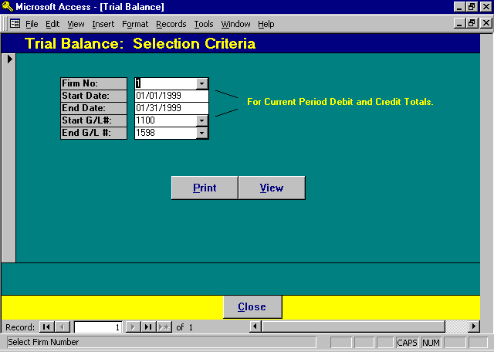

Trial Balance Selection Screen

FIRM NO
Enter the firm number with which the Trial Balance is to be printed. The default Firm # is “1”.

START AND END DATES
Enter the date range for inclusion of data on the report. All transactions falling within this date range, and meeting the other criteria, will be summarized within the current debit and current credit columns on the report. The default dates for the report are the first and last day of the month referenced within the WIP Entry Cutoff Date in the Firm file.

START GL# / END GL#
Enter the range of general ledger numbers to be contained on the trial balance. L.A.W.S. automatically inserts the lowest GL number for the firm as the starting GL# and the highest GL number for the firm as the ending GL#. These numbers may be changed as desired. For a single account, enter the desired account number in both the start and end GL#’s.

A sample of the Trial Balance Report can be found on the following page. Please note, this trial balance is out of balance. To force the report to fit an a single page the expenses were omitted.

Sample: Trial Balance
L.A.W.S. CORPORATION - DEMONSTRATION
Trial Balance: (Firm#1) 02/01/1998 Thru 02/28/1998
G/L Account Number Beginning Balance Current Current Ending Balance
CO Major Sub Aty Description 1/31/98 Debit Credit 2/28/98
_________________________________________________________________________________________________________________________________________________________________________
Assets
1 100 Cash In Bank - General $3,788.57 $2,690.00 $6,478.57
1 100 01 Cash in Bank - Profit Center 01 ($65.00) ($65.00)
1 101 Cash - Trust Chemical Bank $511.75 $511.75
1 102 Cash- Trust Comerica $1,125.00 $1,125.00
1 103 Cash Trust NBD $9,675.00 $9,675.00
Total Assets: $15,035.32 $2,690.00 $0.00 $17,725.32
_________________________________________________________________________________________________________________________________________________________________________
Liabilities
1 200 Federal Income Tax withholding ($592.18) ($592.18)
1 201 State Income Tax Withholding ($311.75) ($311.75)
1 202 Local Income Tax Withholding $0.00 $0.00
1 203 Trust Account NBD ($4,500.00) ($4,500.00)
1 270 United Fund Withholding ($100.00) ($100.00)
Total Liabilities: ($5,503.93) $0.00 $0.00 ($5,503.93)
_________________________________________________________________________________________________________________________________________________________________________
Equity
1 300 Retained Earnings $51,362.90 $51,362.90
Total Equity: $51,362.90 $0.00 $0.00 $51,362.90
_________________________________________________________________________________________________________________________________________________________________________
Revenue
1 400 Fees Received - general ($7,466.50) ($500.00) ($7,966.50)
1 400 AAA Fees Received - AAA ($3,710.00) ($3,710.00)
1 400 CCC Fees Received - CCC ($3.00) ($3.00)
1 400 FIRM Fees Received - Firm ($149.32) ($149.32)
1 400 JJK Fees Received - JJK $0.00 $0.00
1 400 PDK Fees received = PDK ($47,476.60) ($220.00) ($47,696.60)
1 400 01 AAA Fees Received - AAA - Profit Center 01 ($5.00) ($470.00) ($475.00)
1 400 01 PDK Fees Received -PDK , Profit Center 01 $0.00 $0.00
1 401 Client Expense Reimbursement Account ($1,380.99) ($1,380.99)
1 402 Retainer's Received ($2,340.00) ($2,340.00)
Total Revenue: ($62,531.41) $0.00 ($1,190.00) ($63,721.41)
_________________________________________________________________________________________________________________________________________________________________________
Firm Total: ($1,637.12) $2,690.00 ($1,190.00) ($137.12)

_________________________________________________________________________________________________________________________________________________________________________
Copyright 1998 L.A.W.S. Corporation 4/23/98 4:24:47 PM 1
rptGLTB

DETAIL GENERAL LEDGER

The DETAIL GENERAL LEDGER report lists all transactions associated with general ledger accounts within a user supplied date range. The report can list each detail transaction affecting the selected account, or it can summarize transactions based on the journal entry source.

After selecting the DETAIL G/L, the following form is displayed

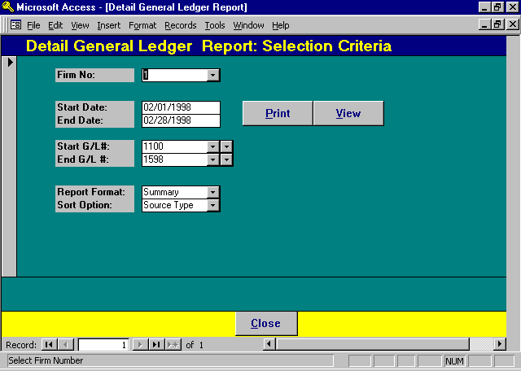

Detail General Ledger Selection

FIRM NO
Enter the firm number with which the detail general ledger is to be printed. The default Firm# is “1”.

START AND END DATES
Enter the date range for inclusion of data on the report. All transactions falling within this date range, and meeting the other criteria, will be included on the report. The default dates for the report are the first and last day of the month referenced within the WIP Entry Cutoff Date in the Firm file.

START AND END G/L #
The data to be included on the report may be selected based on a range of general ledger numbers. The default range is the first through last general ledger number. If desired, the range may be narrowed to as little as a single account.

REPORT FORMAT
Enter the form in which the data should be presented. The available options include:
Detail Prints each individual transaction
Summary Summarizes transactions into a single line item by date within the G/L source code for
each account.

SORT OPTION
Specifies the method by which the report should be sorted. The available options include:
Source Type Subtotals activity on the report by Source Type Code.
Date Subtotals activity on the report by Source Type Code within the transaction month.

For example: The date range for the report may be 01/01/98 through 02/28/98. If the sort option is "Date", then January’s activity will be totaled, and February’s activity will also be totaled. Within each month, activity will be sorted and subtotaled by source type.

A sample of the Detail General Ledger report is displayed on the following page.

Sample: Detail General Ledger Report

L.A.W.S. CORPORATION - DEMONSTRATION Start G/L #: 1100 Start Date: 01/01/1998
Detail General Ledger- Detail Transactions Summary by Source: Firm# 1 End G/L#: 1100 End Date: 04/30/1998
Description Vendor Date Src Je# Debit Credit Check# Client Matter Atty
_________________________________________________________________________________________________________________________________________________________________________
100 Cash In Bank - General Balance Forward: $116,550.21
(52) Delivery Service United Parcel Service (UPS) 04/21/1998 CD 104 ($100.00) 48802
(51) Contract Labor - Yard Work Geroge Hanson (MISC) 04/21/1998 CD 104 ($100.00) 48803
Total (CD): ($200.00) ($200.00)
CR Ref# 1 - 1 02/03/1998 CR 115 $500.00 0
CR Ref# 1 - 3 02/05/1998 CR 116 $500.00 0
CR Ref# 4 - 6 02/06/1998 CR 117 $845.00 0
CR Ref# 4 - 6 02/06/1998 CR 119 $845.00 0
CR Ref# 1 - 3 03/01/1998 CR 123 $1,292.94 0
CR Ref# 1 - 3 03/07/1998 CR 123 $2,500.00 0
CR Ref# 1 - 3 03/25/1998 CR 123 $364.00 0
CR Ref# 9 - 11 04/03/1998 CR 121 $1,340.00 0
CR Ref# 2 - 4 04/03/1998 CR 122 $1,340.00 0
Total (CR ): $9,526.94 $9,526.94
balance cash 01/01/1998 JE 45 ($112,761.64) 0
Record Bank Service Charge - April 1998 04/30/1998 JE 46 ($15.32) 0
Total (JE): ($112,776.96) ($112,776.96)
03/31/1998 PR 5 ($323.25) 0
04/15/1998 PR 6 ($1,318.27) 0
Total (PR): ($1,641.52) ($1,641.52)
Account Total: $9,526.94 ($114,618.48) $11,458.67
Firm Total: Bal Fwd: $116,550.21 $9,526.94 ($114,618.48) $11,458.67

_________________________________________________________________________________________________________________________________________________________________________
Copyright 1998 L.A.W.S. Corporation 4/23/98 4:49:41 PM 1
Detail G/L activity For Each Account Between the Start and Ending G/L No. Subtotaled by G/L Source Type. rptGlDet_Det

CHART OF ACCOUNTS

The CHART OF ACCOUNTS lists all non-financial general ledger account information in account number order.

After selecting CHART OF ACC’TS, the following form is displayed.

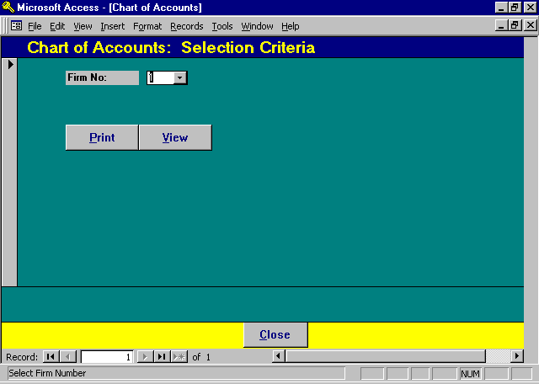

Chart of Accounts Selection

FIRM #
Enter the firm number with which the chart of accounts should be printed. The default firm # is “1”.
All general ledger account numbers associated with the specified Firm Number will be selected.

No other options are available.

A sample of the Chart of Accounts report can be found on the following page.

Sample: Chart of Accounts

L.A.W.S. CORPORATION - DEMONSTRATION
Chart of Accounts: (Firm#1)
G/L Account Number Type of Sub Total Cash
CO Major Sub Aty Description Account Description Account Notes Inactive Date
_________________________________________________________________________________________________________________________________________________________________________
1 100 Cash In Bank - General 1 Yes NBD Account # 2001234567
Signers: John Kelly, Carol Fiztman
1 100 01 Cash in Bank - Profit Center 01 1 Yes
1 101 Cash - Trust Chemical Bank 1 Yes
1 102 Cash- Trust Comerica 1 Yes
1 103 Cash Trust NBD 1 Yes
1 200 Federal Income Tax withholding 2 No
1 201 State Income Tax Withholding 2 No
1 202 Local Income Tax Withholding 2 No
1 203 Trust Account NBD 2 No
1 270 United Fund Withholding 2 No
1 300 Retained Earnings 3 No
1 400 Fees Received - general 4 No
1 400 AAA Fees Received - AAA 4 No
1 400 CCC Fees Received - CCC 4 No
1 400 FIRM Fees Received - Firm 4 No
1 400 JJK Fees Received - JJK 4 No
1 400 PDK Fees received = PDK 4 No
1 400 01 AAA Fees Received - AAA - Profit Center 01 4 No
1 400 01 PDK Fees Received -PDK , Profit Center 01 4 No
1 401 Client Expense Reimbursement Account 4 No Overhead expenses reimbursed from clients. Overhead expensed may
be allocated to a different account based on the bill code used.
1 402 Retainer's Received 4 No
1 500 Client Costs 5 No
1 500 01 AAA Client costs for alan Appleberry 5 No
1 500 02 PDK Client Costs for PDK 5 No
1 502 Rent Expense 5 No
1 506 Payroll Tax Expense 5 No
1 507 Payroll- Officers 5 No
1 507 02 Payroll - Attorneys 5 No
1 508 Telephone Expense 5 No
1 508 01 Telephone Expense Reimbursement 5 No
1 508 02 Fax Reimbursement 5 No
1 509 Photocopy Expense 5 No
1 509 01 Photocopy Client Reimbursement 5 No
1 510 Office Expense 5 No
1 598 Postage 5 No

_________________________________________________________________________________________________________________________________________________________________________
Copyright 1998 L.A.W.S. Corporation Type of Account: 1=Asset 2=Liability 3=Equity 4=Revenue 4/23/98 5:14:18 PM 1
rptGLChart - Chart of Accounts

FINANCIAL STATEMENTS

L.A.W.S. allows for the creation of “User Defined” Financial Statements. User defined statements allow the firm to design customized income statements, balance sheets, budgets, and supporting statements. These statements may be as detailed, or as summarized, as the firm desires. Many people find the setup and design of Financial Statements unnecessarily confusing. Take time to review the associated examples, especially relating to the total lines. Within a little time and experimentation your financial statements will not only look professional, but also balance.

After specifying FINANCIAL STATEMENTS, the following form is displayed.

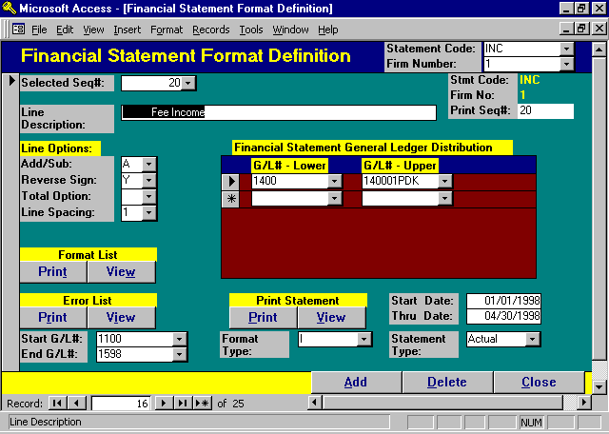

Financial Statement Processing Screen

This screen has four major functions including:
1) Entry and modification of Financial Statement formats.
2) Listing of existing Financial Statement formats.
3) Generation of a Financial Statement Format Error List identifying duplicate,
missing or extra account numbers within a specified format.
4) Generation of the actual Financial Statement in Actual or Budget form.

The concepts associated with building Financial Statements are straight forward, but sometimes difficult to grasp. Throughout this section in the documentation manual, we will be building an actual Income Statement. All the examples will relate specifically to the Income Statement being created. Listed at the end of this section is the end result of our efforts portrayed as a Financial Statement along with the corresponding Financial Statement Format Listing. Please pay close attention to the examples to gain an understanding of how the Financial Statement program functions.
The Financial Statements may be printed in one of three layouts including the Income Statement Format, Budget Format or the Balance Sheet Format. Actual performance is defined as the actual performance of the firm as accumulated within the general ledger. Actual balances are reported through standard financial reports such as the trial balance and detail general ledger. Budget performance is defined as the budget values developed within the firm and posted to specific general ledger numbers using the Budget button within General Ledger Maintenance.

The Income Statement compares the actual current month and year to date performance to the prior
year’s actual month and year to date performance.

The Budget compares the actual current month and year to date performance to the budgeted month
and year to date performance.

The Balance Sheet notes the Current and Prior year-to-date totals only.

All financial statements are user defined meaning the firm determines what will be included on the statement and how the data will be summarized and titled. The firm may develop many different statements such as income statements, balance sheets, and supporting schedules. Each individual statement must be defined through the Statement Code. Examples of Statement codes are "INC" for the Income Statement, "BAL" for the Balance Sheet, "Sch1" for supporting Schedule 1, etc. Although statements can be defined with any code, the convention within L.A.W.S. is that Balance sheet type statements start with the letter "B" while Income Statement and Budget reports start with letters other then "B".

As a default, all statement codes starting with “B” will utilize the Balance Sheet format, while statement codes starting with letters other then "B" will use the Income Statement or Budget format.

Financial statements consist of a series of user defined line items. Each line item specifies to L.A.W.S. the information to print on the statement such as headings, detail, or total lines. The order of printing the lines is determined by the line items Print Sequence Number.

The Financial Statement Format refers to the collection of line items constituting each financial statement.

Financial statements consist of three distinct types of line items as defined below:
Header: Lines that print titles and are not associated with General ledger numbers. Heading lines
do not print dollar amounts.
Detail: Lines that compute and print the dollar balances for all general ledger account numbers
identified with the line item.
Total: Lines that print the total of the proceeding detail lines. Total lines can be defined to print
a single subtotal which summarizes a few detail lines within a financial statement, or to
summarize several of all of the previously computed subtotals.

POSTING THE SCREEN

It is important that the each financial statement format line item is posted prior to adding or modifying another line item. BE SURE TO CLICK THE PENCIL, LOCATED IN THE RECORD SELECTOR, TO POST THE CURRENT RECORD PRIOR TO MOVING TO A NEW LINE ITEM.

A detailed description of the information associated with each financial statement line item follows:

STATEMENT CODE
Specify the user defined statement code associated with the desired financial statement. If an pre-defined statement code is referenced, the heading line of the specified format will be displayed. When a new statement code is entered, the statement heading must be entered on the line description of print sequence number zero.
FIRM NUMBER
Specifies the Firm for which the financial statement is being developed. This field is required only if the multiple firm numbers have been established within Firm Maintenance, and the law firm maintains separate and distinct general ledgers on all established firms. In the great majority of instances, the law firm will be utilizing a single firm only which is defined as firm "1".

Financial statements are specific to a firm number. Assume a law firm maintains two general ledgers for firm numbers 1 and 2, and desires income statements for the established firms. Two separate financial statements need to be established, the first for firm 1 using firm 1's general ledger account numbers, and the second for firm 2 using firms 2's general ledger numbers.

SELECTED SEQ#
The Selected Seq# specifies the line number of the financial statement format which is currently being created or modified. All line items entered into a financial statement format print consecutively by the print sequence number. L.A.W.S. automatically assigns sequence numbers to new lines in increments of ten (10). If desired, the sequence number of new or existing line items may be modified so that the line prints in the desired location on the format.

The first line within a financial statement format is always numbered zero (0) and contains the Statement Heading.

PRINT SEQ#:
The Print Sequence Number is usually equal to the Selected Sequence Number. The purpose of this field is to allow modification of the previously assigned line item sequence number.

Example: Assume a line item was entered into the format with a sequence number of 50. Upon review of the format it is decided to change the position of the line item from 50 to 77. The Selected Seq# has to reference the original line item, in this example 50. Once line 50 is displayed, the Print Seq# will be changed from 50 to 77. After exiting the field, the line item sequence number will be changed and both fields will read the current value.

LINE DESCRIPTION
Enter the description of the line that should appear on the financial statement line for this line item. When entering description lines, be consistent with the spacing of “like” types of lines. For example, heading lines may be flush left, detail lines may be indented several spaces, and total lines may be indented an additional few spaces. The indentation options are totally dependant on the users preference. Please review the Sample below and note the line item types.
Revenue (Heading Line)
Fee Income (Detail Line)
Client Expense Recovered (Detail Line)
Other Income
Total Income (Total Line)

The Statement Heading is always entered with print sequence number zero. The statement heading will be automatically centered under the firm name, and should be entered flush left.

ADD/SUB
This field specifies whether the current balances associated with the line items General Ledger account numbers, should be added to or subtracted from the running totals or sub-totals. This option is applicable to Detail line items only and is ignored when used with Heading or Total line items. The addition or subtraction occurs after reversing the sign. The available options are:
A The generated line item total is added to the report’s totals,
S The generated line total is subtracted from the report’s totals.
REVERSE SIGN
This field specifies if the sign of the computed dollar amount should be reversed prior to being accumulated and printed. The available options are:
Y The computed dollar amount associated with this line item will be reversed.
N The computed dollar amount associated with this line item will not be reversed.

Fees, Liabilities, and Equity accounts are naturally recorded throughout the general ledger as credit, negative, balances. When printed on financial statements, it is normally clearer to reverse the sign of the credit accounts and display them as positive numbers.

Asset and Expense accounts normally have debit, positive, balances. When displaying these accounts, the sign is not normally reversed.

Add and subtract options refer to the impact on the final figure. In the income statement the final figure is "Net Income". Accordingly, revenue amounts are added to net income, while the expense lines are subtracted from net income. Subtotaled amounts within the statement may need to be reversed based on the line item options. Pay special attention to the examples for a fuller understanding or this concept.

As the general rule, the add/subtract options and reverse sign options work as follows on the specified statements.

Statement Type GL Type Usual Line Item Treatment

Income/Budget Statements: Assets Generally not included on this statement.
Liabilities Generally not included on this statement.
Equity Generally not included on this statement.
Revenue Added Reversed
Expenses Subtracted Not Reversed

Balance Sheet: Assets Added Not Reversed
Liabilities Added Reversed
Equity Added Reversed
Revenue &
Expenses Usually totaled together into a single amount titled
something like "Year To Date Income". This total is
usually listed within the equity section of the Balance
Sheet. The treatment is the same as the equity.
Added Reversed

Please review the add/subtract and reverse sign options associated with the sample line items below:

Revenue (Heading Line-codes ignored)
Fee Income (Detail Line - Reverse & Add)
Client Expense Recovered (Detail Line - Reverse & Add)
Other Income (Detail Line - Reverse & Add)
Total Income (Total Line-Do not Reverse, Add/Sub ignored)

Expenses (Heading Line-codes ignored)
Client Costs (Detail Line-Do not reverse & Sub)
Administrative Expenses (Detail Line-Do not reverse & Sub)
Total Expense (Total Line-Reverse, Add/Sub ignored)

Net Income (Total Line-Do not Reverse, Add/Sub ignored)

If “Subtract” is used to subtract expense amounts from the net income total, then the subtotal of expenses will be a negative number and should be reversed prior to printing. The example associated with the Sub Total option displays running totals that reinforce the concepts associated with these codes.

TOTAL OPTION
Specifies whether the line item is a heading, detail or total line. The financial statements allow for six “levels” of totals. The available options for this option are:
Blank Detail Line Item.
H Heading Line
1 - 6 Total Line. - the entered number specifies the specific total to be printed. When printed the
specified total and all lower number totals are set to zero.

The Financial Statement program contains six levels of totals. Whenever a detail line is processed the computed balances associated with the detail line item are added to or subtracted from all six totals. The Total option specifies which Total balance, 1 - 6, is to be printed.

Below, please review the subtotal accumulations associated with the above example.

Cur Month
Total/Add Line Item
Option Amount Level 1 Level 2 Level 3 Level 4 Level 5 Level 6
Revenue H $ 0 $ 0 $ 0 $ 0 $ 0 $ 0 $ 0
Fee Income Blank/Add $ 45,130 $ 45,130 $ 45,130 $ 45,130 $ 45,130 $ 45,130 $ 45,130
Client Expense Blank/Add
Recovery $ 50 $ 45,180 $ 45,180 $ 45,180 $ 45,180 $ 45,180 $ 45,180
Other Income Blank/Add $ 1,000 $ 46,180 $ 46,180 $ 46,180 $ 46,180 $ 46,180 $ 46,180
Total Income 1 $ 46,180 $ 46,180 $ 46,180 $ 46,180 $ 46,180 $ 46,180 $ 46,180

The total income line is classified as Total, Level 1. Accordingly, the current value of the level 1 total will be used as the total amount, then cleared after it is printed.

Total Values
After Printing $ 0 $ 46,180 $ 46,180 $ 46,180 $ 46,180 $ 46,180

Expenses H $ 0 $ 0 $ 46,180 $ 46,180 $ 46,180 $ 46,180 $ 46,180
Client Costs Blank/Sub $ 7,700 $ -7,700 $ 38,480 $ 38,480 $ 38,480 $ 38,480 $ 38,480
Administrative
Expenses Blank/Sub $ 16,765 $-24,465 $ 21,715 $ 21,715 $ 21,715 $ 21,715 $ 21,715
Total Expense 1 (rev sign) $ 24,465 $-24,465 $ 21,715 $ 21,715 $ 21,715 $ 21,715 $ 21,715
The total expense line is also classified as a level 1 total. Since the level 1 total was cleared after Total Income, the value of level 1 represents the sum total of all detail line items processed since the last level 1 total. Expenses are coded as being subtracted from totals. The value of the Level 1 Total is therefore negative and must be reversed prior to printing.

The total expense line is classified as Total, Level 1. Accordingly, the current value of the level 1 total will be used as the total amount, then cleared after it is printed.

Total Values
After Printing $ 0 $ 21,715 $ 21,715 $ 21,715 $ 21,715 $ 21,715
Net Income 2 $ 21,715 $ 0 $ 21,715 $ 21,715 $ 21,715 $ 21,715 $ 21,715

The Net Income Total number could have been any level number greater than 1 since level 2 - 6 contain equal values and there are no additional line items in this sample format. After the net income is printed, the value of the level, 2, and all lower levels are automatically cleared as noted below.

Total Values
After Printing $ 0 $ 0 $ 21,715 $ 21,715 $ 21,715 $ 21,715
LINE SPACING
The line spacing value specifies how many blank lines should be printed AFTER the specified line is printed. The available options are:
1 Single Spaced
2 Double Spaced
3 Triple Spaced

Single spacing is assumed if the Line Spacing option is blank.

GENERAL LEDGER DISTRIBUTION
The General Ledger Distribution allows G/L #s to be associated with detail line items. Each distribution line contains a G/L Lower and G/L Upper number. If a single account is to be associated with a line, simply enter the lower value and leave the upper blank. If a range of numbers should be processed, enter the lower and upper values and the system will accumulate the value of all accounts within the specified range. The G/L Lower value is verified for accuracy, but the G/L Upper value is not verified. There is no limit to the number of GENERAL LEDGER DISTRIBUTION lines which may be associated with a financial statement line item.

Note: The upper right corner displays identification information about the currently displayed record. Please note that if the record selectors are used to scroll through the format, all line items from all defined formats will be available for review. Use care, when modifying data to ensure that the desired line item is being changed.

FORMAT LISTING (PRINT/VIEW)
The Format Listing button simply prints a copy of a financial statement format. A sample Income Statement and Balance Sheet format are displayed at the end of this section.

ERROR LIST (PRINT/VIEW)
The Error List is designed to detect three common errors associated with Financial Statement Formats.

In order to run the Error List, the START G/L# and END G/L# fields must be entered identifying the account numbers to be utilized for verification. The Start and End numbers associated with a balance sheet would include the entire chart of accounts from the first asset account through the last expense. An income statement would have a more limited scope including the first revenue account through the last expense account.

The errors noted on the report include:

Duplicate General Ledger Numbers: If duplicate General Ledger Account Numbers are included in the same or different line items within the same financial statement format, the accumulated total will be misstated causing the statement to be inaccurate. The Duplicate General Ledger Number portion of the Error Report checks for, then identifies Duplicate General Ledger Numbers used within the displayed format.

Missing General Ledger Numbers: The Missing Number portion of the Error Report verifies that all G/L numbers from the chart of accounts, within the entered Start and End G/L# range, are included in the format. If a new account is added to the chart of accounts, it must be added to the appropriate financial statement format. It is possible that the added number will be naturally added to a line item if it falls within a pre-defined range of numbers.

Extra General Ledger Numbers: The Extra General Ledger Number portion of the report checks for and reports all account numbers falling outside the specified Start and End G/L # range. For example, Income statements typically include only revenue and expense items. If a liability account were inadvertently added to the income statement format in error, it would be detected via the extra account number section of this error report.

The error list cannot verify the accuracy of the Add/Sub or the Reverse Sign codes. It is important to visually verify the accuracy of new formats as they are entered into the system. It is highly recommended that existing formats be reviewed for accuracy on a regular basis to ensure that all new accounts are reflected in the formats accurately.

An sample Error list can be found at the end of this section.
PRINT STATEMENT (PRINT/VIEW)
The Print Statement button prints the actual financial statement defined through the format. A Thru Date must be specified defining the scope of the report. The current month is always the month noted within the Thru Date. Year to Date Totals are computed from the Start Date through the Thru Date.

FORMAT TYPE:
The Format Type identifies the type of Statement to be printed. The two available types of formats are the Balance Sheet Format and the Income Statement Format. The default format type is determined by the first character of the Statement Code. Statement codes starting with the letter "B" default to the Balance Sheet Format. All other Statement Codes default to the Income Statement Format. The available options are:
I: Income Statement Format. Compares Current and Year to Date totals to either the
prior year or to budget values. Computes a variance.
B: Balance Sheet Format. Reports current year to date balances only.

STATEMENT TYPE:
The Statement Type identifies the type of Statement to be printed. Balance Sheet type formats, Formats starting with a “B" always utilize actual. Income Statement type formats may use either option. The available options are:
Actual: Compares the Current Year General Ledger Values to the Prior Years General Ledger
Values.
Budget: Compares the Current Years General Ledger Values to the Budgeted Values.

A sample balance sheet and income statement is displayed at the end of this section.

Sample: Financial Statement Format List - Income Statement

Sample: Financial Statement Format List - Balance Sheet

Sample: Error List

Sample: Income Statement

Sample: Budget Statement

Sample: Balance Sheet

L.A.W.S. CORPORATION - DEMONSTRATION
Financial Statement Format List: INC
Print Add Rev Lower Upper
Seq Line Description Sub Sign Total Space Page GL # GL # Ref No.
_________________________________________________________________________________________________________________________________________________________________________
0 Income Statement A N H 2 1 46
10 Revenue A N H 1 1 47
20 Fee Income A Y 1 1 1400 140001PDK 48
22 Client Expenses Recovered A Y 1 2 1401 93
27 Other Income A Y 1 2 1402 94
30 Total Income N 1 2 1 49
33 Expenses N H 1 2 73
35 Client Costs S N 1 2 1500 150002PDK 92
40 Administrative Expenses S N 1 2 1502 1999999 53
50 Total Expenses Y 1 2 2 96
60 Net Income N 2 1 2 97

_________________________________________________________________________________________________________________________________________________________________________
Copyright 1998 L.A.W.S. Corporation 4/24/98 4:12:15 PM 1
Financial Statement Format contains the Instructions used to print financial statements.
rptGlFinStmt_Fmt
L.A.W.S. CORPORATION - DEMONSTRATION
Financial Statement Format List: BS
Print Add Rev Lower Upper
Seq Line Description Sub Sign Total Space Page G/L # G/L # Ref No.
_________________________________________________________________________________________________________________________________________________________________________
0 Balance Sheet N H 1 1 98
10 ASSETS N H 1 1 79
20 Cash in Bank A N 1 1 1100 110001 80
30 Cash in Bank - Trust Accounts A N 1 1 1101 1103 81
40 Total Assets N 6 2 1 82
50 LIABILITIES Y H 1 1 83
55 Payroll Withholdings A Y 1 1 1200 1202 56
60 Other Liabilities A Y 1 1 1203 84
A Y 1 1 1270 84
65 Total Liabilities N 1 2 1 89
70 EQUITY N H 2 1 85
80 Year to Date Income A Y 1 1 1400 1598 86
85 Retained Earnings A Y 1 1 1300 88
86 Total Equity N 1 2 1 100
90 Total Equity and Liabilities N 6 2 1 87

_________________________________________________________________________________________________________________________________________________________________________
Copyright 1998 L.A.W.S. Corporation 4/24/98 4:29:53 PM 1
Financial Statement Format contains the Instructions used to print financial statements.
rptGlFinStmt_Fmt
L.A.W.S. CORPORATION - DEMONSTRATION Start G/L#: 1300
End G/L #: 1598
Financial Statement Format Error List - Format Code: INC
_____________________________________________________________________________________
Duplicate Account Numbers Referenced within this Format:
Acct No Account Description Sequence #'s

_________________________________________________________________________________________________________________________________
Missing Account Numbers within this Format:
Acct No Account Description
1300 Retained Earnings

_________________________________________________________________________________________________________________________________
Account Numbers within this Format Outside Specified Range:
Acct No Account Description

_________________________________________________________________________________________________________________________________
4/24/98 4:55:53 PM 1
Copyright 1998 L.A.W.S. Corporation
rptFmtErr - Financial Statement Format List
INC L.A.W.S. CORPORATION - DEMONSTRATION
Income Statement
Month to Date ( Apr 30 1998 ) Year to Date ( Jan 01 1998 - Apr 30 1998 )
Current Year Prior Year Variance % Current Year Prior Year Variance %
_________________________________________________________ _____________________________________________________
Revenue
Fee Income $45,130 $44,673 $458 1% $48,267 $56,580 ($8,313) -15%
Client Expenses Recovered $50 $146 ($96) -66% $40 $1,381 ($1,341) -97%
Other Income $1,000 ($90) $1,090 -999% $1,000 $2,340 ($1,340) -57%
Total Income $46,180 $44,728 $1,452 3% $49,307 $60,301 ($10,994) -18%

Expenses
Client Costs $7,700 $11,927 ($4,227) -35% $6,700 $11,765 ($5,065) -43%
Administrative Expenses $16,765 $23,369 ($6,603) -28% $15,110 $23,506 ($8,396) -36%
Total Expenses $24,465 $35,295 ($10,830) -31% $21,810 $35,271 ($13,461) -38%

Net Income $21,715 $9,433 $12,281 130% $27,497 $25,030 $2,466 10%

_________________________________________________________________________________________________________________________________________________________________________
Copyright 1998 L.A.W.S. Corporation 4/24/98 5:17:22 PM 1
Financial Statement Format printed in Income Statement Format. rptGlFinStmt_Inc
Budget L.A.W.S. CORPORATION - DEMONSTRATION
INC Income Statement
Month to Date ( Apr 30 1998 ) Year to Date ( Jan 01 1998 - Apr 30 1998 )
Actual M-T-D Budget M-T-D Variance % Actual Y-T-D Budget Y-T-D Variance %
____________________________________________ _____________________________________________
Revenue
Fee Income $45,130 $10,000 $35,130 351% $48,267 $40,000 $8,267 21%
Client Expenses Recovered $50 $0 $50 $40 $0 $40
Other Income $1,000 $0 $1,000 $1,000 $0 $1,000
Total Income $46,180 $10,000 $36,180 362% $49,307 $40,000 $9,307 23%

Expenses
Client Costs $7,700 $0 $7,700 $6,700 $0 $6,700
Administrative Expenses $16,765 $0 $16,765 $15,110 $0 $15,110
Total Expenses $24,465 $0 $24,465 $21,810 $0 $21,810

Net Income $21,715 $10,000 $11,715 117% $27,497 $40,000 ($12,503) -31%

_________________________________________________________________________________________________________________________________________________________________________
Copyright 1998 , L.A.W.S. Corporation 4/24/98 5:24:31 PM 1
Financial Statement Format printed in Budget Statement Format.
rptGlFinStmt_Bgt
BS L.A.W.S. CORPORATION - DEMONSTRATION
Balance Sheet
As of April 30, 1998
Current Year to Date Prior Year to Date
___________________________________ ________________________________
ASSETS
Cash in Bank $11,393.67 $118,592.86
Cash in Bank - Trust Accounts $11,001.33 $11,311.75
Total Assets $22,395.00 $129,904.61

LIABILITIES
Payroll Withholdings $1,274.25 $311.75
Other Liabilities $4,672.60 $4,500.00
Total Liabilities $5,946.85 $4,811.75

EQUITY

Year to Date Income $27,496.76 $25,030.27
Retained Earnings ($11,048.61) $97,444.09
Total Equity $16,448.15 $122,474.36

Total Equity and Liabilities $22,395.00 $127,286.11

_________________________________________________________________________________________________________________________________
Copyright 1998 L.A.W.S. Corporation 4/24/98 5:31:21 PM 1
Financial Statement Format printed in Balance Sheet Format. rptGlFinStmt_Bs

DAILY ACTIVITY

The DAILY ACTIVITY button summarizes Cash, Accounts Receivable and Work In Process. The Daily Activity inquiry functions always display the Cash, A/R or WIP balance forward amount along with individual line items summarizing activity per day. The ending balance always displays the Cash, A/R or WIP balance as of the specified End Date. The Daily Activity Report has the option of summarizing data by either day or by month.

After selecting Daily Activity, the following form is displayed.

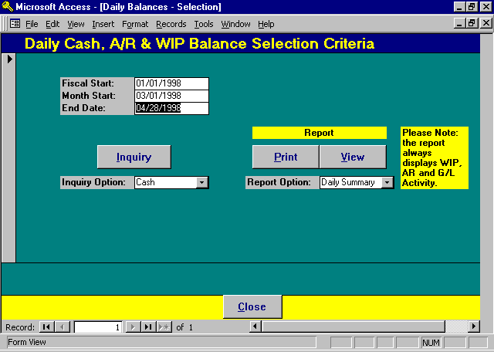

Daily Activity Selection

FISCAL START
This field is used when generating the Monthly Summary Report only. It is ignored when used in conjunction with the Inquiry and the Daily Summary Report options. The Monthly Summary Report summarizes twelve months of activity. The report begins at month identified within the Fiscal Start field and ends at the month identified within the End Date field.

MONTH START
Identifies the starting date for inclusion of data on the Inquiry and Daily Summary Report options. This option is ignored with the Monthly Summary Report.

END DATE
Identifies the ending date for inclusion of data within all Daily Activity options.

Inquiry Option
The inquiry option allows review of Cash, Accounts Receivable or WIP. The Inquiry option summarizes activity by day. The Balance column displays the actual balance forward on the first line of the form. Each Daily Activity Line summarizes the daily activity along with the daily change in value. The form total always displays the actual ending balance. The Available options include:
Cash Cash Activity will be summarized and displayed.
A/R Accounts Receivable Activity will be summarized and displayed.
WIP Work In Process Activity will be summarized and displayed.

INQUIRY BUTTON
The Inquiry Button will display either the firms Cash, Accounts Receivable or WIP activity within the date range specified.

Daily Cash Inquiry Option

Cash: If the Cash option is specified, the following form will be displayed:

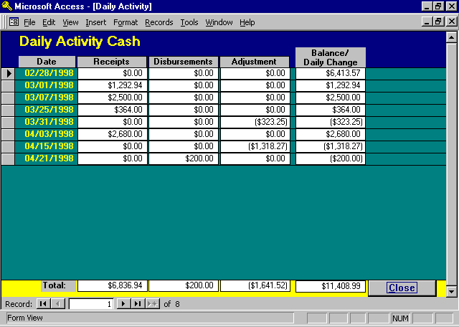
Information Displayed

DATE
The date on which cash activity occurred. Only dates on which cash activity was posted will be displayed. The first entry on the form represents the balance forward date. All other dates on the form represent the summary of daily activity.
RECEIPTS, DISBURSEMENTS, and ADJUSTMENTS
Represents the summarized daily cash activity for the specified date. Receipts are accumulated through the Cash Receipts program, Disbursements through the Cash Disbursement program, and Adjustments through the processing of Manual Journal Entries.

BALANCE / DAILY CHANGE
Represents either the beginning or ending cash balance or the daily change in cash position.

The first line on the form represents the Cash Balance Forward amount.

Each line item thereafter summarizes daily cash activity. The Balance / Daily Change amount on these lines represents the net change per day in the cash balance, i.e. the daily disbursements and or adjustments subtracted from the daily receipts.

The total line on the form summarizes all activity by category on the form. The Balance / Daily Change amount is the Ending Cash Balance as of the specified End Date.

A/R Inquiry Option

A/R: If the A/R option is specified, the following form will be displayed:

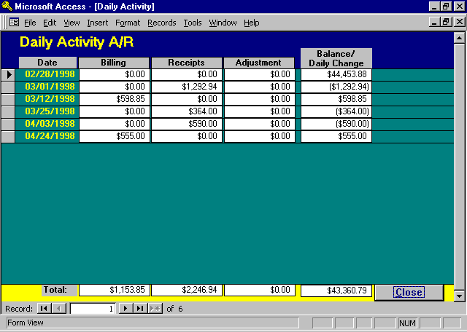
Information Displayed

DATE & BALANCE / DAILY CHANGE
The Date and Balance / Daily Change columns are as described with the Cash Inquiry option. Only days on which A/R activity is posted are displayed. The Daily Change is computed by subtracting the A/R Receipts and Adjustments from the Billings.

BILLING, RECEIPTS, ADJUSTMENTS
Billing totals are accumulated from the Finalized Bills based on the invoice date. Receipts and Adjustments are accumulated from the Process Cash program based on the Deposit Date.

WIP Inquiry Option

WIP: If the WIP option is specified, the following form will be displayed::

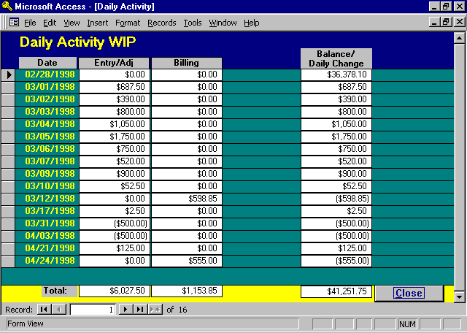

Information Displayed

DATE & BALANCE / DAILY CHANGE
The Date and Balance / Daily Change columns are as described with the Cash Inquiry option. Only days on which WIP activity is posted are displayed. The Daily Change is computed by subtracting the Billing from the Entry / Adjustments.

ENTRY / ADJUSTMENT
The dollar value of WIP entered into the system through Time Entry and Check Writing , net of the adjustments to WIP entered through the WIP adjustment program.

Daily Activity Report Options

PRINT / VIEW Button

The Print/View button will generate the Daily Activity Reports. The generated reports summarize all three categories on information including Cash, Accounts Receivable, and Work in process. The report may be generated based on the available options:
Daily Summary Displays the summarized daily activity within each category of data. Days
without activity are not included on the report.
Monthly Summary Summarizes Cash, Accounts Receivable and Work In Process activity within
month.

Sample Daily Activity Reports are displayed on the following pages.

Sample: Daily Cash, Accounts Receivable and WIP Activity

Sample: Monthly Summary of Cash, A/R and WIP
L.A.W.S. CORPORATION - DEMONSTRATION Start: Mar 01,1998
Daily Cash, Accounts Receivable and WIP Activity End: Apr 28,1998
Cash Accounts Receivable Work In Process
Date Receipts Disb's J/E's Balance Billing Receipts Adj's Balance Entry/Adj Billing Balance
___________ ______________________________________________________ _____________________________________________________ _______________________________________
02/28/1998 6,414 44,454 36,378
03/01/1998 1,293 0 0 7,707 0 1,293 0 43,161 688 0 37,066
03/02/1998 0 0 0 7,707 0 0 0 43,161 390 0 37,456
03/03/1998 0 0 0 7,707 0 0 0 43,161 800 0 38,256
03/04/1998 0 0 0 7,707 0 0 0 43,161 1,050 0 39,306
03/05/1998 0 0 0 7,707 0 0 0 43,161 1,750 0 41,056
03/06/1998 0 0 0 7,707 0 0 0 43,161 750 0 41,806
03/07/1998 2,500 0 0 10,207 0 0 0 43,161 520 0 42,326
03/09/1998 0 0 0 10,207 0 0 0 43,161 900 0 43,226
03/10/1998 0 0 0 10,207 0 0 0 43,161 53 0 43,278
03/12/1998 0 0 0 10,207 599 0 0 43,760 0 599 42,679
03/17/1998 0 0 0 10,207 0 0 0 43,760 3 0 42,682
03/25/1998 364 0 0 10,571 0 364 0 43,396 0 0 42,682
03/31/1998 0 0 -323 10,247 0 0 0 43,396 -500 0 42,182
04/03/1998 2,680 0 0 12,927 0 590 0 42,806 -500 0 41,682
04/15/1998 0 0 -1,318 11,609 0 0 0 42,806 0 0 41,682
04/21/1998 0 200 0 11,409 0 0 0 42,806 125 0 41,807
04/24/1998 0 0 0 11,409 555 0 0 43,361 0 555 41,252
Firm Total: 6,837 200 -1,642 11,409 1,154 2,247 0 43,361 6,028 1,154 41,252
Accounts Payable Due: 0 - 7 Days: $977.00
8 - 14 Days: $0.00
15 - 21 Days: $0.00
22 - 28 Days: $0.00
Over 28 Days: $0.00
Total Due: $977.00

_________________________________________________________________________________________________________________________________________________________________________
Copyright 1998 L.A.W.S. Corporation 4/28/98 12:49:19 PM 1
rptDayBal - 'Daily Activity' from G/L Menu
L.A.W.S. CORPORATION - DEMONSTRATION Start Date: January 01 1998
Monthly Summary of Cash, A/R && WIP End Date: April 28 1998
Jan Feb Mar April May June July Aug Sept Oct Nov Dec
_________________________________________________________________________________________________________________________________________________________________________

CASH
Balance Fwd: $116,485.21 $3,723.57 $6,413.57 $10,247.26 $0.00 $0.00 $0.00 $0.00 $0.00 $0.00 $0.00 $0.00
CR $2,690.00 $4,156.94 $2,680.00 $0.00 $0.00 $0.00 $0.00 $0.00 $0.00 $0.00 $0.00
Disbursements ($200.00) $0.00 $0.00 $0.00 $0.00 $0.00 $0.00 $0.00 $0.00
J/E Adj ($112,761.64) ($323.25) ($1,318.27) $0.00 $0.00 $0.00 $0.00 $0.00 $0.00 $0.00 $0.00
Ending Balance: $3,723.57 $6,413.57 $10,247.26 $11,408.99 $0.00 $0.00 $0.00 $0.00 $0.00 $0.00 $0.00 $0.00
_________________________________________________________________________________________________________________________________________________________________________

Receivables
Balance Fwd: $45,396.88 $45,396.88 $44,453.88 $43,395.79 $0.00 $0.00 $0.00 $0.00 $0.00 $0.00 $0.00 $0.00
Billing $0.00 $97.00 $598.85 $555.00 $0.00 $0.00 $0.00 $0.00 $0.00 $0.00 $0.00 $0.00
Receipts $0.00 ($1,040.00) ($1,656.94) ($590.00) $0.00 $0.00 $0.00 $0.00 $0.00 $0.00 $0.00 $0.00
Write Up/Down $0.00 $0.00 $0.00 $0.00 $0.00 $0.00 $0.00 $0.00 $0.00 $0.00 $0.00 $0.00
Ending Balance: $45,396.88 $44,453.88 $43,395.79 $43,360.79 $0.00 $0.00 $0.00 $0.00 $0.00 $0.00 $0.00 $0.00
_________________________________________________________________________________________________________________________________________________________________________

Work In Process:
Balance Fwd: $36,524.75 $37,028.50 $36,378.50 $42,182.15 $0.00 $0.00 $0.00 $0.00 $0.00 $0.00 $0.00 $0.00
Billing $0.00 $0.00 ($598.85) ($555.00) $0.00 $0.00 $0.00 $0.00 $0.00 $0.00 $0.00 $0.00
Wip Entry/Adj $503.75 ($650.00) $6,402.50 ($375.00) $0.00 $0.00 $0.00 $0.00 $0.00 $0.00 $0.00 $0.00
Ending Balance: $37,028.50 $36,378.50 $42,182.15 $41,252.15 $0.00 $0.00 $0.00 $0.00 $0.00 $0.00 $0.00 $0.00
_________________________________________________________________________________________________________________________________________________________________________

_________________________________________________________________________________________________________________________________________________________________________
Copyright 1998 L.A.W.S. Corporation
rptMoSum_CWA - General Ledger Menu - Daily Activity 4/28/98 2:02:26 Page 1 of 1

