TRUST PROCESSING
TABLE OF CONTENTS

TRUST PROCESSING 348
Trust Menu 348
ACCOUNT MAINTENANCE 349
Trust Account Maintenance Screen 349
General Ledger Integration 350
TRUST ACTIVITY 351
Trust Activity Screen 351
Sample: Trust Activity Edit List 356
Sample: Trust Disbursement Check 356
TRUST INQUIRY 359
Trust Inquiry Selection Screen 359
Detail Trust Inquiry Screen 360
LIST ACCOUNTS 362
Sample: Trust Account List 362
PRINT TRUST ACTIVITY 364
Trust Activity Selection Criteria 364
Sample: Trust Activity - Detail Transactions 365
Sample: Trust Activity - Summary by Matter 365
Sample: Trust Activity - Summary by Client 365

TRUST PROCESSING

L.A.W.S. offers extensive Trust Processing capabilities allowing for the entry, storage and review of trust activity by matter. Multiple trust accounts may be created to mirror physical trust bank accounts.

Trust Processing allows for recording trust deposits, for processing trust disbursement checks, and for reporting trust activity.

After selecting TRUST from the Master Menu, the following screen is displayed:

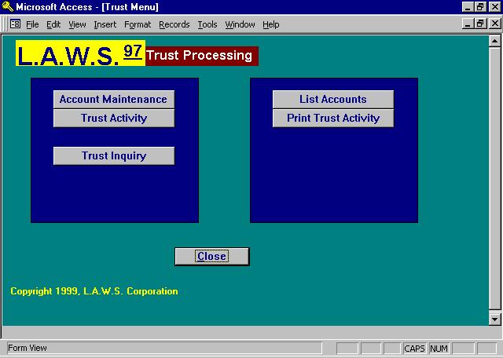

Trust Menu

A detailed explanation of each item follows:

ACCOUNT MAINTENANCE

The purpose of Account Maintenance is to define the physical bank accounts utilized by the trust system. A Trust Account should be setup for each physical bank account in which client trust funds are deposited. L.A.W.S. summarizes Trust within the utilized Trust Accounts.

After selecting ACCOUNT MAINTENANCE, the following screen is displayed:

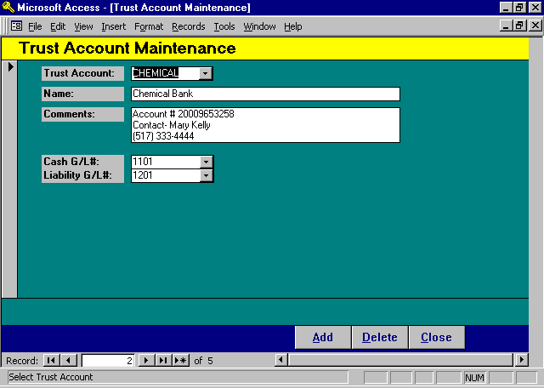

Trust Account Maintenance Screen

TRUST ACCOUNT
Enter a code that identifies the trust account. The Account code is user defined and can be either Alphabetical or numeric.

NAME
Enter the name of the trust account.

COMMENTS
Enter any miscellaneous comments associated with this account.

General Ledger Integration

L.A.W.S. offers the option of recording Trust activity in the general ledger. Due to the fact that the firm has control of the funds, many firms desire reference to the Trust Balances within the general ledger. Other firms do not want the trust balances reflected in the general ledger since the funds are not owned by the firm.

Each Client Trust account uses two general ledger numbers if the funds are recorded in the general ledger, an Asset Account and an offsetting liability account. The asset account records the cash balance within the Trust Account while the liability account contains the same figure which represents the amount of funds the firm has collected, and is holding, on behalf of its clients.

If both the asset and liability accounts are entered, L.A.W.S. will post trust activity to the general ledger. If the liability account is blank, L.A.W.S. will not post trust activity to the general ledger.

If general ledger integration is desired, Trust Receipts increase, while trust disbursements decrease the asset and liability general ledger balances.

The general ledger balances associated with the asset and liability accounts should offset each other.

CASH G/L#
Enter the cash general ledger account number associated with this trust account. This is a required field. Cash General Ledger Account Numbers are used to identify checks within the Bank Reconciliation program. In order to segregate trust checks within the reconciliation, each trust account should reference a separate Cash General Ledger Number. There will be posting to this account only if a corresponding General Ledger Liability Number is entered.

LIABILITY G/L#
Enter the liability General Ledger number associated with this trust account. This field is NOT required. Trust Activity will not post to the general ledger if the Liability Account is not entered.

TRUST ACTIVITY

TRUST ACTIVITY is a single source by which all trust activity is entered into the system including Trust Receipts, Trust Disbursements, and non-cash Trust Adjustments. If desired, Trust Checks may be system generated, or manually created checks may be processed through this program.

All trust transactions are batched together, verified, then posted.

After selecting TRUST ACTIVITY, the following screen is displayed:

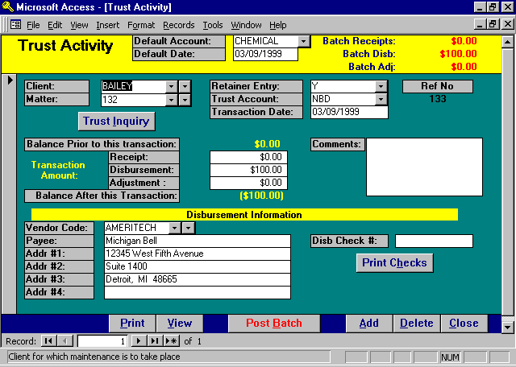

Trust Activity Screen

Heading Information

DEFAULT ACCOUNT
Enter the default Trust Account that will be assigned to each new transaction. As each new Trust transaction is processed, this Default Trust Account will be assigned to each entry. If desired, Trust Accounts may be assigned to matters through Matter File Maintenance. Trust Accounts assigned to matter take precedence over this Default Account Number. Transactions pertaining to multiple trust accounts may be processed within a single batch.

DEFAULT DATE
Enter the default Transaction Date to be assigned to each new entry. As each new Trust transaction is processed, this Default Date will be assigned to each entry. This date may be modified on a transaction by transaction basis.
BATCH RECEIPTS/DISB/ADJS
Informational only, L.A.W.S. displays the total non-posted Receipts Disbursements and Adjustments currently within the system. The displayed totals will match the Trust Edit List Totals.

Detail Transaction Information

CLIENT/MATTER
Enter the client/matter combination for which the trust transaction applies. Client is required but the matter may be left blank.

If a Client/Matter combination is entered, the trust transaction is associated with the specified matter. If the Matter is blank, the trust transaction is posted to the client only. Retainer entries posted with a blank matter will be allocated to all matters, within the specified client, at the time of billing. If the matter code is left blank, L.A.W.S. automatically inserts the word “*BLANK* as the matter code.

RETAINER ENTRY
Specifies whether this transaction should be considered a retainer entry. The balance of all transactions marked as RETAINER ENTRY-YES will be included in a retainer balance that will decrease amounts due within the client-billing program. Entries marked as RETAINER ENTRY-NO will not be used to reduce amounts billed.

Retainers received from clients deposited into the trust, as well as trust checks payable to the firm for payment of fees are usually considered retainer entries. Settlement checks received in contingent matters would not usually be considered retainer entries.

Please Note: If the Retainer Entry is not marked appropriately, retainers may be misapplied. For Example: Assume the firm received $1000 as a retainer from a client. When deposited in Trust, the Retainer Entry option was specified as Yes. When the client statement is generated, the $1000 retainer will be applied against the client invoice. L.A.W.S. automatically creates a Retainer Disbursement entry within the trust processing system that records the retainer allocation. The Retainer Entry option on this transaction is set to "Yes". When posted, the trust balance and retainer balance will be correct. The Trust Balance is the total of all trust transactions assigned to a matter, while the Trust Retainer Balance is the total of all trust transactions coded as Retainer Entry "Yes". Both these balances would read zero.

If the Retainer Entry option on the system generated trust disbursement transaction is changed to "No" the trust balance will be correct but the trust retainer balance will be incorrect. In this instance, L.A.W.S. would still assume that $1000 was available for allocation against future invoices.

If the Retainer Entry option is incorrectly recorded, it may be changed through the Trust Inquiry option.

TRUST ACCOUNT
Enter the trust account associated with this transaction. L.A.W.S. checks for the existence of, and utilizes, a trust account in the matter record. If the specified matter is not associated with a trust account, the default account entered in the header of the record is used. The operator may override this value.

TRANSACTION DATE
Enter the transaction date. The utilized date will be the default date noted in the header of the form. The transaction date may be modified, as desired, to reflect actual dates of activity.

REF #
Informational only. The system assigned reference number for this transaction.

TRUST INQUIRY BUTTON
The Trust Inquiry button is used to display all existing trust activity for the referenced client/matter. This is the same option that is listed on the main Trust Menu. Please review the TRUST INQUIRY section of this documentation manual later in this chapter for a detailed explanation of the inquiry function.

The Trust Inquiry button is helpful when a message is displayed in red stating “Trust Balance in other Trust Accounts”. When the Inquiry is selected, all transactions associated with the entered Client/Matter will be displayed regardless of the trust account to which the transactions are posted.

BALANCE PRIOR TO THIS TRANSACTION
L.A.W.S. computes the trust balance WITHIN THE SPECIFIED ACCOUNT, for the referenced client/matter. This balance does not include the current transaction but DOES include non-posted transactions within the current trust batch.

Note: If trust activity, for this client/matter combination, has been posted to other trust accounts, the balance in trust accounts other than the one referenced is displayed above the comments. This is for informational purposes only to alert the operator to possible errors in the current, or previously assigned, account number.

TRANSACTION AMOUNTS
The Trust Activity function allows for the recording of trust receipts, disbursements and /or adjustments. If more than one type of transaction is applicable, they must be entered through separate transactions.

Receipt: Enter the amount of trust receipts entered into the system for the specified client/matter combination. Receipts represent cash received only. The total receipts entered into the trust processing screen should equal the trust deposit ticket(s) taken to the bank. Each receipt transaction should equal a specific check on the deposit ticket. Receipts increase the trust balance and are entered as positive numbers.

Disbursement: Enter the amount of the cash disbursements to be entered into the system for the specified client/matter. The disbursement is an outlay of cash from the trust system through a trust disbursement check. Each disbursement entry should correspond to a single disbursement check. Disbursements decrease the trust balance. Disbursements are entered as positive numbers and are then subtracted from the trust balance.

Adjustment: Enter non-cash adjustments affecting the specific client/matter balance. Non-cash adjustments are used to record items such as beginning balances at the initiation of the system. Adjustments are always added to the trust balance. Accordingly, positive adjustments are entered as positive numbers while negative adjustments are entered as negative.

BALANCE AFTER THIS TRANSACTION
Informational only. The balance after this transaction represents the displayed beginning balance, plus this transaction’s receipts and adjustments minus disbursements. This balance includes any other non-posted transactions associated with this matter within this batch.

Always check the BALANCE AFTER THIS TRANSACTION to ensure that the balance is what you expect. If a transaction amount is entered incorrectly, or with a wrong sign, this balance will be incorrect.

COMMENTS
Enter comments associated with this transaction.

DISBURSEMENT INFORMATION
The information described below pertains only to disbursement entries. It is ignored for receipts and/or adjustments.

VENDOR
The Trust Disbursement program has the ability to access vendor information within the Cash Disbursement program. If desired, a cash disbursement vendor code may be entered in this vendor field and L.A.W.S. will automatically utilize the predefined vendor name and address. If vendor codes are utilized within the trust system then trust disbursement information may be imported into the L.A.W.S. 1099 program.

PAYEE
Enter the payee’s name for which the check should be generated.
ADDR #1/ADDR #2/ADDR #3
Enter the address to which the check should be sent. The address need be entered only if a window envelope is to be used.

DISB CHECK#
If processing a manual trust check, enter the manual check number. Otherwise, leave the DISB CHECK# blank and a trust check will be printed. Once the system has generated a check, the system generated check number is entered into this field. This is a required field for trust disbursements. The current batch of trust transactions cannot be posted if it contains trust disbursements without check numbers.

PRINT CHECKS BUTTON
The Trust Activity selection allows for the printing of computer generated checks.

To produce a computer generated check, ensure that the disbursement transaction record is entered as it should be; i.e.: the client, matter, trust account, disbursement amount and address are correct. Be sure to leave the Disb Check# blank, otherwise L.A.W.S. will assume that a manual check has already been prepared and will not prepare a system check.

After visual verification of the information, press the PRINT CHECKS button. The following screen will be displayed.

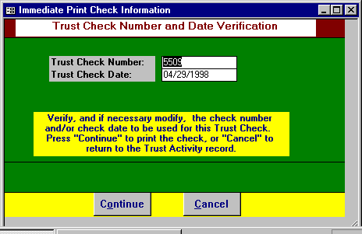

TRUST CHECK NUMBER
If necessary, enter or modify the number of the check to be utilized. The next available check number, based on the Trust Account Cash General Ledger Number, is automatically displayed.

TRUST CHECK DATE
Enter the date of the check. The transaction date, noted on the trust processing screen, is displayed as a default. This date may be changed if necessary.

Pressing "CANCEL" will return to the Trust Processing screen without additional action. Pressing "CONTINUE" will generate a check.

After pressing "CONTINUE", the following message is displayed.
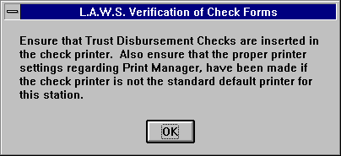

Pressing OK will physically print the check.

Once the check is processed, the check number and date are automatically posted to the trust disbursement record.

To help ensure that the data posted throughout the system parallels the information physically printed on the check, the trust check transaction cannot be modified after the check has been printed. If need be, the entire check may be deleted then re-entered. It is the operators' responsibility to void and destroy the physical check if the system generated disbursement is deleted.

If a system generated trust check is deleted, a notation is recorded within the check reconciliation file, for a zero amount, stating that the trust disbursement was deleted.

A copy of a Trust Disbursement Check is displayed at the end of this section.

PRINT/VIEW BUTTON
The Print or View button will produce the Trust Activity Edit List. The purpose of the list is to display and total, for visual verification all trust transactions within the current batch.

The report sub-totals all activity by trust account. The debit and credit general ledger numbers are noted below the receipt and disbursement totals respectively. If a credit number exists, a journal entry will be created then the batch is posted. Otherwise, a journal entry will not be created.

A sample Trust Edit report is displayed at the end of this section.

POST BATCH BUTTON
The purpose of the POST BATCH button is to process all transactions within the current batch of trust transactions. It is suggested that the edit list be reviewed for accuracy prior to posting.

The POST BATCH button will create journal entries for trust accounts containing both an asset and liability general ledger number. It also posts disbursements to the check reconciliation file.

After pressing the POST BATCH button, the following message is displayed:

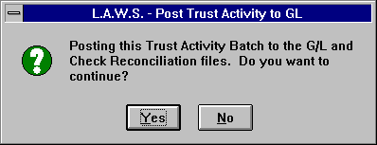

Answering “NO” will return to the Trust Activity form, while “YES” will continue with the posting.

After the posting is complete the Trust Menu is displayed.

Sample reports capable of being generated from the Trust Activity program are displayed on the following pages.

Sample: Trust Activity Edit List

Sample: Trust Disbursement Check

Please Note: The Sample Disbursement Check's format has been modified to fit within the documentation manual. Its purpose is to show the general format of the check only. DO NOT BASE YOUR ACTUAL FIRMS DISBURSEMENT CHECK LAYOUT AND DESIGN ON THIS SAMPLE CHECKS FORMAT.

L.A.W.S. is a registered product at NEBS - New England Business forms. Call 1-800- 388 3810. The Laser Check order number is 9039.

L.A.W.S. CORPORATION - DEMONSTRATION
Trust Activity Edit Listing
Ref No Client Matter Tran Date Receipt Disbursement Adjustment Payee Name, Address & Check Description Ret
_________________________________________________________________________________________________________________________________________________________________________
NBD: National Bank of Detroit
109 BAILEY LOAN 04/28/1998 $0.00 $100.00 $0.00 Jim Simth - Expert Witness Y
Check No: 5509
Daily Total: 04/28/1998 $0.00 $100.00 $0.00
110 WARD *BLANK* 04/29/1998 $100.00 $0.00 $0.00 Y
111 CHEATHAM 123 04/29/1998 $0.00 $0.00 $1,500.00 Record beginning balance N
Daily Total: 04/29/1998 $100.00 $0.00 $1,500.00
Trust Account Total: $100.00 $100.00 $1,500.00
DR: 1103 CR: 1203
_________________________________________________________________________________________________________________________________________________________________________
FirmTotal: $100.00 $100.00 $1,500.00

_________________________________________________________________________________________________________________________________________________________________________
Copyright 1998 L.A.W.S. Corporation 4/29/98 10:02:56 AM 1
Dr & CR # Identify G/L Posting Accounts. If one or both are blank, G/L will not be posted.
TrActEdit
L.A.W.S. CORPORATION -DEMONSTRATION 5509
Payee: Jim Smith Check No: 5509
Client: (Bailey) Bailey Construction Check Date: 04/28/98
Matter: (Loan) Construction Loan Check Amt: $100.00
Description: Expert Witness Fee

NBD 1103

---------------------------------------------------------------------------------------------------------------------------
L.A.W.S. CORPORATION - Trust Account ABC BANK 5509
Legal, Accounting and Wordprocessing System Roscommon Office 123
PO BOX 455, ROSCOMMON, MI 48653 Roscommon, MI 48653
12-23/0001 CHECK NO. 5509

DATE AMOUNT One Hundred Dollars and 00 Cents
04/28/1998 $100.00
PAY Jim Smith
TO THE 1600 Jefferson Avenue
ORDER Suite 300
OF Troy, MI 48653

________________________________________________________
AUTHORIZED SIGNATURE

---------------------------------------------------------------------------------------------------------------------------

L.A.W.S. CORPORATION -DEMONSTRATION
Payee: Jim Smith Check No: 5509
Client: (Bailey) Bailey Construction Check Date: 04/28/98
Matter: (Loan) Construction Loan Check Amt: $100.00
Description: Expert Witness Fee

NBD 1103

5509

TRUST INQUIRY

TRUST INQUIRY displays trust activity pertaining to a specified client and/or Client-Matter combination. The inquiry function also allows an easy method with which to modify the transaction Retainer Entry status and/or Vendor Code associated with each entry.

After selecting TRUST INQUIRY the following screen is displayed:

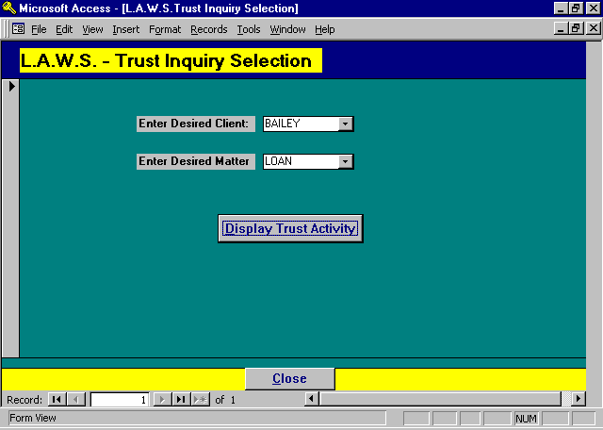

Trust Inquiry Selection Screen

DESIRED CLIENT/MATTER
Enter the desired client / matter combination identifying the activity to be displayed. The client is required but the matter may be left blank. If the matter is blank, L.A.W.S. automatically enters the code “*Blank*” within the matter field. Only transactions not associated with specific matters, within the client, will be displayed with the “*Blank*” matter code.

DISPLAY TRUST ACTIVITY BUTTON
After the client and matter are entered, press the DISPLAY TRUST ACTIVITY button to display the detail Trust Activity.

After pressing the DISPLAY TRUST ACTIVITY button, the following form is displayed:

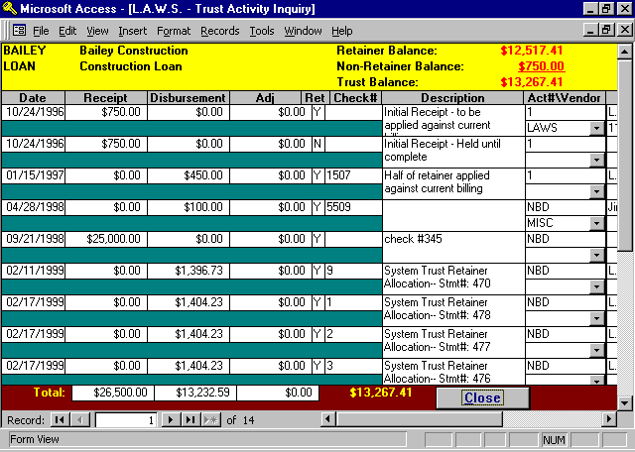

Detail Trust Inquiry Screen

CLIENT/MATTER
The selected client and matter carried over from the initial trust selection screen.

RETAINER BALANCE
The total of all transactions marked as retainers “Y”. The total retainer balance will be used to decrease the total due on client statements.

NON RETAINER BALANCE
Displays the total of all transactions marked as retainers “N”. The noted non-retainer balance will not be used to decrease the balance of client statements.

TRUST BALANCE
The total trust balance associated with this matter (retainer plus non-retainer).

DATE
The date of each individual trust transaction.

RECEIPT/DISBURSEMENT/ADJUSTMENT
The dollar amount associated with the referenced transaction. The total of these categories are noted at the bottom of the form.

RET
Refers to the retainer status code, “Y” specifies that this entry should be included in the retainer total. “N” states that this entry is a non-retainer entry. THIS IS A MODIFIABLE FIELD.

CHECK#
The check number associated with disbursement entries.

COMMENTS
The user entered comments, from the trust activity form, associated with the referenced transaction.

ACCT
The trust account associated with the referenced transaction

VENDOR
The cash disbursement vendor code utilized with this trust disbursement. THIS IS A MODIFIABLE FIELD. If the firm wishes to import trust disbursements into 1099 processing, and the original trust disbursements were generated without vendor codes, a new vendor may be assigned.

Additional data may be viewed by utilizing the horizontal scroll bars to move the form right. The right portion of the form is displayed below.

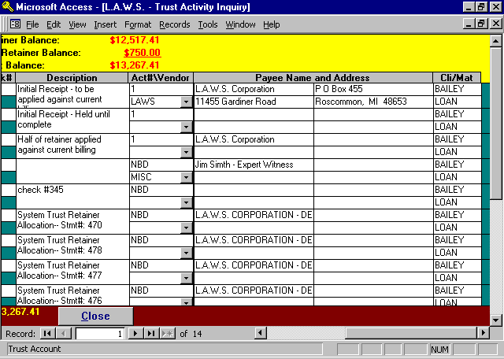
PAYEE/ADDRESS
The payee’s name and address on disbursement entries.

CLIENT / MATTER
The client and matter code associated with the displayed transactions.

LIST ACCOUNTS

The purpose of the LIST ACCOUNTS option is to print information pertaining to the Trust Accounts.

After selecting LIST ACCOUNTS, the following form is displayed:

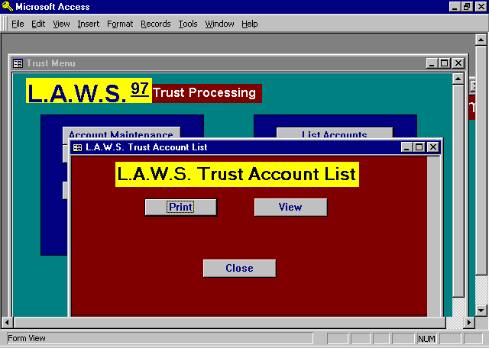

There are no selection options associated with this option. Press PRINT to print the report, or VIEW to display the report on the screen.

A sample of the Trust Account List is displayed on the following page.

Sample: Trust Account List

L.A.W.S. CORPORATION - DEMONSTRATION
Trust Account List
General Ledger Numbers
Account Description Cash Liability Comments
_________________________________________________________________________________________________________________________________
1 Trust account One 1103
CHEMICAL Chemical Bank 1101 1201 Account # 20009653258
Contact- Mary Kelly
(517) 333-4444
COMERICA Comerica 1102
FIRST First Of America
NBD National Bank of Detroit 1103 1203

_________________________________________________________________________________________________________________________________
Copyright 1998 L.A.W.S. Corporation 4/29/98 12:01:37 PM 1

PRINT TRUST ACTIVITY

The PRINT TRUST ACTIVITY report is designed to select and print trust activity in a variety of formats. Variations of the selection criteria allow the scope of the report to be as broad or as narrow as desired. The Trust Activity Reports show a beginning trust balance; a summary of receipts, disbursements and adjustments within the requested data range; and an ending trust balance as of the specified end date.

After selecting PRINT TRUST ACTIVITY the following form is displayed.

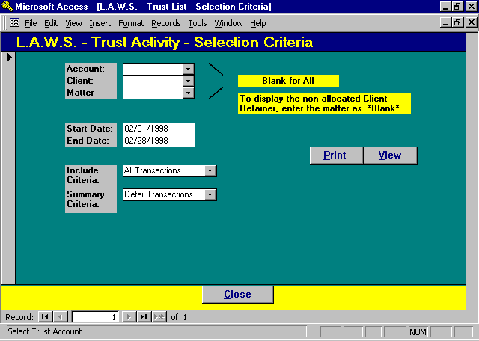

Trust Activity Selection Criteria

ACCOUNT
Enter a single trust account code to limit selection to a single account, or leave blank for all trust accounts.

CLIENT
Enter a specific client code for a single client’s activity, or leave blank for all clients.

MATTER
Enter a specific matter code for a single matter, or leave blank for all matters.

START/END DATES
Enter the date range for inclusion of data on the report. All trust transactions dated between the start and end dates will be included on the report.
INCLUDE CRITERIA
Select the type of transaction to be included on the report. The available options include:

All Transactions The report will include all Receipt, Disbursement and Adjustment transactions
matching the specified criteria.

Receipts Only The report will include only Receipt transactions matching the specified criteria.

Disbursements Only The report will include only Disbursement transactions matching the specified
criteria.

Adjustments Only The report will include only Adjustment transactions matching the specified
criteria.

SUMMARY CRITERIA
Select the manner in which the selected information should be presented. The available options include:

Client Totals A single line will be printed per client summarizing the client’s trust activity.

Matter Totals A single line will be printed per matter, with client totals, summarizing the matter’s trust
activity.

Detail
Transactions All detail transactions will be printed on the report. The detail transactions are totaled by
matter and client.

Please review the sample Trust Reports displayed on the following pages.

Sample: Trust Activity - Detail Transactions

Sample: Trust Activity - Summary by Matter

Sample: Trust Activity - Summary by Client
L.A.W.S. CORPORATION - DEMONSTRATION Account: *** All *** Start Date: Feb/01/1998
Trust Activity - Detail Transactions: All Transactions Client: *** All *** End Date: Feb/28/1998
Matter: *** All ***
Client/Matter Tran Date Receipt Disbursement Adjustment Balance Payee Description Check # Ret
_________________________________________________________________________________________________________________________________________________________________________
1: Trust account One $31,050.00 Trust Beg Bal
_________________________________________________________________________________________________________________________________________________________________________
Water Corporation (1) $0.00 Client Beg Bal
EPA VIOLATION #76589 (98767) $0.00 Matter Beg Bal
02/03/1998 $100.00 $0.00 $0.00 Y
Matter Totals: $100.00 $0.00 $0.00 $100.00
Client Totals: $100.00 $0.00 $0.00 $100.00
_________________________________________________________________________________________________________________________________________________________________________
ABC Corporation (ABC) $0.00 Client Beg Bal
New Matter Description (NEW) $0.00 Matter Beg Bal
02/03/1998 $0.00 $200.00 $0.00 test 12345 N
Matter Totals: $0.00 $200.00 $0.00 ($200.00)
Client Totals: $0.00 $200.00 $0.00 ($200.00)
_________________________________________________________________________________________________________________________________________________________________________
Trust Account Total: $100.00 $200.00 $0.00 $30,950.00
DR: 1103 CR:

_________________________________________________________________________________________________________________________________________________________________________
Copyright 1998 L.A.W.S. Corporation 4/29/98 2:04:22 PM 1
Dr && CR # Identify G/L Posting Accounts. If one or both are blank, G/L will not be posted.
Beginning and Ending Balances are Accurate Trust Balances regardless of type of selection requested. Trust Account Total
represents the total of displayed data only and may not be accurate unless selection criteria is "ALL".
TrLst_Det
L.A.W.S. CORPORATION - DEMONSTRATION Account: *** All *** Start Date: Feb/01/1998
Trust Activity - Summary by Matter: All Transactions Client: *** All *** End Date: Feb/28/1998
Matter: *** All ***
Account / Client / Matter Beg Balance Receipt Disbursement Adjustment Ending Balance
_________________________________________________________________________________________________________________________________________________________________________
1: Trust account One $31,050.00
Water Corporation (1) $0.00
EPA VIOLATION #76589 $0.00 $100.00 $0.00 $0.00 $100.00
Client Totals: $100.00 $0.00 $0.00 $100.00
_________________________________________________________________________________________________________________________________________________________________________
ABC Corporation (ABC) $0.00
New Matter Description $0.00 $0.00 $200.00 $0.00 ($200.00)
Client Totals: $0.00 $200.00 $0.00 ($200.00)
_________________________________________________________________________________________________________________________________________________________________________
Trust Account Total: $100.00 $200.00 $0.00 $30,950.00
DR: 1103 CR:

_________________________________________________________________________________________________________________________________________________________________________
Copyright 1998 L.A.W.S. Corporation 4/29/98 2:29:02 PM 1
Dr && CR # Identify G/L Posting Accounts. If one or both are blank, G/L will not be posted.
Beginning and Ending Balances are Accurate Trust Balances regardless of type of selection requested. Trust
Account Total
represents the total of displayed data only and may not be accurate unless selection criteria is "ALL".
TrLst_Mat

L.A.W.S. CORPORATION - DEMONSTRATION Account: *** All *** Start Date: Feb/01/1998
Trust Activity - Summary by Client: All Transactions Client: *** All *** End Date: Feb/28/1998
Matter: *** All ***
Account / Client / Matter Beg Balance Receipt Disbursement Adjustment Ending Balance
_________________________________________________________________________________________________________________________________________________________________________
1: Trust account One $31,050.00
_________________________________________________________________________________________________________________________________________________________________________
Water Corporation (1) $0.00 $100.00 $0.00 $0.00 $100.00
ABC Corporation (ABC) $0.00 $0.00 $200.00 $0.00 ($200.00)
_________________________________________________________________________________________________________________________________________________________________________
Trust Account Total: $100.00 $200.00 $0.00 $30,950.00
DR: 1103 CR:

______________________________________________________________________________________________________________________________________________________________________
Copyright 1998 L.A.W.S. Corporation 4/29/98 3:01:27 PM 1
Dr && CR # Identify G/L Posting Accounts. If one or both are blank, G/L will not be posted.
Beginning and Ending Balances are Accurate Trust Balances regardless of type of selection requested. Trust Account Total
represents the total of displayed data only and may not be accurate unless selection criteria is "ALL".
TrLst_Cli

