CALENDAR / CASE MANAGEMENT
TABLE OF CONTENTS

CALENDAR / CASE MANAGEMENT 371
Calendar / Case Management Menu 371
CALENDAR 372
Calendar Selection Screen 372
Daily Activity Section 373
Reminders / Deadlines 374
Entering / Modifying Calendar Entries 375
Add/Modify Calendar Entries Screen 375
History Screen 377
Posting WIP From Calendar / Docket Transactions 378
Other Functions Available From The Calander 379
Time Entry Button 379
Case Management Button 379
Print / View Daily Calendar 379
Sample: Daily Calendar Report 379
CASE MANAGEMENT 381
Case Management Selection 381
DATA SOURCE 383
Inquiry Buttons 383
Client Inquiry 383
Matter Inquiry 383
WIP Inquiry 383
AR Inquiry 384
Template Processing 384
Template Processing Screen 384
Display Transactions Button 386
Client Inq Button 387
Matter Inq Button 387
Print / View Button 388
Add New Entry Button 388
Sample: Docket Report- Summary by Firm 388
Sample: Two Weeks At-A-Glance Calendar 388
CONFLICT SEARCH 391
Conflict of Interest Selection Screen 391
SEARCH CRITERIA 392
FIND Box 392
COI Detail Screen 394
Searching Fields Other Then Description 395
Print/View Options 395
Performing Multiple Conflict Searches 395
Additional Search Criteria 395
Matter Search Criteria 396
Missed Searches 396
Client / Matter Inquiry Buttons 396
Sample: Conflict of Interest Report - Summary 396
Sample: Conflict of Interest Report - Detail 396
DOCKET TYPE MAINTENANCE 399
Docket Type Maintenance Screen 399
TEMPLATE MAINTENANCE 400
Template Maintenance Screen 400
Assignment of Templates to Matters 401
Matter Maintenance 401
Case Management 401

COURT / LOCATION FILE MAINTENANCE 402
Court / Location Maintenance Screen 402
DEFINE USER 403
Define L.A.W.S. User Criteria Screen 403
ACTIVITY DISPLAYED 405
Security Class Summary 406
Security Class - SECURITY 406
Security Class - FULL 406
Security Class - PARTIAL or STAFF: 406
Security Class - ADMIN 407
Security Class - INQ 408
Security Class - 1 409
Security Class - 2 410
Security Class - 3 411
Security Class - 4 412
Security Class - 5 413
Security Class - 6 414
Security Class - 7 415
Security Class 8 416
Security Class 9 417
Security Class 10 418

CALENDAR / CASE MANAGEMENT

The L.A.W.S. Calendar / Case Management System consists of an integrated Personal Calendar capable of tracking the attorney’s daily activity as well as a complete Docket System managing critical dates pertaining to matters. The Personal Calendar monitors pre-defined appointments as well as reminders and self-imposed deadlines. The Case Management system allows for the entry, tracking and retrieval of docket activity by attorney, client, case type, date range, location or virtually any other method imaginable.

After selecting CASE MANAGEMENT from the Master Menu, the following form is displayed.

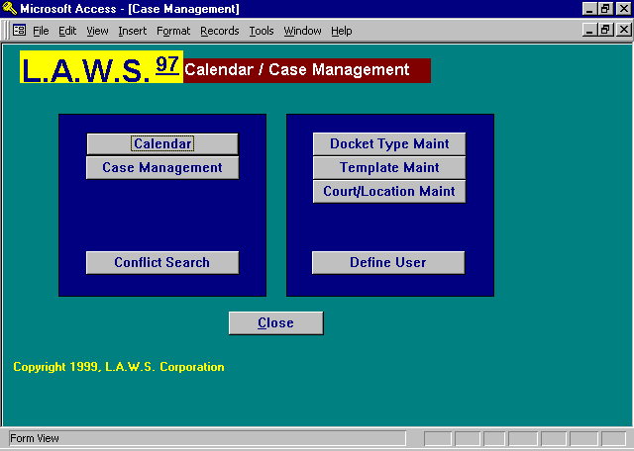

Calendar / Case Management Menu

The available options associated with Case Management are described in detail below.

CALENDAR

The Calendar option manages the attorney’s personal daily calendar. Time Entry as well as Case Management may be directly accessed from the personal calendar. The calendar has the capability of monitoring calendars for up to five attorneys simultaneously. If desired, calendar entries may be directly transferred to Work In Process without re-keying the transaction. Pre-defined settings for the calendar may be defined and stored by user.

After selecting the CALENDAR option from the Case Management screen, the following form is displayed.

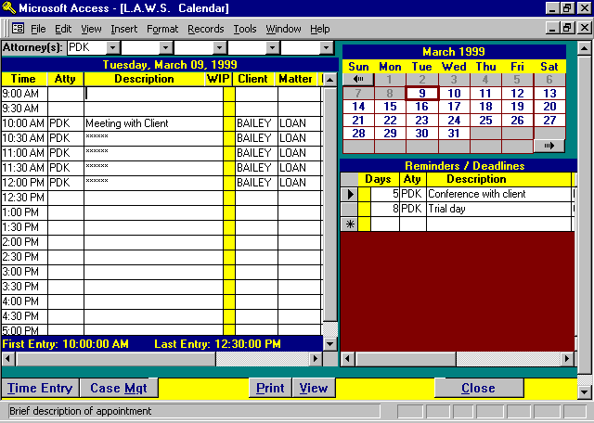

Calendar Selection Screen

ATTORNEY(s)
Identifies the attorneys to which the calendar applies. Calendars for up to five attorneys may be viewed simultaneously. The displayed attorneys are retrieved from the user information associated with the individual signing onto the system. If an attorney code is not assigned to the user, the calendar option is not functional. (Please review the Define User option within this chapter for additional information.)

The attorney operates in conjunction with the View Global Activity option within Attorney File Maintenance. If the displayed attorney has global activity rights, the attorney code may be changed and other attorney calendars may be accessed. Otherwise, only attorneys associated through the Define User may be displayed.

The Calendar contains three major sections consisting of the Current Month Calendar, Daily Activity, and Reminders and Deadlines. Some of the fields contained on this form may be too narrow to display the entire contents of large fields. To display a complete transaction, simply click the description column of the desired entry.

Current Month Calendar Section

The Current Month Calendar initially displays the current system date month. All dates prior to the system date are a dull color, (gray), while all dates from the system date forward are bright, (Blue). All dates are accessible. The monthly calendar may be scrolled either forward or backward using the arrows located at the start and at the end of the calendar.

The term Focus Date, utilized throughout this chapter, is the date for which information is accumulated and displayed. The Focus Date is selected by clicking the cursor on the desired date within the calendar. The Focus Date has a red border.

Daily Activity Section

The Daily Activity section of the screen lists all entries, associated with the attorneys and focus date, which have a starting time and duration. The duration must be assigned in half-hour increments. If the entry is an hour or more, the additional line items associated with the entry are asterisked out. The starting and ending times daily activity are displayed at the bottom of the section. If the Daily Activity is blank, the notation “No Entries” is displayed.

To view different days simply click the desired date from the Monthly Calendar section of the screen.

The information displayed within the Daily Activity section is inquiry only - not modifiable. To add a new entry, or modify an existing entry, click on the Description column of the desired line item which displays the Add/Modify Calendar Entries screens. The information associated with each Daily Activity calendar entry includes the following:

TIME
Identifies the time range associated with the referenced entries. Time within the calendar is entered in half hour increments. If the duration of the entry is greater than on half-hour, the additional line items are asterisked out. Clicking on the time column will automatically mark the entry as completed. Activity is listed within the calendar in ascending time order. If multiple transactions are entered with a common time, then the same time will be listed on several consecutive line items.

ATTY
Identifies the attorney assigned to the transaction.

DESCRIPTION
A brief description of calendar entry.

WIP
A designation as to whether this calendar entry has been posted to WIP through the Calendar program. If the entry has been posted to WIP, the yellow column will contain a “W”, otherwise the column will be blank. (See Posting WIP From Calendar / Docket Transactions later in this section for a detailed explanation of the procedures associated with posting calendar entries to WIP.)

CLIENT/MATTER
The client / matter combination associated with this transaction.

Scrolling the Daily Activity screen right, using the scroll bars at the bottom of the form will display additional fields.
LOCATION
The location associated with this transaction. The location code must be defined through the Court / Location File Maintenance function.

COMPLETED
Identifies the completion date of the entry. The word “Done” is automatically inserted into the description for all entries containing a completion date. The insertion is cosmetic only. The existing description is not modified. If an entry is marked as completed in error, simply remove the completed date using the Add/Modify Calendar Entries screen and the word "Done" will be eliminated.

Reminders / Deadlines

The Reminders / Deadlines section of the form displays calendar entries which are not associated with a time or duration. A number of “Reminder Days” may also be associated with calendar entries. If the scheduled calendar entry date is less than the “Reminder Days”, then the referenced calendar entry will be listed in the Reminders / Deadlines section of the form until its scheduled date.

The Reminders / Deadlines information associated with each calendar entry includes the following:

DAYS
If, within the calendar entry, a value is entered for “Reminder Days”, this field represents the number of days between the Focus Date and the Scheduled Date. If the entry contains a start time and duration, the entry will be transferred from the Reminder / Deadlines section of the form to the Daily Activities section on the scheduled activity date. If the Scheduled Calendar Date equals the Focus Date, but the Calendar Entry is not associated with a time or duration, then the entry will remain in the Reminder / Deadline section of the form with zero days.

Each calendar entry may contain up to five reminder day values. When the number of days between the focus date and the calendar date is less than or equals the first reminder day value, the calendar entry is displayed as a reminder. Clicking on the Days column performs one of two functions. If the Days value is greater than zero, the all the reminder days values are automatically rolled forward. If the Days value equals zero, the entry is marked as "Done" by automatically inserting into the entry he current system date as the completed date.

If the criteria is met, the calendar entry will be continually displayed as a Reminder or Deadline until acknowledged by clicking the Days column.

ATY
Identifies the attorney assigned to the transaction.

DESCRIPTION
A brief description of calendar entry.

WIP
A designation as to whether this calendar entry has been posted to WIP. If the entry has been posted to WIP, the yellow column will contain a “W”, otherwise the column will be blank. (See Posting WIP From Calendar / Docket Transactions later in this section for a detailed explanation of the procedures associated with posting calendar entries to WIP.)

CLIENT/MATTER
The client / matter combination associated with this transaction.

Scrolling the Reminders / Deadlines screen right, using the scroll bars at the bottom of the form will display additional fields.

LOCATION
The location code associated with the docket transaction.

COMPLETED
Identifies the completion date of the entry. The word “Done” is automatically inserted into the description for all entries containing a completion date. The insertion is cosmetic only. The existing description is not modified. If an entry is marked as completed in error, simply remove the completed date and the word "Done" will be eliminated.

Entering / Modifying Calendar Entries

Calendar entries may not be modified directly through the Daily Activities or the Reminders / Deadlines sections of this program. To enter a new, or modify an existing calendar entry, click the courser in the description portion of the desired line item to display the ADD / MODIFY CALENDAR ENTRIES screen.

After requesting the add or modify function, the following ADD / MODIFY CALENDAR ENTRIES form is displayed as noted below:

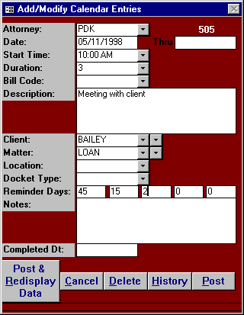

Add/Modify Calendar Entries Screen

All information contained on the Add/Modify Calendar Entries screen may be modified. A complete historical record is maintained of all calendar modifications.

ATTORNEY
The attorney associated with the docket/calendar transaction. The attorney defaults to the first attorney referenced on the L.A.W.S. calendar screen.

DATE
The date associated with the docket/calendar transaction. The date defaults to the focus date referenced on the L.A.W.S. calendar form.
START TIME
The starting time pertaining to this docket/calendar transaction. If a start time is entered, the transaction will be displayed in the Daily Activity section of the Calendar. The start time must be entered in 30-minute increments. If the start time is blank, the transaction will be displayed in the Reminders / Deadlines section of the Calendar.

DURATION
Specifies the duration of this docket/calendar transaction. The duration must be entered in 30-minute increments. The default value for new entries is 0.5 hours. If the duration is for more than 0.5 hours, L.A.W.S. will block out the time on the attorneys' calendar.

The Start Time and Duration work in conjunction with each other. They must be either both entered or both blank. If values are entered, the transaction will be listed on the Daily Activity section of the attorneys' calendar. If the values are blank, the transaction will be noted on the Reminders / Deadlines section of the Calendar.

BILL CODE
Enter the bill code applicable to this transaction. The bill code performs the same function as in Time Entry. If utilized, the bill code description is automatically inserted into the description field.

DESCRIPTION
The description associated with this docket/calendar transaction. If the transaction is posted to WIP, this description will be posted as the WIP description.

CLIENT
The client associated with this transaction. When a client is entered, the matter is automatically cleared. A transaction may be applied to a client without a matter.

MATTER
The matter associated with this transaction. A matter must be entered in conjunction with a client. If a matter is entered without a client, all matters will be available for selection regardless of client. When a matter is selected, the corresponding client will be inserted in the client code. Note: If two clients have the same matter code, and the client code is left blank, the lowest client code will be assigned.

LOCATION
The location associated with this docket/calendar transaction. The location corresponds to a code entered through the Court / Location File Maintenance. The location code allows docket / calendar transactions to be selected and reviewed by a specific location. The location codes are user defined and may apply to courts, offices, or conference rooms.

DOCKET TYPE
Specifies the docket type associated with this transaction. The docket type corresponds to user defined codes entered through Docket Type File Maintenance. Examples of docket types may be Trial, Deposition, Accounting Deadlines, etc. Docket Types may be assigned to bill codes. Accordingly, if a docket type is associated with a utilized bill code, this docket type is automatically inserted into the transaction. Pre-defined reminder days associated with the Docket Type will automatically be assigned to new transactions.

REMINDER DAYS
Specifies the number of days prior to the actual transaction date that this transaction should appear on the Reminders / Deadlines section of the Calendar. L.A.W.S. can support up to five reminder days. The transaction will continue to be displayed in the Reminder / Deadlines section of the Calendar until the Reminder Days value is decreased to a lower number, or until the transaction date associated with this transaction passes. Multiple Reminder Day values should be entered in descending order.

NOTES
Enter miscellaneous notes pertaining to this transaction. These notes do not interface with WIP. Reasons for using notes may include directions to a location, phone numbers, materials needed at a meeting, etc.
COMPLETED DT
Specifies the completion date of the transaction. If the calendar / docket entry has been completed, a date may be entered in this field. The word “DONE” is inserted at the beginning of the descriptions of completed transactions. It is not required that transactions be marked as completed. Clicking the Time column on the desired Daily Activity transaction automatically inserts the system date in the completed date field. Clicking the Days column will close the transaction if the reminder days values are zero.

POST Button
This will post the current transaction then return to the Calendar screen.

POST & REDISPLAY Button
This button will post the current transaction and then re-display a new entry with the existing data. A memorandum entry “Posted” is displayed specifying that the original entry has been posted and the displayed data corresponds to a new transaction. Any or all fields within the displayed data may be modified creating a new transaction. If the Attorney, Date or Time are not modified, a conflict may be created within the system. If it is decided that a new entry is not to be created, simply cancel the current transaction to return to the Calendar menu.

CANCEL Button
This will cancel the current transaction then return to the Calendar screen. New entries, and modifications to existing entries, will be ignored.

DELETE Button
This will delete, physically remove, the displayed calendar / docket transaction.

HISTORY Button
All modifications to calendar / docket transactions are recorded in a Docket History file. Each historical line item displays the field name that was modified, and the value of the field prior to the modification. After clicking the HISTORY button, the following form is displayed.

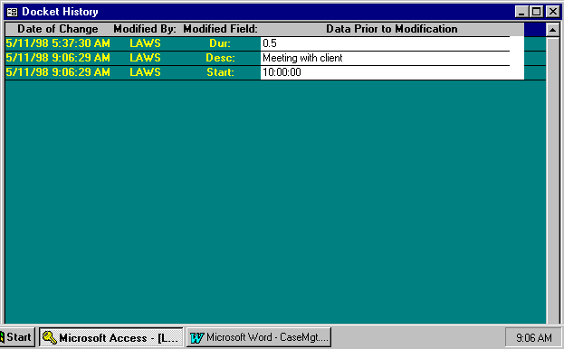

History Screen

DATE OF CHANGE
Displays the date and time the transaction was modified.

MODIFIED BY
Displays the user ID of the person making the modification. The user ID will be meaningful only if each L.A.W.S. user has a unique USER record defined through USER File Maintenance. In network installations, the user ID can be captured during sign on.

MODIFIED FIELD
Displays the title of the field that was modified. If multiple fields are modified, multiple line items will be displayed.

DATA PRIOR TO MODIFICATION
Displays the value of the modified field prior to the current modified value. Scroll bars may be used to display excess data not initially displayed in the field.

______________________________________________________

Posting WIP From Calendar / Docket Transactions

L.A.W.S. allows the ability to post calendar entries into WIP. The information associated with the calendar entry will automatically be inserted into the WIP transaction eliminating re-keying of data. Any or all information relating to the transaction may be changed prior to the actual posting of WIP. To post a calendar entry to WIP, simply click the yellow WIP column located on the first line of the desired transaction. Reminders may be posted to WIP by moving the Reminder form to the right to display the WIP column. The following WIP transaction form will be displayed.

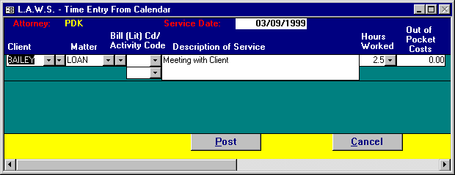
FIELDS TO VERIFY/ENTER:
Service Date The service date may be modified, if necessary, to correspond to the actual date of
service.
Client / Matter,
Bill Code,
Activity Code,
Description of Service,
Hours Worked,
Out of Pocket Costs

Please review Time Entry in the Time Processing chapter of this manual for an explanation of data to be entered into this form.
POST Button
The POST button will post the entry to WIP then close the Time Transaction Screen. All data is verified prior to posting.

CANCEL Button
The CANCEL button will close the Time Transaction Screen without posting the entry to WIP.

Other Functions Available From The Calander

Time Entry Button

The Time Entry Button displays a complete time sheet for the referenced attorney and focus date. All Time Entry transactions are displayed regardless of whether they were generated from the Time Processing function or from the Calendar program.

If an erroneous entry was posted from the Calendar into WIP, simply display all transactions posted to WIP, through the TIME ENTRY button, and delete the erroneous entry. The WIP designation will automatically be removed from the WIP column.

Please review TIME ENTRY in the TIME PROCESSING chapter of this manual for an explanation of data to be entered into this form.

Case Management Button

The CASE MGT button displays the Case Management function. Case Management analyzes all data within the Calendar / Case Management system and allows selection and review based on a wide variety of formats.

Please review CASE MANAGEMENT, found later in this chapter, for a detailed explanation of the Case Management system.

Print / View Daily Calendar

The PRINT and VIEW buttons will select and produce the Daily Calendar Report for the referenced attorney and focus date. The report contains both the Daily Appointments and Reminders and Deadlines. If desired, the report may be used as a daily time sheet when the attorney is out of the office.

A sample of this report is displayed on the following page.

Sample: Daily Calendar Report

L.A.W.S. CORPORATION - DEMONSTRATION
Daily Calendar for: Paul D Karlsberg (PDK)
Susan S Jones (SSJ)
Carol C Cliffton (CCC)
Monday, May 11, 1998

Daily Appointments:
_________________________________________________________________________________________________________________________________
Start Atty Activity Client Matter Matter Description
_________________________________________________________________________________________________________________________________
8:30 AM
9:00 AM
9:30 AM
10:00 AM
10:30 AM
11:00 AM PDK Meeting with client regarding loan application BAILEY LOAN Construction Loan
11:30 AM ****** BAILEY LOAN Construction Loan
12:00 PM ****** BAILEY LOAN Construction Loan
12:30 PM ****** BAILEY LOAN Construction Loan
1:00 PM ****** BAILEY LOAN Construction Loan
1:30 PM ****** BAILEY LOAN Construction Loan
2:00 PM
2:30 PM
3:00 PM
3:30 PM
4:00 PM
4:30 PM
5:00 PM
_________________________________________________________________________________________________________________________________

Deadlines / Reminders:
_________________________________________________________________________________________________________________________________
Days Date Atty Activity Client Matter Matter Description
_________________________________________________________________________________________________________________________________
3 Days 5/14/98 CCC Trial Day BAILEY LOAN Construction Loan

_________________________________________________________________________________________________________________________________
Copyright 1998 L.A.W.S. Corporation 5/11/98 9:32:53 AM
1

CASE MANAGEMENT

The Case Management function allows for the selection, review and modification of the calendar / docket activity through a variety of different formats.

After requesting CASE MANAGEMENT, the following form is displayed.

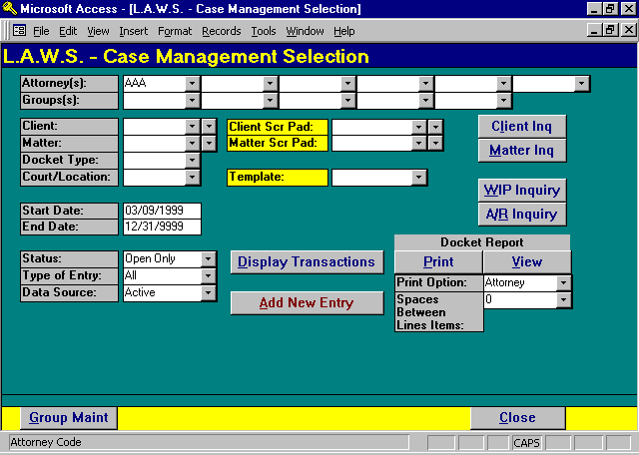

Case Management Selection

The entered Selection Criteria determine the calendar / docket entries to be selected and displayed. All selection criteria works in conjunction with each other allowing the selected records to be as broad or as narrow as desired. The selection criteria may be left blank or may contain an entry. If a response to selection criteria is entered, only entries matching the response will be selected. Blank responses will include all.

ATTORNEY(s)
Enter the desired attorney(s) for which the calendar activity should be selected. The selection may include from one to six attorneys. The attorney codes work in conjunction with the Global Activity feature in the Attorney file and the available attorneys noted in the Define User option. Only authorized attorneys will be available.

GROUP(S)
Enter the Groups of attorneys for which calendar activity should be selected. Attorney Groups may be reviewed, entered or modified by pressing the Group Maintenance button at the bottom of the screen. After pressing Group Maintenance, the following form is displayed.

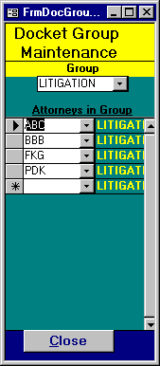
The GROUP code is user defined. Use the dropdown box to display the existing groups. Once the group is selected, all attorneys within the group will be displayed.

CLIENT
Enter the desired client code.

MATTER
Enter the desired matter code. Matter codes must be entered in conjunction with a client code. If the client code is not known, all matters within the firm may be searched by either code or description. When a matter is selected, the client code associated with the matter is automatically inserted into the client code.

DOCKET TYPE
Enter the desired docket type associated with the entries to be selected.

COURT/LOCATION
Enter the desired court or location code associated with entries to be selected.

START DATE
Enter the starting date for selection of the desired docket activity. The start date corresponds to the current system date. This date may be modified or deleted. If the date is blank, all non-purged docket entries dated prior to the end date will be displayed.

END DATE
Enter the ending date for selection of the desired docket activity. The end date will default to 12/31/9999 that results in displaying all open docket activity from the start date. If desired, the end date may be modified, but it cannot be blanked out.
STATUS
Select the status of the entries to be selected for review or reporting. The available options include:
Open Only Only docket transactions without a Completed Date will be selected.
Completed
Only Only docket transactions with a Completed Date will be selected.
All All docket entries will be included, both open and completed transactions.

TYPE OF ENTRY
Specify the type of entries to be included for review or reporting. The available options include:
All Both Calendar and Reminder entries are selected.
Calendar Only Calendar entries will be selected. Calendar entries are defined as transactions
containing a Starting Time and Duration.
Reminder Only Reminder entries will be selected. Reminder entries are defined as transactions
without a Starting Time and Duration, or transactions selected as reminders based on a
Reminder Day value.
History Displays all historical transactions based on the dated of change.

DATA SOURCE
The source of the transactions to be displayed. The available options include:
Active Docket transactions are selected from the active docket entries.
Purged Docket transactions are selected from the purged docket entries.

CLIENT/MATTER SCRATCH PADS
The client and matter scratch pad options allow review or modification of scratch pad information associated with the referenced client or matter. The client or client/matter must be entered to access this information. The Client scratch pad field displays data associated with the client while the Matter scratch pad displayes data associated with the matter.

Two drop down boxes are associated with the scratch pad inquiry options. The box on the right displays all utilized scratch pad codes while the box on the left displays all available scratch pad codes. To access the Scratch Pad information, click on the YELLOW HEADINGS associated with the desired scratch Pad.

Inquiry Buttons

As a matter of convenience, the L.A.W.S. Case Management system provides several inquiry functions allowing immediate access to associated data throughout the system. A brief summary of each inquiry button follows:

Client Inquiry
Client Inquiry allows inquiry access only to client information. Data may be viewed, but not modified. A client code must be specified in the Client field prior to selecting client inquiry. Useful information available to the attorneys includes the clients' name and address, phone number, and conflict of interest data. Please review the Client File maintenance section of this manual for a detailed description of the data presented via Client Inquiry.

Matter Inquiry
Matter Inquiry allows inquiry access only to Matter information. Data may be viewed, but not modified. A client and matter code must be specified in the Client and Matter fields prior to selecting matter inquiry. Useful information available to the attorneys includes the billing and responsible attorneys, conflict data, and matter notes. Please review the Matter File maintenance section of this manual for a detailed description of the data presented via Matter Inquiry.

WIP Inquiry
WIP Inquiry allows for the review of billed and/or unbilled Work in Process. Although a Client and Matter code are not required, if entered they will be carried forward to the WIP Inquiry selection screen. Please review the WIP Inquiry section of the Time Processing chapter for a detailed review of this option.

AR Inquiry
AR Inquiry allows for the review of Accounts Receivable information. Although a Client and Matter code are not required, if entered they will be carried forward to the AR Inquiry selection screen. Please review the AR Inquiry section of the Accounts Receivable chapter for a detailed review of this option.

Template Processing

L.A.W.S. allows the development of user defined templates listing activity associated with specific types of matters. Please review Template Maintenance for a detailed description of templates. If a pre-defined template should be utilized to facilitate the assignment of docket dates, enter the desired template code. The client, matter and attorney must be entered to utilize the template function.

After entering the template code, click the yellow template heading to continue. After initiating Template Processing, the following screen is displayed.

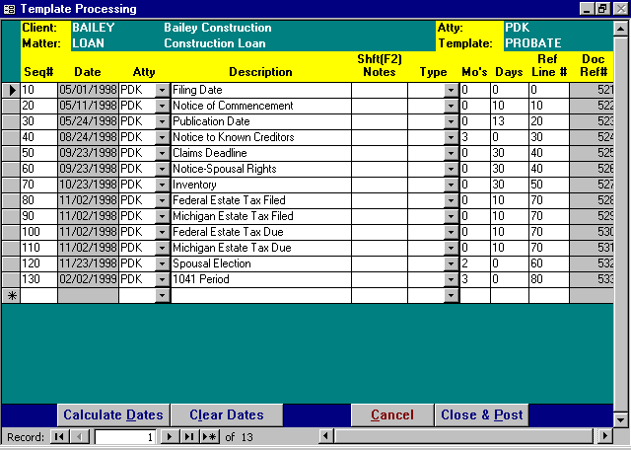

Template Processing Screen

Please note that the line items on the displayed template processing form parallel the accessed template format with the addition of a date column. The data on the screen applies to the current matter only. Template lines may be added, deleted or modified as appropriate for the matter being processed. Dates may be manually entered on all desired lines. Dates that are to be computed from previous line items may be left blank. Please review the Template Maintenance section of this chapter for a detailed review of the other fields on this form.
SEQ#
Displays the sequence number previously assigned to the template line item. Line items are displayed in sequence number order. The automatically assigned sequence number for new line items will always be ten digits higher than the last assigned sequence number. New Lines may be inserted between existing line items by manually entering the desired sequence number. New line items may be added to the Matter’s template, but existing lines may not be deleted unless the line is deleted from the master template through Template Maint.

DATE
Displays the date assigned to each line template line item. The dates on new templates will always be blank. Once the Calculate Dates button is pressed, line item dates will be computed and assigned based on the template formula. Base Dates, original dates used in the computation of other dates, must be entered manually.

DESCRIPTION
The description of the template entry. May be modified if desired.

NOTES
If desired, notes may be associated with template transactions. To enter comments, activate the "Zoom Box" by pressing the "Shift" and "F2".

TYPE
The Docket Type. May be modified if desired.

MO'S
The number of months that should be used in the computation of the Template Date. May be modified if desired.

DAYS
The number of days that should be used in the computation of the Template Date, May be modified if desired.

REF LINE#
The line number of the Template that contains the base date used in the computation of the current line item's date. May be modified if desired.

CALCULATE DATES Button
The Calculate Dates button will compute values for all line items within the template. Computation of dates consists of adding the number of months and/or days to the existing date contained on the referenced line number. All existing dates will be re-calculated. If the date on the referenced line number is blank, a date will not be computed.

CLEAR DATES Button
The Clear Dates button will automatically blank out all dates within the current form. Prior to clearing the dates, the following message will be displayed.

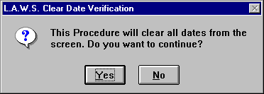

To continue with the clear, select “Yes”. Otherwise, select “No” to return to the Template Processing form.
CLOSE & POST Button
The Close and Post button will create docket transactions for each line item listed on the form. If the specified attorney or docket date associated with a transaction is blank, then the transaction will not be posted.

CANCEL Button
The Cancel Button will exit the Template Processing form WITHOUT posting any of the displayed transactions. Once cancel is selected, the following message is displayed.

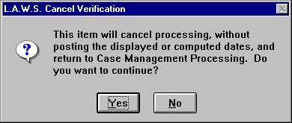

“Yes” will continue with the cancellation. While “No” will return to the Template Processing screen.

_______________________________________________________________

Display Transactions Button

The Display Transactions button will display, in Inquiry Form, the entries selected from the system based on the entered Selection Criteria. After clicking the Display Transactions Button, the following screen is displayed.

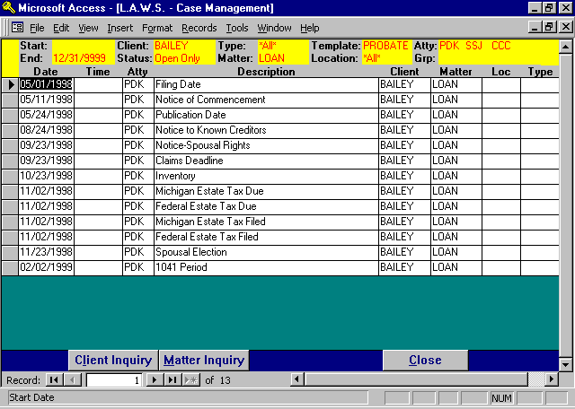

All criteria utilized in the selection of entries are displayed at the top of the form. If the displayed data is either too broad or narrow, simply close the form and re-enter the selection criteria.

The Display Transactions screen displays the following columns corresponding to the data entered into the docket entries.
Date;
Time;
Attorney;
Description;
Client;
Matter;
Location;
Docket Type.

This information may be reviewed only - not modified. To modify data pertaining to the transaction, simply click anywhere on the entry line to display the ADD / MODIFY CALENDAR ENTRIES form. For a detailed explanation of this form please review the CALENDAR section of this chapter.

Client Inq Button

Pertinent information associated with case management may be found in the client file or in the related client scratch pads. The Client Inquiry button allows inquiry and review of this information stored in the Client file. If the Client Code on the selected transaction line is blank, the following message is displayed.

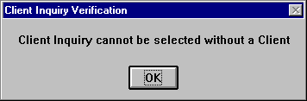

Please select a transaction line containing a client code before continuing.

Client information associated with the client code on the selected line will be displayed. Inquiry may be performed only on the client referenced on the calendar / docket transaction line.

Please review the Client File Maintenance function, described within the Data File Maintenance chapter of this manual for a detailed review of the displayed client information.

Matter Inq Button

Pertinent information associated with case management may be found in the matter file or in the related matter scratch pads. The Matter Inquiry Button allows inquiry and review of information stored in the matter file. If the Client / Matter Codes, on the selected transaction line, are blank, the following message is displayed.

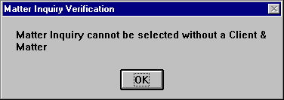

Please select a transaction line containing a valid client / matter code before continuing.

Matter information associated with the matter code on the selected line will be displayed. Inquiry only may be performed on the matter referenced on the calendar / docket transaction line.

Please review the Matter File Maintenance function, described within the Data File Maintenance chapter of this manual for a detailed review of the displayed matter information.

_______________________________________________________________

Print / View Button

The Print Button will generate a Docket Report containing all calendar / docket transactions, matching the entered selection criteria. The available options for generation of the docket report are described below.

Print Option
Attorney Detail transactions are grouped together chronologically within attorney. Page breaks
occur between attorneys.
Firm Detail transactions are grouped chronologically regardless of attorney.
Matter Detail transactions are grouped chronologically within matter. Page breaks occur
between matters. If desired, Scratch Pad data associated with the matter can be
included on the report.
One Week A one week At-A-Glance docket report. The report summarizes seven days of activity in
calendar form.
Two Weeks A two week At-A-Glance docket report. The report summarizes 14 days of activity in
calendar form.
Month A one month At-A-Glance docket report. The report summarizes a month of activity in
calendar form.

SPACES BETWEEN LINE ITEMS
Enter the desired number of blank lines to be printed between line items for the Firm, Attorney or Matter reports. The available options include zero - five.

Samples of Docket reports are displayed at the end of this section.

Add New Entry Button
The Add New Entry Button will display the ADD / CHANGE CALENDAR ENTRIES form. For a detailed explanation of this form please review the CALENDAR section of this chapter.

Samples of Docket reports are displayed on the following pages.

Sample: Docket Report- Summary by Firm

Sample: Two Weeks At-A-Glance Calendar

L.A.W.S. CORPORATION - DEMONSTRATION Client: *All* Start Date: May 01/1998
Docket Report- Summary by Firm - Reminder & Calendar Matter: *All* End Date: May 31/1998
Atty: *All* Type: *All*
Groups: Template: PROBATE Loc: *All* Open Only
Date Start Duration Atty Type Client/Matter Location Description Completed
_________________________________________________________________________________________________________________________________
Fri 05/01/1998 0 PDK (BAILEY / LOAN) Construction Loan Filing Date
Fri 05/08/1998 0 PDK (ABC / NEW) New Matter Description Publication Date
Mon 05/11/1998 0 PDK (BAILEY / LOAN) Construction Loan Notice of Commencement
Sun 05/24/1998 0 PDK (BAILEY / LOAN) Construction Loan Publication Date

_________________________________________________________________________________________________________________________________
Copyright 1998 L.A.W.S. Corporation 5/11/98 5:16:12 PM 1
Sorted by Date, Start Time, Sequence Number
RptDoc1_Firm
L.A.W.S. CORPORATION - DEMONSTRATION Client: *All* Type: *All* Template: PROBATE
Two Weeks At-A-Glance Calendar Matter: *All* Loc: *All* Include: Open Only
Atty(s): PDK SSJ CCC Groups: Reminder & Calendar
May 11 1998 through May 24 1998
Monday Tuesday Wednesday Thursday Friday Saturday /Sunday
11  8:00 PDK BAILEY LOAN TRIAL  10:00 SSJ ABC GEN DEP  11:00 PDK SMIRH TAX | 12 | 13 | 14 | 15 | 16 / 17
18 | 19 | 20 | 21 | 22 | 23 / 24

_________________________________________________________________________________________________________________________________________________________________________
Copyright 1998 L.A.W.S. Corporation 5/11/98 5:16:12 PM 1
At A Glance - RptDoc_2W

CONFLICT SEARCH

The Conflict Search allows for the analysis and review of selected field within the L.A.W.S. database, for a possible Conflict of Interest. Conflict checking is performed on Client Names, Matter Descriptions, Conflict of Interest Entries and Scratch Pad Responses.

After selecting Conflict Search, the following form is displayed.

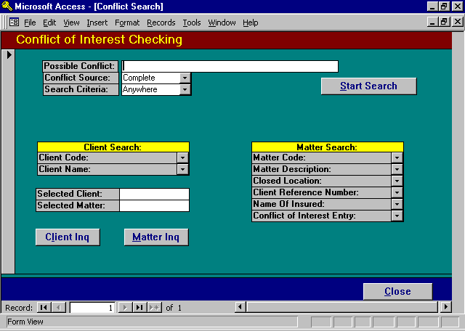

Conflict of Interest Selection Screen

POSSIBLE CONFLICT
Enter the name of the possible conflict for which the conflict search should be performed. The possible conflict may be any character string identifying the possible conflict. It should be entered as briefly as possible, yet still be detailed enough to eliminate significant duplications. The entered conflict does not need to completely describe matches, but the entered conflict must fall exactly within the matched entries. The conflict search is not case sensitive.

Example: The firm acquires a new client called Horace J. Witherspoon III and desires to perform a conflict search of the database for a possible conflict.

To perform a search, an entry must be entered in the possible conflict field. Assume “Horace J. Witherspoon III” was entered as a possible conflict.

If an exact match was found in the L.A.W.S. database, including spaces and punctuation, the entry will be displayed during a conflict search. If the name “Horace J Witherspoon III” , existed in the L.A.W.S. database, the conflict would not be found. The possible conflict contains a period after the middle initial, while the actual database entry does not.

A better way to search for conflicts would be to enter a more concise search pattern such as “Witherspoon”, or “Withers”. Either search patterns would display the conflict since they both contain characters that exactly match characters within the actual database conflict. It does not matter where the match occurs within the entry, as long as there is an exact match someplace in the entry.

CONFLICT SOURCE
L.A.W.S. automatically checks for conflicts from several sources. If the name is listed elsewhere, other then the referenced sources( such as within Work In Process Text), the conflict will not be found. The available conflict source options are:

COI: The conflict check will be performed against all entered conflict of interest entries entered through client and/or matter maintenance.

Matter: The conflict check will be performed against all matter descriptions.

Client: The conflict check will be performed against all client names.

Scratch Pad: The conflict search will be performed against all scratch pad responses entered through the client and/or matter file maintenance or inquiry. Only scratch pad line items marked as “Y” , within the Scratch Pad Maintenance function, will be selected for conflict checking. Please review Data File Maintenance - Scratch Pad, for a detailed review of the conflict code.

SEARCH CRITERIA
Specifies how the search should be performed. The possible options include:
Anywhere The entire text is evaluated for the search criteria, Longest option.
Start The search criteria is assumed to be at the start of the record. Only the start of the
record is evaluated for conflict searching. This is the fastest option, but not as through.

START SEARCH Button
After entering a search pattern within the possible conflict field, L.A.W.S. builds a work file merging all conflict information into a single source. For this example, "With" was entered as a possible conflict. After the Work File is created, the following form is displayed.

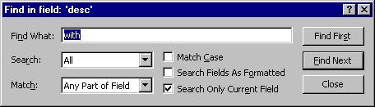
L.A.W.S. automatically searches characters within the description field for the match of the possible conflict. When Found, the record selector of the possible conflict is highlighted. If this entry seems like a possible conflict, the Find box may be closed allowing for further analysis. Otherwise the Find Next button may be pressed displaying the next match.

All parameters noted on the Find form may be modified, if desired, to better accommodate the search.

FIND Box

FIND WHAT
The Find What field displays the search characters. The value entered in the possible conflict field is automatically displayed.
SEARCH
Specifies the direction of the search. All items are listed alphabetically by description. The down direction will search alphabetically from first to the last record. The UP direction will search from the last record to the first record. Down is recommended.

MATCH
Specifies where in the fields the search pattern must be found. The default value is “Any Part of Field” meaning the search pattern may fall anywhere, (start, middle or end), within the displayed fields. The other options include:
Any Part of Field: The value entered must match any part of the database field.
Whole Field: The value entered must exactly match the entire database field.
Start of Field: The value entered must be found at the start of the database field.

FIND FIRST BUTTON
Selecting the Find First button will display the first match, lowest record number, within the displayed entries.

FIND NEXT BUTTON
Will display the next record matching the entered criteria.

If the Find Box blocks the detail form, simply click and hold the mouse on the blue title bar, then drag the box out of the way.

If a possible match is found, click the Close Button on the Find Box to return to the Detail COI Form. The record selector associated with the possible conflict will be selected. Several review options are available from the Detail COI form including:

To re-display the Find Box, simply press Control + F simultaneously.

Press the “Close” button to close the Find Box and display the Detail COI Screen.

A sample of the COI Detail screen is displayed below.
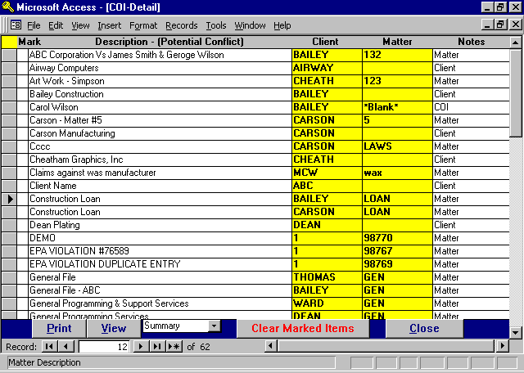

COI Detail Screen

MARK
This column allows the user to identify line items that represent possible conflicts. Line items are Marked or unmarked by double clicking the desired record selector. The Mark column works in conjunction with the Print/View option. All marked line items may be printed for additional review by the attorneys associated with the possible conflict.

DESCRIPTION(Possible Conflict)
The Description column lists the data from the selected source as noted below:
COI: Conflict of interest entries associated with clients or matters.
Matter: The matter description.
Client: The client name.
Scratch Pad: The scratch pad response associated with scratch pad heading lines.

CLIENT
Specifies the client associated with the line item. The client will always be entered.

MATTER
Specifies the matter associated with the line item. The matter will not be entered in conjunction with a client source selection. The matter may, or may not, be listed in conjunction with scratch pad entries. If the scratch pad is associated with the client, the matter code will read “*Blank*”.

NOTES
Lists the source of the conflict search. If the source is scratch pad, the notes will display the scratch pad code and line description associated with the line item.

Searching Fields Other Then Description
If desired, columns may be searched other than the description column. To do so, perform the following:
1 Close the find box to display the COI Detail screen.
2 Click the cursor on the column to be searched.
3 Re-display the find box by pressing the "Ctrl" and "F" keys.
4 Specify the new search criteria then press "Find Next".

CLIENT/MATTER INQUIRY OPTIONS
The yellow Client and Matter columns allow immediate access to Client or Matter inquiry. To select Client Inquiry, click the mouse on the desired Client Code. To display Matter Inquiry, click the mouse on the desired Matter Code. Please review Client and Matter File Maintenance in the Data File Maintenance chapter for a detailed review of information available from the Client and/or Matter Inquiry options.

Print/View Options
The Print/View buttons allow the "marked" conflict entries to be printed in either summary or detail form. The dropdown box to the right of the buttons identifies the format of the report. Samples of both the Detail and Summary reports are displayed at the end of this section.

CLEAR MARKED ITEMS
Once the "marked" items have been printed, or they are no longer required, press the Clear Marked Items button to automatically remove all marks from the selected line items.

Performing Multiple Conflict Searches
Each time a conflict search is performed from the COI Selection screen work files need to be created. The time required for creation of this file can be significant and varies based on the size of the database. If possible, it is most productive to perform several conflict searches using the same work file. To do so, perform the following steps:
1 Enter your initial search criteria from the COI Selection screen and perform the search.
2 Analyze possible conflicts.
3 Print the desired Conflict report.
4 Clear Marked Entries.
5 Redisplay the Find Box by pressing the "Ctrl" and "F".
6 Change the search criteria to the next conflict and restart the process.

Sample Conflict of Interest reports are displayed at the end of this section.

Press the Close button to re-display the Conflict Of Interest Selection screen.

Additional Search Criteria
The Conflict of interest function provides the means of finding clients and/or matters based on variety selection criteria. Once a client or matter is selected the value is posted to the “Selected Client” or “Selected Matter” field.
If a client is entered in the “Selected Client” field then matter searches are limited to the selected client. If the “Selected Client” is blank, then all matters will be included in the search criteria.

Client Search Criteria
Clients may be searched for by either client code or name. To search by:
Client Code: click on the client code dropdown box then start typing the desired client code.
Client Name: click on the client name dropdown box, then start typing the client name AS THE
CLIENT NAME IS ENTERED IN THE CLIENT NAME FIELD.

Once a client is selected, the client code is inserted into the “selected Client” field. All matter searches will be limited to the entered “Selected Client”. If the “Selected Client” value is entered in error, simply blank out the selected client.

Matter Search Criteria
Matter records may be found using a variety of search criteria. To initiate a search, click on the desired dropdown box, then start keying in the desired search criteria based on the selected line item. The available search criteria is as follows:

Matter Code,
Matter Description,
Closed Location.
Client Reference Number,
Name of Insured,
Conflict of Interest entry.

Missed Searches
L.A.W.S. will automatically display matched data as long as a match is available. The data within the dropdown box is bolded as the match is being performed. Once the match criteria is exhausted, the data within the dropdown box is no longer bolded and the displayed data starts at the beginning of the list.

When the match criteria is exhausted, either backspace until the data within the dropdown box is again highlighted, or press the escape key several times to clear the typed characters, then re-start the search.

Client / Matter Inquiry Buttons
Once the Selected Client and/or Matter are entered, the Inquiry buttons will display the selected Client or Matter.

Listed below are sample Conflict of interest reports.

Sample: Conflict of Interest Report - Summary

Sample: Conflict of Interest Report - Detail
L.A.W.S. CORPORATION - DEMONSTRATION Search Name: with
Conflict of Interest Report - Summary Bill Resp
Client Matter Atty Atty Date Open Date Closed Conflict Description COI Source
_________________________________________________________________________________________________________________________________________________________________________
(12345) (*Blank*) Jim Wilson COI
(CARSON) Carson Manufacturing (LAWS) Cccc AAA BBB 10/17/1996 04/30/1998 National Hay Association (NHA) COI
(DEAN) Dean Plating (GEN) General Programming Services PDK PDK 04/30/1998 Horace Witherspoon COI
(HICKEY) Hickey Entertainment () Hickey Entertainment Client
(JOHNSON) Johnson And Johnson (GENERAL) NEW MATTER CCC BBB 01/14/1997 04/30/1998 NEW MATTER Matter
(1) Water Corporation (98767) EPA VIOLATION #76589 AAA AAA 03/26/1997 04/30/1998 Mary Ruth SP: DIVORCE-Spouse's name

_________________________________________________________________________________________________________________________________________________________________________
Copyright 1998 L.A.W.S. Corporation 5/12/98 10:03:40 AM Page 1 of 1
rptCOI_Sum - COI Search - Summary Option
L.A.W.S. CORPORATION - DEMONSTRATION *Blank* Search Name: with
Conflict of Interest Report - Detail Bill Resp
Client Matter Atty Atty Date Open Date Closed Conflict Description COI Source
_________________________________________________________________________________________________________________________________________________________________________
(ABC) ABC Corporation (132) ABC Corporation Vs James Smith CCC PDK 05/18/1995 04/30/1998 ABC Corporation Vs James Smith & Geroge Matter
Client & Address Phone# Atty Det Txt Sub Tot Dun Not Dom
Contact TaxID Fiscal Start Det Hrs Aty Aloc Chg Int Entity
Bill Name Start Dt Aty Rate DetCst Retner Mis Cst Bus Cd
I/A Date Class Rate Aty Init A/R Bal Disc% Stat
Ext Fee Cvr Ltr
A/R Sum
_______________________________________________________________________________________________________________________________________________
Client Information ABC ABC Corporation (313) 939 9876 SSJ
12345 West Avenue 11
Suite 600 08/03/1996 ABC
INS-2
Detroit MI 48226
Scratch Pad: CORP Response Additional Data
State of Incorporation Michigan Michigan
Tax ID Number 38-1234567
Doing Business as Name
Accountant Jacobs & Wilson Jacobs & Wilson
3422 East Big Beaver Road
Suite 601
Troy, MI 48632
(248) 555-9877
Trust#/
Description/ Resp/ Dt Open/ Prft Ctr/
Contact/ Bill/ Dt Close/ BilStat/
Client ID#/ Type/ Dt Destry/ Branch/ Matter Matter
Client/ Insured/ Court/ Inc Date/ Aty Rt Cd/ Matter Draft Bill
Matter Misc Address Close Loc File Dt Cls Rt Cd Notes Notes Notes
Matter Information _________________________________________________________________________________________________________________________________________________
ABC ABC Corporation Vs James Smith & Geroge Wilson NBD These are general These are Matter These are the
132 Mr. James Connor PDK 5/18/95 01 Matter Notes. They Draft Notes. They Matter Bill Notes.
028-36-9643 CCC 4/30/98 B do not appear any appear on the data They appear on the
place in the system input screen or the data input screen,
Mr. James Smith 2 except for the detail matter list the detail matter
1/1/93 ABC data input screen and on the Bill lists, and on the
5/1/94 or the detail matter Drafts. client statement.
Scratch Pad: CORP Response Additional Data
Date of Incorporation 1/7/1983

_________________________________________________________________________________________________________________________________________________________________________
Copyright 1998 L.A.W.S. Corporation 5/12/98 11:34:42 AM Page 1 of 1
rptCOI_Sum - COI Search - Detail Option

DOCKET TYPE MAINTENANCE

Calendar and Docket entries may be classified by type through the use of Docket Type Codes. This procedure allows for the definition of the Docket Type Codes. After selecting Docket Maintenance, the following form is displayed.

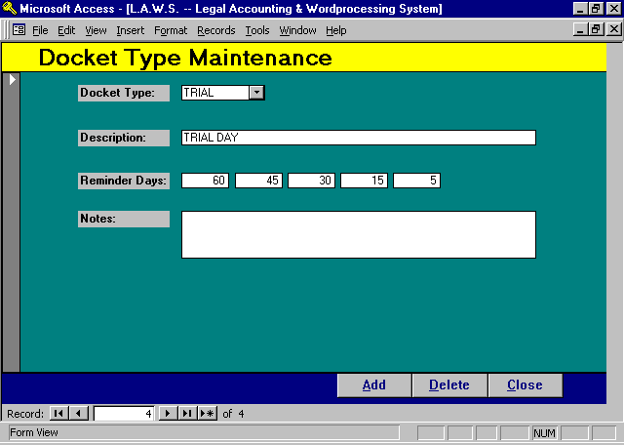

Docket Type Maintenance Screen

DOCKET TYPE
Enter the Code associated with this Docket Type. The docket type may classify docket entries. All At-A-Glance monthly calendars print the docket type as a brief description of the line item

DESCRIPTION
Enter the Description associated with the Docket Type.

REMINDER DAYS
Enter the number of Reminder Days that should be associated with this docket type. The reminder days will automatically be inserted into all new entries when this docket type code is utilized. Please Note: The Reminder Days values of existing Docket entries are not affected by the assignment of Docket Types. Multiple Reminder Days values must be entered in descending order.

NOTES
Miscellaneous notes associated with this Docket Type. The Notes are not utilized outside of this menu item and may specify reasons for creating the Docket Type code or distinctions between two similar codes.

TEMPLATE MAINTENANCE

L.A.W.S. allows the option of creating user-defined templates of docket activity based on the type of law. Each template will list all known activities pertaining to the type of law being processed. When a new matter is entered into the system, a pre-defined template may be referenced which will display all of the activity associated with the chosen template. Each entry within the template may be referenced to other entries allowing the docket dates to be automatically generated. After selecting Template Maintenance, the following form is displayed.

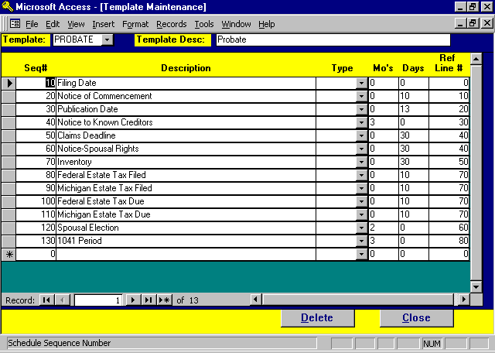

Template Maintenance Screen

Listed below is a detailed description of the fields utilized within Template Maintenance.

TEMPLATE
Enter the desired template code. The first existing template will always be displayed. Different templates may be setup to accommodate different areas of law, such as one for real estate and a second for litigation, etc.

TEMPLATE DESC
Enter the description of the template.

SEQ#
Enter the sequence number of the template entry. If the sequence number is left blank, L.A.W.S. will automatically increment the last utilized sequence number by 10. The sequence number determines the order of the events. If desired, a sequence number may be entered or modified to place a line between existing events.
DESCRIPTION
Enter the description of the transaction.

TYPE
Enter the Docket Type code, if appropriate, associated with this transaction. The docket type will allow related transactions to be retrieved and reported by code. The Reminder Day values associated with the Docket Type are automatically assigned to the created docket transactions.

MO’S / DAYS
The L.A.W.S. template provides the ability of computing docket dates based on the date value assigned to prior lines within the template. The new date, for the current transaction, is computed by adding the specified number of Months and/or Days to the previously computed date identified by the Referenced Line Number.

REFERENCED LINE#
Identifies the sequence number of the line containing the date that should be used to compute the current transaction date. If the referenced line number is blank, a manual date may be entered

Assignment of Templates to Matters

Templates may be assigned matters through either Matter File Maintenance or through Case Management.

Matter Maintenance
As matters are entered, or modified, a template code may be entered into the Template field. Clicking on the yellow title will display the template. Dates entered previously into the template will be displayed. Line items may be deleted, by clicking the record selector then pressing the delete key. New line items may be added on the first available blank line. Modifications to templates at the Matter level affect that Specific Matter only and have no bearing on the Template setup or on other Matters utilizing the template.

Case Management
Template information associated with a matter may be accessed through Case Management. A client and matter code must be entered prior to accessing the template. After specifying the desired Template code in the Template field, click the yellow heading. Existing data will be displayed. New templates will display the template format without dates. As in matter maintenance, the template can be modified to this specific matter without affecting any other part of the system.

There is no limit to the number of templates that may be associated with a matter.
.

COURT / LOCATION FILE MAINTENANCE

Calendar / Docket entries may be associated with courts and locations. These codes may be defined in any manner useful to the firm. Courts are usually associated with either a specific court or a generic court type. Locations may correspond to conference rooms or other locations where activities may occur.

After selecting Court / Location Maintenance, the following screen is displayed.

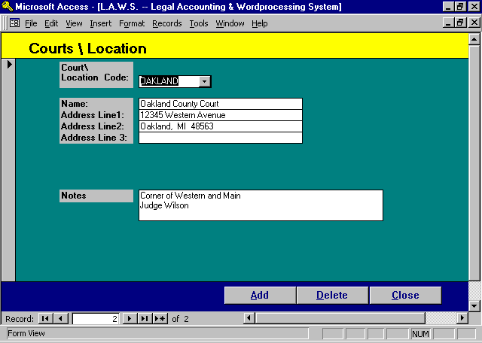

Court / Location Maintenance Screen

This menu item duplicates the Court / Location File Maintenance described in the Data File Maintenance chapter of this manual. It is placed on the Calendar / Case Management menu as a convenience only. Please review Data File Maintenance for a detailed description of this item.

DEFINE USER

Each user within L.A.W.S. must be associated with a USER record. A user is defined as any person who tries to access the L.A.W.S. software. When L.A.W.S. is initiated, login user id and password is verified against information within the Define User program. If the user is not defined, or if the User / Password combination is invalid, access is denied.

To define users within L.A.W.S. select the DEFINE USER button from the Calendar /Case Management menu to display the following form.

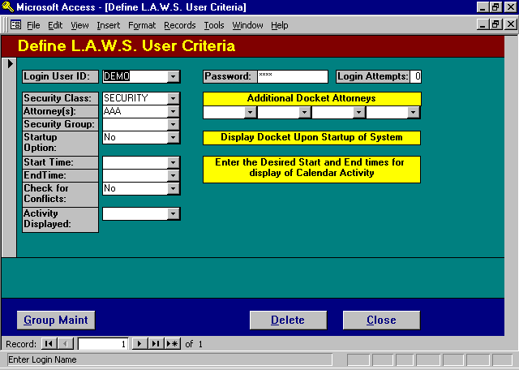

Define L.A.W.S. User Criteria Screen

LOGIN USER ID / PASSWORD
The Login User Id identifies the individual signing onto L.A.W.S. The Password represents the secured code that must be entered with the User Id to gain access to L.A.W.S. The User ID and Password of the individual signing onto the system is validated against the list of USERS entered into L.A.W.S. If a match is found, the appropriate L.A.W.S. menu is displayed. Otherwise, L.A.W.S. access is denied.

LOGIN ATTEMPTS
The Login Attempts field records the number of unsuccessful consecutive login attempts per user. If the user fails to enter the correct User ID \ Password in three login attempts, the user is denied further access to L.A.W.S. until this field is reset to zero.

SECURITY CLASS
The Security Class specifies the menu that should be displayed when the User signs on. A complete list of security classes and the corresponding menus are listed at the end of this section.

ATTORNEY(s)
The attorney codes within L.A.W.S. that should be associated with the user logging in. The first attorney is used as the Default attorney in many L.A.W.S. applications. The Calendar program allows up to five individual attorneys to be processed simultaneously. The Additional Docket Attorneys are automatically inserted into the Calendar program. The attorney code may be left blank IF THE CALENDAR / CASE MANAGEMENT system is not used. The Calendar / Case Management is intricately integrated with the attorney and may not be used without this attorney code defined.

SECURITY GROUP
Attorney Groups may be established. If a user is associated with a group, then the user has review and modification rights to all system activity pertaining to members of the group. Groups may be defined by pressing the Group Maint button at the bottom of the Screen. After pressing the Group Maint button, the following screen is displayed:

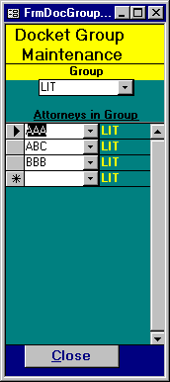
The GROUP code is user defined. Use the dropdown box to display the existing groups. Once the group is selected, all attorneys within the group will be displayed.

Attorney access is designed to work with the View Global Access field within the attorney file. If the View Global Access field, for the defined attorney, is set to “Yes” then this attorney may view ALL other attorneys WIP, AR and/or Calendar Entries. If the View Global Activity option, associated with the attorney is set to “No”, than only WIP, AR and Calendar entries associated with this particular attorney or group may be viewed.

STARTUP OPTION
Specifies whether the Calendar screen should automatically be displayed when this user signs on to L.A.W.S. the available options include:
No- The Calendar form will not be automatically displayed, for this user, upon signing onto L.A.W.S.
Yes- The Calendar Form will automatically be displayed upon signing onto L.A.W.S.
START / END TIMES
Specifies the default start and end times associated with the specified attorneys calendar. If calendar entries fall outside of the specified start and end times, the start and end times for the exception days will be automatically adjusted to accommodate the actual times.

CHECK FOR CONFLICTS
Specifies if the Calendar program should allow conflicting line items within the system. The available options include:
Yes Conflicts are verified and disallowed. If a conflict exists for a certain attorney on a certain day
and a specific time, than a message is displayed upon entry and the posting is disallowed.
No Conflicts are not verified and are allowed.

ACTIVITY DISPLAYED
Specifies if the type of docket transactions to be displayed. The available options include:
Current All Activity dated on or after the focus date will be displayed on the daily calendar. Open
transactions dated prior to the docket focus date will not be displayed.
Open All Activity dated on or after the focus date -or- all non-completed activity dated prior to
the focus date will be displayed. Open docket transactions dated prior to the current
focus date will be displayed.

Listed below are the available security classes and the menu options available with the class.

Security Class Summary

Only the functions noted on the security class menu(s) may be performed. Access to attorney data is determined by the attorneys View Global Access setting and the users group setting. The security class is listed in the title of each security class menu.

Security Class - SECURITY
Provides the user full access to all functions within L.A.W.S. including the Define User Function. Will display the Master Menu.

Security Class - FULL
Provides the user full access to all functions within L.A.W.S. excluding the Define User Function. Will display the Master Menu.

Security Class - PARTIAL or STAFF:
The security classes of “Partial” or “Staff” will display a limited menu as noted below.

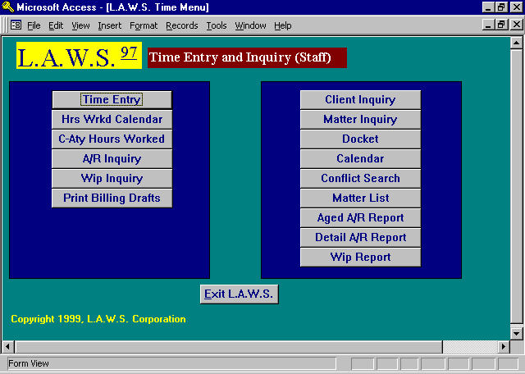

Security Class - ADMIN
The Administrative Security Class is very similar to the Partial Class except the Client and Matter Inquiry functions are modified to Client and Matter Maintenance. A sample of the ADMIN Security Class Menu is listed below.

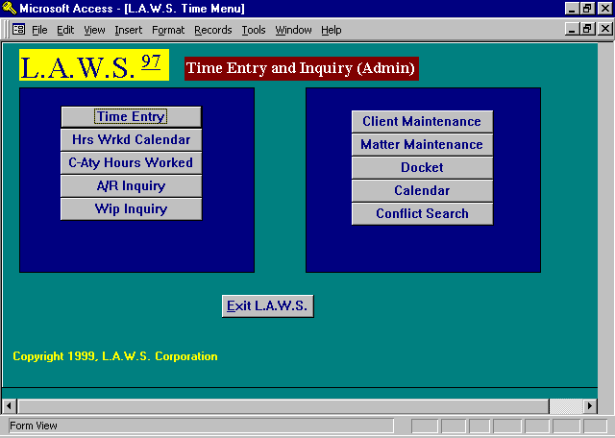

Security Class - INQ

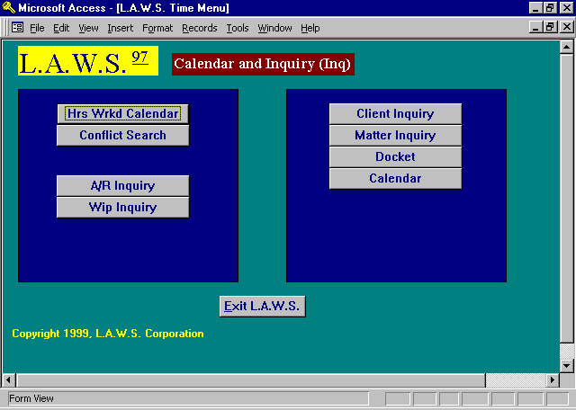

Security Class - 1

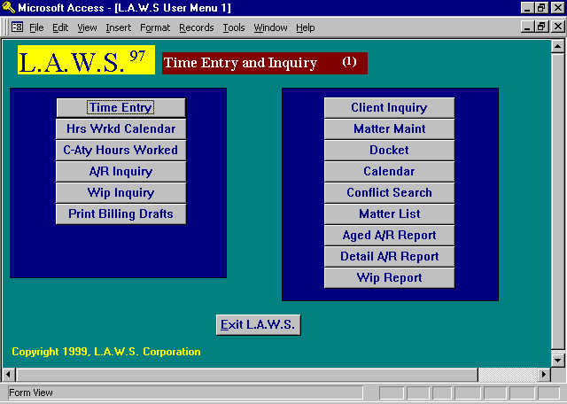

Security Class - 2

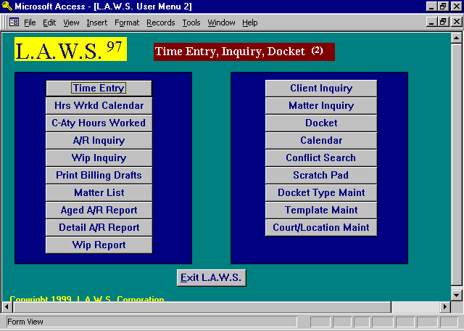

Security Class - 3

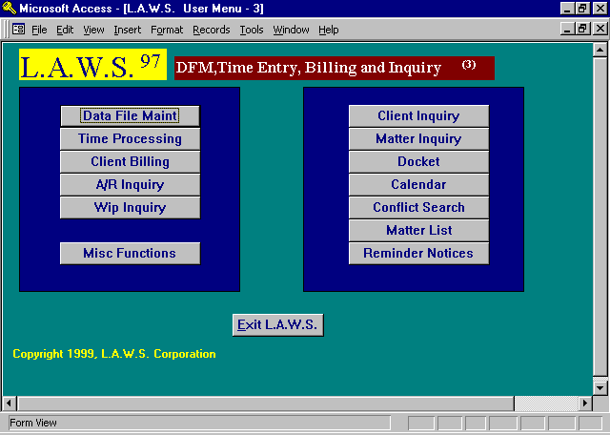

Security Class - 4

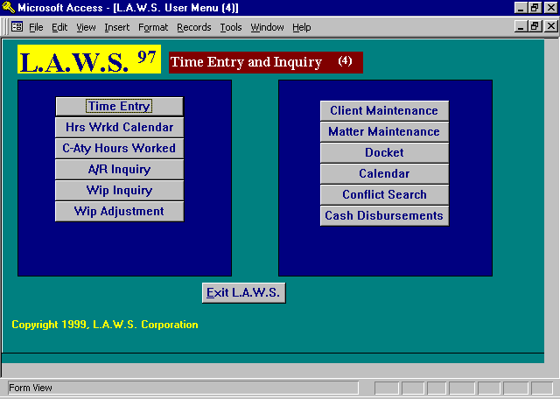

Security Class - 5

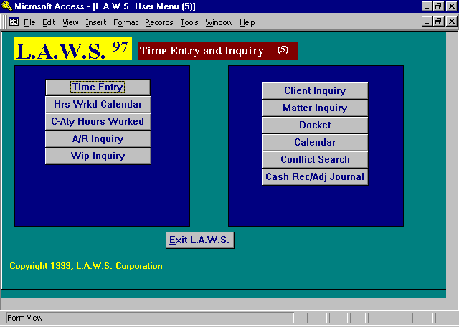

Security Class - 6

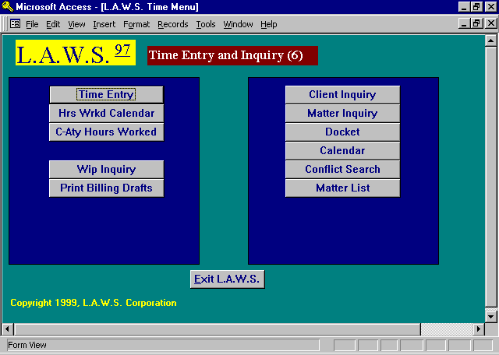

Security Class - 7

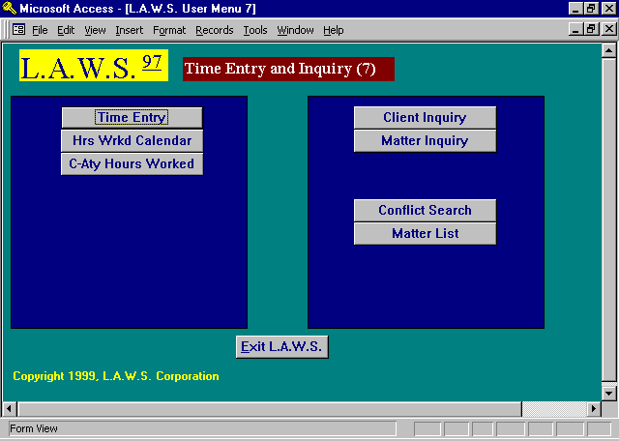

Security Class 8

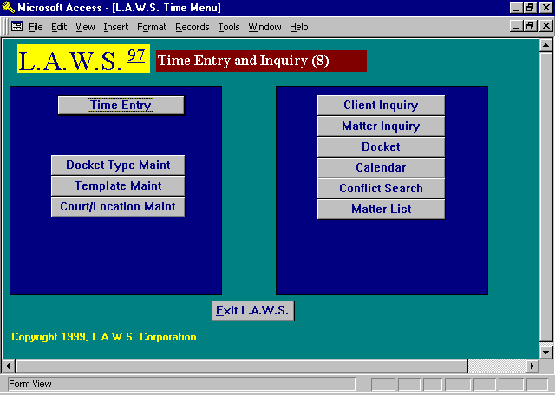

Security Class 9

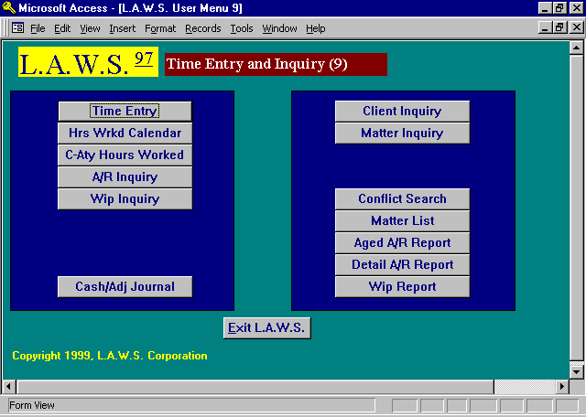

Security Class 10

