MISCELLANEOUS FUNCTIONS
TABLE OF CONTENTS

MISCELLANEOUS FUNCTIONS 420
Miscellaneous Menu 420
RE-CLASSIFY WIP 421
Reclassify WIP Screen 421
RE-POST WIP RATES 422
Rate Change Selection Screen 422
ATTACH(UN) TABLES 425
Attach Path Selection Screen 425
EXISTING A/R ENTRY 427
Existing A/R Invoice Screen 427
INTERIM BILL CYCLE 429
Interim Bill Cycle Entry Screen 429
DEFINE HOURS WORKED 430
Define Hours Worked Entry Screen 430
CHANGE CODES 431
Change Codes Selection Screen 431
Change Attorney Codes 431
Change Bill Codes 432
Change Client Codes 432
Change Matter Codes 432
ORIGINAL O/S/CHECKS 433
Original Outstanding Checks Entry Screen 433
PURGE WORK IN PROCESS 434
Purge WIP Selection Screen 435
PURGE A/R 438
Purge AR Selection Screen 439
CLEANUP AR 441
Cleanup A/R Screen 441
Reassignment of Billing Attorney 441
Zeroing Out Misapplied Or Small Balance Invoices 442
Sample: A/R Cleanup - Modification of Billing Attorney 443
Sample: A/R Cleanup - Zeroing Out of Balances +/- $0.00 443
PURGE G/L TRANSACTIONS 446
Purge G/L Selection Screen 446
PURGE DOCKET ENTRIES 447
Purge Calendar/Docket Transactions Screen 447
PURGE MATTERS BASED ON THE DESTROY DATE 449
Purge Matter Selection Screen 449
DISPLAY ERROR LOG 450
Display Error Screen 450

MISCELLANEOUS FUNCTIONS

The MISCELLANEOUS FUNCTIONS contains functions that are useful tools, but are not utilized in the normal day to day law firm operation. Since these functions are rarely, if ever used, extra care should be used to ensure an understanding of the procedures being performed.

After selecting MISCELLANEOUS FUNCTIONS, the following form is displayed:

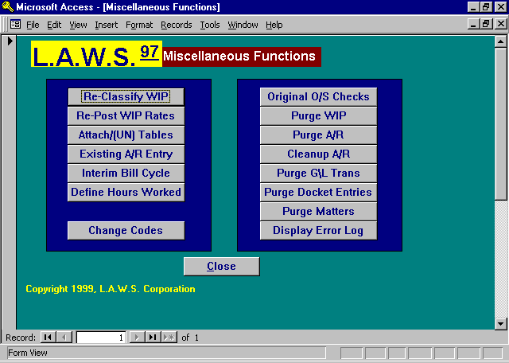

Miscellaneous Menu

A detailed explanation of each option follows.

RE-CLASSIFY WIP

Several Work In Process reports analyze performance based on billable, non-billable and contingent hours. As each time entry is processed through the Time Entry program, a status code is assigned to the WIP entry classifying it into one of the three categories previously mentioned. Changes made through Data File Maintenance, affecting the status of WIP entries, are not retroactively posted to existing WIP.

Assume, for example, a matter is entered into the system as “billable”. All WIP posted to this matter will have a status of “billable”. If the status of the matter is then changed to “contingent”, all WIP entered thereafter will be classified as “contingent”. WIP entered into the system when the matter was considered “billable” would still be considered “billable” since the status of the original hours worked would not be changed.

Other factors affecting the classification of WIP are the client billable status and the non-billable option associated with the bill code. This menu item re-classifies the billable status of all WIP to the current system status reflected within the Matter, Client and Bill Code maintenance programs.

After selecting Re-Classify WIP, the following screen is displayed.

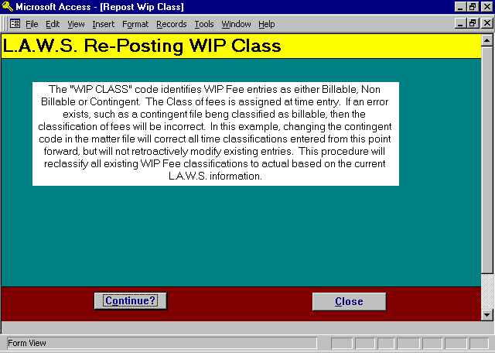

Reclassify WIP Screen

To re-classify existing WIP entries as billable, non-billable or contingent based on the current status of the system, press continue. Otherwise, press Close to return to the Miscellaneous Function menu.

The length of time involved in the reclassification of WIP will vary based on the volume of WIP as well as with the performance capabilities of the PC.

RE-POST WIP RATES

Rates are assigned to WIP fee entries as they are processed through the Time Entry program based on the then current system rate structure. Varying factors affect the rate assignment including the client or matter billable status, the utilization of attorney or class rates, the use of overrides at the client or matter level, the use of effective dates of rate increases, or per diem bill code classifications to name a few. If any of these factors change, future rate assignment will reflect the modifications, but existing WIP fee entries will not be affected. If desired, existing rates, associated with individual WIP entries, may be modified through the WIP Adjustment program.

This option allows modification of a block of existing WIP entries based on user entered criteria. All criteria works in conjunction with each other allowing the selection of WIP to be as broad or as narrow as desired. Only non-billed WIP entries are selected for rate modification. Use care when using this option to ensure that the selected WIP SHOULD have its rate modified.

After selecting Re-Post WIP Rates, the following form is displayed.

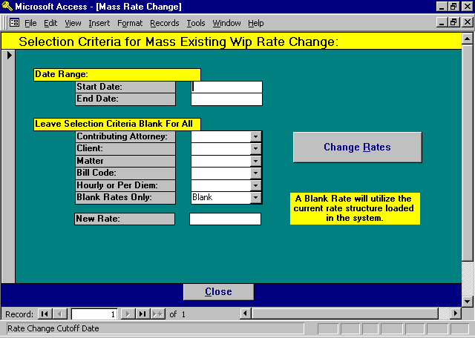

Rate Change Selection Screen

START/END DATE RANGE
Enter the date range pertaining to the WIP to be selected. Both the start and end dates are required.

CONTRIBUTING ATTORNEY
Define the attorneys to be considered for a rate change. Enter a single contributing attorney, or leave blank for all attorneys.

CLIENT
Define the clients to be considered for a rate change. Enter a single client, or leave blank for all clients.

MATTER
Define the matters to be considered for a rate change. Enter a single matter, or leave blank for all matters.

BILL CODE
Define the bill code to be considered for a rate change. Enter a single bill code, or leave blank for all bill codes. The system looks at the primary bill code only. Activity codes or nested bill codes utilized within the service description are not considered.

HOURLY OR PER DIEM
Per diem bill codes have a different rate structure than hourly codes. This option allows limitation of the scope of change to either hourly or per diem entries. If desired, the option may be left blank and all fee entries, meeting the other criteria, will be changed regardless of the hourly/per diem status.

BLANK RATES ONLY
WIP rate changes can be made to entries which contain blank rates only or to all entries. If “Blank” is selected, only rate fields that are blank will be re-computed. If “all” is selected, all selected entries will be re-computed.

NEW RATE
The new rate to be assigned to the selected WIP may be computed by one of two methods.

METHOD 1: The dollar value entered in the new rate field will be considered the new rate. This value will be posted as the billing rate to all selected WIP entries. If desired, a zero dollar value ($0.00) may be entered to set the rate of the selected entries to zero.

METHOD 2: Leave the new rate field blank. A blank (not zero) rate signifies that the new billing rate should be computed for each selected entry based on the current rate structure.

The length of time involved in the re-posting of rates will vary based on the volume of data involved as well as with the performance capabilities of the PC.

Method 1 is relatively fast due to the fact that the rate is already determined and is simply posted to the selected WIP entries. It works well if the selection criteria is narrow and well defined.

Method 2 will be relatively slow due to the fact that each selected entry must perform the complete rate assignment function.

CHANGE RATE BUTTON
Once the selection criteria has been entered and verified, press the CHANGE RATES button to initiate the actual change.

L.A.W.S. will re-display, for visual verification, the selection criteria as displayed below:

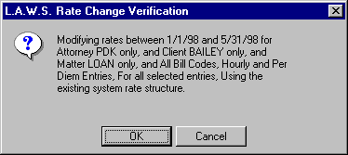

If the displayed information is correct, press the “OK” button to continue, or press “Cancel” to return to the selection criteria screen. After pressing “OK”, a count of selected entries is displayed for visual verification as displayed below.

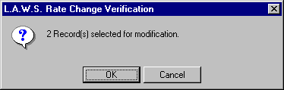

If the count is out of line based on what your estimate of the count should be, it is possible that the selection criteria may be incorrect and need to be re-keyed. To continue with the re-posting of rates, press “OK”. Otherwise, press “Cancel” to return to the selection criteria. A transaction record documenting all rate changes is created and may be viewed via the WIP Adjustment report.

Once the re-posting of rates is complete, the selection criteria is cleared and a message is displayed stating the posting is complete.

ATTACH(UN) TABLES

All data utilized by L.A.W.S. is stored in a database separate from the L.A.W.S. application software. This database contains “tables” in which information is stored such as “tblAtty” for attorney information, “tblWIP” for Work In Process information, etc. It is possible to setup multiple databases on your system, containing the same table names with different data. The Attach/(UN) Tables function allows for the switching back and forth between databases. The system default database is \LAWS\DATA.MDB.

Example: A law office may contain an “of counsel” attorney whose activity needs to be kept separate from the primary law firms records. The primary law firm could utilize one database, while the “of Counsel” attorney could utilize a second. The Attach/(UN) Tables function allows the firm to switch between the different databases.

After selecting Attach/(UN) Tables, the following form is displayed.

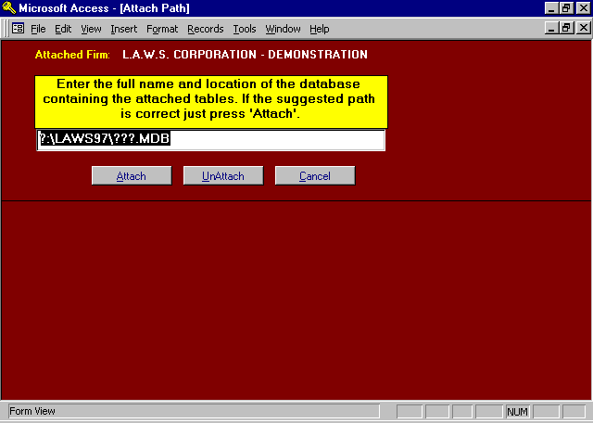

Attach Path Selection Screen

The firm name to which the L.A.W.S. application software is currently attached is displayed at the top of the form. The message “Tables are not attached" will be displayed if L.A.W.S. is not attached to a database.

The DOS path name of the database that will be processed is displayed in the center of the screen. The default path of ?:\LAWS97\???.MDB is initially displayed. The first question mark represents the drive letter on which the data is stored. The last three question marks represent the actual name of the database. Usually L.A.W.S. data is stored in a directory called \LAWS97. If the data is stored in a directory other than \LAWS97, modify the path accordingly.
ATTACH BUTTON
This option will attach the L.A.W.S. application software to the referenced database. If L.A.W.S. is currently attached to a specific table, new attachments to that table will be ignored.

For example, to attach to the \LAWS97\DATA97.MDB, ensure the path is entered correctly then press the “Attach” button. If we are currently attached to some or all of the tables in the \LAWS97\DATA97.MDB database, messages will be displayed for each table in the database stating that it is currently attached, and the table attachment will be ignored. If the table is not currently attached, the system will attach it.

UNATTACH BUTTON
This option will un-attach tables in the referenced database from the L.A.W.S. application software.

Application Example: Suppose that there are two databases, as noted in the above example, one for the law firm (C:\LAWS97\DATA97.MDB) and a second for “of Counsel” (C:\LAWS97\DATAOC.MDB. Also, assume that we are currently attached to the law firm’s data. The drive letter must reflect the drive letter on which the database resides.

Switching between the databases is a two step process. The first step is to un-attach from the law firm. The second step is to attach to the “of counsel”.

To un-attach from the law firms tables, enter the correct path, C:\LAWS97\DATA97.MDB, then press the UnAttach button. As each table is unattached, it is noted on the screen. After completion of this step, all data is disassociated from the L.A.W.S. application program, and the application will not operate.

The next step, in this example, is to re-attach the database containing the information of the “of counsel”. The default path would be changed to C:\LAWS97\DATAOC.MDB. Once the Attach button is pressed, each table within the C:\LAWS97\DATAOC.MDB database will be attached to the L.A.W.S. application software. When the function is complete the L.A.W.S. application software is operational with the “of counsel” database.

To switch back to the C:\LAWS97\DATA97.MDB, simply reverse the process by un-attaching the C:\LAWS97\DATAOC.MDB and attaching the C:\LAWS97\DATA97.MDB.

Attachment to tables remains permanent until the tables are physically un-attached. Accordingly, exiting the program or turning off the system will not attach or un-attach databases.

EXISTING A/R ENTRY

The purpose of this option is to record accounts receivable invoices created prior to the installation of L.A.W.S. All invoices created after the installation of L.A.W.S. will naturally be entered into the system through the billing program. This program allows entry of receivables only, it does not allow modification of existing entries. Accordingly, if an invoice is entered incorrectly, the balance must be corrected through the normal Cash Receipts/Adjustment program.

After selecting the Existing A/R Entry button, the following form is displayed.

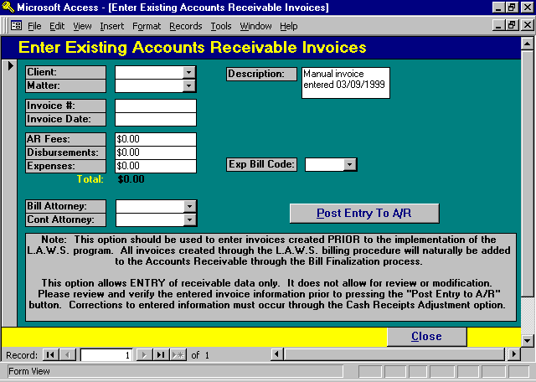

Existing A/R Invoice Screen

L.AW.S. naturally keeps track of the distribution of fees by contributing attorney. This breakdown is utilized in computation of fees billed, and/or fees received by contributing attorney in management reports. If you elect to enter the contributing attorney breakdown, multiple line items must be entered for each invoice as noted in the following example. An invoice generated prior to the installation of L.A.W.S. contains the following data:

Client/Matter: ABC/ONE
Invoice Number: 123345
Invoice Date: 03/311/98
Bill Attorney: PDK
Contributing Attorney Distribution
Fees Disb Exp
Contributing Atty: PDK $2,500 $160 $25 (Postage)
JJK $1,000 $0 $0
Invoice Total $3,500 $160 $25

In this example, two entries would be required to record the invoice. Both entries would have the same client/matter, invoice number, invoice date and billing attorney. The first entry would have the dollar values for contributing attorney PDK, while the second entry would record the dollar values for contributing attorney JJK.
The Expense amount is normally posted to the Billing Attorney. Expense amounts must be assigned an appropriate expense bill code. The total represents the total of each individual entry, not necessarily the invoice total.

CLIENT/MATTER
Enter the client/matter combination to which the invoice applies.

INVOICE NUMBER
Enter the invoice number assigned to the existing invoice.

INVOICE DATE
Enter the date of the existing invoice. This should be the actual date of the invoice and may be outside the current fiscal year.

A/R FEES
Enter the amount of A/R fees to be associated with this transaction. A/R fees are by definition within L.A.W.S., charges for services rendered -- hours worked times rate.

DISBURSEMENTS
Enter the amount of A/R disbursements to be associated with this transaction. Disbursements are normally assigned in total to the billing attorney. By definition within L.A.W.S., disbursements represent a physical outlay of cash by the firm. Two General Ledger transactions are involved in this outlay, the first is when the check is written, and the second is when the client reimburses the disbursement.

EXPENSES
Enter the amount of A/R expenses associated with this transaction. The total of the A/R expenses are normally posted to the billing attorney. By definition, expenses represent the assignment of overhead charges, such as photocopy or telephone charges, to the client. A single General Ledger transaction is associated with expenses to record reimbursement by the client.

EXP BILL CODE
Expenses must be identified by a bill code. The bill code defines the G/L account to which the expense reimbursement should be posted. This is a required field if expenses are entered. It should be left blank if the expense amount is zero.

DESC
The description is a non-modifiable field documenting the entry of the manual invoice.

POST ENTRY TO A/R BUTTON
Once the existing invoice transaction is entered, and visually verified, press the Post Entry to A/R button to post the information to the accounts receivable system. If Accounts receivable information is entered incorrectly, corrections should be posted through the Cash Processing option within the Accounts Receivable menu.

After the entry is posted, the posted data is cleared from the form allowing the entry of another existing invoice transaction, or the form may be closed.

INTERIM BILL CYCLE

This option allows the definition of the firms interim bill cycles. The interim billing cycle is a pre-set billing cycle that may be used to select matters for billing drafts or client invoices. Each matter may be assigned one or more interim billing cycles.

After selecting the INTERIM BILLING CYCLE, the following screen is displayed.

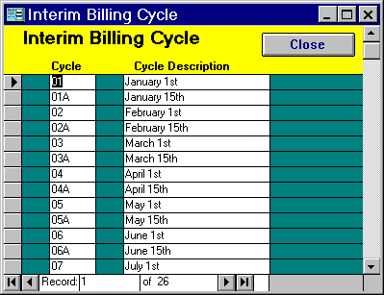

Interim Bill Cycle Entry Screen

CYCLE
Enter the cycle identification code. Usually the cycle corresponds to the numeric month code. Some firms desire multiple billing cycles within a month. If desired, a suffix may be added to the month code allowing for multiple cycles within a single month.

A special cycle of “99” should be entered as a billing cycle. The code “99” allows for the selection of billing drafts for all matters which are not assigned a billing cycle.

CYCLE DESCRIPTION
Enter a brief description of the billing cycle.

Standard cycle codes come standard with L.A.W.S. which may be modified to better meet the firms needs.

DEFINE HOURS WORKED

This option allows for the definition of the firms hours worked table. The hours worked table is accessed during time entry and WIP adjustments. If desired, additional increments of time may be added or removed.

After selecting DEFINE HOURS WORKED, the following screen is displayed.

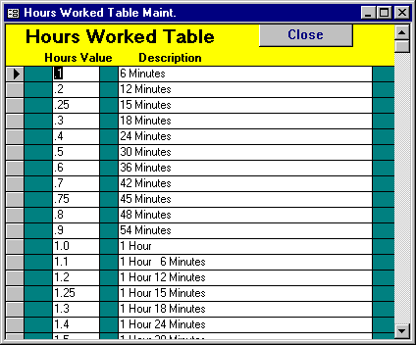

Define Hours Worked Entry Screen

HOURS WORKED
Enter the hours worked increments which should appear in the hours worked dropdown boxes within the Time Entry and WIP Adjustment programs.

DESCRIPTION
Verbal description of the numeric hours worked..

CHANGE CODES

The Change Codes option allows existing master file codes to be changed. The Change Codes option can be used to change Attorney, Bill Code, Client or Matter codes. L.A.W.S. examines all tables for reference to the Existing codes and replaces them with the New code. L.A.W.S. maintains an audit trail by changing the system notes associated with the modified codes

After selecting Change Codes from the Miscellaneous menu, the following form is displayed.

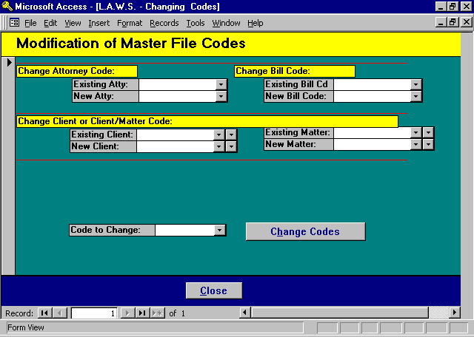

Change Codes Selection Screen

Change Attorney Codes
The Change Attorney Codes section of the screen will replace one attorney code with another.
Existing Atty: The attorney code currently in use which is to be changed to a different attorney code.
New Atty: The attorney code to which the existing attorneys code should be changed.
Change Code Option: Must be set to Attorney.

If the new attorney code exists, all information associated with the ExistingAtty will be transferred to the New Atty. Both attorney codes will reside on the system after the code change. The existing code is marked as inactive.

If the new attorney code does not exist, the existing attorneys code is changed to the new attorney code. After the change only the new attorney resides on the system.

Change Bill Codes
The Change Bill Codes section of the screen will replace one attorney code with another.
Existing Bill Cd: The bill code currently in use which is to be changed to a different bill code.
New Bill Code: The bill code to which the existing bill code should be changed.
Change Code Option: Must be set to Bill Code.

All data will be transferred from the Existing Bill Cd to the New Bill Code. The New Bill Code may or may not exist. The Existing Bill Cd is always removed from the system after the code modification.

Change Client Codes
The Change Client Codes section of the screen will replace one client code with another.
Existing Client: The client code currently in use which is to be changed to a different client code.
New Client: The client code to which the existing client code should be changed.
Change Code Option: Must be set to Client.

If the new client code exists, all information associated with the Existing Client will be transferred to the New Client. Both client codes will reside on the system after the code change. The existing code is marked as inactive.

If the new client code does not exist, the existing client code is changed to the new client code. After the change only the new client resides on the system.

Change Matter Codes
The Change Mattert Codes section of the screen will replace one matter code with another.
Existing Client/Matter: The client/matter combination identifying the matter currently in use that is to
be changed to a different client/matter combination.
New Client/Matter: The client/matter combination to which the existing client/matter code should be
changed. The new client must exist, but the new matter may or may not exist.
Change Code Option: Must be set to Matter.

If the new client/matter code exists, all information associated with the Existing Client/Matter will be transferred to the New Client/Matter. Both entries will reside on the system after the code change. The existing entry is marked as inactive.

If the new client/matter code does not exist, the existing client/matter code is changed to the new client/matter code. After the change only the new client/matter resides on the system.

CHANGE CODES Button
The Change Codes Button will initiate the changing of the specified codes. All reference to the existing codes will be changed to the new codes. Be sure the information is correct before continuing.

As the matter codes are being changed, the corresponding table names are displayed on the screen.

L.A.W.S. automatically creates a system message within the modified master files noting the code changes. The system notes may be viewed but not modified.

After the code changes are completed, a confirmation message is displayed on the screen stating that the existing code was converted to the new code.

ORIGINAL O/S/CHECKS

L.A.W.S. provides a full Bank Reconciliation program that reconciles the general ledger cash account to the bank statement balance. This procedure provides the means to record outstanding disbursement checks, created prior to the installation of L.A.W.S., which have not cleared the bank. This procedure should be utilized only once, at the initiation of the system. Only disbursement checks created prior to the installation of L.A.W.S. should be entered since all current disbursement transactions are automatically entered into the reconciliation system.

After requesting the Original O/S Checks, the following form is displayed.

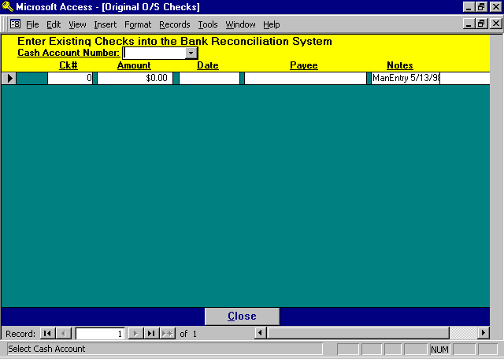

Original Outstanding Checks Entry Screen
CASH ACCOUNT NUMBER
Enter the general ledger cash account number on which the checks were drawn.
AMOUNT
Enter the amount of the outstanding checks.
DATE
Enter the date of the outstanding checks.
PAYEE
Enter the name of the payee associated with the check.
NOTES
L.A.W.S. automatically inserts the description “ManEnt” plus the date of entry into the NOTES field.

Please Note: This procedure should be used to enter the existing outstanding checks created prior to the installation of L.A.W.S. Once these checks are entered, it should not be used again. The entered outstanding checks will be displayed until the form is closed. Upon re-opening the form, the entered outstanding checks will not be displayed, but they will be included in the bank reconciliation outstanding check list.

PURGE WORK IN PROCESS

Work In Process transactions are accumulated through time entry and the generation of client cost checks. Billing finalization marks WIP as having been billed, but does not physically remove the WIP from the system. Over time, a significant number of billed WIP transactions may accumulate which may tend to degrade the normal operation of the system.

L.A.W.S. contains two WIP tables, active WIP and billed WIP. The active WIP table contains all non-billed WIP as well as billed WIP that has never been purged. The billed WIP table is an on-line historical file containing billed WIP transactions which have been purged from the active WIP table but are stored on-line, available for reporting and inquiry.

All WIP reports automatically combine WIP transactions from both the active and inactive WIP tables as needed. The WIP daily calendar utilizes the active WIP table only. Accordingly, it is recommended that one or two months of billed WIP remain in the active table allowing an accurate reflection of hours worked in the recent past months daily calendar inquires.

Purging WIP physically removes transactions from either the active WIP or billed WIP tables depending on the options selected. Purging WIP reduces the number of transactions in the WIP tables increasing performance. Although purging is never required, it is suggested that only one to two months of billed WIP reside in the active WIP table. Several years of billed WIP should remain in the billed table.

NOTE: WIP reports utilize detail WIP transactions. WIP reports may not be accurately generated for periods prior to the purge date of the billed WIP table. Accordingly, leave as many years of billed WIP on the system as will be reasonably needed for management reporting.

It is strongly suggested that purges be performed after the month end backup is performed. If any error occurs resulting from hardware failure, user error, software failure, etc., then the month end backup may be utilized to recover data. IF A FAILURE OCCURS WITHOUT A CURRENT BACKUP IT WILL NOT BE POSSIBLE TO RECONSTRUCT OR REPAIR DATA.

After selecting Purge Work In Process, the following form is displayed.

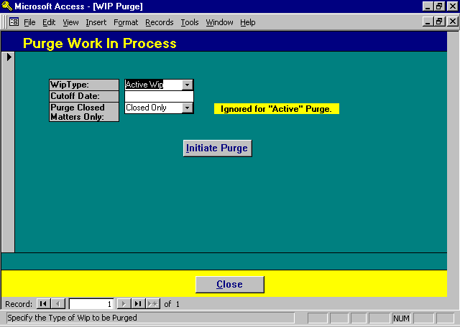

Purge WIP Selection Screen

WIP TYPE
Specifies the type of WIP purge to be performed. The available options are:

Active WIP: Specifies that all billed WIP transactions will be removed from the active WIP table
through the specified cutoff date. The removed transactions will remain in the billed
WIP table and will be available for reporting and inquiry.

Billed WIP: Specifies that all billed WIP transactions will be removed from the billed WIP table
through the specified cutoff date. The removed transactions will not remain on the
system and will not be available for reporting or inquiry.

CUTOFF DATE
Enter the cutoff date to be used for the purge. All WIP transactions dated prior to the specified cutoff date will be removed from the system. The cutoff date cannot be greater than the current system date.

Please remember that the Daily Calendar Inquiry utilizes the active WIP table only. Billed WIP, purged from the active WIP table, will not be included in the Daily Calendar resulting in inaccurate totals. It is therefore recommended that one to two months of billed WIP remain in the active WIP table enabling the Daily Calendar Inquiry to accurately reflect recent months performance. All other WIP functions automatically combine the active and billed WIP tables as needed, eliminating any negative impact resulting from the active WIP purge.
PURGE CLOSED MATTERS ONLY
Specifies if WIP should be purged from closed matters only, of from all matters regardless of the closed status. This option is utilized in the Billed WIP purge only. The available options include:
All WIP will be purged from all matters meeting the purge criteria regardless of the matters
closed status.
Closed Only: Only WIP associated with Closed files will be purged from the Billed WIP table.

INITIATE PURGE Button
The Initiate Purge button will start the purging process. After clicking the button, the following confirmation message will be displayed in conjunction with the active WIP purge.

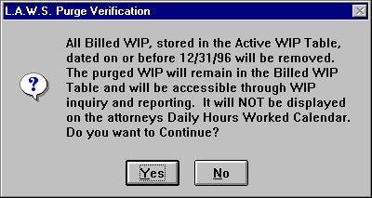

The billed WIP purge will display the following verification message.

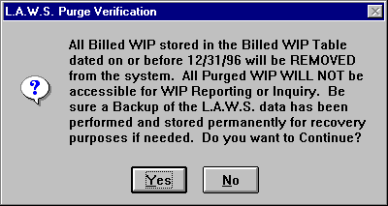

Please read and contemplate the displayed message. Purged entries are removed from the system. Please be sure that a backup copy of the L.A.W.S. data tables are backed up and Permanently stored for safekeeping. If the remote possibility arises for the need to access or review purged data, this backup copy of data will be required. It is best to perform all system purges after the month end backup of data has been performed. Please review the Backup section of this manual for a detailed explanation of the backup procedures.

A “No” option to the above message will cancel the Purge. A “Yes” option will continue. After selecting “Yes”, the following confirmation message is displayed.

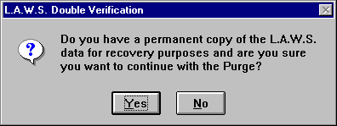

Again, please read the message. If a backup copy exists, you may continue with the purge. Otherwise, select “No” and perform a permanent backup prior to purging.

A “No” option to the above message will cancel the purge. A “Yes” option will continue. After selecting “Yes”, the purge will be initiated. Upon completion, the message “Purge Complete” will be displayed. Upon closing the form, the purge is complete.

NOTE: Purging data may take a significant amount of time depending on the size of the WIP files, the speed of the computers and the volume of purged data. -- DO NOT INTERRUPT THE PURGE PROCESS.

The database should be compacted after purging. See the documentation the L.A.W.S. Utilities which addresses the compaction of databases.

PURGE A/R

Over time a significant number of accounts receivable transactions accumulate within L.A.W.S. These transactions are utilized for productivity reporting. At some point in time, the firm may desire to remove transactions pertaining to paid, zero balance, invoices that have been paid for more than a year. Non-zero balance accounts receivable invoices will not be purged regardless of the date of associated invoice transactions. Only invoices with zero balances which have all transaction activity dated prior to the specified cutoff date will be purged.

L.A.W.S. supports two Accounts Receivable files. The Active Accounts Receivable file, called "tblAR", contains all non-zero AR balance invoices and zero balance AR invoices which have not been purged. The second AR file is used to store historical, zero balance AR invoices. Purged data is accessible through normal A/R reporting or inquiry.

The Accounts Receivable Purge may be run against the Active AR or the Purged AR. The Active AR purge transfers the zero balance invoices from the Active file to the Purged file. The purged data is then cleared from the Active file. All the information is still available for reporting or inquiry.

Purging the Purged AR table physically removes transactions from the table. These records are not available for reporting or inquiry. Ensure that a permanent backup of data is performed and safely stored prior performing any purge.

Purging, which is never required, reduces the number of transactions in accounts receivable tables which increases performance. L.A.W.S. Corporation recommends that at least one years worth of zero balance data reside in the active AR table. Invoices that have had a zero balance for over one year can be purged to the Purged AR table.

It is strongly suggested that purges be performed after the month end backup is performed. If errors occur resulting from hardware failure, user error, software failure, etc., than the month end backup may be utilized to recover data. IF A FAILURE OCCURS WITHOUT A CURRENT BACKUP IT WILL NOT BE POSSIBLE TO RECONSTRUCT OR REPAIR DATA.

After selecting Purge A/R, from the Miscellaneous menu, the following screen is displayed.

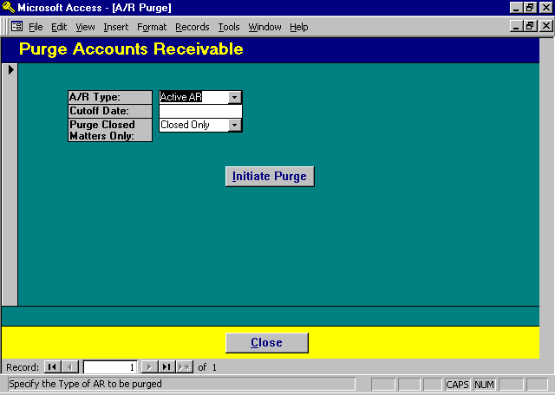

Purge AR Selection Screen

A/R TYPE
Specifies the type of AR purge to be performed. The available options are:

Active AR: Specifies that all zero balance AR invoices will be removed from the active AR table
through the specified cutoff date. The removed transactions will remain in the Purged
AR table and will be available for reporting and inquiry.

Purged AR: Specifies that all zero balance AR invoices will be removed from the Purged AR table
through the specified cutoff date. The removed transactions will not remain on the
system and will not be available for reporting or inquiry.

CUTOFF DATE
Enter the cutoff date to be used for the purge. All zero balance AR invoices dated prior to the specified cutoff date will be removed from the system. The cutoff date cannot be greater than the current system date.

PURGE CLOSED MATTERS ONLY
Specifies if zero balance AR invoices should be purged for closed matters only, of from all matters regardless of the closed status. The available options include:
All Zero balance AR invoices will be purged from all matters meeting the purge criteria
regardless of the matters closed status.
Closed Only: Only zero balance AR invoices associated with Closed matters will be purged from the
Purged AR table.

INITIATE PURGE Button
The Initiate Purge button will start the purging process. After clicking the button, the following confirmation message will be displayed if the Active AR purge option is chosen.

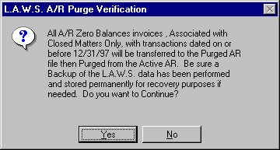

If the Purged AR option is selected the following message is displayed.

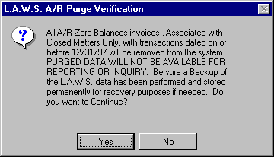

Please read and contemplate the displayed message. Purged entries are removed from the system. Please be sure that a backup copy of the L.A.W.S. data tables are backed up and permanently stored for safekeeping. If the remote possibility arises for the need to access or review purged data, this backup copy of data will be required. It is best to perform all system purges after the month end backup of data has been performed. Please review the Backup section of this manual for a detailed explanation of the backup procedures.

A “No” option to the above message will cancel the purge. A “Yes” option will continue. After selecting “Yes”, the following confirmation message is displayed.

Again, please read the message. If a backup copy exists, you may continue with the purge. Otherwise, select “No” and perform a permanent backup prior to purging.

A “No” option to the above message will cancel the purge. A “Yes” option will continue. After selecting “Yes”, the purge will be initiated. Upon completion the message “Purge Complete” will be displayed. Upon closing the form, the purge is complete.

CLEANUP AR

The Cleanup AR function provides the ability of making mass adjustments to Accounts Receivable. Two options are available. The first is the reassignment of the A/R billing attorney to the current billing attorney assigned to the matter. The second allows for the automatic write-off of misapplied payments, or of invoices with very small A/R balances.

After selecting Cleanup A/R the following screen is displayed.

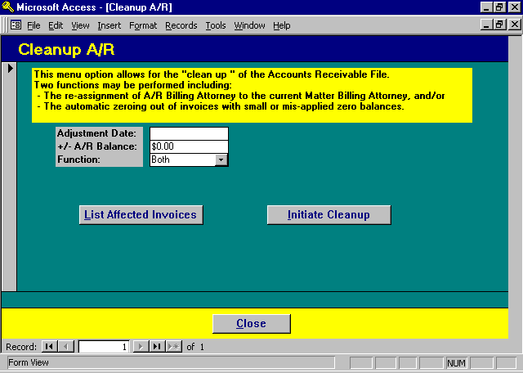

Cleanup A/R Screen

Reassignment of Billing Attorney

When invoices are created within L.A.W.S. the billing attorney assigned to the matter is automatically assigned as the billing attorney associated with the Accounts Receivable invoice. As payments are applied to the invoice, the billing attorney assigned to the invoice receives billing attorney credit.

Changing the billing attorney assigned to the matter, through Matter File Maintenance, does not change the billing attorney previously assigned to Accounts Receivable invoices. Accordingly, when payment is received for a matter that has had a billing attorney change, the billing attorney assigned to the invoice receives credit rather than the newly assigned billing attorney for the matter.

The Attorney function automatically reassigns the current matter's billing attorney as the accounts receivable billing attorney for all accounts receivable invoices.

Zeroing Out Misapplied Or Small Balance Invoices

Each invoice within L.A.W.S. contains a fee, disbursement and expense balance. The invoice balance is considered zero, when the invoice's fee balance, disbursement balance and expense balance equal zero. It is possible that payments or adjustments may be misapplied within L.A.W.S. allowing the invoice to total zero, but the fees balance, disbursement balance and/or expense balance will not equal zero.

Please review the following example.

Correctly applied payment:
Fees Disbursements Expenses Total
Charges: $1,000 $50 $25 $1,075
Payments/Adjustments: $1,000 $50 $25 $1,075
Balance: 0 0 0 0

Misapplied payment:
Fees Disbursements Expenses Total
Charges: $1,000 $50 $25 $1,075
Payments/Adjustments: $1,025 $50 $ 0 $1,075
Balance: 25- 0 25 0

Since misapplied payments do not exactly zero out fees, disbursements, and expenses, invoices with misapplied payments will continue to be included on Accounts Receivable reports until the allocation is corrected.

A second option within this function is the ability of automatically writing off small balance invoices. Due to rounding or conversion errors, it is possible that Accounts Receivable invoices exist with plus or minus $.01 or $.02 balances. If desired, all small balance invoices can automatically be written off. The maximum dollar value of invoices to be written off is $5.00.

A detailed description of the Cleanup A/R selection options follow.

ADJUSTMENT DATE
Specifies the date of the system generated A/R Adjustment. This field is not utilized when re-assigning Billing Attorneys.

PLEASE NOTE: Account Receivable balances are always computed as of the current date, not as of the Adjustment Date.

+ / - A/R BALANCE
Identifies the maximum dollar value of the small balance invoices which should be written off. The value entered will be treated as a plus or minus value. Accordingly, if a value of $1.00 is entered, then all invoices with a balance due of between $1.00 and $1.00- will be adjusted to zero. This value cannot be greater than $5.00. This field is not utilized when re-assigning Billing Attorneys.

FUNCTION
Specifies which function should be performed. The available options include:
Attorney The Accounts Receivable Billing Attorney will automatically be modified to equal the
current Billing Attorney stored in the matter file. This is an all or nothing option. When
the Attorney option is chosen, all Accounts Receivable Billing Attorneys will be modified
to the Matters Billing Attorney.

Balance Small or misapplied Accounts Receivable invoice balances will be automatically set to
zero.

Both Both functions will be performed. The Accounts Receivable Billing Attorney will
be reassigned to the current Matter Billing Attorney and small or misapplied balances will
be written off.
LIST AFFECTED INVOICES Button
L.A.W.S. allows the ability of listing the affected invoices prior to initiating the change. The generated list(s) are determined by the Function code. Only the affected invoices will be listed. Samples of the available reports are displayed at the end of this section.

INITIATE CLEANUP Button
The Initiate Cleanup button will start the requested function(s). A message is displayed, based on the requested function(s), verifying the desire to continue. If the "Yes" option is chosen, the requested functions will be performed, otherwise the functions are canceled.

Please Note: Be sure to review the edit lists prior to initiating the cleanup to ensure that only the desired changes are performed. Also, ensure that a valid backup of your database exists so that, if needed, the recovery of the original data is possible.

Samples of the Cleanup reports are displayed on the following pages.

Sample: A/R Cleanup - Modification of Billing Attorney

Sample: A/R Cleanup - Zeroing Out of Balances +/- $0.00
L.A.W.S. CORPORATION - DEMONSTRATION
A/R Clean Up - Modification of Billing Attorney:
Original Modified
Bill Atty Bill Atty Client Matter Invoice # Inv Date Balance
_________________________________________________________________________________________________________________________________
JJK PDK BAILEY LOAN 101 02/25/1998 $7.10
JJK PDK BAILEY LOAN 234 08/28/1995 $0.00
JJK PDK BAILEY LOAN 315 12/23/1996 $0.00
JJK PDK BAILEY LOAN 325 01/13/1997 $856.83
JJK PDK BAILEY LOAN 337 01/21/1997 $428.41
JJK PDK BAILEY LOAN 56389 02/15/1997 $19.39
JJK PDK BAILEY LOAN RETAINER 01/02/1997 $88.41

_________________________________________________________________________________________________________________________________
Copyright 1998 L.A.W.S. Corporation 6/1/98 12:38:37 PM 1
rptCleanup_Atty
L.A.W.S. CORPORATION - DEMONSTRATION Adjustment Date: 05/31/1998
A/R Cleanup -Zeroing Out of Balances +/- $1.00
Bill Cont Exp
Client Matter Invoice# Atty Atty Code Fees Disb Exp Total
_________________________________________________________________________________________________________________________________
BAILEY LOAN 234
JJK JJK ADMIN ($1,622.45) $0.00 ($6.00) ($1,628.45)
JJK JJK $1,622.44 $0.00 $6.00 $1,628.44
Invoice Total: ($0.01) $0.00 $0.00 ($0.01)
_________________________________________________________________________________________________________________________________
BAILEY LOAN 315
JJK PDK ($0.01) $0.00 $0.00 ($0.01)
Invoice Total: ($0.01) $0.00 $0.00 ($0.01)
Report Total: ($0.02) $0.00 $0.00 ($0.02)
_________________________________________________________________________________________________________________________________

_________________________________________________________________________________________________________________________________
Copyright 1998 L.A.W.S. Corporation 6/1/98 12:56:09 PM 1
rptCleanUp_Bal

PURGE G/L TRANSACTIONS

All balances within the general ledger system are actually a compilation of individual journal transactions. Over time it is possible that individual general ledger accounts may accumulate tens of thousands of individual transactions. Performance of normal general ledger functions may start to degrade over time. To rectify ths situation, it is possible to purge general ledger activity periodically.

Purging the general ledger physically removes individual general ledger transactions, and replaces them with a single total line item per general ledger account. DO NOT PURGE GENERAL LEDGER ACTIVITY IF THERE IS A LIKLYHOOD OF ITS NEED IN THE NEAR FUTURE.

Prior to purging the general ledger, ensure that the firm has a complete backup of the firms data files and that hard copies of the information to be purged have been produced.

After the purge it will not be possible to generate general ledger reports dated prior to the general ledger purge date.

To continue with the purge select PURGE G/L TRANSACTIONS from the Miscellaneous Functions to display the following screen.

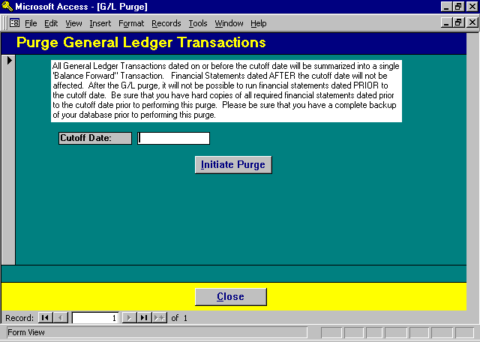

Purge G/L Selection Screen

To continue with the purge, enter the cutoff date then click Initiate Purge. Otherwise click Close to cancel the General Ledger Purge.

PURGE DOCKET ENTRIES

Calendar / Docket transactions are not automatically removed from the system. Over time, a significant number of these transactions may accumulate within L.A.W.S. which are no longer current and may not need to be kept on the system. The Purge Docket Option physically removes calendar / docket entries from the system based on a user specified criteria.

After selecting Purge Docket Entries, the following form is displayed.

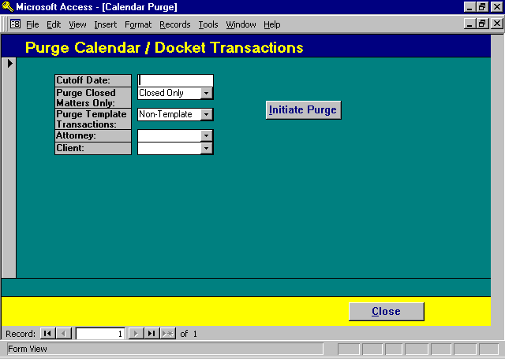

Purge Calendar/Docket Transactions Screen

CUTOFF DATE
Enter the cutoff date to be used for the purge. All calendar and docket transactions dated prior to the specified date, meeting the other criteria, will be removed from the system. The Cutoff Date must be less than the current system date.

PURGE CLOSED MATTERS ONLY
Specifies if purged transactions should be limited to closed matters only. The available options include:
Closed Only Only Docket Activity associated with Closed Files will be removed from the system.
All Docket entries meeting all other purge criteria will be removed from the system
regardless of the closed matter status.

PURGE TEMPLATE TRANSACTIONS
Specifies if purged transactions assigned to Docket Templates should be removed from the system. The available options include:
Non-Template Only Docket transactions non associated with docket templates will be considered for the
purge.
All All entries will be considered for purge regardless of the template status.

ATTORNEY
Enables all docket transactions assigned to a specific attorney to be purges. To limit the purge to a single attorney, enter the attorneys code, otherwise, leave the attorney code blank to purge transactions for all attorneys.

CLIENT
Enables all docket transactions assigned to a specific client to be purges. To limit the purge to a single client, enter the client code, otherwise, leave the client code blank to purge transactions for all clients.

INITIATE PURGE Button
The Initiate Purge button will start the purging process. After clicking the button, the following confirmation message will be displayed.

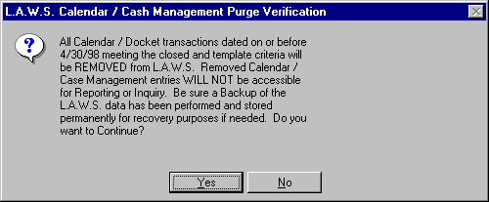

Please read and contemplate the displayed message. Purged entries are removed from the system. Please be sure that a backup copy of the L.A.W.S. database tables are backed up and permanently stored for safe keeping. If the remote possibility arises for the need to access or review purged data, this backup copy of data will be required. It is best to perform all system purges after the month end backup of data has been performed. Please review the User Guide chapter of this manual for a detailed explanation of the backup procedures.

A “No” option to the above message will cancel the Purge. A “Yes” option will continue. After selecting “Yes”, the following confirmation message is displayed.

Again, Please read the message. If a back copy exists, you may continue with the purge. Otherwise, select “No” and perform a permanent backup prior to purging.

A “No” option to the above message will cancel the purge. A “Yes” option will continue. After selecting “Yes”, the purge will be initiated. Upon completion the message “Purge Complete” will be displayed. Upon closing the form, the purge is complete.

PURGE MATTERS BASED ON THE DESTROY DATE

L.A.W.S. offers the ability of purging matters based on the matters destroy date. All matters destroy dates equal or prior to the cutoff date will be physically removed from the system. Existing WIP transactions and Accounts Receivable transactions associated with the purged matters are converted to the client / matter code “DELETED / DELETED”.

Be sure a backup of the firms data files exist and are permanently stored for possible future retrieval purposes.
Purged matters will no longer be assessable. Do not purge matters if the possibility exists for their future necessity.

Prior to purging maters, print a matter list with the selection by Destroy Date. Ensure that the list is thoroughly reviewed. Individual destroy dates may be modified, outside of the purged date range, on files which should not be purged.

After selecting Purge Matters from the Miscellaneous Menu, the following screen is displayed.

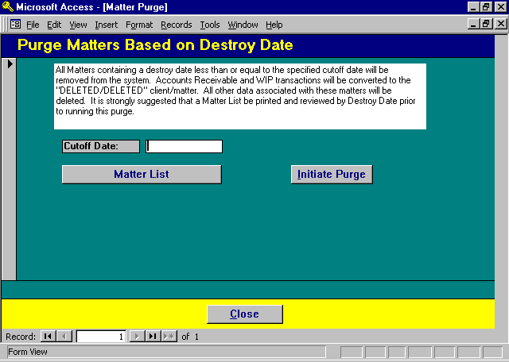

Purge Matter Selection Screen

To continue with the matter purge, enter a cutoff date then click “Initiate Purge”. Otherwise, select “Close” to cancel the purge.

DISPLAY ERROR LOG

L.A.W.S. maintains an error log of software failures associated with major functions within L.A.W.S. Software failures can be caused by a variety of situations such as by trying to operate a new release of L.A.W.S. software prior to performing the L.A.W.S. utilities, operating in conjunction with a damaged database, missing G/L numbers within the firm file, etc. Prior to this release, if software failures occurred we had to rely on memory to determine the cause of failure. This release of L.A.W.S. captures error messages occurring within the following modules:
Time Entry and WIP Adjustments,
Remote Time Processing,
Client Bill Finalization,
Split Bill Finalization,
Bill Reversal
Cash Disbursement Checks - both from Immediate Payment and Cash Requirements,
Journal Entries,
Trust Posting.

Listed below is a sample of the display error screen.

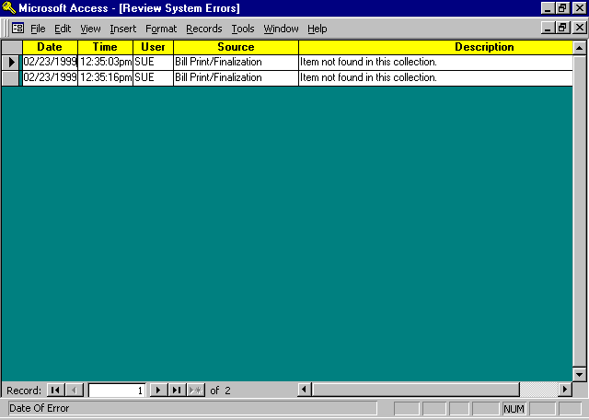

Display Error Screen

If unusual situations occur, review the error log. It is possible that there might be correlation between your situation and the error log. Errors should be few and far between so the volume of errors should be low.

