APPENDIX
TABLE OF CONTENTS

SYSTEM BACKUP 452
Introduction: 452
Suggested Backup Schedule 452
Daily Backup: 452
Weekly Backup: 452
Monthly Backup: 453
Summary 453
L.A.W.S. 97 UTILITIES 454
L.A.W.S. 97 Utilities Menu 454
REPAIR OR COMPACT DATABASE 455
Repair / Compact Database Selection 456
UPGRADE THE FILE STRUCTURE OF A L.A.W.S. DATABASE 457
Overview: 457
Upgrade Installation Instructions: 457
Upgrade File Structure Screen 458
Attaching LAWS97 to tables in the appropriate database(s) 460
Attach Path Screen 460
Attaching L.A.W.S. to multiple databases: 460
Network Installations: 461
REMOTE TIME 463
Remote Time Entry Selection Screen 463
Remote Time - Detail Sceen 464
Print / View Button 466
Create Transfer File and Purge Existing WIP 466
Sample: Remote Hours Worked Report 467
L.A.W.S. 97 SECURITY 469
Security Access 469
User File 469
Password Security 471
Signing onto L.A.W.S. 97 471
Unsuccessful Login Attempts 471
Re-activating a De-activated User 472
Application Security 472
Predefined Security Classes 472
User Defined Security Classes 472
Data Security 473
View Global Activity - Yes 473
View Global Activity - No 473
Secured Functions 473
What to do if you forget your password 473
RENEWING YOUR ANNUAL SOFTWARE MAINTENANCE AGREEMENT 474
CUSTOMER COMMENT REPORT 476

SYSTEM BACKUP

Introduction:

Backing up consists of copying all data files and directories on the fixed disk to tape (possibly multiple tapes), or some other media such as diskette. The BACKUP would then be stored securely either onsite or off site (perhaps in a safe deposit box). A current backup copy of all data files and libraries should exist at all times. It's possible that, at some point in time, the fixed disk (located in the main computer unit) may become damaged and
unusable. If this situation arises, all information on that disk (or the entire computer system) could be destroyed.
The only safeguard against the total loss of information is the backup procedure.

L.A.W.S. does not provide back up procedures for data or for application programs. It is the users responsibility to ensure that the L.A.W.S. application program and the related L.A.W.S. data files are backed up. If there are any questions pertaining to backing up the computer system, call L.A.W.S. Corporation for review and implementation of backup procedures.

Due to the volume of data it is usually impractical to backup to diskette. Most users utilize a tape backup system that backs up the entire computer system regularly, usually at night when the system is idle. Tape drives utilizes proprietary backup software. It is important to become familiar with the tape drive operation.

Suggested Backup Schedule

L.A.W.S. Corporation Strongly suggests that the following backup schedule is followed.

Alternating DAILY Backup -- Stored on- or off site
Alternating WEEKLY Backup -- Stored off site
12 month rotating MONTHLY Backup -- Stored off site

Daily, Weekly and Monthly backups always represent a complete copy of the computer system. There is no physical difference between a daily , weekly or monthly backup. The difference between the backups is the schedule with which the tapes are used and the storage of backed up tapes.

Daily Backup:

Daily backup includes two sets of backup media (tapes or diskettes). These may be kept on site and should be used on alternate days. For example:

Set 1 will be used on Monday.
Set 2 will be used on Tuesday.
Set 1 will be reused on Wednesday.
Set 2 will be reused on Thursday.

The intent of the daily backup is to provide the operator with a current copy of all data, and a second, one day old, copy of data. The most common form of data loss results from operator error or from equipment failure. Neither of these errors cause damage to the immediate surroundings. It is therefore suggested that the DAILY backups be kept on site for the convenience of restoring data when needed.

Weekly Backup:

Once per week, usually on Friday, a weekly backup should be performed instead of the daily backup. This backup should be stored OFF site when not in use. This set will be rotated on an alternating basis with a second weekly backup.

The reason for off site storage is in case of a major disaster, such as fire, where the entire physical building may be destroyed. Off site storage provides a secondary safe storage site for data.

The weekly alternating tape is important ensuring that a weekly off site backup is always secure. Note the following remote example: A fire destroys a law firm during normal working hours.. The computer operator performed a weekly backup, as suggested, but left the tape on their desk planning to take it home that evening. In this example, the fire would destroy the daily and weekly backup tapes. If a rotating weekly backup was performed, a week old backup would be stored safely off site. If the rotating backup was not performed, we lose one level of backup security and would need to rely solely on monthly backups.

Monthly Backup:

Once per month, usually after all monthly activity has been performed, a permanent month end backup of all data should be made. This information should be stored on a rotating 12 set system. For example, 12 tapes would be kept, one for each month. Every month a backup would be performed on the appropriate set. After the 12 sets are filled, the operator would begin re-using the set in chronological order. Therefore, the operator would always have one year's worth of data backed up. These backups should be kept off-site in a fire-safe location.

It is strongly suggested that a directory of the Month End Backup tape be printed and stored with the tape. The printout will probably be quite long, but could be important in the event of data restoration. The directory should also be reviewed monthly to ensure that the backup procedures are actually backing up the computer system correctly.

L.A.W.S. Corporation has worked with firms who performed backups as noted in this schedule. They neglected to ensure that the backup was backing up the required drives. When the need arose to restore backed up data after a disk crash, the firm found out that only a local c:\ drive was being backed up rather than the server. Their backups were useless. If they had periodically reviewed the backup directory to ensure that all critical drives and directories were backed up then the error would have been discovered.

Summary

These Backup Procedures represent the Minimum Standards for backing up your computer system. If desired, you may modify your backup procedures to provide additional layers of security. For example, the firm may decide to four sets of daily tapes rather than the alternating two sets.

Remember that backing up the computer system is a very inexpensive form of insurance. Hopefully you will never need to rely on backed up data, but if the need arises, it is imperative to have the most current, up to date backup procedures possible.

L.A.W.S. 97 UTILITIES

As a matter of convenience, L.A.W.S. 97 provides utility functions which allow for the Repair and/or Compact of databases and for the Upgrading Of The File Structure required for new releases of L.A.W.S. The L.A.W.S. Utilities must have exclusive access to the database(s) being repaired, compacted or updated. Be sure no other user is accessing the referenced databases.

The L.A.W.S. 97 Utilities is separate from L.A.W.S. and must be called from its own program ICON. To access the L.A.W.S. 97 Utilities perform one of the following:

1) Click the Start button on the Windows 95 desktop.
2) Click Programs,
3) Click L.A.W.S. 97
4) Click L.A.W.S. Utilities.

Older installations of L.A.W.S. may not have the L.A.W.S.97 Utilities option in the L.A.W.S. 97 program group. If you are unable to open the utilities from the desktop, the utilities may be opened from the Windows Explorer as follows:

1) Open Windows Explorer by right clicking the Start button then clicking Explore.
2) Double click the LAWS97 directory on the C:\ drive.
3) Double Click the Utilities97.MDB database ICON within the LAWS97 Directory.

The L.A.W.S. 97 Utilities menu should now be displayed as shown below.

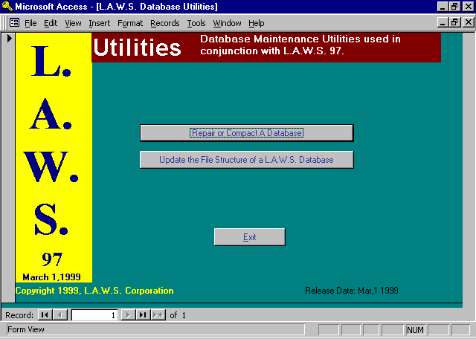

L.A.W.S. 97 Utilities Menu

A detailed description of the L.A.W.S. 97 Utility functions are described in the following sections.

REPAIR OR COMPACT DATABASE

It is possible to corrupt the L.A.W.S. database. Corruption usually occurs when a workstation is turned off without exiting L.A.W.S. The premature exiting of L.A.W.S. bypasses the normal closing of the database causing possible corruption. The Repair function repairs damaged databases. Please note, the Repair function cannot repair all databases. Be sure that proper backup procedures are followed allowing for recovery of data if the repair fails.

REPAIR
The Repair function should be run when access to L.A.W.S. is denied due to a damaged database. Repair rebuilds members of the database. It does not recreate the database nor does Repair remove fragmented space within the database.

COMPACT
The Compact function rebuilds all objects,(tables, queries, forms, etc.) and releases unused space. During normal day to day use databases tend to increase in size. Programs within L.A.W.S. create queries and work files that are deleted after use. The space utilized by these queries or work files is not decreased upon the deletion. Databases should be compacted on a regular basis, weekly or monthly. Compaction will improve performance by decreasing the size of the database and by rebuilding all indexes and objects.

The Compact function physically copies all data from the original database into a new database. During the copy procedure all objects of the database, (queries, tables, forms, etc.), are naturally repaired and rebuilt. Fragmented space within the database is removed.

The original database is never modified during the compaction process. L.A.W.S. automatically appends "BKU" to the original databases name prior to performing the compaction. This renamed database is then rebuilt as the original databases name

Example: Assume the firm wants to compact the DATA97.MDB database. L.A.W.S. will automatically rename the database DATA97.MDB to DATA97BKU,MDB. All objects within the renamed database will then be compacted, copied, into a new database called DATA97.MDB. After the compaction process both databases will reside on the system. An existing database with the "BKU" extension will be deleted prior to the compaction.

The Compact function performs both the compact and Repair. The Compact function should be used whenever possible. If the Compact function cannot be run due to a damaged database, repair the database using the Repair function then compact the database.

To Repair or Compact a database(s) select the Repair or Compact Databases from the L.A.W.S. Utilities menu to display the following screen.

Repair / Compact Database Selection

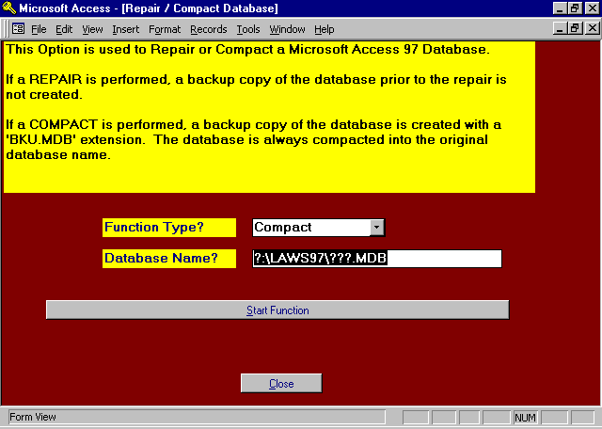

FUNCTION TYPE
Specifies the type of function to be performed. The available options include:
Compact The specified database will be compacted.
Repair The specified database will be repaired.

DATABASE NAME
Identifies the database to be repaired or compacted. Enter the complete DOS paths of the database to be processed. (If multiple databases are to be processed, this procedure must be run several times – Once for each database.)

START FUNCTION Button
The Start Function button will perform either the Repair or Compaction of the specified database. L.A.W.S. displays the status of the system as each table is being processed.

Be sure to Compact the database if the Repair function was performed,

UPGRADE THE FILE STRUCTURE OF A L.A.W.S. DATABASE

Overview:

These instructions review the release upgrade instructions pertaining to L.A.W.S. 97. They address the procedures for converting data from an earlier version of L.A.W.S. to the current L.A.W.S. 97 format.

L.A.W.S. 97 must operate in conjunction with Windows 95. If ALL prospective L.A.W.S. 97 users are not running Windows 95, do not upgrade to L.A.W.S. 97.

L.A.W.S. 97 requires a high speed Pentium processor with a minimum of 16MB ,(32MB or higher recommended), of memory. Performance will degrade with low memory or slow speed processors.

All users within the law firm must use the same version of L.A.W.S., either L.A.W.S. 97 or L.A.W.S. 20. Although L.A.W.S. 97 has the ability to access L.A.W.S. 20 data, only converted databases should be accessed by L.A.W.S. 97. The record locking, table sharing, printing, queries etc are different between the versions and unexplained problems and/or errors may result from accessing a 2.0 database from 97.

All L.A.W.S. users within the firm must be updated simultaneously. The L.A.W.S. 97 upgrade may modify some table layouts. If both updated users and older release users access the modified tables, you may encounter data integrity problems. It is suggested that all batch processing be completed prior to installing this upgrade. Accordingly all Cash Receipts should be posted and non-finalized client statements should be finalized.

The upgrade procedure requires exclusive access to the L.A.W.S. data. The person performing the upgrade should have full access to the Miscellaneous Functions menu. Please make sure that other users are not accessing L.A.W.S. during the upgrading process.

Ensure that a complete, permanent, and secure backup of the L.A.W.S. data has been performed prior to installing this update. If a failure occurs during the release upgrade process, for whatever reason whatsoever, the backed up copy of the L.A.W.S. data may be the only method available for recovery.

Please Note: It is not possible to incorporate custom programming changes into L.A.W.S. 97 without the full Microsoft Access 97 program. It is not possible to incorporate custom changes into the actual L.A.W.S. 97 application software without additional ‘.MDB’ tables, not supplied with the installation disks, from L.A.W.S. Custom Changes must be stored in and run from a separate Custom Database.

If you rely on custom reporting, discuss the custom reporting with L.A.W.S. Corporation prior to performing the upgrade to ensure access to your custom programming. Verify that custom changes have been secured in a Custom Database. Otherwise they will probably be overwritten during the upgrade process.

Upgrade Installation Instructions:

1) Post all non-posted deposits utilizing the Process Cash menu item.

2) Finalize all not-finalized client statements.

3) Ensure that a complete current backup of the firms data database has been performed. This database is usually stored in the \LAWS or \LAWS97 directory. If the firm utilizes a network, the directory will probably reside on a network drive, otherwise, the data is normally stored on the C:\ drive. The data’s database name is normally the firm name with a “.mdb” extension. It is possible that the database name may simply be called “Data.mdb”. If you are in doubt as to the data’s database name talk to the office administrator or a representative of L.A.W.S. Corporation for the name and location. MAKE SURE THAT THE DATABASE(S) BEING MODIFIED HAS BEEN BACKED UP.
4) Ensure that you have exclusive access to L.A.W.S. If other users access the L.A.W.S. database during the update process, sharing errors may result. If desired, the name of the firms data database may be modified prior to performing the upgrade ensuring exclusive access.

If changing the database name, record the new database name here:

Database Name & Path Date of Upgrade

__________________________________________________________________________

__________________________________________________________________________

__________________________________________________________________________

__________________________________________________________________________

5) Install the upgrade on one initial system. One system should be chosen for the L.A.W.S. 97 upgrade. If installing from disks, Insert Disk 1 of the release upgrade into the diskette drive then run “A:\SETUP”. If installing from CD, run SETUP.EXE from within the UPGRADE directory on the CD. Follow the instructions on the screen. Choose the ‘Typical’ installation option.

6) Access the LAWS. 97 Utilities menu in the L.A.W.S. 97 program group. Review the L.A.W.S. 97 Utilities section of this chapter for information on accessing the LAWS. 97 Utilities

Select the Update the File Structure of a L.A.W.S. Database Button to display the following screen.

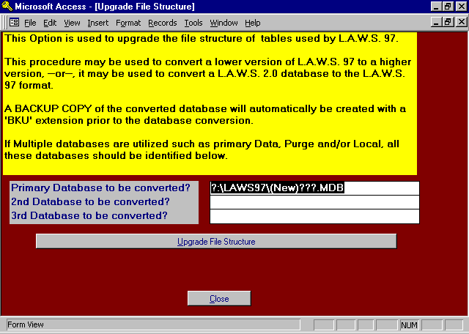

Upgrade File Structure Screen
The L.A.W.S. update procedure analyses each table within the listed database(s). All required modifications are made to the appropriate tables for the new release. The length of time required to perform the update will vary based on the quantity of changes and the size of the database. Small databases may be modified in several minutes, while larger databases will take longer. The status of the modifications is displayed on the screen for user review.

If multiple databases are utilized for the storage of data, all databases should be converted simultaneously. Most firms use a primary database that contains all files utilized by L.A.W.S. Some firms have created a secondary database PURGED database containing the Billed WIP and Purged Accounts Receivable. Some firms have secondary LOCAL database containing the Cash Receipt tables. If there is doubt pertaining to the utilized databases, call L.A.W.S. Corporation for assistance prior to Converting.

L.A.W.S. analyzes all tables. within the listed databases. If additional tables are required for the new release that is not contained in the listed databases, L.A.W.S. will add these tables to the Primary Database.

This listed database(s) ARE NOT MODIFIED. The data contained in these database(s) will be copied into a new database(s) identified with a "BKU.MDB" extension. The Database(s) must exist.

The complete DOS path identifying the firm’s database(s) name must be entered. Enter database names that contain L.A.W.S. tables only. Do not convert non-L.A.W.S. databases or the L.A.W.S. application software database. If the database was previously renamed, as suggested in step 4, the modified path must be entered.

Information To Enter:

PRIMARY DATABASE TO BE CONVERTED
The Primary Database represents the database that contains all tables utilized by L.A.W.S. This database may be either a L.A.W.S. 20 or L.A.W.S. 97 database.

2ND / 3RD DATABASE TO BE CONVERTED
If the firm utilizes multiple databases for the storage of L.A.W.S. data, enter the additional databases in these fields. The order of entry makes no difference. Do not duplicate database names.

After entering the correct paths, press the Update File Structure button to initiate the change, otherwise, press cancel to exit this procedure. L.A.W.S. displays, for visual verification, the entered Source and Destination path names. If an error was entered, cancel the update then re-key the path names.

As reference for future use, please list the upgraded database(s) below:

Primary Database Purged Database(if Any) Local Database(If Any) Date
Example:
F:\Laws97\Data97.mdb F:\Laws97\Purged97.MDB C:\LAWS97\LOCAL97.MDB 12/97
___________________ _______________________________________________________
___________________ _______________________________________________________
__________________ _______________________________________________________
___________________ ______________________________________________________
___________________ ______________________________________________________
___________________ _______________________________________________________
___________________ _______________________________________________________

After all the databases are converted, the L.A.W.S. application software must be attached to the modified database as noted below.

Attaching LAWS97 to tables in the appropriate database(s)

Sign onto L.A.W.S. 97 in the normal manner. New versions of L.A.W.S. are not attached to database tables. Immediately after signing on to the upgraded software, the Attach Path form is displayed as shown below:

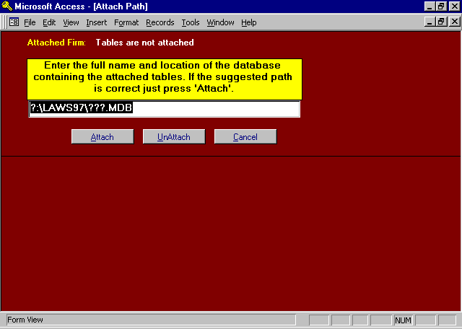

Attach Path Screen

Enter the complete path corresponding to the Path to be attached. Be sure to refer to the correct directory and drive letters. (If in doubt, refer to the list of utilized, converted database names noted on the prior step).

Attaching L.A.W.S. to multiple databases:

If multiple Databases are utilized, the Attach procedure must be run for each database.

Example: Assume a firm has three databases in the C:\LAWS97 directory. A primary database called Data97.MDB and two secondary databases called Purge97.MDB and Local97.MDB. Upon signing onto L.A.W.S. 97, the displayed Attach Path screen will be displayed. The secondary databases should be attached first. The order of attachment of the secondary databases does not matter.

For this example, C:\LAWS97\LOCAL97.MDB is entered. After pressing the Attach button, the tables contained in the entered database will be attached to the LAWS97.MDB application software. After the attachment, the L.A.W.S. Attach Path screen will be re-displayed.

Repeat the attach procedure for the other secondary databases. In this example, the remaining database is called C:\LAWS97\PURGE97.MBD. The Attach Path screen will be redisplayed after attaching to the additional secondary database.
Repeat the attach procedure for the primary database. In this example, the primary database is called C:\LAWS97\DATA97.MBD. After Attachment to the primary database, the master menu will be displayed.

After the database(s) are attached to the L.A.W.S. 97 application software, take a few minutes to review the system and ensure that its function seems reasonable. Check functions that access all attached databases such as those functions noted below:

Primary Database:
Normally the primary database contains all tables except for the A/R and WIP history tables or the Cash Receipt tables. Review the following:
- Any of the Data File Maintenance functions;
- Time Entry;
- General Ledger.

Purged Database:
The purged database normally includes the Billed WIP and Purged A/R. Review the following:
- A/R Inquiry - Complete option to review historical A/R Activity;
- WIP Inquiry - Billed WIP option to review Billed WIP.

Local Database:
The local database normally includes the cash receipt processing files. Review the following:
-Try entering a Cash Receipt Entry then run an edit listing. If the entry and edit works correctly
the local database is attached correctly. - The entry does not need to be posted and may be
deleted if desired.

Remove Redundant Databases:

It is important to have permanent copies of all databases, prior to conversion, for possible recovery purposes. It is equally important that the backup copies of thes databases NOT be stored in the \LAWS97 directories.

TO DECREASE CONFUSION AS TO THE NAMES OF THE LIVE DATABASES, only a single current copy of the L.A.W.S. application software, (LAWS97.MDE), and a single current copy of each utilized data database should be stored in the \laws97 directory(s).

Permanent backup copies of older databases should be permanently stored off line, or in specific historical directories outside of the \LAWS97 directory.

Standalone installations are now complete!!!!!

Network Installations:

Initial installation of the Runtime Software.

The initial LAWS97 installation diskettes contain the runtime version of Access 97 along with other required system files. The installation diskettes must be installed on each networked system utilizing L.A.W.S. 97. These diskettes need only be installed once. Additional upgrades of the LAWS97 software do no require the re-installation of the initial installation disks. The UPGRADE diskettes do not need to be copied to each system.

All L.A.W.S. users should utilize consistent network drive letter mappings for the network drives.

Perform the initial installation, or upgrade, and attachment of databases to the LAWS97 application software on a single system as described earlier in this section. Copy the upgraded application software, C:\LAWS97\LAWS97.MDE, from the initially installed system to the network drive. Next, copy this file, LAWS97.MDE from the network drive to each individual system’s C:\LAWS97 directory throughout the office.
Note: The initial installation diskettes and the upgrade diskettes contain a complete copy of the L.A.W.S. application software. This software is not attached to any databases. Copying a correctly configured LAWS97.MDE application database to the server then to the individual system eliminates the need to attach the utilized databases at each workstation.

Access L.A.W.S. from a networked system after the copying of the files to ensure the proper operation. If different levels of security are utilized within the firm, sign onto the system as different users to ensure proper security access.

The conversion should now be complete.

REMOTE TIME

L.A.W.S. provides Remote Time Entry software that allows timekeepers to accumulate time from remote sites. Remote sites are defined as computer systems that do not contain the L.A.W.S. application software or are not directly attached to the firm's data tables. Remote sites could include portable notebook computers or home systems. Once entered, the remote time is copied from the remote site into the full L.A.W.S. system.

The L.A.W.S. 97 Remote Time Entry software must be installed on the remote system. The Remote Time Entry software is included within the L.A.W.S. 97 installation programs. Once installed, access Remote Time Entry by selecting the program "LAWS97 Remote Time Entry" from the Windows Program Group.

Remote Time Entry is very similar to Time Entry within L.A.W.S. The major difference is that remote data is not verified for accuracy when entered at the remote site. Remote time is verified for accuracy as it is posted to the firms Work In Process through Remote Time Processing within L.A.W.S.

After selecting LAWS97 Remote Time Entry, the following screen appears:

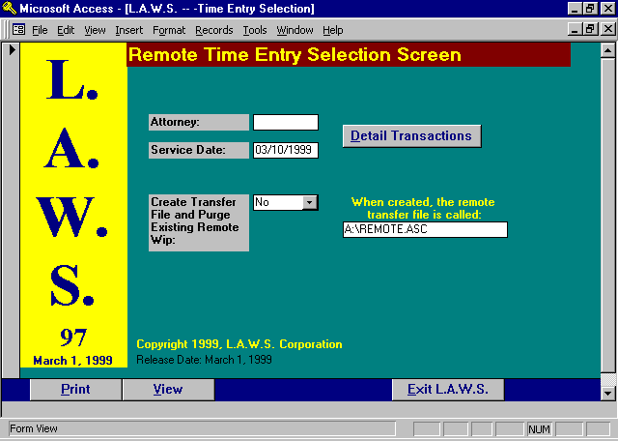

Remote Time Entry Selection Screen

ATTORNEY
Enter the attorney code associated with the remote time.

SERVICE DATE
Enter the service date of the remote time being entered.
After entering the service date, the remote time Detail Transactions screen is automatically displayed. If desired, the Detail Transactions screen may also be displayed by clicking the Detail Transactions button.

Displayed below is an example of the Remote Time Detail Transactions screen.

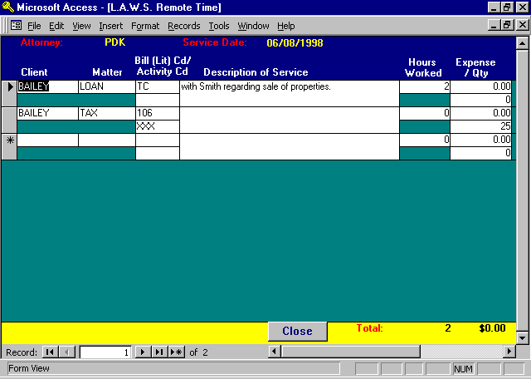

Remote Time - Detail Sceen

The Attorney/Service Date information is carried over from the previous screen. This information should be verified prior to entering the time sheet. It is easier to correct an incorrect service date or attorney prior to completing the timesheet then after.

CLIENT
Enter the client code associated with the time entry.

MATTER CODE
Enter the matter code associated with the time entry.

If the client and matter are blank, the client and matter are automatically duplicated from the last line entered.

BILL (LIT) CD/
ACTIVITY CD
The L.A.W.S. Time Entry program allows reference to two bill code fields. The first Bill Code is classified as the Litigation Code while the second Bill Code is classified as the Activity code. Bill Codes are optional for fee transactions, hours worked times rate. At least one Bill Code is required for expense transactions.
Many firms are required to submit ASCII billing files, along with the physical copies of the client invoices, to clients. A requirement of many ASCII billing files is the utilization of the American Bar Association (ABA) TASK CODE structure. The ABA task coding structure consists of three major classifications of codes identified as follows:
Lxxx Litigation Codes
Axxx Activity Codes
Exxx Expense Codes.

Each ABA code consists of a letter identifying the type of code followed by three digits. Fee transactions usually require a litigation code along with an activity code. Expense transactions usually require an expense code only. If your firm is required to use the ABA Task Codes, please contact the either the ABA, or the client imposing the task code requirement for a complete listing of the Task Codes.

DESCRIPTION OF SERVICE
Enter the description of service performed.

The bill code description is not extended into the "Description of Service" within remote time entry. The bill code description will be inserted at the start of the Description of Service when the remote time is imported into the actual WIP files. If a bill code is entered, do NOT enter the bill code description into the "Description of Service" field.

Example: The bill code "TC" is defined as "Telephone conference with". The attorney wishes to record a telephone conference with John Smith. The Bill code for this transaction would be entered as "TC". The "Description of Service" would be entered as "John Smith." When the remote time is imported into WIP, the description will be modified to read " Telephone conference with John Smith."

If desired, additional bill codes can be used within the Description of Service (to save time typing only) by placing a "\" (back slash) before a bill code within the Description Of Service.

Example: A bill code “CW” may be used which will insert “Conference with” into the WIP Description. If a bill code has been established as “PA” for “Plaintiff Attorney”, then the characters “\pa “ may be entered as the remote time entry's Description of Service. The extension of the bill code(s) will not occur within the remote time system. When the remote time is imported into the firms WIP, the Description of Service will automatically be extended to “Conference with Plaintiff Attorney”.

To enlarge the Description of Service field, ensure that the cursor is located within the desired field then press the SHIFT and the F2 key simultaneously to activate the ZOOM Box. Exit the ZOOM Box by pressing ENTER or clicking on OK.

There is no practical limit to the amount of data that can be inserted into the Description of Service.

HOURS WORKED
Enter the hours or fraction thereof, for the time entry. Hours are entered in tenths of hours, so 30 minutes would be entered as .5 while 1 hour would be entered at 1.

EXPENSE
Expenses incurred such as parking, meals, photocopies, etc. can be recorded directly through Time Entry. Expenses are costs which are being charged to the client, BUT FOR WHICH THE FIRM IS NOT GENERATING A DISBURSEMENT CHECK. Be sure not to duplicate Cash Disbursement entries that are automatically entered through the Check Writing program.

QTY
If applicable, enter the quantity of expense units. For example: Faxes are charged at $1.00 per page. A $1.00 charge per page may be associated with the fax bill code as the “unit cost” in Bill Code Maintenance. If a 5-page fax was sent, a quantity of 5 could be entered instead of a $5.00 expense amount. L.A.W.S. will then multiply the quantity-entered times the unit cost, generating an expense amount. The quantity entered is automatically appended to the existing bill code description when the remote time is imported into the firms WIP.
NOTE: Both Hours Worked and Expenses may be entered thorough the Time Entry Option. However, hours and costs must be entered on separate lines.

Values entered as “Hours worked” are considered hours unless a Per Diem Bill Code is used. A Per Diem Bill Code (Per Diem = Yes in Bill Code File Maintenance) automatically converts the Hours Worked value into Days Worked. The analysis of the bill code and classification of the Per Diem status occurs when the remote time is imported into the firms WIP files.

Clearing a Partially Entered Line
All verifiable data is checked for accuracy prior to posting the line item. If, for whatever reason, a partially entered line item must canceled, press the ESC key. It is possible that the ESC key must be pressed twice. The first ESC will clear data from the current field while the second ESC will clear the entire record. Since L.A.W.S. performs extensive verification procedures, a partially entered record cannot be exited without pressing the ESC key.

The footer of the form displays the total hours worked along with the total days worked for visual verification by the user.

Once all time has been entered for a day, press the "Close" button to return to the Remote Time Entry Selection Screen

___________________________________________________________

Print / View Button
The Print / View buttons allow the accumulated remote time to be printed or viewed. It is strongly suggested that a printed copy of accumulated remote time accompany the transfer diskette to the LAWS full-service system as verification as to the data contained within the transfer file.

It is also strongly suggested that a printed copy of remote time be run after the Purge is performed to verify the functionality of the Purge.

A copy of the Remote Time Report may be found at the end of this section.

Create Transfer File and Purge Existing WIP

In order for the remote time to be integrated into the firms Work in Process, the remote time must be copied off the remote PC then copied onto a LAWS full-service system PC. This is accomplished through the creation of a transfer file.

The transfer file is created using the Create Transfer File And Purge Existing Wip field located on the Remote Time Entry Selection Screen. Please review the available options noted below:

NO
A no option will not create a transfer file nor purge the remote time from the system. "No" is the default.

CREATE
A transfer file will be created which contains all remote time accumulated on the remote system since the last remote "Purge" was performed. The name of the created transfer file defaults to "A:\REMOTE.ASC". If desired, the path may be changed to any valid path name. If you change the path name, remember what the new path is changed to. The path name must be entered when importing remote time into L.A.W.S. Please review the Remote Time Processing functions within the Time Processing chapter of this manual for information on importing remote time into WIP.

As a safety precaution, the Create option does not purge remote time from the remote system. Due to any number of reasons, such as diskette failure, it is possible that the transfer file may need to be created a second time. Remote time will not be removed from the system until the Purge option s performed.

To install the transfer file onto the LAWS full-service system perform the following steps.
1: Insert the diskette containing the current transfer file into the full-service system's diskette drive.
2: Access Windows Explorer.
3: Double click the A: drive to display contents of the diskette.
4: Select the transfer file by single clicking the REMOTE.ASC file within the A: drive.
5: Use the mouse and left button to drag the selected REMOTE.ASC file from the A: drive to the
LAWS97 directory on the C: drive.

Please Note: The above series of steps assumes the path name has not been changed from A:\REMOTE.ASC. If the path name has been changed simply replace the path A:\REMOTE.ASC with the changed path name. Once the remote time has been successfully imported into the firms WIP, ensure that the imported remote time has been purged from the remote system.

Do not enter additional remote time until the imported remote time is purged from the remote system.

The following page contains a sample of the Remote Time Entry report.

Sample: Remote Hours Worked Report
Remote Hours Worked by Contributing Attorney :
Service Bill / Act Hours Entry
Date Client/ Matter Code Description Worked Cost Qty Date
_________________________________________________________________________________________________________________________________
PDK
06/08/1998
BAILEY LOAN PDK TC with Smith regarding sale of properties. \cw John Smith. 2.00 $0.00 0 06/08/1998
BAILEY TAX PDK 106 XXX 0.00 $0.00 25 06/08/1998
Time Sheet Total: 06/08/1998 : 2.00 $0.00
_________________________________________________________________________________________________________________________________
Attorney Total PDK : 2.00 $0.00

_________________________________________________________________________________________________________________________________
Copyright 1998 L.A.W.S. Corporation 6/9/98 12:48:16 PM 1
WIP-1RmtRemote Time Menu-Edit List - Complete

L.A.W.S. 97 SECURITY

The security features within L.A.W.S. have been greatly expanded in this version of L.A.W.S. 97. Security consists of:
1: Password Security: User ID and Password required for L.A.W.S. sign-on.
2: Application Security: Full or partial access to L.A.W.S. applications determined by User ID and
Password.
3 Data Security: Full or partial access to L.A.W.S. data determined by User ID and Password.

The key features of L.A.W.S. 97 Security are discussed in detail throughout this chapter.

Security Access
Security within L.A.W.S. is accessed through the Define User function within Calendar / Case Management as well as through Attorney Maintenance within Data File Maintenance. Please ensure that access to these functions is limited to individuals responsible for security functions.

L.A.W.S. 97 is delivered with a runtime version of Microsoft Access 97. Security is tight, and relatively hard to bypass using the supplied runtime Access 97 software. WARNING - If L.A.W.S. 97 is installed on systems containing the full version of Access 97, users may be able to bypass L.A.W.S. security and access secured data. Users with limited access of L.A.W.S. should not have the full version of Access 97 installed on their systems.

User File
A user within L.A.W.S. is defined as any individual requiring access to any or all of the L.A.W.S. 97 application software. All security information is associated with the user. Users accessing L.A.W.S. must have a User record created through the Define User function of Calendar / Case Management. For an in-depth description of the Define User function, review the Calendar / Case Management section of this manual.

Please Note: The DEFINE USER function is displayed on the Case Management menu ONLY IF THE SECURITY CLASS ASSIGNED TO THE PERSON LOGGED ONTO LAWS IS SET TO SECURITY. if the security class is set to anything other than SECURITY, the function is not displayed.
Listed below is a copy of the Define User input screen.

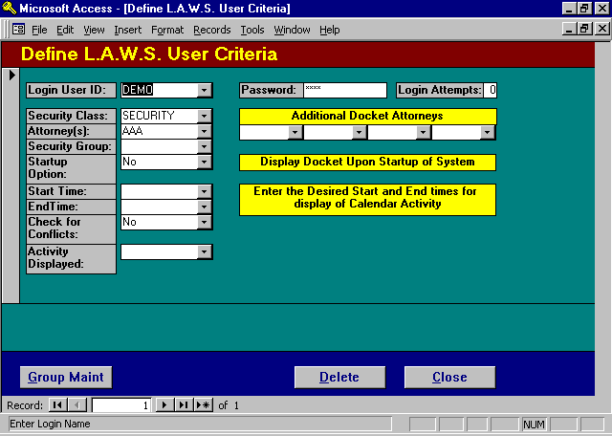
The key security fields listed on this screen are the Login User ID, Password, Security Class, Attorneys and Security Group. The significance of these fields are described below.

LOGIN USERID and PASSWORD
The initial login screen (Welcome to L.A.W.S.) is always displayed when signing on to L.A.W.S. The User ID and Password entered on the initial login screen is compared to the information entered through the L.A.W.S. Define User Screen. If both the Userid's and Password's match, the user is logged on, otherwise the login is canceled.

SECURITY CLASS
The Security Class determined the menu that is displayed upon a successful login. Please review the User Maintenance section within Case Maintenance for a complete listing of the available security classes.

ATTORNEY(S)
The first attorney is the primary attorney assigned to the logged in user. This attorneys initials are displayed during normal L.A.W.S. functions such as in entering time, printing productivity reports, etc. The View Global Activity setting, see Attorney File Maintenance within the Data File Maintenance section of this manual, is assigned to the current user. If the View Global Activity is set to NO, then the logged in user has access only to the attorneys reverenced on this screen. Referenced attorneys include the Attorney(s), and attorneys within the listed security group.

Password Security

Signing onto L.A.W.S. 97

Displayed below is the L.A.W.S. 97 sign-in screen displayed whenever a user accesses L.A.W.S.

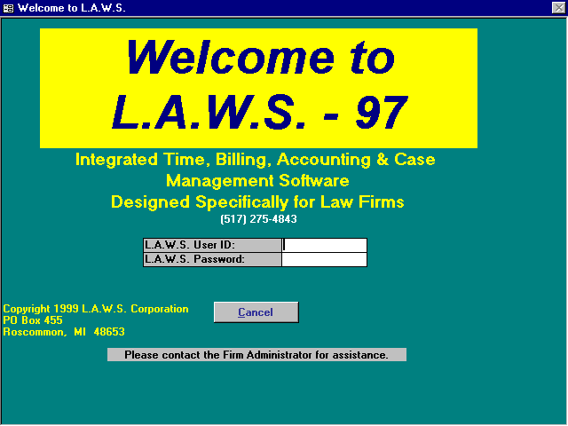
Each user must have a unique User ID and Password. When a user signs onto L.A.W.S. the sign-in User ID and Password are validated against the User Ids and Passwords entered through the Define User screen. Upon validation of the sign-in User ID and Password, access to L.A.W.S. is allowed.

Unsuccessful Login Attempts
As a security feature, L.A.W.S. records the number of consecutive unsuccessful login attempts per user. When a user enters an invalid User ID / Password combination, the following message is displayed.

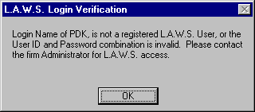
Upon acknowledgement of the message, the L.A.W.S. application software is closed and control returns to the Windows 95 Desktop. Consecutive unsuccessful Login attempts are monitored by L.A.W.S. When a successful login occurs, the counter accumulating unsuccessful login attempts automatically reset to zero (0).

When a user accumulates four (4) or more consecutive unsuccessful login attempts, the following message is displayed and access to L.A.W.S. by that user is automatically terminated.

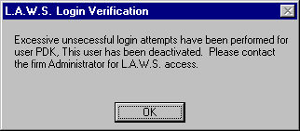
Login by the specified user will hereafter be denied. Successive login attempts for the specified user will always display the above message regardless of whether a valid or invalid password is entered.

Re-activating a De-activated User
Re-activating a user that has been de-activated is a simple process consisting of the following steps:

1: A valid user, with access to the Calendar / Case Management menu, must sign on. (If there are
no valid users left on the system, or if all valid users and passwords are forgotten, call L.A.W.S.
Customer Support at (517) 275-4843 for support.)
2: Access the Define User function on the Calendar / Case Management menu.
3: Access the de-activated users record and determine the correct password.
4: Re-set the Login Attempts counter to zero (0).
5: Close the Define User .
6: Verify that the de-activated user can sign on with the correct password.

Application Security

Predefined Security Classes
The Security Class assigned to the user determines access to L.A.W.S. Applications. Upon entry of a valid User ID and Password, L.A.W.S. displays the appropriate menu as noted in the Security Class field. Please review the Define User section of the Calendar / Case Management chapter for samples of the security Class menus. The standard security classed within L.A.W.S. as defined below:
Security Class Description

SECURITY Full Access to L.A.W.S. The master menu is displayed - Full access to User Security.
FULL Full Access to L.A.W.S. The master menu is displayed - No access to User Security.
PARTIAL -or- STAFF Limited Access to L.A.W.S. consisting of Time Entry; WIP, A/R Client and
Matter Inquiry; Docket & Calendar; Conflict of interest checking; Limited WIP
and A/R Reporting. (The security class of "Partial" or "Staff" display the same
menu.)
ADMIN Limited Access to L.A.W.S. Same functions as Partial except that Client and
Matter Inquiry are replaced with Client and Matter Maintenance.
INQUIRY Limited menu containing the time entry through daily calendar, and limited
inquiry functions.

User Defined Security Classes
L.A.W.S. users may develop "User Defined Menus" that exactly match the user access requirements. The development of User defined menus consist of copying then modifying existing menus to meet the firms needs. All user defined menus MUST start with the prefix of "frmUserMenu_" followed by the security class.

Assume for example that a user, Kathy, required a custom menu. The firm administrator developed a user menu specifically for Kathy which was named "frmUserMenu_Kathy". Kathy's security class would be set to "Kathy. Upon logging on, L.A.W.S. would determine that "Kathy" was a user defined security class and would automatically display the menu called "frmUserMenu_Kathy".

There are currently seven user-defined menus that come standard within L.A.W.S. These menus have been developed for current users of L.A.W.S. The user-defined menus are numbered consecutively from 1 to 7. Accordingly, to access the existing user-defined, such as "frmUserMenu_7", simply enter "7" in the users security class.

Please review the Define User section of the Calendar / Case Management chapter for samples of the included user-defined menus.

Data Security

L.A.W.S. provides limited data access security within L.A.W.S. based on the attorneys View Global Activity setting within Attorney File Maintenance. Each user must be associated with one or more attorneys. The primary attorney is the first attorney listed by "Attorney(s)" within the Define User screen..

View Global Activity - Yes
Upon logging on, L.A.W.S. reviews the View Global Activity setting associated with the primary attorney. If the setting is "Yes" then the user has the ability to access all attorneys' data within the scope of the users Application Security. A "Yes" View Global Activity setting does confer "Full" security. The global activity setting operates in conjunction with the Security Class.

Example: Attorney SSJ has a View Global Activity setting of "Yes" and a Security Class of "Partial". Upon logging in, SSJ is limited to the functions listed on the "Partial" menu. Within the functions contained on this menu, SSJ may select any attorney code.

View Global Activity - No
If the primary attorneys View Global Activity setting is "No" then access to other attorneys activity is limited to the attorneys referenced in the Define User option. The available attorneys include the primary attorney, the "Additional Docket Attorneys" and all attorneys within a referenced "Security Group".

Example: Attorney SSJ has a View Global Activity setting of "No" and a Security Class of "Partial". SSJ's user record contains "SSJ" as the primary attorney and "BBB" as and additional docket attorney. Upon logging in, SSJ is limited to the functions listed on the "Partial" menu. Within the functions contained on this menu, SSJ may select attorney codes "SSJ" and'or "BBB" only.

Secured Functions
The secured functions within L.A.W.S. are listed below:

- Time Entry,
- Hours Worked Calendar,
- Contributing Attorney Hours Worked Report,
- Docket and Calendar.

All other functions allow access to all attorneys.

What to do if you forget your password

If you are not the firm administrator, talk to the firm administrator.

If you are the firm administrator, call L.A.W.S. customer support at (517) 275-4843.

RENEWING YOUR ANNUAL SOFTWARE MAINTENANCE AGREEMENT

L.A.W.S. keeps track of the Annual Software Maintenance (SMA) expiration date. Forty five days prior to the SMA expiration date the following screen is displayed.

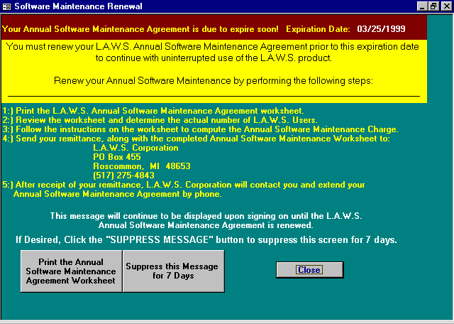

This screen will initially appear on the stations of users with security clearance only. The Security user can print the SMA worksheet then suppress this screen for 7 days. If three days pass and the message is not suppressed, then the message will be displayed on all users screens upon login. Please note, non-Security users cannot print the SMA Renewal sheet, or suppress the message.

To renew your maintenance, print the SMA Worksheet and remit a copy of the worksheet, along with your remittance, to L.A.W.S. Corporation, PO BOX 455, Roscommon, MI 48653

Upon receipt of your remittance, L.A.W.S. Corporation will extend your maintenance via the phone.

If you have any questions whatsoever, Please call L.A.W.S. Corporation at (517) 275 4843.

The SUPPRESS THIS MESSAGE FOR SEVEN DAYS button will suppress the message for seven days. The message cannot be suppressed less than 7 days prior to the expiration date.

The worksheet contains the formula for computing the Annual L.A.W.S. SMA. A sample of this worksheet is listed below.
L.A.W.S. Annual Software Maintenance Agreement Renewal
Firm: L.A.W.S. Corporation Report Date: 03/10/1999
PO Box 455
Roscommon. MI 48653 SMA Expiration Date: 03/25/1999
Number
Date of First Date of Last of Check if
User ID Sign-On Sign-On Log-Ins Active User Explanation if User is not Active
__________________________________________________________________________________________________________________
DEMO 03/10/1999 03/10/1999 5 ______ ___________________________________________________________
Number of other users not listed: _______ Users sharing the same User ID etc.
__________________________________________________________________________________________________________________
Summary: Total Active Users: _______

Primary User Maintenance Fee: 1 at $600 Per Primary License = $600.00
Additional User Maintenance Fee: _______ at $60 Per Additional User = __________
(Total Active Users less 1)
Total Due L.A.W.S. Corporation
(Sum of Maintenance Fees) ______________
Upon Receipt of the Software Maintenance Fees by L.A.W.S. Corporation, you will be contacted by our
Customer Support representative who will extend your Software Maintenance period by phone.

L.A.W.S. Corporation thanks you for your continued support.

_______________________________________________________________________________________________________
Copyright 1999 L.A.W.S. Corporation 3/10/99 10:19:26 AM 1
L.A.W.S. Annual Software Maintenance Renewal Form

CUSTOMER COMMENT REPORT

Please use this form to report documentation errors, software bugs, or enhancement requests. Mail this form and any attachments to:
L.A.W.S. CORPORATION
PO Box 455
Roscommon, MI 48653
(517) 275 4843

Please Identify the law firm:

Name ______________________________________________________________________

Street ______________________________________________________________________

City _______________________ State __________ Zip ___________________________

Contact _______________________________________ Phone ________________________

DATE _________________

CATEGORY
______ Documentation Problem ______ Software Enhancement
______ Software Problem ______ Other

DETAILED DESCRIPTION - Please provide a specific description of problem or enhancement. Attach reference information, if available.

_______________________________________________________________________________________

_______________________________________________________________________________________

_______________________________________________________________________________________

_______________________________________________________________________________________

_______________________________________________________________________________________

_______________________________________________________________________________________

SOFTWARE/HARDWARE DESCRIPTION

L.A.W.S. Version ____________________________________________________________

Hardware Description ________________________________________________________

_________________________________________________________

_________________________________________________________

